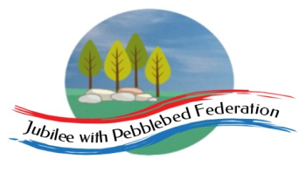 Home Learning Grid 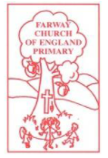
This is the home learning grid for the week beginning 19th April 2021. Please use this as a grid to support planning your child’s home learning. Additional resources will be made available on ‘google classrooms’, to support your child to access these activities. A daily reading and counting task are important to support your child to access their education but remember to have fun!
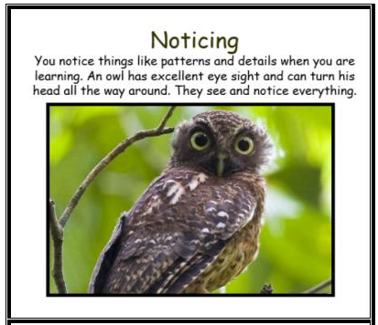
This week, we will be starting our new Topic: Scented Garden! It is an extremely exciting topic, exploring the natural plants and world around us, using our senses. We will also learn about the different properties and uses of plants, inspiring us to create our own gifts. Therefore, this week, Class 1 will begin focusing on the key Learning Behaviour: Noticing. We will be spending a lot of time outdoors and noticing the different smells, sights, sounds and textures around us, to enhance our learning experience, so get those eyes open wide and be that Owl. What plants, patterns and details do you notice around you?
If you have internet issues during a self-isolation period, you can still access Google Classrooms using your phones. You can also contact the school and we can try and support you with appropriate, alternative learning options.
Home Learning – week beginning 19th April 2021
Monday
Session 1  9:20 – 9:50 | Session 2  9:50 – 10:30 | Break time  10:30 – 10:50 | Session 3  10:50 – 11:50 | Collective Worship  11:50-12:00 | Session 4  Afternoon
Phonics  Reception – recapping phase 3 sounds  ai/ee/igh/oa/ng/  th/sh/ch  Year 1 – recapping phase 5 sounds  Unit 22 ear – written as ‘ere’/’eer’  Year 2 - SPAG | Engaging – Introducing new Topic: Scented Garden  Spend time outside, in the garden area (NJ and SL), exploring the plants in the Tuff tray.  Can you identify any? What can you smell? What colours do you like?  Today, we will be engaging in our new topic by exploring different plants and spending time planting some of our own – whilst SL discusses the plants and how we need to look after them.  - Sweet peas  - Pansies  - Tomato plants  - Radishes…  Chn will need laminated flower sheets, to support identification of plants.  TAs to record what chn say/ask and take photos of the experience for their books and display wall.  Generate questions: what would you like to ask ‘our gardener’ (SL)? What would you like to know more about?  What do you think we mean by ‘scented’ garden?  WALT: Ask simple questions and recognise that they can be answered in different ways.  Ask and answer scientific questions about the world around them. View progression  Understand that questions can help us find out about the world (yr2).  Listen attentively to what is being said and ask/answer appropriate questions (yr 1). | Do something physical that you enjoy. Move your body, have a drink, rehydrate your body and give your mind a break. | Maths  Reception/Yr1/Yr2 – shapes  WALT: explore lines of symmetry  Warm up activity PowerPoint  Chn need WB and Pen to write down their answers.  Reception – shape sorting task  (sorting 2D and 3D shapes) – chn to be given a selection of 2D and 3D shapes to sort. How have you sorted them? How do you know a shape is 2D? Explain your thinking… explore vocabulary: solid, flat, face, sides, edges, vertices.  Year 1 and 2 – discussing the properties of shapes, including one line of symmetry (vertical)  Which shapes have a line of symmetry? How do you know?  PowerPoint – lines of symmetry  Task – spectacular lines of symmetry shapes (Reception, Yr1, EC and DSH)  Yr2 (OB and IL if master task a) BM, DW and JL – deeper dive activity.  Can you fold/find more than one line of symmetry? Show your thinking. | New theme - Justice | Holistic Wellbeing/P.E  Spring is defibitely here and the sun is shinning! Take some time this afternoon to do an hours exercise of your choice. Go for a run, go cycling, skip around your garden, or even make up you own exercise rotuine to get your heart pumping.  Listen to the sounds around you and feel the sun on your face.  Spending time outdoors, in nature, exercising and doing something you enjoy, are fabulous ways to help stay healthy in both your mind and your body.  But remember to rehydrate with a glass of water when you have fininshed!  Have a look at the ten a-day to balancing mental health and think about the different ways you can help keep happy and healthy.  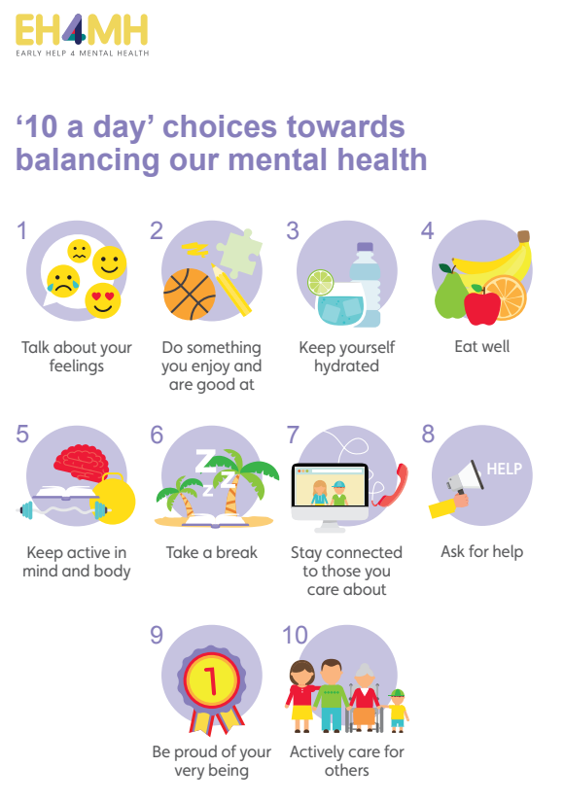
Tuesday | R.E |  | Maths | Justice | Science
Phonics  Reception – recapping phase 3 sounds.  Year 1 – recapping phase 5 sounds  Unit 22 air - written as ‘are’/’ear’.  Year 2 - SPAG | Gospels – Unit 1.4  WALT: think about what we mean by ‘good news’ and why we might want to share ‘good news’ with others.  Explore the Gospel story - ‘Ascension Day’. PowerPoint available on Google Classroom.  This is one of the ‘good news’ Gospels that Jesus told his followers to inspire them to share the ‘good news’ and messages of the Lord, around the World.  Can anyone remember any of the ‘good news’ stories we have shared before?  Gospel – discuss what we mean by Gospel (Christian messages, told using stories in the bible, to teach Christians about Jesus. Four main Gospel writers: Matthew, Mark, Luke and John. These stories are found in the New Testament, and Christians believe they are the word of God.)  Task: have a go at completing the Gospel Elicitation sheet to help inform Mrs Jackson’s planning. |  | Reception/Yr1/Yr2 – WALT: draw lines of symmetry.  Recap lines of symmetry – What do we mean by lines of symmetry?  Give each child a shape, can you fold me a vertical or horizontal line of symmetry? Explain how you know that you have folded a line of symmetry?  Warm up – identifying those shapes who have a line of symmetry shown – PowerPoint warm up.  Today we are going to have a go at drawing the other half of shapes, using the symmetrical line.  In pairs, using the grid paper, can they draw the other half of the shape – compare to their partners. Do they look the same? What do you notice?  Scaffolding – complete the symmetrical shapes.  Dive deeper – BM and DW |  | Continue engaging into the new topic: Scented Garden.  Today, we will have a ‘visit’ from ‘our gardener’ (SL) – the chn will ask the gardener their questions they gathered yesterday and explore they senses. SL will be giving them a little talk about gardening tools, different plants, answering their questions and allow chn to engage in the new vocabulary fully; then explore gardening magazines and gather information about plants that interest them.  At home – chn can generate questions they would like to ask a gardener about: exploring the 5 W’s – then research different gardens and plants.  Why not look into the biodomes of the Eden project?  https://www.edenproject.com/
Wednesday | Literacy |  | Maths | Justice | Reading
Phonics  Reception – recapping phase 3 sounds  Year 1 – recapping phase 5 sounds  Unit 22 – language session  Year 2 - SPAG | Fiction – The Enormous Turnip  Ensure that all children are familiar with at least one fairy tale before attempting this elicitation. If not, then find a story that they are familiar with (Goldilocks and the Three Bears).  Reception – using phonics knowledge, write captions / simple sentence about favourite fairy tale, using pictures to support thinking/writing.  Y1 - using pictures from their known story or fairy tale, ask them to put the pictures in order and write sentences about each picture.  Y2 - children are to write their own version of a fairy tale that they know.  Plenary – listen to the story of The Little Red Riding Hood  https://www.dltk-teach.com/RHYMES/littlered/story.htm |  | Reception/Yr1/Yr2  Exploring 3D shapes – identifying the edges, faces and vertices.  Recap identifying the 3D shape – can you name the 3D shape? Explore maths talk to identify the shape.  Edges / vertices / faces  Complete the worksheet.  Plenary – sort the shapes according to their properties. |  | Individually, spend time exploring and reading the articles about sunflowers, herbs and interesting plants (available on Google Classroom). Explore information books and magazines, that you may have at home, gathering as much information about different plants and flowers.  https://www.rhs.org.uk/advice/profile?PID=679 Explore this interesting website about herbs. Maybe you could try planting some herbs of your own?  When you have gathered your information, have a go at writing some of the ‘fascinating facts’ that you have discovered – with the aim of creating an interesting ‘Plant Fact File’.
Thursday | Literacy |  | Maths | Justice | Geography
Phonics  Reception – recapping phase 3 sounds  Year 1 – recapping phase 5 sounds  Unit 23 ‘c’ – written as ‘ch’  Year 2 - SPAG | Queen’s birthday – Daily Dashboard.  Reading focus / retelling a fairy tale  Now, provide a whole sequence of resources for the children to engage with the stories.  - Roleplay areas and puppets to play different parts from the stories  - Recording devices to retell a story for a class collection  - Guided reading sessions using collections of fairy tales, e.g. ORT phonically decodable versions  - Book display and reading times to look at other well-known versions, such as The Jolly Postman, Each Peach Pear Plum, Once Upon a Time.  Observe children in the environment against Reading Outcomes on the Babcock sequence objectives  Reception - Working with KS1 today.  Plenary – Listen to the story, Goldilocks and the Three Bears. |  | Reception / Yr1 / Yr2  WALT: use my knowledge of shape properties to sort 3D shapes.  Recap number of edges and identify the name of the shape.  Show slide of home objects – child search 3D shapes within and around the classroom and sort accordingly.  Ask chn: how have you sorted these shapes? Can you think of another way?  Lots of sorting and talking – edges, faces, roll… |  | A Community Walk  (garden if self-isolating)  Take a walk around the local community, park, meadow, or your garden to see what plants and flowers are growing there.  Capture interesting images using cameras or tablets.  Make a list of the plants and flowers seen, recording your findings in a simple table (link to statistics in Maths – pictogram, tally chart).  Have a go at creating a map or plan of your walk, recalling and sequencing what was seen, using the images as a reference. Remember: Include a key, identifying geographical features, such as the school, shops, Church, road, park and woodland.  Note: some plants are poisonous so shouldn’t be touched, such as nettles, deadly nightshade and berries.  Back in the classroom, display images of common plants and flowers so that children become familiar with their names and features – perhaps roses, lavender, sweet peas, and hydrangeas from the garden and wildflowers such as buttercups, daisies, poppies and foxgloves.
Friday | Literacy |  | Maths | Justice | DT
Phonics  Reception – recapping phase 3 sounds  Year 1 – recapping phase 5 sounds  Unit 23 – language session  Year 2 - SPAG | Today, have a chart with a picture of the fairy tale along the top and the headings down the side (see resources - blow up as big as you can). Collect information for the 4 headings.  - main characters  - main event 1  - main event 2  - ending  Display these on the working wall.  Children to pick their favourite fairy tale and to write their own main character, main events and ending using some of the fairy tale language from the learning journey.  Reception  Read ‘The 3 Little Pigs’. Now use the story sequencing pictures to see whether the children can retell the story and whether they use any of the story language - observations. |  | Reception/Yr1/Yr2 –  WALT: use 2D and 3D shapes to complete and make simple patterns.  Shape sorting PowerPoint – explore repeated patterns using 2D and 3D shapes – can you continue the patterns?  Now have a go at creating your own patterns using 2D and 3D shapes.  Take photo and make notes of the language chn use to describe their pattern.  Plenary – problem solving activity on PP.  Reception – using shape sponges, can they create repeated patterns using the 2D shapes?  Can they use the math vocabulary, talking about shape properties and identifying the shapes? |  | Do you like pizza?  What ingredients do you like on your pizza? Do you know where eat of the ingredients comes from? How do you make the dough?  https://www.agfoundation.org/news/where-does-pizza-come-from  Have a look at the website above. Did you know? Dough comes from wheat, planted in the fields by farmers, often using a drill.  Where does the tomato paste come from?  Today, we are going to start growing our very own pizza garden!  Check out the instructions on Google Classroom.  We will be planting fast growing seeds and bulbs to grow a pizza garden, including, tomatoes, basil, onions, rocket, spinach, peppers, and oregano.  Discuss, with your grown up, what seeds and bulbs need in order to grow and make a list of the daily jobs that will need to be done to care for the plants, ie: watering them.  https://www.bbc.co.uk/bitesize/topics/zpxnyrd/articles/zxxsyrd

