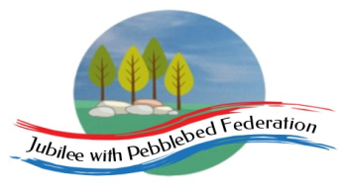 Home Learning Grid 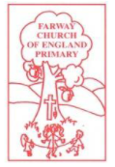
This is the home learning grid for the week beginning 1st March 2021. Please use this as a grid to support planning your child’s home learning. Additional resources will be made available on ‘google classrooms’, to support your child to access these activities. A daily reading and counting task are important to support your child to access their education but remember to have fun!
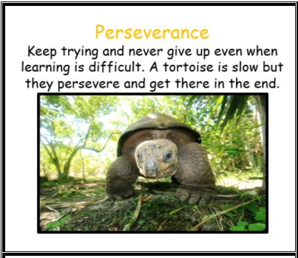
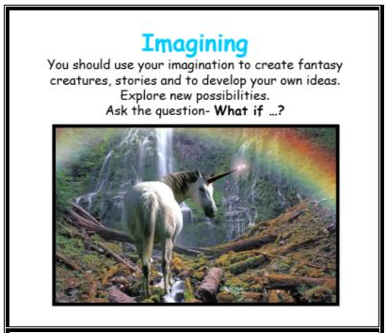
This week Class 1 will be focusing on the key Learning Behaviours: Perseverance and Imagining. You have all stressed that learning from home is becoming increasingly more challenging. Especially when the weather outside is so beautiful! But keep going! Keep persevering! You only have one more week to go! In Literacy this week, we will be beginning to develop our own ideas for how to get the Woolly Mammoth in the bath, and inventing humorous questions, so this week we are focusing on using our imagination to create some fabulous ideas! Have fun with your learning but remember to send all your work to Mrs Jackson and please make sure your child completes all Literacy and Maths tasks for the week. This will really help their transition back into school, on the 8th of March, by ensuring they feel more confident about their learning. Please do contact me if your child has any questions or concerns about returning. Look forward to seeing you all very soon!
Please remember, if you have internet issues during this lockdown period, you can still access Google Classrooms using your phones. You can also contact the school and we can try and support you with alternative learning options.
 | Farway C of E Primary School - Class 1 – week beginning 1st March
 | Lesson 1 | Lesson 2 | Break time | Lesson 3 | Lesson 4
Monday  Please read for at least 10 minutes every day with an adult or a sibling.  You can use the Bug Club online books to access books in line with your child’s phonics ability. | Phonics - https://www.activelearnprimary.co.uk/login?e=-1&c=0#bugclub_phonics  Reception –  Recap Phase 3, unit 10, phoneme /ar/, written as ‘ar’.  Year 1  Recap - Phase 5, Unit 27, phoneme /ch/, written as ‘tch’  Year 2  SPAG – Exception words | R.E  WALT: think about why the palm cross is important to Christians and how it links to the Easter story.  Today we are learning about Palm Sunday. If you have a bible, explore the story together -  Luke 19:28-40 – read about the entry into Jerusalem (Miles Kelly Bible stories, page 426)  Alternatively, read about Palm Sunday using the link below – there is a beautiful photo of a palm leaf on this website.  https://www.christianity.com/wiki/holidays/what-is-palm-sunday-bible-story-and-meaning-today.html  Now, watch the video link about palm story riddle.  https://www.bbc.co.uk/bitesize/clips/zy2hyrd  The palm cross reminds Christians that, although the crowds welcomed Jesus, some people were jealous of him… and, a week later, Jesus was arrested and killed on a cross.  Have a look at some of the activities and chose one or more, that takes your interest. Please send photos to Mrs Jackson.  Ideas:  - Make a peg donkey.  - Cut out palm leaves.  - Explore outside and collect some leaves or twigs to create your own cross. Maybe you could decorate your cross with flowers and grass?  - Challenge: children to write/draw the Palm Sunday story in their own words.  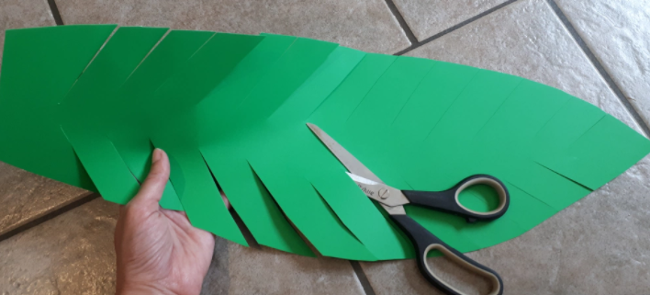  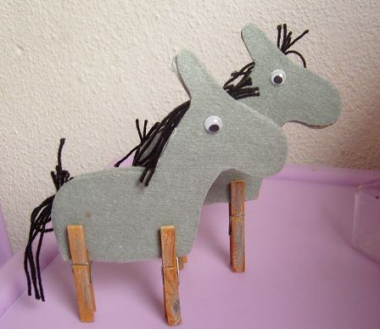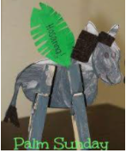 | Make sure you take time to have a brain break today and stretch your bodies. Why not go for a walk around your garden or local area. Take in the signs of spring.  Alternatively, have a look through the mindfulness colouring sheets (found on google classroom) – make sure you take a break from the screen and enjoy being you! | Maths  Reception  https://whiterosemaths.com/homelearning/early-years/building-9-10-week-3/ - building with 3D shapes  Activity - https://wrm-13b48.kxcdn.com/wp-content/uploads/2021/02/PDF-Building-9-10-Wk-3-Session-1-Building-with-3-D-Shapes.pdf  Year 1  WALT: identify one more and one less than any given number  https://whiterosemaths.com/homelearning/year-1/spring-week-6-number-place-value-within-50/ - lesson 1  Year 2  WALT: draw pictograms (2, 5, 10)  https://whiterosemaths.com/homelearning/year-2/spring-week-6-statistics/ - draw pictograms (activity) | Holistic wellbeing – Physical and Mental health.  Physical Education – please warm up by doing a quick, power walk around your local area (10 - 15 minutes). Stretch those legs, breathe deeply and listen to the sounds around you. If you love walking, check out the link below:  https://www.activedevon.org/take-part-in-lets-walk-devons-biggest-workplace-walking-challenge/  Then, have a go at taking part in this week’s online video (available on google classroom).  Why not try something different? Have a go at taking part in some yoga!  https://www.yourschoolgames.com/sgo/south-east-devon/yoga-ideas-and-poses/  Wellbeing – today we are focusing on putting words to our feelings and emotions. This week many of you may be feeling lots of different feelings and emotions about returning to school, on Monday 8th March.  Have a look at the emotion wheel, below:  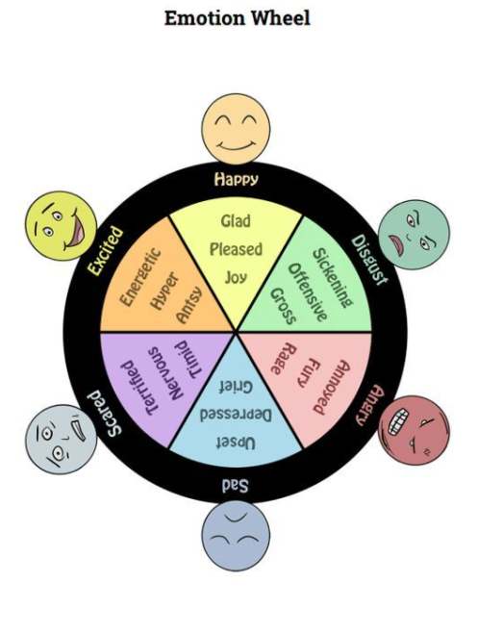  We all experience different emotions and this is healthy. How we manage these emotions can either help us to feel better, or to feel worse.  Why not have a go at creating your own emotion wheel, thinking about times you have felt scared, happy, anxious, sad, angry…  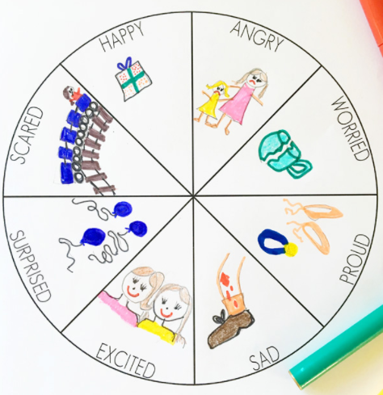  Do you feel any of these emotions about returning to school?  Maybe you would like to write a letter to Mrs Jackson, telling her how you are feeling? (see letter template attached).
Tuesday  Please read for at least 10 minutes every day with an adult or a sibling. | Phonics  https://www.activelearnprimary.co.uk/login?e=-1&c=0#bugclub_phonics  Reception – Recap Phase 3, unit 10, phoneme /or/, written as ‘or’.  Year 1  Recap Phase 5, Unit 27, phoneme /sh/ alternatives.  Year 2  SPAG – Homophones | Literacy  First, recap the story of ‘How to Wash a Woolly Mammoth’ – you can watch the video clip again or try retelling the story using the story map. Pay particular attention to the step-by-step instructions!  Next, complete task 1 and 2.  If you have already completed task 1 and sent to Mrs Jackson, then please move on to task 2. Task 1 is really important for next week, when you will be in school.  Task 1  WALT: say out loud what we are going to write about before writing it.  Together have a look more closely at the text. In some areas of the text, the writing is rather sparse or non-existence. Why do you think that is? What do you think the writer was intending? Explain your thinking.  Together, discuss your ideas and listen to each other ideas.  Children to select their favourite page and orally rehearse ideas to create missing text for the page. Practise the sentence orally (maybe facetime a relative) – when you feel confident and feel you have orally created a well-structured sentence, write up your ideas on a photocopy of their chosen page.  Task 2  Step 7 – Now for the Woolly bit!  Have a look at the images of the Mammoth’s hair styles - why not create your own mammoth hairs styles using shaving foam!! Print off the image attached, grab your parent’s shaving foam! Have fun creating!!  Can you think of a creative name for your hair style, using alliteration?  i.e: hair-raising riot, mullet madness, spikey spin-off! | Make sure you take time to have a brain break today and stretch your bodies. Why not go for a walk around your garden or local area. Take in the signs of spring.  Alternatively, have a look through the mindfulness colouring sheets (found on google classroom) – make sure you take a break from the screen and enjoy being you! | Maths  Reception  https://whiterosemaths.com/homelearning/early-years/building-9-10-week-3/ - matching 3D shapes  Activity - https://wrm-13b48.kxcdn.com/wp-content/uploads/2021/02/PDF-Building-9-10-Wk-3-Session-2-3-D-shape-Matching-Objects.pdf  Year 1  WALT: continue finding one more and one less than a given number.  https://whiterosemaths.com/homelearning/year-1/spring-week-6-number-place-value-within-50/ - lesson 2  Year 2  WALT: consolidate my understanding of drawing pictograms (2, 5, 10)  https://whiterosemaths.com/homelearning/year-2/spring-week-6-statistics/ - draw pictograms (2, 5, & 10) – watch the video, then have a go at the activities provided. | History  WALT: explore how rocks were formed and tell a rock story.  Watch the recorded lesson about rocks and fossils. The BBC video isn't very clear, so here is the link for you to watch it again.  https://www.bbc.co.uk/bitesize/topics/z9bbkqt/articles/z2ym2p3  It is meant for slightly older children, so ask your grown-up if there are any words that you are unsure of.  Y2 - Write a rock story.  Rec/ Y1 - use the booklet to make your chosen rock in the plastic cup. Draw your rock and then label it.  Send me photographs of your Rock Story and have fun writing about your rock.  I have also attached the activity booklet as this will give you the instructions that you need for this activity.  Have fun!
Wednesday  Please read for at least 10 minutes every day with an adult or a sibling. | Phonics  https://www.activelearnprimary.co.uk/login?e=-1&c=0#bugclub_phonics  Reception – Phase 3, unit 10, phoneme /ur/, written ‘ur’.  Year 1  Phase 5, Unit 27, phoneme /ee/, written as ‘ea’  Year 2  SPAG – Imperative verbs | Literacy  WALT: explore the importance of writing/following instructions in chronological order.  Have a go at following these instructions (non-chronological order):  Step 1: Put on your shoes  Step 2: Go for a walk  Step 3: Put on your socks  Step 4: Open the door.  How did you get on? Did you get into a bit of a muddle?  Have a look at the instruction cards available on google classroom – they are in non-chronological order. Have a go at sequencing them, in chronological order. Then write the instructions out, in chronological order.  Challenge:  Have a look through your instructions. Can you identify any verbs? Can you think of any different verbs that you could use? Maybe you could add some adverbs, to instruct the reader how they should go each imperative verb! – There will be 10 house points awarded if you come up with some good ones! | Make sure you take time to have a brain break today and stretch your bodies. Why not go for a walk around your garden or local area. Take in the signs of spring.  Alternatively, have a look through the mindfulness colouring sheets (found on google classroom) – make sure you take a break from the screen and enjoy being you! | Maths  Reception  https://whiterosemaths.com/homelearning/early-years/building-9-10-week-3/ - printing with 3D shapes  Activity - https://wrm-13b48.kxcdn.com/wp-content/uploads/2021/02/PDF-Building-9-10-Wk-3-Session-3-Printing-with-3-D-Shapes.pdf  Year 1  WALT: compare objects to 50  https://whiterosemaths.com/homelearning/year-1/spring-week-6-number-place-value-within-50/ - compare objects to 50  Year 2  WALT: interpret pictograms (2, 5, 10)  https://whiterosemaths.com/homelearning/year-2/spring-week-6-statistics/ - interpret pictograms.  Please watch the video and have a go at the activity available on google classroom) | Music / Computing  Reception/Y1/2:  Click on to this link to open up Chrome Music Lab  https://musiclab.chromeexperiments.com/  Check out the Song Maker experiment, which lets you make and share your own songs.
Thursday  Please read for at least 10 minutes every day with an adult or a sibling. | Phonics  https://www.activelearnprimary.co.uk/login?e=-1&c=0#bugclub_phonics  Reception – Phase 3, unit 10, phoneme /ow/, written as ‘ow’.  Year 1  Phase 5, Unit 27, phoneme /w/ /o/, written as ‘wa’  Year 2  SPAG – suffixes (-ly, -ment, -less) | Literacy  WALT: Recap what we mean by a verb  Task 1:  Watch the video link below:  https://www.bbc.co.uk/bitesize/articles/z3y9vwx  Have a look through the worksheet available on google classroom. Read the sentences aloud and highlight the verbs.  Today, we are learning about imperative verbs. In other words, ‘bossy’ verbs. For example: scrub, fill, make, fill…  Watch this video link: https://www.bbc.co.uk/bitesize/articles/zv98jhv and complete the activity attached.  Task 2:  Now, have a look at our story, STEP THREE. Model creating a sentence starting with an imperative (bossy) verb for each figure. Speak the sentence aloud, then write the sentence in your books. Check for correct spelling and punctuation.  Task 3:  Finally, write down a clear step – by -step instruction guide, for getting the woolly mammoth into the bath (each figure to be a step), making sure you have included your imperative verb within your sentence. Please send to Mrs Jackson! | Make sure you take time to have a brain break today and stretch your bodies. Why not go for a walk around your garden or local area. Take in the signs of spring.  Alternatively, have a look through the mindfulness colouring sheets (found on google classroom) – make sure you take a break from the screen and enjoy being you! | Maths  Reception  WALT: explore patterns  https://whiterosemaths.com/homelearning/early-years/building-9-10-week-3/ - pattern  Activity - https://wrm-13b48.kxcdn.com/wp-content/uploads/2021/02/PDF-Building-9-10-Wk-3-Session-4-Pattern.pdf  Year 1  WALT: Compare numbers within 50  https://whiterosemaths.com/homelearning/year-1/spring-week-6-number-place-value-within-50/ - compare numbers within 50  Year 2  WALT: explore block diagrams  https://whiterosemaths.com/homelearning/year-2/spring-week-6-statistics/ - block diagrams | Art  WALT: To use different materials to add texture to sculptures.  Can you create a woolly mammoth using a recycled milk bottle carton?  Use the top of a 4 pint milk bottle to make a woolly mammoth. Add strips of brown paper/tissue/felt/wool with PVA to add a shaggy texture to the bottle. Leave it to dry – then add more features.  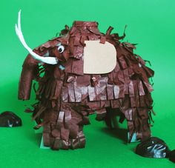
Friday  Please start the morning looking through the spellings of tricky words – appropriate phases available on google classroom. | Phonics  https://www.activelearnprimary.co.uk/login?e=-1&c=0#bugclub_phonics  Reception  Phase 3, unit 9, phoneme /oi/, written as ‘oi’.  Year 1  Phase 5, unit 27, phoneme /u/ written as ‘o’.  Year 2  SPAG – noun phrases | Literacy  WALT: use question marks and exclamation marks within our writing.  https://www.bbc.co.uk/bitesize/topics/z8x6cj6/articles/z3dcmsg  https://www.bbc.co.uk/bitesize/topics/z8x6cj6/articles/zcm3qhv  Explore the videos above, learning about question marks and exclamation marks.  Now, look through the book together, can you find any exclamation marks or question marks within the text? (alternatively use the PowerPoint slides attached)  Discuss what they are and why we use them.  Finally, encourage your children to have a go at creating their own funny questions and answering with an exclamation!  For example:  ‘Does your dinosaur need a mint?  Yes, she stinks!!’  Some funny images have been attached to google classroom to support your imagination, should you need it! | Make sure you take time to have a brain break today and stretch your bodies. Why not go for a walk around your garden or local area. Take in the signs of spring.  Alternatively, have a look through the mindfulness colouring sheets (found on google classroom) – make sure you take a break from the screen and enjoy being you! | Maths  Reception  WALT: continue exploring patterns  https://whiterosemaths.com/homelearning/early-years/building-9-10-week-3/ - pattern 2  Activity - https://wrm-13b48.kxcdn.com/wp-content/uploads/2021/02/PDF-Building-9-10-Wk-3-Session-5-Pattern.pdf  Year 1  WALT: Order numbers within 50  https://whiterosemaths.com/homelearning/year-1/spring-week-6-number-place-value-within-50/ - order numbers within 50  Year 2  WALT: gather our own information and interpret our findings.  Task: Chose a topic you are interested in or would like to know more about. For example: This week is World Book Day (please note we will be celebrating this together, next week, when you are all back in school!)  You may like to explore which books people in your family, friends, like best. You could choose 3 or 4 of your own favourites, create a tally chart and gather your information!  Once you have chosen your interest and gathered your data, using a tally, have a go at displaying your data as a pictogram (1-1 and 2-1), and a block diagram. Finally, write a short report on the interpretation of your findings.  Please send your results to me so I can display them in class! | PSHE  WALT: To identify emotions and the physical effects they have.  Watch the teacher video and complete the worksheets in google classroom.  Write a list or draw face pictures to show all the different emotions that you know without adult help. Then discuss how different emotions make you feel physically (butterflies in tummy when nervous etc). Draw an outline of a person and label where different feelings make you feel a physical effect.  Reading – dedicate 30 minutes this afternoon to share a book with your grown up. Maybe you could read to them for 20 minutes, then they read to you? Or you could try reading one of the play stories together (Bug Club) and read a part each? Just have fun sharing a story!

