’10 a day’ for Positive Mental Health 11
While we are working from home it is important that you continue to support your mental health. One way of doing this is to continue to use the ’10 a day’.
Below are some activities to try at home this week. Each one is linked to one of our ’10 a day’. Each week some new activities are put on so you can look at numbers 1-10 for more ideas.
Booklet for Key Stage 2 children to complete to support their Mental Health.
https://mcusercontent.com/57437507f4a3aad76843b6d9e/files/56b455e3-8d40-4041-aaaa-156b42e7062c/mental_health_booklet_2_.pdf
10 a day | Activity
The following link gives information about how to deal with emotions directly linked with the Coronavirus from Exeter Diocese.
https://exeter.anglican.org/wp-content/uploads/2020/03/Covid-19-Primary-School-Parent-Pack.pdf
A good video that shows different emotions and what you might be doing when you feel those emotions.
https://www.bbc.co.uk/bitesize/clips/zk2w2hv

Using M&M’s or Smarties with your family, take it in turns to close your eyes and select a sweet. Open your eyes look at the colour you have chosen. For every red one say something that makes you happy. For every blue one, say something that makes you sad. For every orange one, say something that makes you feel grateful. For every brown one, say something that makes you feel angry.
You could make up your own emotions for the other colours. You might use the words excited, scared, worried etc.
If you don’t want to use the sweets or don’t have them, make some coloured counters with paper.

Print out a photo of yourself or draw a picture. Then cut and stick pictures from magazines or draw pictures of things you love doing all around you. Stick it up in your bedroom to remind yourself of all the things you love to do. Choose something from there when you are feeling bored or fed up. It will give you a boost!
Enjoy colouring together with these relaxing patterns.
https://familyresource.eci.org.uk/download/Colouring-Book-for-Boys-Girls.pdf
Take the quiz to find out why it is important to stay hydrated.
https://www.n4hk.com.au/game/jimmysthirsty/

Infuse your water with flavour by adding fruits like berries, cucumber, lemon or lime. You could also freeze ice cube trays with berries and add this to your water to keep it extra cold.
Help prepare lunch or dinner for the family.
Maybe try some of the recipes from this websites.
https://www.nhs.uk/change4life/recipes

With a grown up put a variety of different foods on the table. Sort which things you feel are healthy that we should eat lots of and which foods we should eat in moderation. Can you learn why these foods are good for us?
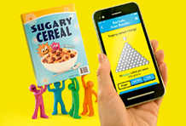
Older children could have a guess at which foods they feel have the most sugar content. Then check the nutritional values on the packet (if they have one) Were you correct? Did anything surprise you? There are some great facts about sugar on the Change4life NHS website.
https://www.nhs.uk/change4life/food-facts/sugar
Have a look at the website and see if you can make any of their suggested sugar swaps, you can even download an app that will tell you how many cubes of sugar are in your favourite foods.

Exeter diocese has set up a Family Fun Cooking Club. Look at their recipes on the following link.
https://exeter.anglican.org/resources/faith-action/family-fun-cooking-club/

Healthy Eating 5-8 years and 8-11 years. These resources will help you think about healthy food choices.
https://us8.campaign-archive.com/?u=57437507f4a3aad76843b6d9e&id=95c2531caa&e=b9859c0018

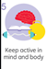 | The Balance Challenge  https://www.youtube.com/watch?v=K50qOYOR9pM  A weeks physical activities linked to pirates.  https://www.onerunningmovement.com/wp-content/uploads/2020/05/Foundation-and-Key-Stage-1-activity-Cards-Pirates.pdf  Try some 60 second challenges  https://www.youthsporttrust.org/60-second-physical-activity-challenges  Try some Zumba  https://www.youtube.com/watch?v=doSmJ9AOA1E  There are some brilliant active Shake Up games created by Change for life based around some popular Disney movies. They have great ideas for physical activity linked to some of the characters from the movies.  Follow this link and try some of them out!  https://www.nhs.uk/change4life/activities/indoor-activities
This video will support breathing.
https://www.youtube.com/watch?v=-pye091kE9k&feature=youtu.be

Go Noodle. Calming mindfulness.
https://www.youtube.com/watch?v=bRkILioT_NA
Go noodle. A walk through for calming yourself and switching off negative feelings and switching on positive ones. Putting yourself back in control.
https://www.youtube.com/watch?v=1ZP-TMr984s
Go Noodle. Rainbow Breathing. Mindfulness breathing technique.
https://www.youtube.com/watch?v=O29e4rRMrV4

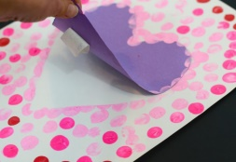
Cut out a heart and loosely attach it to some paper, then fingerprint all over the paper, peeling off the heart afterwards. Can you write a message in the heart to somebody you love and care about? What do you love about them?
Ask your parents if you can call a relative. Chat to them about how they are and what they have been doing. They will love the fact that you are taking time out of your day to reach out to them and it will remind you that you are loved by lots of people too.

Can you make this gorgeous rainbow fan pop up card for somebody you care about? Write a lovely message inside for somebody you care about.
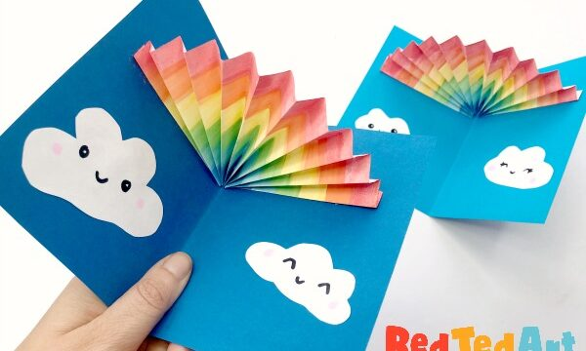
Follow the instructions here, or make your own version!
https://www.redtedart.com/?s=rainbow+pop+up+card
RedTedArt have lots of other lovely ideas for crafts on their website too.
If you are stuck on your home learning or with you feelings ask someone for help. If you can’t put it into words write it down or draw pictures.
- Remember, it's okay to ask for help. Don't be embarrassed, and don't worry about other people judging you.
- Decide what the problem is and what help you need.
- Think about who you can ask for help. Choose someone you trust and who will know how to help you.
- Think about what you'll say when you ask for help. Do it.

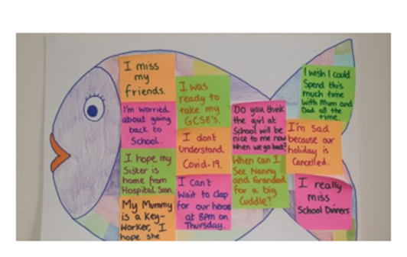
The Rainbow Fish is a story of a fish that is happier once she learns to share her beautiful scales. Watch or read the story on this link. https://www.youtube.com/watch?v=r9mryuEKkKc)
Worries can be like that too! Sharing our worries helps them to seem smaller and sometimes even means they go away. Have a go at this activity by The Great Ormond Street play team and make your own rainbow worry fish.
https://www.gosh.org/power-of-play-hub/games-and-activities/rainbow-worry-fish

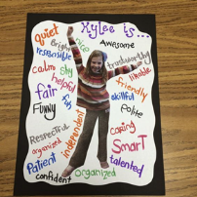
Ask a grown up to print out a photo of you or draw yourself. Can you ask everybody in your family to write words around the picture that describe you. Put it up on your bedroom wall to remind yourself how special you are.
Can you write an acrostic poem using your name?
S
A
R
A
H
Write a sentence that describes something positive about yourself beginning with the letters from your name that starts that line. If you find it tricky to think of things, ask a grown up to tell you what they love about you. Display it somewhere you can regularly see it.
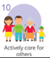 | The Treasure Chest  Think about all of the lovely things in your life that make you feel happy and warm. These things are like pieces of treasure in a treasure chest. Use an actual treasure chest and coins. Model putting coins into the treasure chest and saying the things you like to do as a teacher. Make sure you say the little things as well as the big things, like ‘smelling a rose in your garden’.  Sometimes, secret acts of kindness are the most special. Today, do something nice for someone else without them knowing it’s from you! You might leave them a card on their pillow, or write them a note saying something lovely about them, or post a picture through a friend or relatives door. This will bring you joy and bring joy to others!

