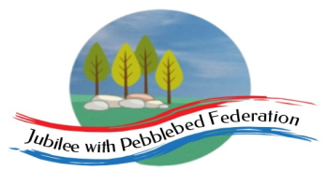 Home Learning Grid 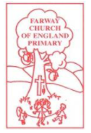
This is the home learning grid for the week beginning 3rd May 2021. Please use this as a grid to support planning your child’s home learning. Additional resources will be made available on ‘google classrooms’, to support your child to access these activities. A daily reading and counting task are important to support your child to access their education but remember to have fun!
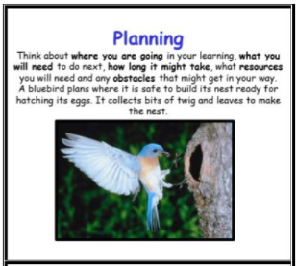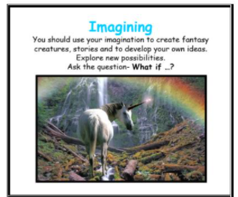
This week, we will be planning and creating our very own fairy tale story, with the purpose of reading them aloud to our Nursery children, when the children have written and published them. Therefore, the Learning Behaviours, for Class 1, will be: planning and imagining. If you have internet issues during a self-isolation period, you can still access Google Classrooms using your phones. You can also contact the school and we can try and support you with appropriate, alternative learning options.
Home Learning – week beginning 3rd May 2021
Monday

Bank Holiday Monday – Have a lovely day at home together.
If you have time, please spend some time today, reading traditional fairy tale stories to your children. Which story is your favourite? I wonder if you can notice any repeated refrains or exciting openers?
Tuesday | Literacy |  | Maths | Justice | Science
Phonics  Reception – Phase 3, Unit 11 – language session  Year 1 – Phase 6, unit 29 suffix ending ‘-ing’  Year 2 – SPAG  Learning suffixes – er/est/ment/ ful | WALT: join two sentences together using ‘and’.  Give the children two single clause sentences using examples of the children’s work as a model (see resources). Hammer the verbs. Model how to join the sentences using ‘and’ and then finish with a full stop. Give children other combinations of single clause sentences to join with ‘and’ (using a selection of fairy tale stories they have learnt). Use CL card and full stop cards to practise putting them in the correct places. Introduce (Y2) the term ‘compound sentence’. Demonstrate how we don’t need to repeat the subject after ‘and’.  Display some examples on the working wall. |  | WALT: make equal parts  Recap what we mean by one ‘whole’ – being one object or one quantity. ‘Show me one whole’  Children explore making equal and unequal parts – using real life objects and pictorial representations.  Questions:  What is the whole? What are the parts? How many parts is the object/quantity split into? Are the parts equal? How do you know? Do equal parts always look the same? Is there more than one way to split the object/quantity into equal parts? |  | WALT: explore the importance of our senses.  Explore a range of garden herbs using all the senses. Talk about how herbs feel, smell and taste (where appropriate). Describe which smells they like and don’t like and explain why. Grind herbs with salt or on their own using a pestle and mortar to release a stronger smell. Order the smells according to preference or strength.  Questions: Why do you think we have the sense of smell?
Wednesday | Literacy |  | Maths | Justice | Art
Phonics  Reception – Phase 4, unit 12 – adjacent consonants (CVCC)  Year 1 – Phase 6, unit 28, suffix ending ‘-ed’  Year 2 – SPAG  Learning suffixes – er/est/ment/ ful | WALT: write expanded noun phrases to describe the subject/object to the reader.  Give children groups of adjectives that describe different objects, characters etc in the stories they have read. Practise whole word reading and segmenting/blending these words. Play noun riddles by asking children questions, e.g. What is gold and shiny? (straw, golden egg, Aladdin’s lamp); What is bright, shiny and red? (Red Riding Hood’s cape, the rose in Beauty and the Beast, the fire in the Three Little Pigs’ kitchen). What is leafy, green and huge? (the forest, the beanstalk). Model writing noun phrases for fairy tale objects/characters by choosing words and combining them with nouns. Ask children to make their own noun phrases by combining some of the adjectives with suitable nouns from the stories. |  | WALT: find a half of an object  Using a variety of real-life objects and photographs – chn will explore using the language ‘whole’, ‘half’ and ‘halves’, using stem sentences: ‘The whole leaf, has been cut into two equal parts. Each part is worth a half.’  It is important that they know that a half means ‘one of two equal parts’ and are able to count them.  Year 2 – will be introduced to the fractional notion of ½ and be introduced to the language of numerator and denominator and what these represent.  Children will explore ‘halves’ in different contexts, ie: half of a length, half of a shape or set object.  Questions:  How many parts have I split my object into? How can you show a half of something? How do you know if a shape is split into halves? How many halves make a whole? Can we count them? How do you know if an object or shape has not been split in half? Is there more than one way to show half of a shape or object? Is this the same for all shapes? |  | WALT: refine our observational drawing skills  Explore the work of Georgia O’Keefe - https://www.georgiaokeeffe.net/  Make detailed observational drawings of scented flowers, using hand lenses to look closely at colours, shapes and patterns. Choose from a range of drawing materials, such as chalks, felt pens, wax and pencil crayons and pastels, to record their ideas. Try smelly pens to add a sensory dimension to artwork.
Thursday | Literacy |  | Maths | Justice | PSHE
Phonics  Reception – Phase 4 – language session (1)  Year 1 – Phase 6 - verbs – identifying past and present verbs.  Year 2 – Verbs (past and present) | WALT: identify the structure of the text to support organisation of ideas.  Identify the structure and/or plot of the text and record to support organisation of ideas and writing.  Use one of the four-part stories (The Enormous Turnip) to model the structure of each summary but divide it into three parts, rather than four, ie: beginning, middle and end. For example: The old man/planted some turnip seed in his beautiful garden/and the turnip grew and grew into the most enormous turnip in the world, before being pulled and pulled out of the ground by the old man, the old lady, the little boy, the little girl, the dog, the cat and the mouse.  Revisit where the verbs are and the conjunction ‘and’ joining the two simple clauses to make a compound sentence.  Children to have a go at writing a summary of the Three Billy Goats Gruff, using the three-part structure. |  | WALT: find half of an amount  Children use their understanding of finding half of an object or shape and apply this to finding half of an amount/quantity.  It is important that children find the total amount and can then show how this whole amount can be shared equally into two parts (two halves).  Use concrete manipulatives, such as counters to help children find a half.  -links to be made into dividing by 2.  Children may need to use the concept of sharing to find a half. Paper plates, hoops and containers can be used to share objects into 2 equal groups.  -Model using graphics to represent the children’s thinking.  Questions:  How can we find half of an amount? How many groups do we need to share our beads between? How can you check that you have found half? How many equal parts should you have when you have split the objects in half? (year 1)  How did you halve the sweets? What is the value of the whole? What is the value of half of the whole? What do you notice? What do you notice about your answers? How can you use your answer to a half of 4 to help you work out a half of 40? (year 2) |  | WALT: explore the importance keeping our teeth health.  Explore the questions: How can we help to keep our teeth healthy? Why is this important?  https://www.dentalhealth.org/key-stage-one  Set up the experiment below and see what happens.  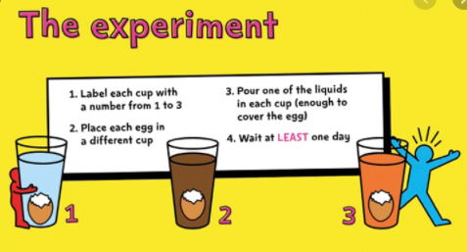  Can you make a prediction?  Can you record the results?
Friday | Literacy |  | Maths | Justice | DT
Phonics  Reception – Phase 4 – adjacent consonants (CCVC)  Year 1 and 2 – Focus tricky words | WALT: write a summary of our favourite fairy tale story, identifying the beginning, middle and end.  Model putting another known fairy story into the three-part structure (as above when structuring the text). Children practise this one but can write a different compound sentence to the one that you have modelled.  Snow White/had a jealous stepmother with a talking mirror/and moved in with the seven dwarves before being poisoned by an apple.  If completed yesterday – todays WALT: box-up our own ideas to start creating our own fairy tale story.  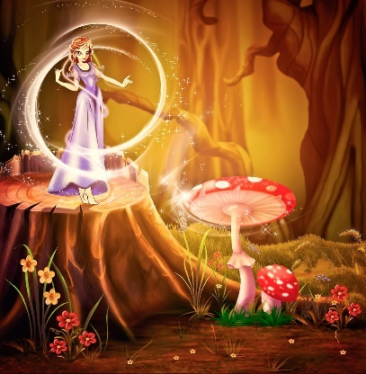 |  | WALT: find a quarter  Children will develop their understanding of equal parts and non-equal parts and relate this to a shape or object being split up into four equal parts (yr1) – extending their knowledge of ‘whole’ and ‘halves’ to recognise quarters of shapes and objects (yr2) – introducing the fractional notion 1/4.  The children will continue to work concretely and pictorially, understanding that they are splitting the whole into 4 equal parts and that each part is one quarter.  Questions:  How many parts does my whole have? Are my parts equal or not equal? How many equal parts can we see/count? Can we make a quarter in a different way? Which shapes show equal parts? Which shapes show four equal parts? Which shapes show quarters? (yr1)  How many equal parts have you split the whole into if you have split it into quarters? In 1 4 what does the 1 represent? What does the 4 represent? Can you shade one quarter in different ways? How do you know that you have shaded one quarter? How many quarters make a whole? (yr2) |  | WALT: design and create scented playdough  Choose appropriate components and materials and suggest ways of manipulating them to achieve the desired effect.  Participate in making scented play dough. Use a range of scents, such as lavender, basil (grind the basil leaves into a watery paste using a pestle and mortar) rose oil or mint tea to add to the dough mixture. Encourage children to carefully select which scents they want to add to their batch of play dough, explaining their choices. Do they want to attract others to play with their dough by giving it a beautiful smell? Or maybe they want to surprise others with a smell they weren't expecting? Help them to measure out and add the ingredients, mixing and kneading, then play by rolling, squeezing and stretching the dough whilst enjoying its fragrant smell!  