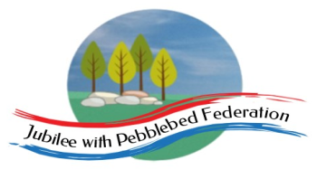 Home Learning Grid 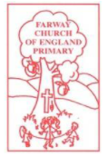
This is the home learning grid for the last three days of the week beginning 19th July 2021. Please use this as a grid to support planning your child’s home learning. Additional resources will be made available on ‘google classrooms’, to support your child to access these activities. A daily reading and counting task are important to support your child to access their education but remember to have fun!
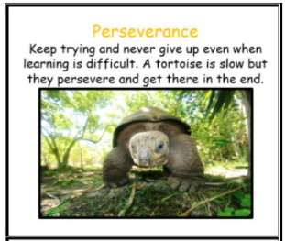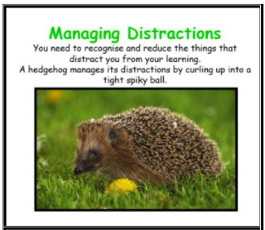
You are so nearly their guys! Keep persevering with your learning for three more days and managing those distractions. You are all amazing! Three days until you can enjoy your fabulous summer holiday and well-earned rest! This week, we will be focusing on being that tortoise and never giving up, alongside managing those summer distractions. The Learning Behaviours, for Class 1, will be: Perseverance and Managing Distractions.
If you have internet issues during a self-isolation period, you can still access Google Classrooms using your phones. You can also contact the school and we can try and support you with appropriate, alternative learning options.

Home Learning – week beginning 19th July 2021
Monday | Literacy | Mind break | Maths |  | Sports day
Tuesday | Literacy |  | Maths |  | R.E / Art
Wednesday | Literacy |  | Maths |  | Theme/Geography
Phonics  Access Bug Club and work through the sounds and books shared with your individual child. | Today, in school we were going to design our own pizzas! It’s such a shame we can not make these together in school today, but why not try designing and making your very own pizzas, at home to enjoy with your family?!  Check out these easy recipes below:  https://www.bbcgoodfood.com/recipes/pizza-margherita-4-easy-steps  https://www.jamieoliver.com/recipes/bread-recipes/pizza-dough/  Alternatively you can use your own. If you are unable to make your own dough, you could use baguettes, muffins or wraps as a tasty alternative.  I wonder, what is your favourite topping?  Could you try something new?  Please send photos of your creations to admin@farway.devon.sch.uk  We would love to see them! |  | In maths the next few days, we have set sessions that relate to our current topic in school. However, should your child wish to explore additional topics, please check out the webpage: https://www.thenational.academy/  Year 1 and year 2  WALT: Exploring Capacity  https://classroom.thenational.academy/units/measures-2-capacity-and-volume-9f1f - (lesson 1)  Reception  WALT: explore depth of numbers within 20  https://classroom.thenational.academy/units/depth-of-numbers-within-20-16d1 - (lesson 1) |  | ​​WATCH: https://www.bbc.co.uk/bitesize/clips/zgmqxnb  While watching the clip, draw your child’s attention could be drawn to the diverse range of leaf shapes and shades of green. There are a number of good points to pause the clip to focus on how the leaves are adapted to channel away excess water using drip tips or to float. You could look at plants in your own garden for the children to explore these adaptations using drops of water. They could compare and contrast the size and texture of leaves with those from their own surroundings and offer reasons why most of the tropical ones are usually found on 'house plants'.  NEED TO KNOW: Climate is the usual or average weather conditions over a long period of time, whereas weather is the specific meteorological conditions on a given day.  TASK: Look at the weather patterns in the rainforest and compare to the patterns in the UK. What Is the Climate of a Rainforest? (Between the Tropics of Cancer and Capricorn, the weather is hot all year round. Rainfall is consistent throughout the year.) Can you find out and explain what’s the weather is like? Make a similarities and differences chart for the UK and the Amazon.  Word Tips:  Climate - Conditions including precipitation, wind and temperature.  Tropical - A place in the Tropics. Hot and humid.  Temperate - Cooler  Humidity - Dampness, usually in the air.  Damp - Slighty wet with moisture in the air.  Precipitation - Rain or a falling of water.  Varies - Changes over a matter of time.  EYFS/KS1 Challenge  Find something that you enjoy doing in your garden. Maybe you could ask your grown-up to take a photograph of what you are up to. (If you don’t have a garden or the weather isn’t pleasant, then find something that you enjoy doing indoors. Be creative!)  Here are some ideas:  1. Make a paintbrush out of natural resources and paint a picture.  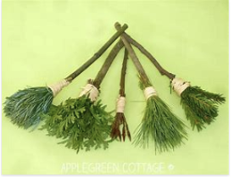  2. Mandalas: A mandala is a circular structure with radial symmetry, meaning that the design radiates out symmetrically from the centre. It is one of nature’s more wonderful and perfect configurations. You can find mandalas in flowers, tree rings, the sun, eyes, snowflakes, spiderwebs, sea shells, seeds, fruits, succulents, and more. Keep an eye out for mandalas around you, both in the natural world (flowers, tree rings, eye balls, etc) and in the fabricated world (bike tires, wheels, fans, etc). How many can you find? Create mandalas in nature with nature’s materials. Try it with seashells, sticks, pebbles, pinecones, leaves etc. 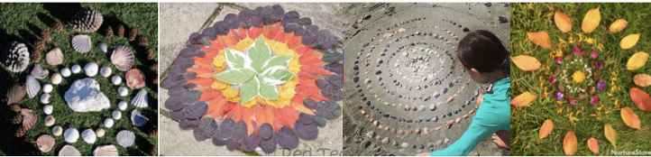  3. Make a beautiful, magical fairy garden and tell some stories as you play: https://theimaginationtree.com/making-fairy-garden/  4. Make a photograph frame out of sticks and string. Can you look carefully at how to lash the sticks together using a figure of eight movement? See if you can find a photograph to put into your frame.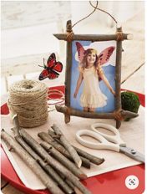
Thursday | Literacy |  | Maths |  | Theme/Science
Phonics  Access Bug Club and work through the sounds and books shared with your individual child. | Please choose one activity below:  1)WALT: write our own story about the most disgusting pizza  This week the children finished writing their own re-creations of the story ‘The Disgusting Sandwich’, by Gareth Edwards.  We have attached a video to familiarise yourselves with the story. In addition, the children brought home their own stories to show you.  Have a look at these stories and watch the clp below:  https://www.youtube.com/watch?v=rWfw29sz6ps  Challenge: Can you plan your own story for the most disgusting pizza?  Remember, have fun and use those adjectives to include detail!  Alternatively: If you have had enough of story writing, why not have a go at the task below: 2) WALT: write instructions for how to make your own pizza.  Here is a link to remind you of what to include in your instructions.  https://classroom.thenational.academy/units/instructions-how-to-make-a-paper-crown-aa36 |  | In maths the next few days, we have set sessions that relate to our current topic in school. However, should your child wish to explore additional topics, please check out the webpage: https://www.thenational.academy/  Year 1 and year 2  WALT: Exploring Capacity  https://classroom.thenational.academy/units/measures-2-capacity-and-volume-9f1f - (lesson 2)  Reception  WALT: explore depth of numbers within 20  https://classroom.thenational.academy/units/depth-of-numbers-within-20-16d1- (lesson 2) |  | ​​Thinking about your learning yesterday, what would be good clothes to wear in a rainforest climate? Children test absorbency or speed of drying of different materials.  Design the front of a rainforest postcard. Now write it to ‘send home’, pretending that you are on holiday in the rainforest – what would you tell your family about the weather you are experiencing?  Next you could do this simple Science investigation to attempt! You will complete two tests with one eye closed and then both eyes open to understand why humans and other animals have two eyes. What to do: Work with a partner (parent or sibling) to complete these two simple tests.  1. Stand a metre apart and hold a pencil out in front of you (both partners). Take it in turns to close one eye and try to touch the tip of your partner's pencil with the tip of your own. Repeat the action again to see what happens when they have both eyes open and when standing different distances apart. Write down a summary of your findings.  2. Sit on a chair with one eye closed. Carefully watch your partner slowly move a coin in the air until you think it is directly above a cup on a table. When you think the coin is in the right place, shout 'Drop!' and watch to see if the coin lands in the cup. Take it in turns to repeat the test with both eyes open. Write down a summary of your findings.  EYFS/KS1 Challenge  Speaking and Listening: Play memory games such as Kim’s game. (Kim’s game is a classic game for developing memory skills. Provide a range of everyday items on a tray, now ask your child to close their eyes and then remove one item. After the item is removed, ask them to look carefully to spot what has been taken. Can they remember what was there and what has been removed?) Talk about how they try to remember all the things on the tray.
Friday | Literacy |  | Maths |  | Theme/PSHE
Phonics  Access Bug Club and work through the sounds and books shared with your individual child. | Speaking and Memory Games!  Game 1: Play spot the difference, choosing someone to go outside of the room and change one thing about themselves (maybe pull one sock down or remove a headband). Spot and describe what the person has changed.  Game 2: Learn and recite some memory rhymes that help us remember things. Read and remember common memory rhymes about topics like the months of the year or the alphabet. Listen carefully and join in where possible. Then practise, reciting them aloud.  Challenge - Can you learn one per day this week? |  | In maths the next few days, we have set sessions that relate to our current topic in school. However, should your child wish to explore additional topics, please check out the webpage: https://www.thenational.academy/  Year 1 and year 2  WALT: Exploring Capacity  https://classroom.thenational.academy/units/measures-2-capacity-and-volume-9f1f - (lesson 2)  Reception  WALT: explore depth of numbers within 20  https://classroom.thenational.academy/units/depth-of-numbers-within-20-16d1 - (lesson 3) |  | Think about a special friend and say why you like them. Identify any shared hobbies, likes and interests and talk about shared experiences. Present these thoughts in any way that you wish to your family (for example poster/speech). Be prepared to answer questions about why you are friends with this person.  Now it’s time for some engineering! Can you choose one of these activities to have a go at?  1. Can you make a table football? You can use whatever you can find to make it. Don’t take pegs from the peg basket without checking with your grown ups first. Any cardboard box will do and you could use sticks or twigs and a scrunched up piece of paper for the ball. See how creative you can be.  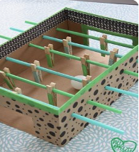  2. Have a go at making a marble run. These are just some ideas, but you could use anything that you have available to you at home.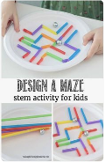  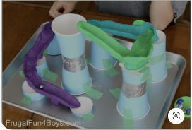  3. Make your own golf course. It doesn’t matter if you don’t have a golf club - you could use anything (an umbrella, broom handle?) If you don’t have a golf ball, what else could you use? Be creative but make sure that you ask your grown up before you take anything!  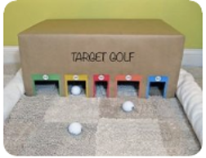  EYFS/KS1 Challenge  We had planned to enjoy a ‘classroom cinema’ afternoon this week. What a shame we cannot. Perhaps instead you could organise a ‘home cinema’ night?  Some ideas:  · Make a poster for the sitting room door.  · Make some tickets.  · Take some money to spend and give change for snacks during the interval.  · Take it in turns to be usher to show family members to their seats using a torch.  Have fun!

Home Learning Certificates awarded for Learning Behaviours:
