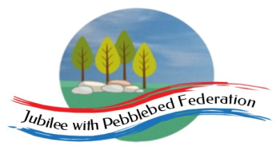 Home Learning Grid 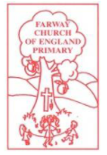
This is the home learning grid for the week beginning 22nd March 2021. Please use this as a grid to support planning your child’s home learning. Additional resources will be made available on ‘google classrooms’, to support your child to access these activities. A daily reading and counting task are important to support your child to access their education but remember to have fun!
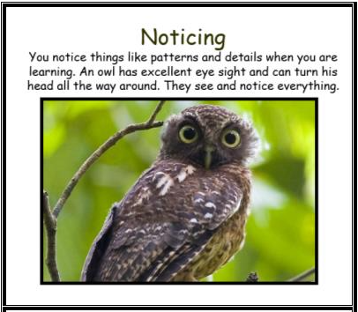
This week, we will be exploring patterns and rhythms in poetry, alongside exploring properties of shapes. Therefore, Class 1 will be focusing on the key Learning Behaviour: Noticing. The world is surrounded by patterns and shapes, just like our learning. Why not be like an owl and pay attention to all these wonderous details when out and about and accessing your learning. Remember to have fun with your learning and to contact Mrs Jackson with any concerns or celebrations, you would like to share.

If you have internet issues whilst accessing your learning, you can still access Google Classrooms using your phones. You can also contact the school and we can try and support you with alternative learning options.

 | Farway C of E Primary School - Class 1 – week beginning 22nd March
 | Phonics | Literacy / R.E | Mental Health | Maths
Monday  Please read for at least 10 minutes every day with an adult or a sibling.  You can use the Bug Club online books to access books in line with your child’s phonics ability. | Phonics - https://www.activelearnprimary.co.uk/login?e=-1&c=0#bugclub_phonics  Reception –  Recap Phase 3 sounds  Year 1 & 2  Recap Phase 5 sounds – unit 27  Once you have completed your phonics session – read for 15 minutes, on one of your allocated books and answer the Bug questions. | Literacy  WALT: explore environmental sounds  WALT: explore what we mean by onomatopoeia  Recap the Poem – ‘Rhythm of Life’, by Michael Rosen.  What do we mean by feel? – one of the senses… does anyone know any other senses?  - Feel  - Hear  - Taste  - Smell  - See  Teach the chn the meditation technique fr managing anxiety. 5 things you can see... 4 things you can feel… 3 things you can hear… 2 things you can smell… 1 thing you can taste.  Teach chn the word Onomatopoeia – what do you think it means?  Hold up a glass of water and tell the children that you are going to pour it into another glass. What sound might it make?  Elicit sound effects from the children. Pour some water, raising the glass high and low to vary the sound as it pours. Now put your hand in a bowl of water. What sound will the water make if you swish your hand about?  Elicit further sound effects and onomatopoeic words from the children, such as whoosh, slosh, splash.  Read children the poem – Tony Mitton’s ‘Voice of Water’.  What onomatopoeic words do you hear? | Practise meditation technique we practised in Literacy - 5 things you can see... 4 things you can feel… 3 things you can hear… 2 things you can smell… 1 thing you can taste.  Now you feel calmer, what do you notice about how your body feels?  This week in Literacy, we will be focusing on our different senses. Have a think, what do we mean by senses?  Pick one of the Mindfulness senses challenge cards, and have a go at doing the activity on the card for at least one minute or more. | Maths  Reception  Year 1 and 2  WALT: explore the difference in length and height  1.Select three different objects of your choice.  2.Measure your objects, using non-standard measurements (Reception) and cms (year 1 and 2).  3.Record your measurements on the sheet attached.  4.Order the objects, according to height / length – shortest to longest/tallest  (Reception – take and photo and record the language they use).  Year 1 and 2 – find the difference bewteen the height/length of the objects, using your ruler.  Which operation do you need to use?  Record your findings on the sheet.  https://www.nagwa.com/en/lessons/715146149359/  Challenge: How could you measure the playground?
Tuesday  Please read for at least 10 minutes every day with an adult or a sibling. | Phonics - https://www.activelearnprimary.co.uk/login?e=-1&c=0#bugclub_phonics  Reception –  Recap Phase 3 sounds  Year 1 & 2  Recap Phase 5 sounds – unit 27  Once you have completed your phonics session – read for 15 minutes, on one of your allocated books and answer the Bug questions. | Literacy  WALT: explore our sense of hearing to create a bank of onomatopoeic words.  Recap yesterday’s lesson – can anyone remember what we mean by onomatopoeia?  https://www.bbc.co.uk/bitesize/topics/z4mmn39/articles/z8t3g82  Show PowerPoint of different objects – sounds (will be available on google classrooms). Can you match the object to the sound that they make?  Linked to Tony Mitton’s poem.  Today, we are going to create some onomatopoeic words to support us in our writing this week.  For example:  We are going to write a poem in the style of Michael Rosen’s ‘Rhythm of Life’, using the onomatopoeic theme from Tony Mitton’s poem, ‘Voice of Water’.  Put your ear to the wave hear the crash of the sea  Put your ear to the flower, hear the buzzzz of the bee.  So, before we start to write we need to generate a bank of onomatopoeic words.  In groups of three, you are going to explore different areas of provision – exploring different experiences to explore sound.  - Make the sound  - Make the sound with your mouths  - Think of a word to describe the sound  - Write the word down on your post it notes and stick to the correct area on the WB  Varied provision - water play using a range of shallow and deep containers, sieves, pouring jugs, ice shapes, guttering for water travel along into another container, pumps – trickling water, pouring water, gushing water…  Painting splodges of paint with paint brush, sponges, dabbing…  Shaking rice in sealed containers…  Pouring rice using cups…  Large material – swoosh  Ticking clock… tick tock,  Bang drum… bang, crash (pans)  Eating crisps… crunch  Fizzy pop… opening the bottle lid … fizz  Horn… beep/honk  Please take photos of the objects you choose and the sounds they make – onomatopoeia words. | Practise the meditation technique we practised yesterday - 5 things you can see... 4 things you can feel… 3 things you can hear… 2 things you can smell… 1 thing you can taste.  Now, have a go at drawing the Easter bunny, using the instructions below. Spend time colouring within the lines, when it is complete. Why not even give it a name?  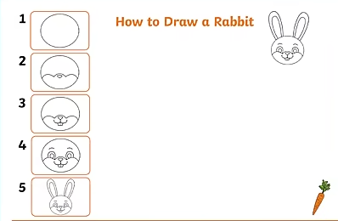 | Maths  Reception/Year 1/ Year 2  WALT: solve word problems  https://www.nagwa.com/en/lessons/602193519875/  Warm up – discuss measuring the playground, using the children’s chosen method. Discuss the findings. Explore meters (m) – how many cms in one m?  Now, have a go at completing your year appropriate task (available on google classroom).
Wednesday  Please read for at least 10 minutes every day with an adult or a sibling. | Phonics - https://www.activelearnprimary.co.uk/login?e=-1&c=0#bugclub_phonics  Reception –  Recap Phase 3 sounds  Year 1 & 2  Recap Phase 5 sounds – unit 27  Once you have completed your phonics session – read for 15 minutes, on one of your allocated books and answer the Bug questions. | R.E.  WALT: continue thinking about the importance of the cross to Christians and how it links to the Easter story.  Question: why do Christians place a cross in their Easter gardens?  Have another look at the image from the ‘Big Freeze’ – recap ideas from last week – remember how the image made you feel.  Teach chn that Christians say Easter is a happy celebration because Jesus did not stay dead, but the Easter story evokes lots of different emotions in Jesus’s followers. For example: Friday (sadness/anger) through to Sunday (pure joy/ overwhelmed/ ecstatic) – Show children lots of different emotion cards and ask them to have a go at matching the emotions to the different stages of the Easter story.  Watch the clip: https://www.biblesociety.org.uk/get-involved/easter/the-seriously-surprising-story/  Make explicit links between the ideas of new life and the Easter story – resurrection of Jesus, after he died on the cross at Easter.  To remember this some people, like to create Easter gardens – flowers symbolising new life, the cross-symbolising Jesus dying on the cross, the stones symbolising the tomb Jesus’ body was buried in…  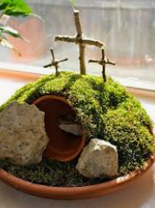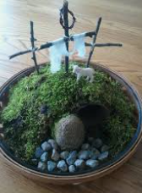  Task: children to have a go at creating their own Easter gardens. | Practise Mindfulness ‘growing flower’ activity, that we have practised in school together.  Now, have a look at the flower ‘I can do’ sheet and colour all the petals in that you are currently go at doing. Have a look at any that you feel unsure of. These will be your target ‘I Can’ goals.  Please share these with Mrs Jackson, together we can create experiences to practise these goals together. | Maths  https://classroom.thenational.academy/units/faces-shapes-and-patterns-lines-and-turns-1338  Reception / Year 1 / Year 2  WALT: name 2D shapes and recognise them by their properties.  Place different shapes within a bag, slowly pulling out each shape, just showing a corner or an edge… what shape do you think this is?  Why do you think that?  Practise stem sentences… The shape has… (a round edge), therefore I think the shape is... (a circle)…  When all the children have had a go at naming the shapes… place all the shapes out to see, on the carpet. Sort the shapes into groups, according to their properties. How do we know they are square? Rectangle?  How do we know they are 2D?  https://www.nagwa.com/en/videos/787189031212/  Reception -  Children to have a go at drawing around the different shapes and writing the name within the middle – encouraged to talk about the properties of the shape, throughout.  Year 1 and 2 –  Have a go at identifying the different shapes within the Klee picture. How do you know this is a …? Lots of questioning.  The children to have a go at using the shapes to recreate their own Klee picture.  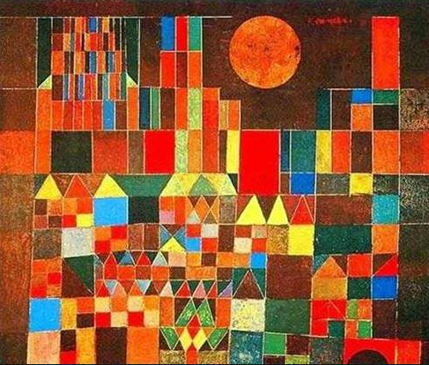
Thursday  Please read for at least 10 minutes every day with an adult or a sibling. | Phonics - https://www.activelearnprimary.co.uk/login?e=-1&c=0#bugclub_phonics  Reception –  Recap Phase 3 sounds  Year 1 & 2  Recap Phase 5 sounds – unit 27  Once you have completed your phonics session – read for 15 minutes, on one of your allocated books and answer the Bug questions. | Literacy  WALT: say out loud what we are going to write about (before writing a well-structured sentence).  Recap the onomatopoeia words the children collected (Tuesday) – can they match the word with the object/item making the noise?  Play different sounds to the children and encourage them to listen to the sounds – creating more onomatopoeia words for the WW.  Tell chn: we are going to write our own poem based on Michael Rosen’s, ‘The Rhythm of Life’.  Verbally model – ‘Put your ear to the wave hear the crash of the sea.  Put your ear to the flower, hear the buzzzz of the bee.’ As an example of expectations.  Ask children – do you have any ideas?  Those that need scaffolding more – use: Put your ear to ………. Hear the _______ of the ……………  Children to verbally create ideas allowed, saying out loud what they are going to write about.  Record ideas down in their books – need at least two sentences (with a rhyming pair if possible) | Go outside, into your garden and spend some time listening to the different sounds that you hear.  Practise the meditation technique (Monday/Tuesday).  Now, choose one of the mindfulness colouring sheets and spend time colouring, within the lines. If it is warm enough, you could colour it in outside in your garden area. | Maths  Reception, year 1 and 2  WALT: name 3D shapes and recognise them by their properties.  Recap 2D shapes, discussing properties and shape language (Widget)  Now, place different 3D shapes within a bag, slowly pulling out each shape, just showing a corner or an edge… what shape do you think this is?  Look at the faces, what do you notice?  What is different between 2D shapes and 3D shapes? What do you notice?  Sort the shapes into 2D and 3D shapes. Can the children name the shapes?  Give children a selection of shapes – which 3D shapes are good for building? Rolling? … why?  Have a go at the activities provided on google classroom (if needed).
Friday  Please start the morning looking through the spellings of tricky words – appropriate phases available on google classroom. | Phonics - https://www.activelearnprimary.co.uk/login?e=-1&c=0#bugclub_phonics  Reception –  Recap Phase 3 sounds  Year 1 & 2  Recap Phase 5 sounds – unit 27  Once you have completed your phonics session – read for 15 minutes, on one of your allocated books and answer the Bug questions. | Literacy  WALT: Read aloud with appropriate intonation to make the meaning clear.  WALT: Discuss our favourite words and phrases.  Using the children’s ideas from yesterday, ask the children to read aloud their sentences to their peers (can they use appropriate intonation to make their meaning clear?) – Children need to discuss what they like about each other’s poem verse?  They need to choose one verse of their own writing each, to add to the class poem.  DW – write up their chosen verses on the WB to create their own class poem.  Children to rehearse their poem together as a class, line by line.  Using previous rhythm markings, practise clapping in time to the rhythm – same as MR poem. | Today, I would like you to focus on your breathing to practise staying in control of your feelings and emotions.  A huge component of mindfulness is learning how to control our own breathing. Let’s make this fun, by breathing like a dragon. With dragon breathing, children need to sit up straight, breathe in, stick their tongue out, and breathe out like a dragon.  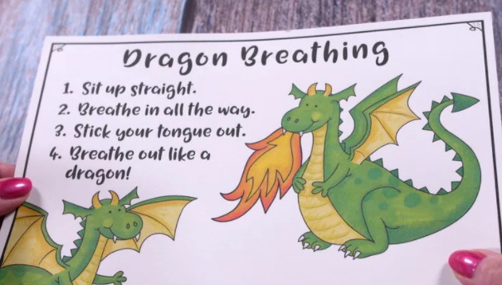 | Maths  Reception/Year 1/Year2  WALT: apply our knowledge of shapes to problem solving (year 2) and recreating 2D shapes (reception/year1).  ie:  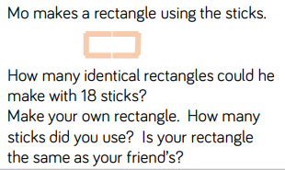  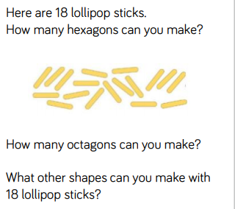  Reception and Year 1 – sorting shapes, through problem solving.  