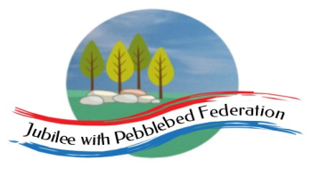 Home Learning Grid 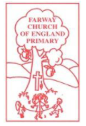
This is the home learning grid for the week beginning 17th May 2021. Please use this as a grid to support planning your child’s home learning. Additional resources will be made available on ‘google classrooms’, to support your child to access these activities. A daily reading and counting task are important to support your child to access their education but remember to have fun!
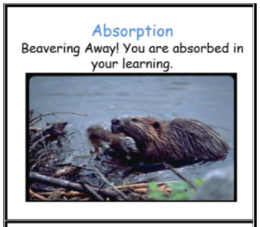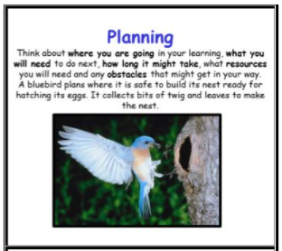
This week, the children will be busy beavering away, learning all about how to make slime, exploring which ingredients make the best slim consistency and planning and generating ideas to create their own scented slime! Therefore, the Learning Behaviours, for Class 1, this week, will be: Absorption and Planning. Please look out for these learning behaviours in your children and award them with the appropriate certificates, attached below.
If you have internet issues during a self-isolation period, you can still access Google Classrooms using your phones. You can also contact the school and we can try and support you with appropriate, alternative learning options.
Home Learning – week beginning 17th May 2021
Monday | Literacy | Mind break | Maths |  | P.E.
Phonics  Reception:  Phase 4, unit 12 – Language session 2: adjacent consonants  Year 1: Phase 5, unit 17- recap (identified gap during recent assessment) – Phoneme /oa/, written as ‘ow’  Year 2:  SPAG – apostrophe of possession versus plural ‘s’ – identified as a misconception across year 2. | WALT: link what we have read to our own experiences  Recap on making slime (Friday) – allow children time to feel and explore the two types of slime, creating a word bank of adjectives to describe how the slime feels (put on WW).  Give each child a copy of the slime instructions (pg 8-9) – working in pairs ask children to annotate and talk about what they like about and notice from the page.  What do they notice about the language used in the descriptive instruction section, compared to the science bit?  Teach:  Come together as a class, share and record these ideas on the writerly knowledge chart.  Discuss – are there any words in the text that you are not sure about? Chn to write the words on post-it  notes and add to the Vocabulary wall. (Yr 2 use dictionaries to find the meaning of their chosen word).  Plenary:  Talking wow words in a sentence, to model their use within different contexts. |  | WALT: recognise and find a third (Yr2)  See Curriculum Maestro – fractions (Whiterose)  https://whiterosemaths.com/homelearning/year-2/spring-week-11-number-fractions/ - find a third  WALT: find a whole amount when given one part (Yr1)  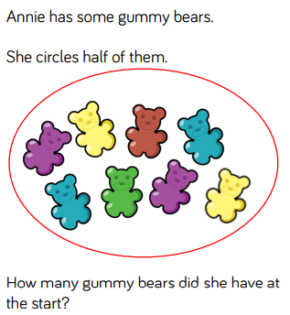 |  | Holistic Wellbeing  Take some time this afternoon to do an hours exercise of your choice. Go for a run, go cycling or even skip around your garden. Listen to the sounds around you, use your sense to smell the different flowers and feel the sun on your face.  Spending time outdoors, in nature, exercising and doing something you enjoy, are fabulous ways to help stay healthy in both your mind and your body.  Have a look at the ten a-day to balancing mental health and think about the different ways you can help keep happy and healthy.  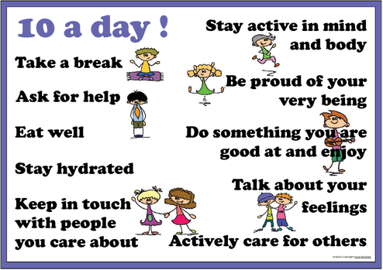
Tuesday | Literacy |  | Maths |  | Science
Phonics  Reception: Phase 4, unit 12, language session: adjacent consonants  Year 1: Phase 5, unit 17- recap (identified gap during recent assessment) – Phoneme /oa/, written as ‘o-e’  Year 2:  Continue addressing the misconceptions around apostrophe of possession and plural ‘s’. | WALT: explore interesting vocabulary and understand the meaning  Recap:  Revisit the Vocabulary wall (will be posted on Google classroom if at home isolating) and explore the interesting words the children have chosen, along with their meaning. Discuss the impact of using such words on the reader.  Teach:  Show the class the Contents page: each pair chooses a different slime to explore. Pupils to annotate their chosen slime page for patterns they notice, things they like and interesting words to add to the vocabulary wall (and WW).  Pick out really good words that the children notice. For year 1 they need to identify words they like.  All children need to identify the words that really help them in the instructions. Display these on the WW as ‘Slime-tastic’ words.  Plenary:  Come together and discuss what they noticed and explore the ‘Slime-tastic words’ and their meanings. |  | WALT: Continue finding a whole when given a part  https://whiterosemaths.com/homelearning/year-1/summer-week-6-number-fractions/  Additional activities available on Whiterose / nrich – to be added to Google Classroom if needed.  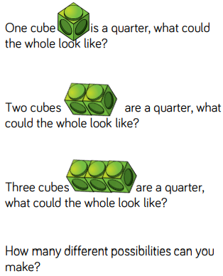 |  | WALT: Describe how plants need water, light and a suitable temperature to grow and stay healthy.  Grow a windowsill garden using food scraps such as carrot tops and shrivelled potatoes. Observe how these scraps grow roots and shoots to form a new plant. Talk about what plants need in order to grow well (such as light and water) and set up a control to see what happens to scraps which don’t get these essentials. Describe and record observations.  Note: Food scraps that will grow easily on a windowsill include pineapple, onions, potatoes, celery, garlic, onions and carrot tops.
Wednesday | Literacy |  | Maths |  | Geography
Phonics  Reception – Phase 4, unit 12, language session 2, adjacent consonants  Year 1: Phase 5, unit 17- recap (identified gap during recent assessment) – Phoneme /oa/, written as ‘o’ and ‘oe’  Year 2  SPAG -  writing verbs in present and past tense (regular and irregular) | WALT: identify verbs and explore how they work within commands and statements.  Recap:  Revisit the pages 8-9 from the text, children to use their actions to support you re-telling the instructions.  ‘Hammer’ each verb from the page (8-9) by saying it and beating your hand every time you hear a verb.  Teach:  Ask the children: what do you notice about the verbs? Where do they come in the sentence?  Ensure that the children know that the sentences which start with a verb are commands (imperative verbs): they tell (command) you to do something.  Take an example from the text, ie: ‘Squirt in some paint’ – and explore how commands work, compared to statements, by transforming the command into a statement, ie: ‘I squirted the paint into the bowl.’ ‘I stirred the mixture well.’  https://k12.thoughtfullearning.com/minilesson/creating-command-sentences (for support)  For example: commands - purpose of the sentence is to instruct the reader how to do something.  Discuss why commands like this have no subject, i.e: because they are general for anyone to do at any time.  Task: collect as many imperative verbs from the book as you can – adding to the WW.  Plenary:  Children can collect as many imperative verbs as they can to support writing their own instructions. |  | WALT: apply our knowledge of fractions to continue solving word problems  https://whiterosemaths.com/homelearning/year-2/spring-week-12-number-fractions/ - problem solving in fractions  Year 1  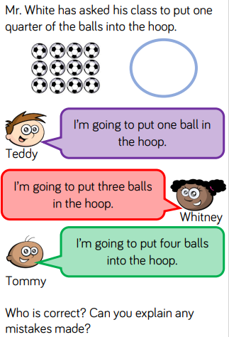  Year 2  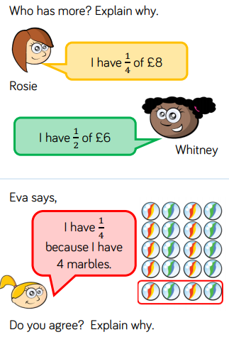 |  | WALT: continue exploring key features and landmarks on a map  Explore finding Farway school on a map.  Begin with the address of the school. Can the children secure the lines of the address accurately?  Discuss the children’s addresses. Do they know them? Have them ready for the activity.  Now, find our school on a map. If you have an OS map you can use this and also show the children on Google Maps. Pinpoint key features or landmarks of the surrounding areas and those which are relevant to your school and village. Model how to change from a street map to a google view and discuss what is different in the aerial view and front facing view that you can get from Google Maps.  Give the children their addresses and ask them to copy their address into their books.  Now, can they find their house on Google Maps (using their Chromebooks). Screen shot when they find their house and print to stick into their books with their address.
Thursday | Literacy |  | Maths |  | PSHE
Phonics  Reception – Phase 4, unit 12, language session 3  Year 1: Phase 5, unit 17- recap (identified gap during recent assessment) – Language session  Year 2 –  Revisit spelling homophones and near homophones | WALT: expand the noun phrase to add more detail for the reader  Recap: what we mean by adjectives and nouns. Can the children give you some examples of each?  Teach:  In pairs/small groups, get the children to see if any adjectives are used in the stretchy slime page. The sorts of adjectives are: super-fun recipe, gloopy stuff, awesome slimes, perfect colour, long molecules, bouncy, stretchy solid.  Talk about the job that these adjectives (expanded noun phrases) are doing: there is a difference between the science bit and the rest. Why?  On the WW collect two types of noun phrases from the rest of the book: Fun phrases and science phrases.  Plenary:  Ask the children to add noun phrases to the two types, from their chosen slime page. |  | WALT: explore the difference between unit and non-unit fractions (Yr2)  https://whiterosemaths.com/homelearning/year-2/spring-week-11-number-fractions/ - unit fractions / non-unit fractions  Additional resources available on Google Classroom.  Year 1 – PowerMaths – consolidating knowledge of halves and quarters. |  | WALT: explore the question: Why do we take medicine?  https://www.bbc.co.uk/bitesize/clips/zrfnvcw  One decision – health  Music  WALT: Sing simple songs and chants with a sense of melody and shape  Learn an action rhyme, such as Here We Go Round the Mulberry Bush joining in with words and actions. Work collaboratively to create new lyrics that inform others how to plant a seed or bulb. Before starting, sequence the process making suggestions about actions to use for each verse.  Note: An example of new lyrics could be ‘This is the way we dig the soil, dig the soil, dig the soil...’ Work together to sing in tune and with actions. Why not perform the new song for an audience later in the project?
Friday | Literacy |  | Maths |  | R.E.
Phonics  Reception – Phase 4 – common exception words (OW/GW)  Phase 2 - LR  Year 1 and 2 – Common exception words. | WALT: identify the structure and key features from the non-fiction text.  Recap: the key features found in a non-fiction text (links to Dino Dinners)  Teach:  Lay out the double page spread (pp8-9) on the WW and with the children’s help, model identifying and labelling the key features of the text. Paying particular attention to the repeated sections so that children can use these to plan when they write.  Display on WW as a large sheet with generic headings.  - Title  - Introduction  - You will need  - Time/difficulty warning  - Numbered steps  - Science bit or top tip  Children should then have a go at identifying these key features on their own chosen slime page  Plenary:  Share labels as a group, to discuss similarities and differences. |  | WALT: add fractions of amounts together (year 2)  https://whiterosemaths.com/homelearning/year-2/spring-week-12-number-fractions/ - counting in fractions  Year 1 – PowerMaths.  Revisiting number bonds to 20 (addition and subtraction) – identified gap in HL) |  | WALT: understand why peace is an important message for Christians  Recap, Matthew and Luke.  Today we are learning about Peace and the fourth Gospel writer, St John.  St John was a disciple at a very young age. He was shipwrecked on his way to Asia to tell the people about Jesus., but survived the storm and was washed ashore.  Read chn the story John 14:27 – Jesus promises his followers peace.  Ask chn what do you think we mean by peace? What does it mean to feel peaceful?  Give pupils four heart outlines each. Get them to draw, colour or stick on images that show a heart that is afraid, ill or worried, using three of the hearts. Talk about what they have expressed. ie: worry, stress, fear, illness, sadness, conflict.  Teach them Jesus’ promise to his disciples from John 14:27: ‘My peace I leave with you, my peace I give to you. Do not let your heart be troubled and do not be afraid.’  Ask the pupils to think about four kinds of peace: peace in my own life (in my heart?), peace with other people (no fights?), peace in the world (no wars?), peace with God for Christians (being forgiven).  Can they paint (or find) a picture to express one or two of these types of peace?  Paint this into a fourth heart shape: it could be their own idea, or they could think about what a Christian would draw to show peace, and why.

Home Learning Certificates.
