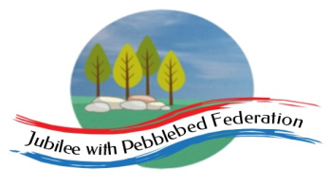 Home Learning Grid 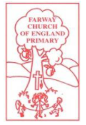
This is the home learning grid for the week beginning 15th March 2021. Please use this as a grid to support planning your child’s home learning. Additional resources will be made available on ‘google classrooms’, to support your child to access these activities. A daily reading and counting task are important to support your child to access their education but remember to have fun!
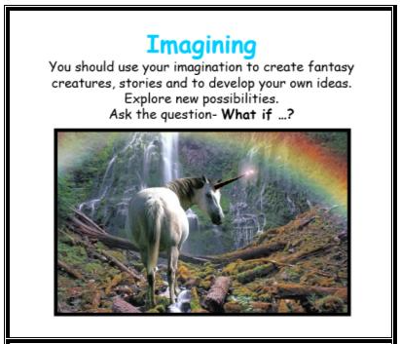
This week, in Literacy, we will begin to explore poetry, using the sounds and senses around us. We will also be focusing on using our imagination to explore how our feelings feel within our bodies and personifying them. Therefore, Class 1 will be focusing on the key Learning Behaviour: Imagination. Imagination plays a huge part in helping us to imagine and create innovative ways in which we can support our own mental health and well-being. It is also a key learning behaviour for supporting creative and rhythmic poetry, in the style of Michael Rosen and Tony Mitton. Have fun using your imagination this week, as Albert Einstein once said, ‘imagination is the language of the soul. It will take you everywhere’.
If you have internet issues during a self-isolation period, you can still access Google Classrooms using your phones. You can also contact the school and we can try and support you with appropriate, alternative learning options.

 | Farway C of E Primary School - Class 1 – week beginning 15th March
 | Lesson 1 | Lesson 2 | Break time | Lesson 3 | Lesson 4
Monday  Please read for at least 10 minutes every day with an adult or a sibling.  You can use the Bug Club online books to access books in line with your child’s phonics ability. | Phonics - https://www.activelearnprimary.co.uk/login?e=-1&c=0#bugclub_phonics  Reception – recapping phase 3 sounds, unit 8 ‘ng’  Year 1 – recapping phase 5 sounds  Unit 22 ear – written as ‘ere’/’eer’  Year 2 – SPAG – adding ‘es’ after /– y/ | Literacy  ‘How to Wash a Woolly Mammoth’.  WALT: proof-read our writing and make editions and revisions where needed  Children to look through their step-by-step instructions for ‘How to Wash a …’, checking for errors and self-editing where possible.  To write their work up (with revisions) in their neatest handwriting. | Do something you enjoy!  Get a snack, move around, and have a brain break. | Maths – due to carrying out maths assessments last week we need to continue exploring length and measure this week.  Reception  WALT: consolidate numeral recognition  https://whiterosemaths.com/homelearning/early-years/spring-consolidation-week-1/  Year 1  WALT: compare lengths  https://whiterosemaths.com/homelearning/year-1/spring-week-8-measurement-length-and-height/  Year 2  WALT: compare lengths  Home Learning - Year 2 | White Rose Maths | Maths Lessons Online – lesson 1 | Holistic Wellbeing  Spring is arriving and the sunshine has come out, finally! Take some time this afternoon to do an hours exercise of your choice. Go for a run, go cycling or even skip around your garden. Listen to the sounds around you and feel the sun on your face.  Spending time outdoors, in nature, exercising and doing something you enjoy, are fabulous ways to help stay healthy in both your mind and your body.  Have a look at the ten a-day to balancing mental health and think about the different ways you can help keep happy and healthy.  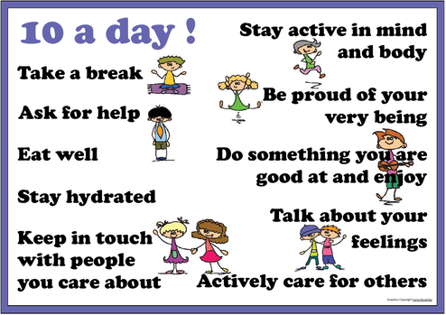
Tuesday  Please read for at least 10 minutes every day with an adult or a sibling. | Phonics - https://www.activelearnprimary.co.uk/login?e=-1&c=0#bugclub_phonics  Reception – recapping phase 3 sounds, unit 8 – language session  Year 1 – recapping phase 5 sounds  Unit 22 air - written as ‘are’/’ear’  Year 2 – SPAG - Apostrophes | R.E.  Juda’s betrayal / Last Supper  Show the children an image of a pile of money and an image of Love, family, friendship. Ask the children: which one do you feel is more important? Discuss children’s ideas and opinions?  Give children a selection of cards (money can buy/money can’t buy) – ask children to sort them into correct categories. Which pile is more important to you? Are there some items that humans need money for, to survive? (Links to PSHE)  Read the children the story of Judas’ Betrayal. Luke 22:1-6 (Miles Kelly page 437)  Ask children: do you feel you have ever betrayed a friend or loved one? Why do they think Judas betrayed Jesus to the Jewish officials?  Show children the artwork of ‘The Last Supper’, by Leonardo da Vinci.  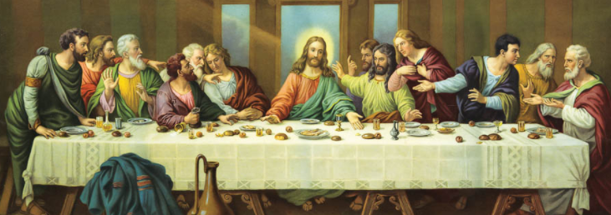  Ask the children: why do you think the last supper was so important to Jesus to share with his disciples?  Discuss with the children what special meals they share with their famiy? Why do they think their family insist on these meals? Do they sit up at the table together to eat? Or infront of tele at separate times?  Children to sit in a circle and have a little bit of bread to taste and a sip of grape juice. Whilst children are eating their bread and drinking their grape juice, teach the children the story of the last supper: page 440 (Miles Kelly) – Luke 22:7-53  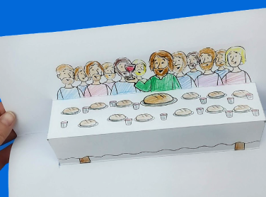  Children to create the Last Supper craft – pop up page.  Year 1 / 2 – write the words of Jesus: Jesus took the bread and said, ‘This is my body’… (year 2 using speech punctuation) | Do something you enjoy!  Get a snack, move around, and have a brain break. | Maths  Reception  https://whiterosemaths.com/homelearning/early-years/spring-consolidation-week-1/ - lesson 2  Year 1  WALT: compare heights  https://whiterosemaths.com/homelearning/year-1/spring-week-8-measurement-length-and-height/  Year 2  WALT: order lengths  Home Learning - Year 2 | White Rose Maths | Maths Lessons Online – lesson 2 | Science  WALT: exploring life cycles  https://www.bbc.co.uk/bitesize/topics/zgssgk7/articles/zwn6mnb  https://www.bbc.co.uk/teach/class-clips-video/science-ks1-animal-life-cycles/zrg9kmn
Wednesday  Please read for at least 10 minutes every day with an adult or a sibling. | Phonics - https://www.activelearnprimary.co.uk/login?e=-1&c=0#bugclub_phonics  Reception – recapping phase 3 sounds, unit 9 ‘ai’  Year 1 – recapping phase 5 sounds  Unit 22 – language session  Year 2 – SPAG - Apostrophes | Literacy  WALT: explore and appreciate poetry, through rhythm and rhyming (yr1 / 2)  Reception – Exploring rhythm and rhyming pairs.  Watch: Michael Rosen’s performance of his poem, ‘The Rhythm of Life’. http://www.poetryline.org.uk/poems/the-rhythm-of-life-44  Ask chn: What do you think of the poem? Was there anything in particular that you liked about the poem or the performance?  Use the ‘Tell Me’ framework to support thinking and elicit responses.  Discuss and identify the rhythm and patterns of the performed poem.  Play Rosen’s performance again, encouraging the children to move or beat to the repeated, undulating rhythm, listening out for emphasised words or joining in with the predictable actions and words, particularly the rhyming pairs.  Discuss the effect of the repeated rhythm, the pauses and the effect Rosen creates when accelerates to a crescendo and then stops.  Display the text of the poem on IWB or visualiser, this time reading it aloud to the children, perhaps more slowly, so they can predict and join in with the refrains and actions, emphasising the repeated rhythmic structure.  DW to beat the syllables of each verse on a tambourine or rhythm sticks (year 2 to support if appropriate).  Repeat through shared reading, allowing the children to enjoy being able to recite parts, or all, of the poem by heart, engaging them in the rhythm and memorable refrains. How do the actions support recital?  Ask children to work on reciting the poem by heart in small groups, organising themselves anyway they like, e.g. in unison throughout or each taking a verse. Support children with an enlarged copy of the poem with visual prompts if appropriate.  Encourage chn to perform the poem to the class, exploring the difference in performance styles.  Plenary – as a class discuss: What else could Rosen have written about where we might feel a rhythm?  Draw on inspiration from the poem, the children’s experiences or take the children on a walk around the school or in the local environment for ideas.  Make a collection of rhythmical things that can be turned into new verses through shared writing, using the repeated structure of the poem: ‘Hand on your…feel the rhythm of…’  Rhyming words can be discussed but this wouldn’t be vital; more valuable to check the rhythmic pattern fits with the Rosen’s poem given its significance in enhancing the meaning of the words. | Do something you enjoy!  Get a snack, move around, and have a brain break. | Maths  Reception  https://whiterosemaths.com/homelearning/early-years/spring-consolidation-week-1/ - lesson 3  Year 1  WALT: compare lengths and heights  https://whiterosemaths.com/homelearning/year-1/spring-week-8-measurement-length-and-height/  Year 2  WALT: four operations with length  Home Learning - Year 2 | White Rose Maths | Maths Lessons Online – lesson 3 | R.E  WALT: think more deeply about the concept of ‘new life’ and what this really means to Christians.  To think about the importance of the cross to Christians and how it links to the Easter story.  Good Friday  Teach children: For Christians, Easter is the most important festival of the year and lasts considerably longer than just one day.  Teacher notes: Easter is also a big secular celebration in Britain, dominated by chocolate eggs, with a focus on springtime. Although the idea of ‘new life’ underpins the flowers, lambs, eggs and chicks, they only become RE when the new life is connected to the Christian belief that Jesus rose victorious from death to new life, and that he gives his followers hope of forgiveness and eternal life with him. In RE we need to ensure that the Christian meaning of the festival is explored.  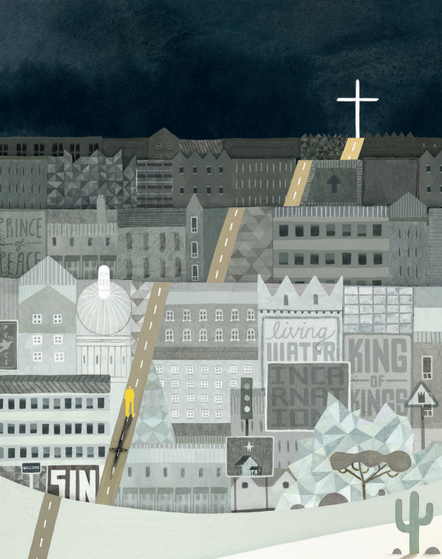  Show chn image of the Big Freeze – how does this image make you feel? Discuss their ideas – writing on a WB around the image.  Ask children to sit in a circle: Show children a real life hot cross bun. Ask children what they notice about the hot cross bun? Do they notice the shape on top of the buns? How do they think it links to the Christian Easter story?  Teach children: Hot cross buns are traditionally eaten on Good Friday, the day Jesus died. This is a ‘Jesus cross’. What can you remember about Jesus and the cross? The Bible says that after Jesus died on a cross, he was buried in a cave with a big round stone in front of it.  Read children the Passion: Luke 22:54-23:49  Children can have a sample of the bun – what does it taste like? Do they recognise any flavours? Do they like it? (GW to be encouraged to try little bit - EHCP). Whilst they are eating their buns, can they remember how Jesus died on a cross and was then buried in a cave (tomb) in a garden.  Tom thinks the bun itself looks like the cave that Jesus was buried in. Tessa thinks the bun is like the stone door of the cave. What do you think?
Thursday  Please read for at least 10 minutes every day with an adult or a sibling. | Phonics - https://www.activelearnprimary.co.uk/login?e=-1&c=0#bugclub_phonics  Reception – recapping phase 3 sounds, unit 9 – ‘ee’  Year 1 – recapping phase 5 sounds  Unit 23 ‘c’ – written as ‘ch’  Year 2 – SPAG – commas for lists | Literacy  WALT: explore the effect of onomatopoeia within poems (word collections)  ‘Voices of Water’, by Tony Mitton  Hold up a glass of water and tell the children that you are going to pour it into another glass. What sound might it make? Elicit sound effects from the children. Pour some water, raising the glass high and low to vary the sound as it pours. Now put your hand in a bowl of water. What sound will the water make if you swish your hand about? Elicit further sound effects and onomatopoeic words from the children, such as whoosh, slosh.  Explore the children’s concept of water. Why we need it, what it is used for, where it comes from, where we find it, etc. Scribe ideas. How does the sound of the water vary from place to place? Children can discuss ideas about where loud water sounds might be heard and when water can sound quiet, echoic, rhythmical etc. Elicit ideas and encourage sound effects.  Make provision for varied water play using a range of shallow and deep containers, sieves, pouring jugs, ice shapes, guttering for water travel along into another container, pumps, etc. Ensure there is ample opportunity for the children to collaborate to experiment with the structures they can craft and the variety of water sounds they can create as a result. Water can be ice cold and warm to produce further interesting sound effects.  Ask the children to collect words and phrases that describe the various sounds we can make with water, e.g. drip dripping, pitter patter, slosh, crick crack.  Examine the word collections, reading aloud and encouraging the children to say them with appropriate intonation.  Discuss which words are onomatopoeic and why. You could play the children some sound clips or find footage of fountains, waterfalls, the seashore, melting glaciers, rain or a tap dripping and ask the children to choose word that they think best fit. | Do something you enjoy!  Get a snack, move around, and have a brain break. | Maths  Reception  https://whiterosemaths.com/homelearning/early-years/spring-consolidation-week-1/ - lesson 4  Year 1  WALT: measure lengths  https://whiterosemaths.com/homelearning/year-1/spring-week-8-measurement-length-and-height/  Year 2  WALT: problem solving  Home Learning - Year 2 | White Rose Maths | Maths Lessons Online – lesson 4 | PSHE - Mental Health/Well being  WALT: Explore emotions within our bodies  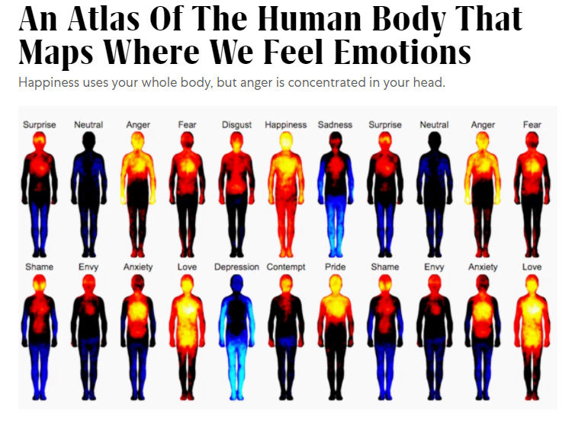  https://www.mentallyhealthyschools.org.uk/media/2065/feelings-activities.pdf  https://www.bbc.co.uk/bitesize/topics/znhmwty/articles/z4q4bdm
Friday  Please start the morning looking through the spellings of tricky words – appropriate phases available on google classroom. | Phonics - https://www.activelearnprimary.co.uk/login?e=-1&c=0#bugclub_phonics  Reception – recapping phase 3 sounds, unit 9 – ‘igh’  Year 1 – recapping phase 5 sounds  Unit 23 – language session  Year 2 – SPAG – common exception words. | Literacy  WALT: explore ellipses and the effect these have within poetry (yr1/2)  Reception – continue exploring the rhythm and sound within poetry.  Remind the children of yesterday’s exploration of water sounds and tell the children you are going to read aloud Tony Mitton’s poem, ‘Voices of Water’.  Ask them to predict what he might write about? Elicit responses from peer discussion.  Read the poem aloud, encouraging the children to predict what the water ‘says’ occasionally (linking to onomatopoeia) - being careful not to break the flow of the poem but modelling the expression and intonation of the piece.  Show the children an enlarged copy of the poem and ask the children to discuss the structure of the poem, identifying the repetitive refrain, and discussing why the printed poem has been laid out on the page in this way. How does it affect the way you read it? Look at the illustration. Why so sparse? Is this what you had in your mind? Has Mitton been successful in creating strong images in our minds? How has he done this?  Using shared reading, model the rhythm of the refrain and the intonation to emphasise the onomatopoeic words.  Examine: ‘The water in the pond…stays still.’ Why has Mitton used ellipses here?  How does this affect our reading, emphasise meaning and allow images to be formed for the reader?  Model text marking the poem to give directions for it to be read aloud and performed. How could we use our voices as a group to best effect? When might silence be most effective? What if we were to add actions or facial expression? Instruments?  Mark the text and try out a performance as a class or using a group to demonstrate.  Evaluate and compare performances, commenting on particularly successful elements in the performances as well as considering new ideas. What did you like about each other’s performances – building confidence and self-esteem (celebrating each other’s success!) | Do something you enjoy!  Get a snack, move around, and have a brain break. | Maths  Reception  https://whiterosemaths.com/homelearning/early-years/spring-consolidation-week-2/ - lesson 1  Year 1  WALT: introducing the ruler.  https://whiterosemaths.com/homelearning/year-1/spring-week-9-measurement-length-and-height/  Year 2  WALT: adding and subtracting lengths.  https://whiterosemaths.com/homelearning/year-1/spring-week-9-measurement-length-and-height/ | Art and Design  WALT: explore different artistic effects, using water (links to Literacy)  Children could depict different forms of water using watercolours or ink and water. Model techniques such as wetting the paper first and dropping the paint or ink onto the page, layering washes of paint over each other, using a range of sponges and brushes to create different effects. Allow the children exploration time.  