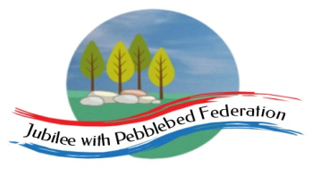 Home Learning Grid 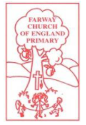
This is the home learning grid for the week beginning 1st February 2021. Please use this as a grid to support planning your child’s home learning. Additional resources will be made available on ‘google classrooms’, to support your child to access these activities. A daily reading and counting task are important to support your child to access their education but remember to have fun!
This week it is National Mental Health week. In recognition of this Class 1 will focus on three key Learning Behaviours for the week: empathy and listening, imagining and collaboration.
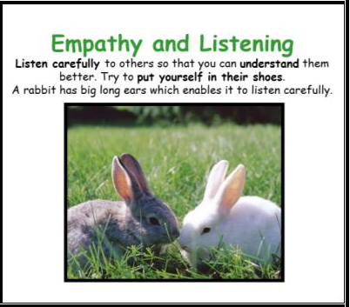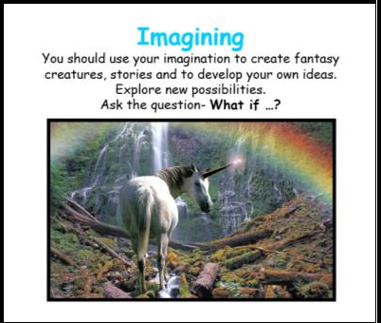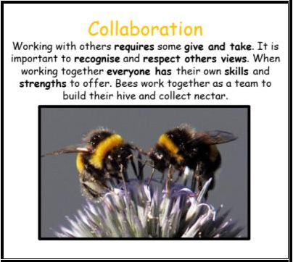
This lockdown has been going on for quite a while now, and I know some of you have been finding it quite challenging. This week Class 1 will be focusing on working together and respecting each other’s needs, feelings and ideas (collaboration); listening to each other more so we can better understand them and be there to support them, as well as listening and valuing your own feelings and emotions (empathy and listening); and using those fantastic imaginations to think of creative and imaginative solutions for reaching out to those we love and staying connected to each other (imagining). It’s really important to look after yourselves and keep connected to those people you miss and love, during this challenging time. I am in school every day should you need anything, and on Google Classrooms.
Please remember, if you have internet issues during this lockdown period, you can still access Google Classrooms using your phones. You can also contact the school and we can try and support you with alternative learning options.
 | Farway C of E Primary School - Class 1 – week beginning 1st February
 | Lesson 1 | Lesson 2 | Break time | Lesson 3 | Lesson 4
Monday  Please read for at least 10 minutes every day with an adult or a sibling.  You can use the Bug Club online books to access books in line with your child’s phonics ability. | Phonics - https://www.activelearnprimary.co.uk/login?e=-1&c=0#bugclub_phonics  Reception – Phase 3, unit 10, phoneme ‘ar’, written as ‘ar’.  Year 1  Phase 5, Unit 16, language session.  Year 2  https://www.bbc.co.uk/bitesize/topics/z8mxrwx/articles/z9hjwxs | Literacy year 1 and 2  WALT: continue writing a dual-text about my chosen prehistoric animal  On Friday, you wrote the information text about your chosen prehistoric animal. Today, we will be writing the ‘voice’ of your prehistoric animal.  Remember this piece of writing also provides the reader with information about the animal, but it is delivered in a more fun, rhythming, sing-song manner, using the personal pronoun ‘I’.  Clue: refer to your text structure to refresh yourself with your ideas and the ‘voice’ you have already planned for.  Again, please encourage your child to write this section independently, correcting or re-editing any of their writing using a different coloured pen.  Please share this writing with Mrs Jackson, to include in your children’s literacy books.  Now, your child will have finished the writing for both ‘voices’ within the text! Well done. Now they can start thinking about illustrating their work!  Reception –  WALT: listen to a story and use our imagination  Watch the story of ‘The Dinosuar that pooped a planet’.  Which part of the story did you like best? Why?  Which part of the story did you least like? Why?  Think about how the dinosaur would have reached the planet?  Could you design your own flying machine?  Use your fantastic phonics knowledge to label parts of your machine, ie: rocket boosters.  Challenge: write a short sentence to tell me how your machine works. You could even make your own machine using recycled materials. | Have a mind break (20 mins) - get a drink and run around the garden or do something you enjoy.  For ideas visit:  https://www.cosmickids.com/mindfulness-meditation-videos-kids/ | Maths  Reception:  https://whiterosemaths.com/homelearning/summer-archive/early-years/ - Day 1 (activity can be found on the link above)  Year 1 and 2  Please take some time today, completing the assessment sheets I have attached. Could you please encourage your child to do these independently, so that I can assess where the gaps in their learning are, and plan properly for these.  I would be really grateful if you could use a different coloured pen, with the answers you help them on.  Year 1  https://whiterosemaths.com/homelearning/summer-archive/year-1/ - make equal groups by grouping  Year 2  https://whiterosemaths.com/homelearning/year-2/spring-week-4-number-multiplication-and-division-2/ - divide by 2 | P.E –  Today, we are going to be looking after our physical and mental health!  Physical health  Complete your warm up mile around your garden lap – then have a go at the weekly challenges, below the home learning grid (bottom of the page).  Mental Health  Watch the video of the story being read: ‘While we can’t hug’.  https://www.youtube.com/watch?v=tarq5nkkGlk  Then have a go at creating your own hug and mailing it to someone you love and miss being able to hug.  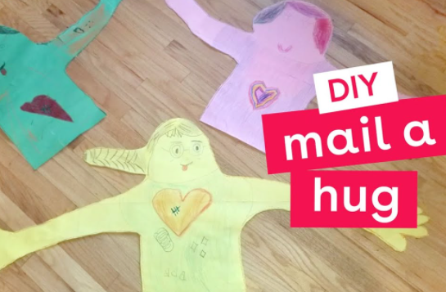  *Lay down on a large piece of paper (or spare wallpaper)- arms out-stretched.  *Ask an adult to draw around the top half of your body and arms.  *Cut out and decorate as you wish.  *Fold up and mail to your chosen loved one.  *Make their day!  *Send as many hugs as you wish to xx  Number 7 on the ten-a-day to a better mental health – stay connected to those you care about.  Number 10 – Actively care for others.
Tuesday  Please read for at least 10 minutes every day with an adult or a sibling. | Phonics  https://www.activelearnprimary.co.uk/login?e=-1&c=0#bugclub_phonics  Reception – Phase 3, unit 10, phoneme ‘or’, written as ‘or’.  Year 1  Phase 5, Unit 28, suffix ending – ‘ing’ (a morpheme).  Year 2  Phase 6, unit 30, prefix ‘re’. | Literacy  WALT: publish our own page of ‘Prehistoric Dinners’.  Well done! You have worked really hard on creating your own page of ‘Prehistoric Dinners’ (our class creation!)  Today, you can have some fun publishing your own page, in the style of Dino Dinners.  Look back over the triceratops page and the notes you have made about what you noticed about the layout and features. Have a go at using water colours to illustrate your page (voice of the dinosaur) and once it has dried you can write on your text, in your neatest handwriting, ie: the ‘voice of your prehistoric animal.’  Down the edge of the page you will have noticed the more formal writing (authors voice) – in your neatest handwriting, write up your information section (from Friday) and illustrate it using scientific sketches.  I CAN NOT wait to see your finished pages!! x  E will be putting these pages together to form a class ‘Lockdown’ book, so please do send them to me.  Reception -  WALT: create a story map to help us learn the story.  Watch the link below, demonstrating how to create a story map, to help you remember the story of ‘The Dinosaur that Pooped a planet’, then have a go at creating your own.  https://youtu.be/TsTl1liPoa0 | Have a mind break (20 mins) - get a drink and run around the garden or do something you enjoy.  For ideas visit:  https://www.cosmickids.com/mindfulness-meditation-videos-kids/ | Maths  Reception  https://whiterosemaths.com/homelearning/summer-archive/early-years/ - Day 2 (activity can be found on the link above)  -You can use Lego to support this learning, or draw patterns.  Year 1 https://whiterosemaths.com/homelearning/summer-archive/year-1/ - make equal groups by sharing  Year 2  https://whiterosemaths.com/homelearning/year-2/spring-week-4-number-multiplication-and-division-2/ - odd and even (exploring further) | Topic: DT – finishing sockosaurus  Lots of you asked if we could have longer to create a sockasaurus o today we will do just that!  Watch the video link below for some inspiration - oddsockosaurus  https://www.bbc.co.uk/iplayer/episode/b07r1hjx/cbeebies-bedtime-stories-552-andy-day-oddsockosaurus  I you finished your sock last week, maybe you would like to create a friend for your sockosaurus, or you could create a story adventure for your sockasaurs. This doesn’t have to be written, you could act out your story as a puppet show, creating props and a backdrop for your show. I would love to see the video!
Wednesday  Please read for at least 10 minutes every day with an adult or a sibling. | Phonics  https://www.activelearnprimary.co.uk/login?e=-1&c=0#bugclub_phonics  Reception – Phase 3, unit 10, phoneme ‘ur’, written as ‘ur’.  Year 1  Phase 5, Unit 28, suffix ending – ‘ed’ (a morpheme).  Year 2  Phase 6, unit 30, prefix ‘un-’. | R.E – WALT: think about which place of worship is sacred for Muslims.  Which place of worship is sacred for Muslims? Recap the places of worship that the children have found out about so far. How are they the same? How are they different?  Show the children pictures of a custom-built mosque and a house that has been converted into a mosque, do they know who this place of worship is sacred to? Give the children photographs (one between two) of the mosque. Encourage them to look carefully at the picture and talk about how they would feel if they were able to visit. What might it be like to walk inside? How might it feel? What might they expect to see?  Ask the children to look at the picture again and come up with one interesting question to ask about the image. Remind the children about using why, what, when and how question starters.  Use the link below to take a virtual-visit to a Mosque. https://www.reonline.org.uk/specials/places-of-worship/islam_video.htm  Explain to the children that today they are going to be finding out about key areas of the mosque. Take the children outside the classroom (or outside of their house) and explain that when Muslims enter the mosque they remove their shoes. Tell the children we are going to find out what this feels like, everyone to remove their shoes and leave them neatly at the classroom (house) door. Why do the children think Muslims do this?  Explain to the children that woman also cover their heads when they enter the mosque, what might they use to do this? Why might they choose to do this? How does it make them feel?  Children to walk into their house/ classroom without their shoes on – and look at images from around the mosque. Have photographs of the following images wuzu/wudu area (washing area), calligraphy, prayer mat, prayer beads, minbar, mihrab, muezzin (person who does the call to prayer) Talk to the children about the key places in the mosque.  Explain that the minaret is where the call to prayer takes place from, why do they think this might be important for believers? Play the children a recording of the call to prayer, how would they feel if they were a believer?  https://www.islamcan.com/audio/adhan/azan6.mp3 Explain to the children that the call is very loud so that everyone can hear.  Tasks – children to label key aspects of a Mosque and create a paper Mosque (available on Google classroom) | Have a mind break (20 mins) - get a drink and run around the garden or do something you enjoy.  For ideas visit: https://www.cosmickids.com/mindfulness-meditation-videos-kids/ | Maths  Reception,  https://whiterosemaths.com/homelearning/summer-archive/early-years/ - Day 3 (activity can be found on the link above)  Year 1  WALT: find a half  https://whiterosemaths.com/homelearning/summer-archive/year-1/ - find a half (part 1)  Year 2  https://whiterosemaths.com/homelearning/year-2/spring-week-4-number-multiplication-and-division-2/ - divide by 5 | Topic: Science  Choose the most unusual or shocking dinosaur facts to make ‘Did you know...?’ cards for a dinosaur display.  Learn their favourite fact by heart and amaze their headteacher, family or friends.  Note: Model correct sentence punctuation, including the use of an exclamation mark.  Ensure that the children understand that a fact must be true.
Thursday  Please read for at least 10 minutes every day with an adult or a sibling. | Phonics  https://www.activelearnprimary.co.uk/login?e=-1&c=0#bugclub_phonics  Reception – Phase 3, unit 10, phoneme ‘ow’, written as ‘ow’.  Year 1  Phase 5, Unit 28, suffix ending: split diagraph silent ‘e’ + ‘ing’, ‘-ed’.  Year 2  Phase 6, unit 30, prefix, root, suffix. | Literacy  WALT: write a biography about our life so far.  Today, we are ging to start our new Literacy sequence (Amelia Earhart). The aim of the sequence is to write a biography about Mary Anning.  To start the sequence, I would like you to all write a biography about your own life. What do we mean by a biography? – Discuss with your parents.  With your parents map out key events in your life so far. You could draw a visual timeline to support your recall of events.  When you have talked through your life events, have a go at writing a short biography to tell me the story of your life – Please can you try and do the writing independently. There is no right or wrong, it will just help me to ensure planning for the sequence addresses your own individual needs.  When you have written your own biography – watch the clip below: introducing you to our new Literacy sequence. It is the story about an inspirational lady called: Amelia Earhart. | Have a mind break (20 mins) - get a drink and run around the garden or do something you enjoy.  https://www.cosmickids.com/mindfulness-meditation-videos-kids/ | Maths  Reception  https://whiterosemaths.com/homelearning/summer-archive/early-years/ - Day 4 (activity can be found on the link above)  Year 1  WALT: find a quarter  https://whiterosemaths.com/homelearning/summer-archive/year-1/ - find a half (part 2)  Year 2 - https://whiterosemaths.com/homelearning/year-2/spring-week-4-number-multiplication-and-division-2/ - divide by 10 | Topic: History -What happened to the dinosaurs?  WALT: Investigate what happened to the dinosaurs.  Using a range of age-appropriate non-fiction books and/or on-line resources, research into what happened to the dinosaurs.  Explore the word: extinction.  Talk about what they discover and make drawings and labelled diagrams to represent some of their ideas.  Discuss their ideas with the rest of the class (family).  Maybe you could create a video to share your ideas with your class teacher.  Useful links to support your research.  https://www.youtube.com/watch?v=oXwoy-Ce1ZE  https://www.youtube.com/watch?v=YQoYF9iRmEs
Friday  Please read for at least 10 minutes every day with an adult or a sibling. | Phonics  https://www.activelearnprimary.co.uk/login?e=-1&c=0#bugclub_phonics  Reception  Phase 3, unit 10, phoneme ‘oi’, written as ‘oi’.  Year 1  Phase 5, Unit 28, language session.  Year 2  Phase 6, unit 30, language session. | Literacy  WALT: create a story map to retell the story of Amelia Earhart  Listen to the story of Amelia Earhart again:  Then have a go at drawing a story map to retell the key events in her life story. I have attached an example story map, to support your learning (Google Classrooms) should you need it. | Have a mind break (20 mins) - get a drink and run around the garden or do something you enjoy.  https://www.cosmickids.com/mindfulness-meditation-videos-kids/ | Maths  Reception  https://whiterosemaths.com/homelearning/summer-archive/early-years/ - Day 5 (activity can be found on the link above)  Year 1  Assessments – multiplication and division (summer 1)  Year 2  Assessments – multiplication (autumn 2) and division (spring 2)  Additional Challenge:  https://whiterosemaths.com/homelearning/summer-archive/year-1/ - Maths Challenge day | Topic: History – Mary Anning (continued to support Literacy sequence)  In Literacy, next week, children will be writing a biography on the life of Mary Anning. Today we are gathering as much information and knowledge about Mary Anning (as we can) to support our writing.  Listen to the story of Mary Anning – links below:  https://www.bbc.co.uk/bitesize/topics/zd8fv9q/articles/zf6vb82  https://www.youtube.com/watch?v=qNOh-85_Dmc  Read the information provided and do any of your own research. Gather as much information as you can, and create a time line (just as you did in the Literacy on Thursday) – to support your recall of key events in Mary Anning’s life.  https://www.nhm.ac.uk/discover/mary-anning-unsung-hero.html

