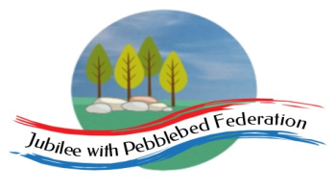 Home Learning Grid 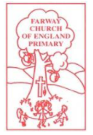
This is the home learning grid for the week beginning 22nd February 2021. Please use this as a grid to support planning your child’s home learning. Additional resources will be made available on ‘google classrooms’, to support your child to access these activities. A daily reading and counting task are important to support your child to access their education but remember to have fun!
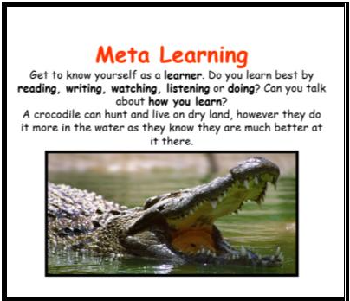
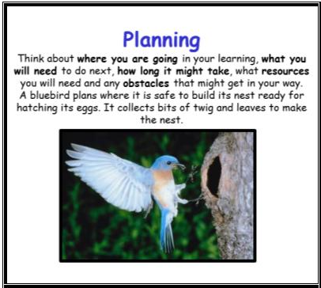
This week Class 1 will be focusing on the key Learning Behaviours: Meta Learning and Planning. We all learn best, in different ways. Why not spend some time getting to know yourselves, as learners and pay attention to how you learn best? Is it by reading, watching, listening, or getting activity and doing? Research shows that planning your week and creating a routine for your children, whilst they are learning from home, can have significantly positive effects on their mental wellbeing and sense of security. It allows children to know what is expected of them and creates a sense of security and control around their week. Have a look at the home learning grid and discuss with your child the different learning tasks they have been set and check if you need to collect any resources, they may need to complete some of the activities.
Please remember we are all still in school, so please do make contact if there is any way we can help you, or you just want to share how fabulous your children are!
Please remember, if you have internet issues during this lockdown period, you can still access Google Classrooms using your phones. You can also contact the school and we can try and support you with alternative learning options.
 | Farway C of E Primary School - Class 1 – week beginning 22nd February
 | Lesson 1 | Lesson 2 | Break time | Lesson 3 | Lesson 4
Monday  Please read for at least 10 minutes every day with an adult or a sibling.  You can use the Bug Club online books to access books in line with your child’s phonics ability. | Phonics - https://www.activelearnprimary.co.uk/login?e=-1&c=0#bugclub_phonics  Reception –  Recap Phase 3, unit 9, phoneme /ai/, written as ‘ai’.  Year 1  Phase 5, Unit 30, Prefix ‘re-  Year 2  SPAG – types of sentences check. | R.E  WALT: talk about signs of new life and discuss what we think these signs mean to Christians.  Children to look at a bunch daffodils. Ask, have you seen any of these flowers on your daily walks recently? Explore the shape and colour of the daffodils.  How do they make you feel?  What is the colour yellow symbolic for? (linking to colour emotions)  Take the children outside for a walk to the church / around playground. Tell the children to be looking out for signs of new life. Maybe give them a ‘spring scavenger hunt sheet’? Or just ask the children to keep their eyes open and have a good look around. Take some photos of the children’s findings.  When you get back to school, ask children to have a go at drawing / painting the signs of new life that they have found. Discuss why they make the children think of new life? What do they notice about the colours?  Show children the photo Theo took on a recent walk – ‘drops of hope’. How does the photo make you feel? Why do you think he took this photo? (P4C).  Children to send their photos into Mrs Jackson, with a handwritten sentence telling her why you think this reminds you of new life. | Make sure you take time to have a brain break today and stretch your bodies. Why not go for a walk around your garden or local area. Take in the signs of spring.  Alternatively, have a look through the mindfulness colouring sheets (found on google classroom) – make sure you take a break from the screen and enjoy being you! | Maths  Reception  WALT:  https://whiterosemaths.com/homelearning/early-years/building-9-10-week-1/  -Representing and sorting numbers to 10.  Year 1and year 2  WALT: recap our understanding of multiplication and division to solve word problems  Before half term, we explored multiplication and division. Today, we are going to recap these skills, applying our knowledge to word problems. | Holistic wellbeing – Physical and Mental health.  Physical Education – please spend time this afternoon completing your favourite mile, around your garden or local area. Keeping fit and active, particularly in the out-doors, is extremely important to help keep your mind and body healthy.  I have attached the weekly workout sheet to the bottom of this home learning grid. Please have a go at taking part in any that grab your interest.  Wellbeing – today we are focusing on ‘bravery’. Amongst the many key workers, children are true superheroes!! Many children have had a real change to their daily routine and schedules, they are separated from their friends and loved ones, and there is much talk of viruses surrounding them.  Today, celebrate being a hero and how brave you are all being!! You are our heroes!  Watch the video clip of Keala Settle (Greatest Showman) talking about how brave she needed to be to sing in her first rehearsal for, ‘This is me!’  https://www.youtube.com/watch?v=XLFEvHWD_NE  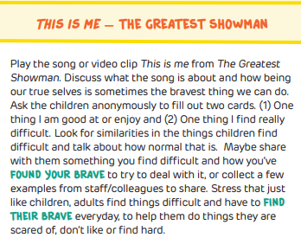
Tuesday  Please read for at least 10 minutes every day with an adult or a sibling. | Phonics  https://www.activelearnprimary.co.uk/login?e=-1&c=0#bugclub_phonics  Reception – Recap Phase 3, unit 9, phoneme /ee/, written as ‘ee’.  Year 1  Phase 5, Unit 30, Prefix ‘un-  Year 2  SPAG – types of sentences | Literacy  Hook – washing our favourite toys and writing instructions.  Today, we are starting our new literacy sequence, based on the story ‘How to Wash a Woolly Mammoth’, by Michelle Robinson and Kate Hindley.  We are going to start our sequence today, with you having a fun session ‘washing’ two of your favourite toys.  At school, we will be setting up stations for children to enjoy washing toys, using different fun soaps. This might be something you want to set up at home.  When you have finished and their toys are all ‘squeaky’ clean, sit down with a pencil and paper and have a go at writing your instructions for ‘How to Wash your Toy ….’.  Send your instructions to Mrs Jackson. This will help her to ensure planning for the sequence meets the needs of your child.  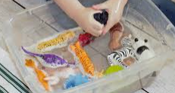 | Make sure you take time to have a brain break today and stretch your bodies. Why not go for a walk around your garden or local area. Take in the signs of spring.  Alternatively, have a look through the mindfulness colouring sheets (found on google classroom) – make sure you take a break from the screen and enjoy being you! | Maths  Reception  https://whiterosemaths.com/homelearning/early-years/building-9-10-week-1/ - Oredring numerals to 10 / Composition to 10.  Year 1  WALT: count to 50 by making 10  Please watch the online video lesson, then have a go at the activities provided on google classroom.  Year 2  WALT: make tally charts  Please watch the online video lesson, then have a go at the activities provided on google classroom. | Museum creation – Innovate.  Dr Michael Storia, has been so impressed by your fabulous learning into dinosaurs, that he would like your help to set up a new dinosaur museum!  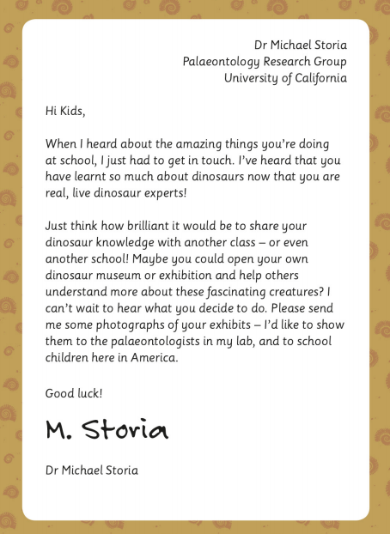  Have a think about what you would want to include in your own dinosaur museum.  So, it’s time to get going and create your museum. Think about your visitors – you’ll need to make sure you label your displays and artefacts clearly and organise them into sections. Your visitors will want lots of interesting dinosaur experiences, using different senses, including touching and holding some of the artefacts.  Don’t forget that all good museums have a gift shop and a café.  Using a large sheet of paper – brainstorm some ideas about what you would like to include in your museum and start sketching areas you feel would be most engaging!
Wednesday  Please read for at least 10 minutes every day with an adult or a sibling. | Phonics  https://www.activelearnprimary.co.uk/login?e=-1&c=0#bugclub_phonics  Reception – Phase 3, unit 9, phoneme /igh/, written ‘igh’.  Year 1  Phase 5, Unit 30 – Prefix, root, suffix  Year 2  SPAG – types of sentences check | Literacy  WALT: listen to the story, ‘How to wash a Woolly Mammoth.’  - Please watch the video link attached to Google classroom, whereby I read the story to you.  - Have a go at learning actions to help yourself learn the story.  - Have a go at drawing your own story map to support yourself, retelling the story (an example has been added to google classroom)  - Ring a friend/relative (or facetime them) and retell the story of ‘How to Wash a Woolly Mammoth’. | Make sure you take time to have a brain break today and stretch your bodies. Why not go for a walk around your garden or local area. Take in the signs of spring.  Alternatively, have a look through the mindfulness colouring sheets (found on google classroom) – make sure you take a break from the screen and enjoy being you! | Maths  Reception  https://whiterosemaths.com/homelearning/early-years/building-9-10-week-2/ - counting back from 10 (10 in a bed)  Year 1  WALT: count forwards and backwards within 50.  Please have a look through the PowerPoint on google classrooms, then attempt the activities provided.  Year 2  WALT: Make pictograms  Please watch the recorded video lesson, then have a go at the activities provided. | Topic – Dinosaur fact files  Create a palaeontologist's fact file about a chosen dinosaur. Write key facts under subheadings including dinosaur name, habitat, diet, appearance and young.  Include a detailed, labelled diagram or downloaded images. Reread and revise their facts, checking for spelling and grammatical errors.  https://www.bbc.co.uk/cbeebies/curations/dinosaur-facts
Thursday  Please read for at least 10 minutes every day with an adult or a sibling. | Phonics  https://www.activelearnprimary.co.uk/login?e=-1&c=0#bugclub_phonics  Reception – Phase 3, unit 9, phoneme /oa/, written as ‘oa’.  Year 1  Phase 5, Unit 30, language session  Year 2  SPAG – common exception words | Literacy  WALT: act out parts of the story to enhance our understanding.  Listen, again, to Mrs Jackson reading the story ‘How to Wash a Woolly Mammoth’.  Try acting out your actions, in time with Mrs Jackson reading, to support your understanding of the story.  Today, we are going to be trying some role-play. Together, with a family member (or on facetime), have a go acting out the role of the zoo-keeper. You are going to be instructing you friend/family member, how to wash a woolly mammoth. See if they can follow your instructions, to ensure you have a happy, clean woolly mammoth at your zoo!  Alternatively, you could ask an adult to film you delivering the instructions to Mrs Jackson and she can have a go at making sure your woolly mammoth is nice and clean, and ready for visitors. | Make sure you take time to have a brain break today and stretch your bodies. Why not go for a walk around your garden or local area. Take in the signs of spring.  Alternatively, have a look through the mindfulness colouring sheets (found on google classroom) – make sure you take a break from the screen and enjoy being you! | Maths  Reception  https://whiterosemaths.com/homelearning/early-years/building-9-10-week-2/ -comparing numbers within 10 (two sessions).  Year 1  WALT: make tens and ones (within 50)  Please have a look through the PowerPoint on google classrooms, then attempt the activities provided.  Year 2  WALT: interpret pictograms  Please have a look through the PowerPoint on google classrooms, then attempt the activities provided. | Art and Design –  - P. of Study Art and design 7 Use a range of materials creatively to design and make products.  - L. Intention Year 1 Manipulate malleable materials by squeezing, pinching, pulling, pressing, rolling, modelling, flattening, poking, squashing and smoothing. View progression  - Knowledge Year 1  Malleable materials include rigid and soft materials, such as clay, plasticine and salt dough.  Sculpt dinosaurs using a malleable material, ready to display in your museum.  View link below for inspiration:  https://www.shutterstock.com/search/plasticine+dinosaur
Friday  Please read for at least 10 minutes every day with an adult or a sibling. | Phonics  https://www.activelearnprimary.co.uk/login?e=-1&c=0#bugclub_phonics  Reception  Phase 3, unit 9, phoneme /oo/, written as ‘oo’ (long).  Year 1  SPAG – common exception words  Year 2  SPAG – common exception words | Literacy  WALT: say out loud what we are going to write about before writing it.  If you need to remind yourself of the class story, ‘How to Wash a Woolly Mammoth’, listen to the video of Mrs Jackson reading the story, or practise saying aloud the story using the story map you created.  Now, have a look more closely at the text (using the PowerPoint slides). In some areas, the text is rather sparse or non-existence. What could it be? Why do you think that?  Choose your favourite page from the story (where there is no or sparse text) then have a go at creating your own text for the page. Practise saying aloud your sentence to a family member, before writing it.  Remember to include capital letters, finger spaces, expanded noun phases and correct punctuation! | Make sure you take time to have a brain break today and stretch your bodies. Why not go for a walk around your garden or local area. Take in the signs of spring.  Alternatively, have a look through the mindfulness colouring sheets (found on google classroom) – make sure you take a break from the screen and enjoy being you! | Maths  Reception  https://whiterosemaths.com/homelearning/early-years/building-9-10-week-2/ - making 10 (two sessions).  Year 1  WALT: represent numbers to 50 in different ways.  Please have a look through the PowerPoint on google classrooms, then attempt the activities provided.  Year 2  WALT: draw pictograms (2,5, & 10)  Please have a look through the PowerPoint on google classrooms, then attempt the activities provided. | Computers – Make your animated ‘Claymation’ video  Using your plasticine/clay dinosaurs from yesterday, have a go at creating your own Claymation video.  https://www.kapwing.com/resources/create-your-own-claymation-video-at-home/  If you do not have access to a computer or smart phone, why not make a flip book about a dinosaur.  https://www.masterclass.com/articles/how-to-create-your-own-flipbook-animation#what-is-a-flipbook  Please send any videos or flip books to Mrs Jackson! I would love to see them.

