Music Home Learning – week beginning 11th May
Since 1945, the end of World War Two in Europe has been marked by Victory in Europe Day, better known as VE Day. On 8th May 1945, Prime Minister Winston Churchill made an announcement on the radio, at 3pm, that the war in Europe had come to an end, following Germany's surrender the day before. This year, the 8th May 2020 marked 75 years since the first VE Day!
Until the current Covid-19 crisis struck, there had been plans to stage celebratory events and street parties in many places. Children would have had the day off school and many parents would have been off work to enjoy these celebrations together! However, although street parties were cancelled many people chose to celebrate virtually, holding video parties, decorating their homes, dancing and listening to music, to celebrate whilst we are all in lockdown!
Can you draw a picture and write a couple of sentences, in the box below, to show how you and your family celebrated VE Day on Friday 8th May.

When you were celebrating VE Day on Friday, did you listen to any music?
If so, what was it?
Have a think… who is your favourite pop star?
Can you name one of their songs that is most memorable to you?
Why was this song so memorable to you?

Note: memorable means – easily remembering something because it is special.

In 1943, during the Second World War, a British song became extremely memorable, when first sung by singer and actress, Vera Lynn, in a musical called: ‘We’ll Meet Again.’’
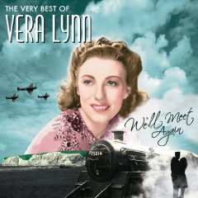
The song spoke out to the British nation through their feelings of separation from their loved ones, during the War, and their feelings of hope that they would meet with their loved ones again.

Using the address below, listen to this memorable song. Then answer the question:
‘Why do you think this song might be important now?’

https://www.youtube.com/watch?v=SKSc8BLXAJ8
The lyrics are printed on the next page, should you wish to sing along!
We’ll Meet Again, Vera Lynn
