’10 a day’ for Positive Mental Health 7
While we are working from home it is important that you continue to support your mental health. One way of doing this is to continue to use the ’10 a day’.
Below are some activities to try at home this week. Each one is linked to one of our ’10 a day’. Each week some new activities are put on so you can look at numbers 1-6 for more ideas.
10 a day | Activity
The following link gives information about how to deal with emotions directly linked with the Coronavirus from Exeter Diocese.
https://exeter.anglican.org/wp-content/uploads/2020/03/Covid-19-Primary-School-Parent-Pack.pdf

https://www.childline.org.uk/toolbox/
Use these games to think and talk about how you are feeling.
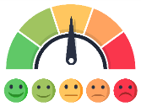
Make your own feeling barometer to show how you are feeling.
‘Big Feelings Come and Go’, a story to help young children deal with their big feelings.
https://protectchildren.ca/pdfs/C3P_BigFeelingsComeAndGo_storybook_en.pdf
Follow this link to find a video, story book and activities to explain the coronavirus and how it might make is feel/
https://ineqe.com/2020/03/20/animation-story-book-explains-the-coronavirus-to-children/?utm_source=hs_email&utm_medium=email&utm_content=85108668&_hsenc=p2ANqtz-8xB6KX5WatNiHKfuFpxVhU0ZWt5Anu39FZOxNm3LWzc9GzcI2mvBpKf2ri_dArnGSBKlRoqdqjd5n6Bri6inOly5td6w&_hsmi=85108668

Print out a photo of yourself or draw a picture. Then cut and stick pictures from magazines or draw pictures of things you love doing all around you. Stick it up in your bedroom to remind yourself of all the things you love to do. Choose something from there when you are feeling bored or fed up. It will give you a boost!

Enjoy colouring together with these relaxing patterns.
https://familyresource.eci.org.uk/download/Colouring-Book-for-Boys-Girls.pdf
Take the quiz to find out why it is important to stay hydrated.
https://www.n4hk.com.au/game/jimmysthirsty/

Infuse your water with flavour by adding fruits like berries, cucumber, lemon or lime. You could also freeze ice cube trays with berries and add this to your water to keep it extra cold.
Help prepare lunch or dinner for the family.
Maybe try some of the recipes from this websites.
https://www.nhs.uk/change4life/recipes

Challenge yourself to eat a rainbow. Think about the food you are eating, can you eat all the colours of the rainbow in one day?

Exeter diocese has set up a Family Fun Cooking Club. Look at their recipes on the following link.
https://exeter.anglican.org/resources/faith-action/family-fun-cooking-club/

Can you make a fruit kebab?
Ask a grown up to chop up lots of different fruit and put it on a kebab stick. Which fruit will you choose? How many colours are in your kebab? Can you make a pattern with the fruit?
The Skipping Challenge
Can you skip 100 times? Sounds easy but can you do it quickly? If you are struggling divide it into sections or skip with family members to make it slower.
https://youtu.be/3ttPXJdIm_8

A weeks physical activities linked to pirates.
https://www.onerunningmovement.com/wp-content/uploads/2020/05/Foundation-and-Key-Stage-1-activity-Cards-Pirates.pdf

Try some 60 second challenges
https://www.youthsporttrust.org/60-second-physical-activity-challenges

Try some Zumba
https://www.youtube.com/watch?v=doSmJ9AOA1E

Lots of indoor activities and games to get you moving.
https://www.nhs.uk/change4life/activities/indoor-activities

This video will support breathing.
https://www.youtube.com/watch?v=-pye091kE9k&feature=youtu.be

Practise this ‘Lazy 8’ breathing technique by drawing an 8 lying on its side.
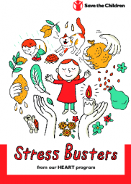
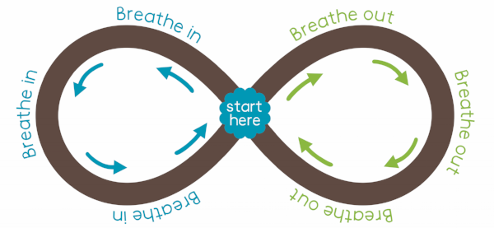
Start in the middle and go to the left breathing in, trace it around as you breathe in then go around the right breathing out. Repeat as many times as you can making sure you breathe fully in and out.
There are some lovely breathing techniques in this Save the Children booklet.
https://resourcecentre.savethechildren.net/library/stress-busters

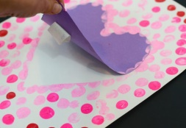
Cut out a heart and loosely attach it to some paper, then fingerprint all over the paper, peeling off the heart afterwards. Can you write a message in the heart to somebody you love and care about? What do you love about them?
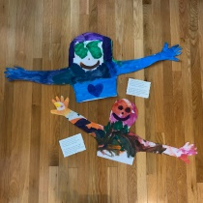
Ask your parents if you can call a relative. Chat to them about how they are and what they have been doing. They will love the fact that you are taking time out of your day to reach out to them and it will remind you that you are loved by lots of people too.
Send a relative or friend a HUG in the post. Lie down and ask a grownup to draw around your head/arms/shoulders on a large sheet of paper. Paint/draw/colour it and then cut it out. Send your hug in the post for a relative or friend.
If you are stuck on your home learning or with you feelings ask someone for help. If you can’t put it into words write it down or draw pictures.
- Remember, it's okay to ask for help. Don't be embarrassed, and don't worry about other people judging you.
- Decide what the problem is and what help you need.
- Think about who you can ask for help. Choose someone you trust and who will know how to help you.
- Think about what you'll say when you ask for help. Do it.
The mental health organisation ‘Heads Up’ have thought of some brilliant activities to help you cope with big feelings.
Have a look at the ‘Cope Cakes’ activity.
https://headsupmha.com/resources/
Ask a grown up to print out a photo of you or draw yourself. Can you ask everybody in your family to write words around the picture that describe you. put it up on your bedroom wall to remind yourself how special you are.
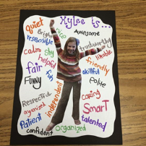
What are your star qualities? What makes you you? You can either draw around your hand and cut it out, writing your special qualities on each finger OR you could print or draw a star and write your star qualities on each point of the star.
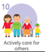 | Help in the house by doing the washing up, setting the table, tidying your room.  It’s Mental Health Awareness Week and mental health charities across the country are providing lots of materials to support this. The theme for this special week is ‘Kindness’ and the focus is on being kind to others and being kind to yourself. Have a watch of this video by the Mental Health Foundation and talk to your grown up about why being kind to others can also help our own mental health.  https://www.mentalhealth.org.uk/campaigns/mental-health-awareness-week

