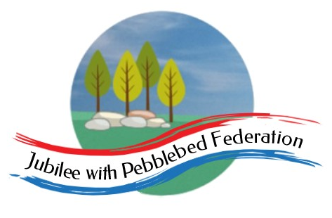
 | Farway C of E Primary School - Class 1 – week beginning 4th January
 | Lesson 1 | Lesson 2 | Break time | Lesson 3 | Lesson 4
Monday  Please read for at least 10 minutes every day with an adult or a sibling. | Phonics – this week we will be recapping the sounds we have learnt from the last weeks of the autumn term  https://www.activelearnprimary.co.uk/planning#bugclub_phonics  Reception – Phase 3, unit 6, phoneme ‘j’, written as ‘j’.  Year 1 and Year 2 – recapping those sounds identified in the end of autumn term assessment Phase 5, Unit 24, phoneme ‘s’, written as ‘c(e), c(i), c(y)’ | Religious Education  What is Christianity? - BBC Bitesize | Have a mind break (20 mins) - get a drink and run around the garden or do something you enjoy.  For ideas visit:  https://www.cosmickids.com/mindfulness-meditation-videos-kids/ | Maths  Reception –  https://classroom.thenational.academy/units/numbers-within-20-edc2 session 1  Year 1  https://classroom.thenational.academy/units/numbers-to-50-fe7e  Year 2  https://classroom.thenational.academy/units/numbers-50-to-100-and-beyond-d3e8 | Science  https://classroom.thenational.academy/units/habitats-c850
Tuesday  Please read for at least 10 minutes every day with an adult or a sibling. | Phonics  https://www.activelearnprimary.co.uk/planning#bugclub_phonics  Reception – Phase 3, unit 6, phoneme ‘v’, written as ‘v’.  Year 1 and Year 2 – Phase 5, Unit 24, phoneme ‘s’, written as ‘sc’, st(l)’ | Literacy  Reception, year 1 and 2  Give chn time to find out about dinosaurs.  https://www.bbc.co.uk/iplayer/cbeebies/episode/b03zmlyp/andys-dinosaur-adventures-19-trex-and-roar  Write about one or more of the dinosaurs in the programme | Have a mind break (20 mins) - get a drink and run around the garden or do something you enjoy.  For ideas visit:  https://www.cosmickids.com/mindfulness-meditation-videos-kids/ | Maths  Reception –  https://classroom.thenational.academy/units/numbers-within-20-edc2  Year 1  https://classroom.thenational.academy/units/numbers-to-50-fe7e  Year 2  https://classroom.thenational.academy/units/numbers-50-to-100-and-beyond-d3e8 | PSHE  https://classroom.thenational.academy/units/forever-friends-45e8
Wednesday  Please read for at least 10 minutes every day with an adult or a sibling. | Phonics  https://www.activelearnprimary.co.uk/planning#bugclub_phonics  Reception – Phase 3, unit 6, phoneme ‘w’, written as ‘w’.  Year 1 and Year 2 – Phase 5, Unit 24, phoneme ‘s’ and ‘z’, written as ‘se’. | Literacy  Reception, Year 1 and 2  Watch this clip of the book: Dino Dinners being read to you  https://www.youtube.com/watch?v=B6vAeBT2ox8  Can you list the names of the dinosaurs you heard being read in the story?  Choose one of the dinosaurs from your list and find out as many facts as you can.  Remember: use bullet points to write down each individual fact. | Have a mind break (20 mins) - get a drink and run around the garden or do something you enjoy.  For ideas visit: https://www.cosmickids.com/mindfulness-meditation-videos-kids/ | Maths  Reception –  https://classroom.thenational.academy/units/numbers-within-20-edc2  Year 1  https://classroom.thenational.academy/units/numbers-to-50-fe7e  Year 2  https://classroom.thenational.academy/units/numbers-50-to-100-and-beyond-d3e8 | Computing  Play on scratch.mit.edu!
Thursday  Please read for at least 10 minutes every day with an adult or a sibling. | Phonics  https://www.activelearnprimary.co.uk/planning#bugclub_phonics  Reception – Phase 3, unit 6, phoneme ‘x’, written as ‘x’.  Year 1 and Year 2 – Phase 5, Unit 24, language session | Literacy  Reception, Year 1 and 2  As a whole class, learn and remember one of the pages using a map and actions.  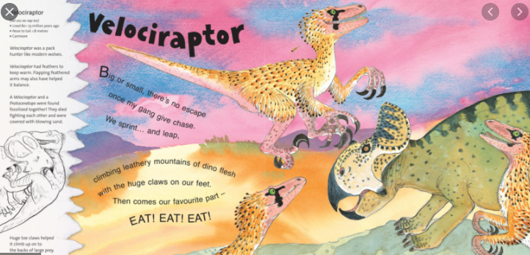  Learn both voices on the page and retell using different voices.  What is different about the two voices? | Have a mind break (20 mins) - get a drink and run around the garden or do something you enjoy.  https://www.cosmickids.com/mindfulness-meditation-videos-kids/ | Maths  Reception –  https://classroom.thenational.academy/units/numbers-within-20-edc2  Year 1  https://classroom.thenational.academy/units/numbers-to-50-fe7e  Year 2 https://classroom.thenational.academy/units/numbers-50-to-100-and-beyond-d3e8 | P.E  School Radio - Dance: Key Stage 1 - Time to Move, Dinosaurs, 1. Mary Anning (bbc.co.uk)
Friday  Please read for at least 10 minutes every day with an adult or a sibling. | Phonics  https://www.activelearnprimary.co.uk/planning#bugclub_phonics  Reception  Phase 3, unit 6 – assessment games.  Year 1 and Year 2 – Phase 5, Unit 25, phoneme ‘j’, written as ‘g(e), g(i), g(y)’. | Literacy  Reception, Year 1 & Year 2  Watch this clip of the book: Dino Dinners being read to you again:  https://www.youtube.com/watch?v=B6vAeBT2ox8  This time create a list of likes and dislikes chart, about the book.  What do you like about the book? Why?  What do you dislike about the book? Why?  Finally, design a dinosaur which contains the same characterstics as you do. For example: what do you like to eat? What coloured hair do you have? What do you like doing? Make it look and behave like you do. For example: Mrs Jacksonasaurus. | Have a mind break (20 mins) - get a drink and run around the garden or do something you enjoy.  https://www.cosmickids.com/mindfulness-meditation-videos-kids/ | Maths  Reception –  https://classroom.thenational.academy/units/numbers-within-20-edc2  Year 1  https://classroom.thenational.academy/units/numbers-to-50-fe7e  Year 2  https://classroom.thenational.academy/units/numbers-50-to-100-and-beyond-d3e8 | History  https://classroom.thenational.academy/assemblies/dinosaurs

