Year 5 Maths Home Learning – Week beginning 18th May 2020
Monday: Revising Shapes and Angles
Remember, in a regular shape all the sides are the same length and all the angles are the same size.
First, watch the video at https://www.youtube.com/watch?v=EcXDAjDgSSo to ensure you understand what tessellation involves.
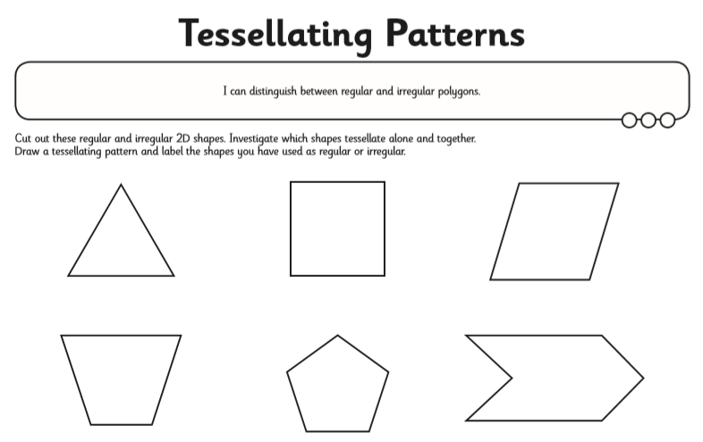
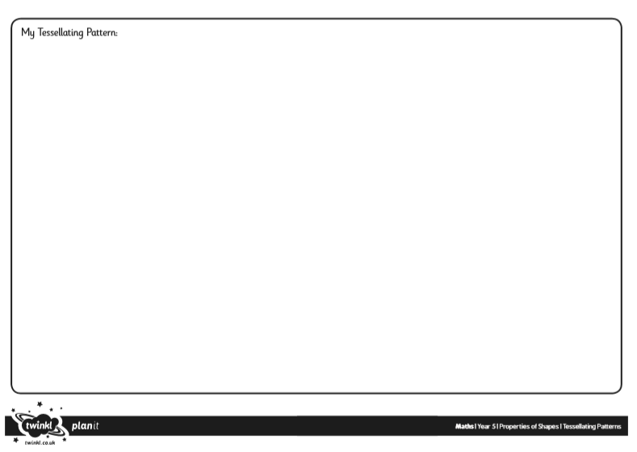
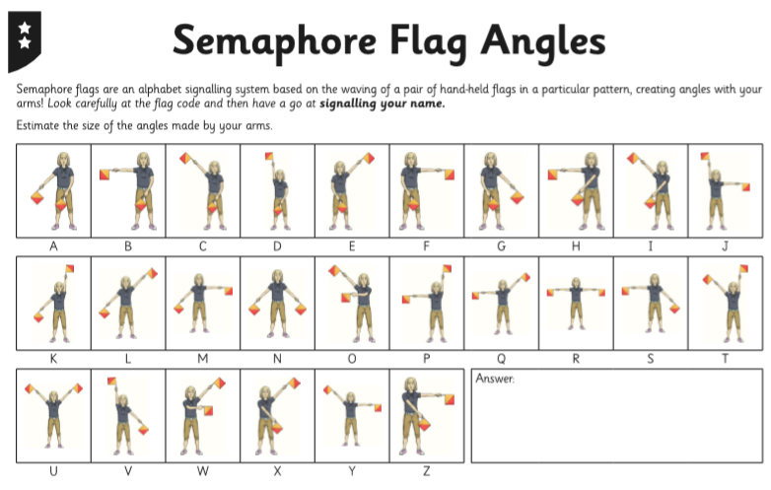
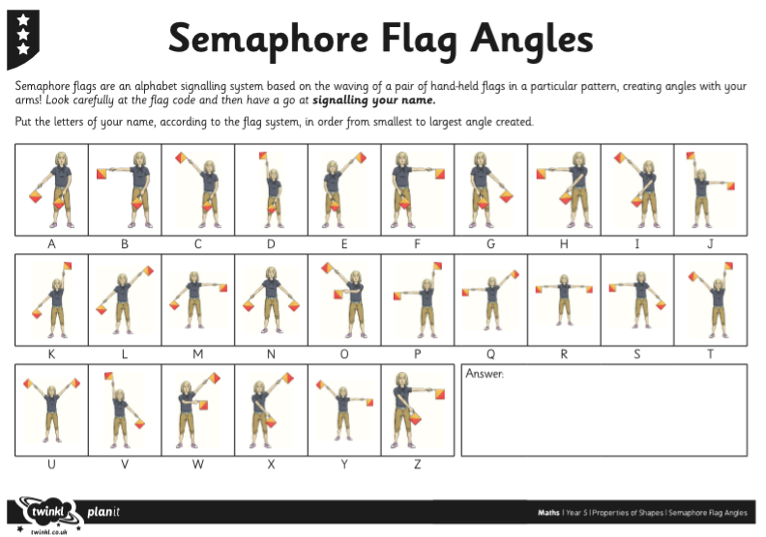

Tuesday: Calculate missing angles on a straight line.
Watch the video at https://www.youtube.com/watch?v=cBIJmmz8flI to help you understand what to do, then answer the questions below:
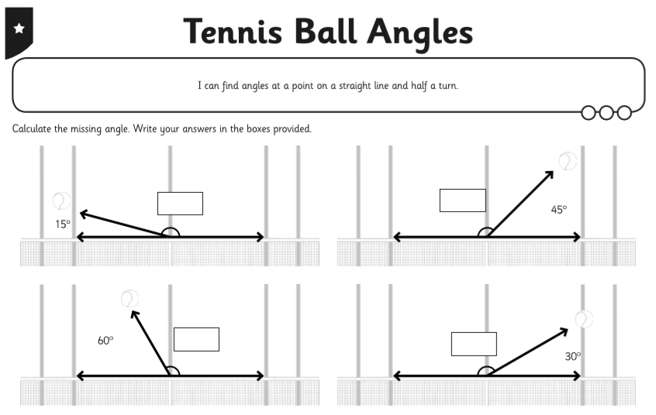
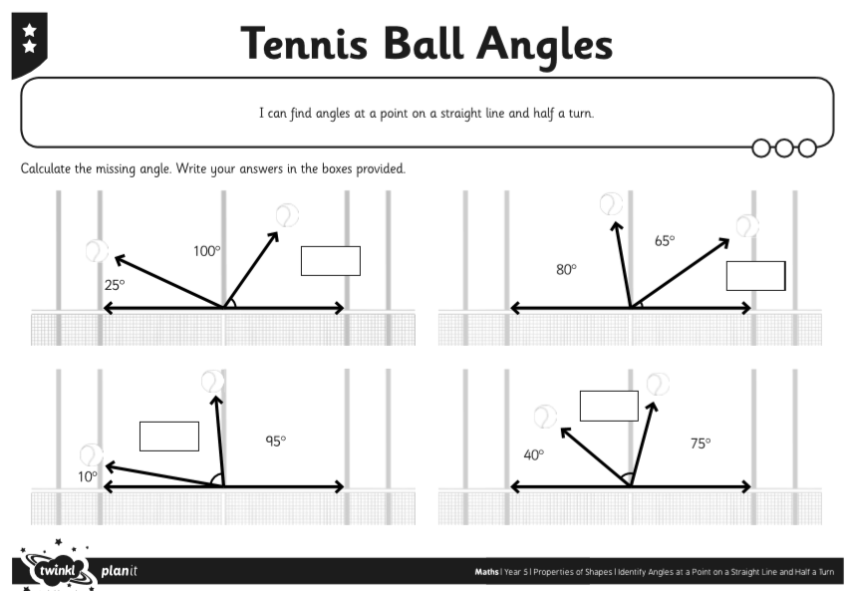

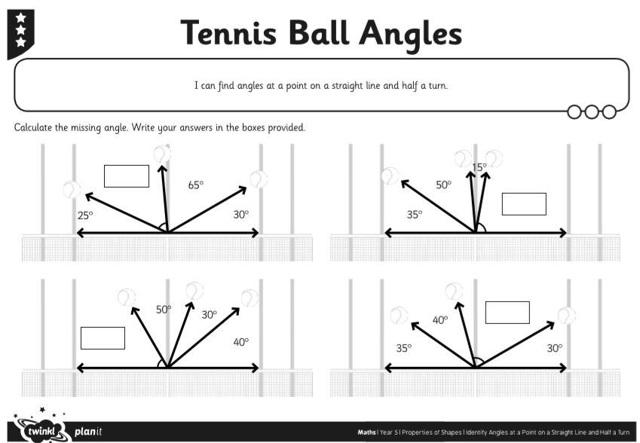

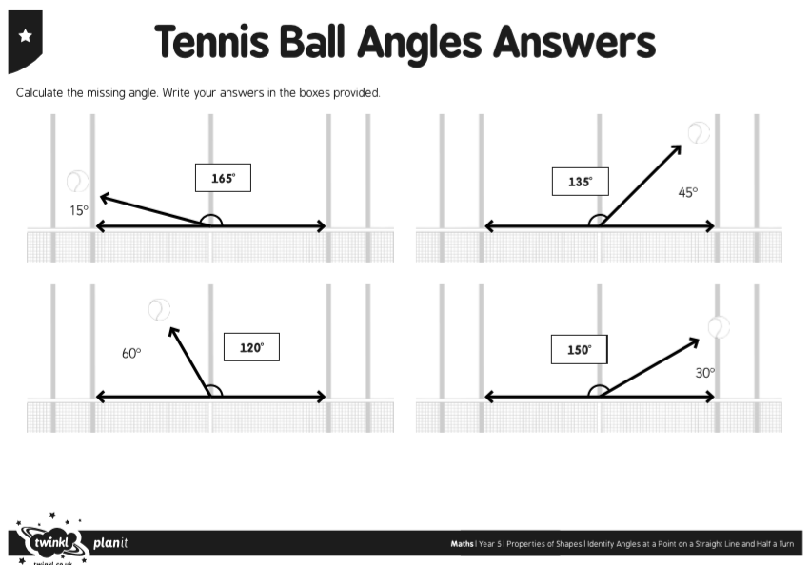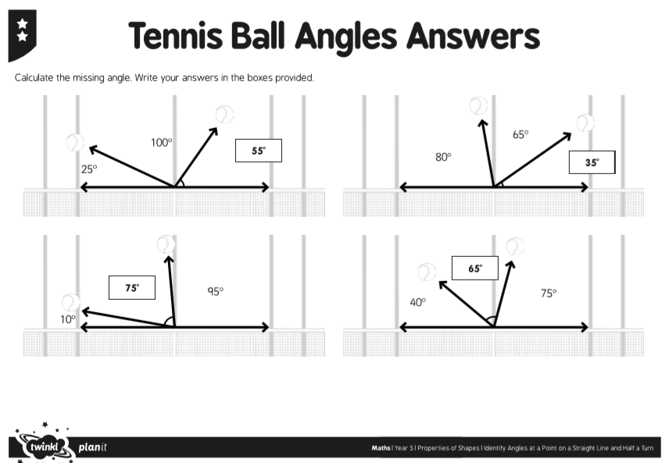
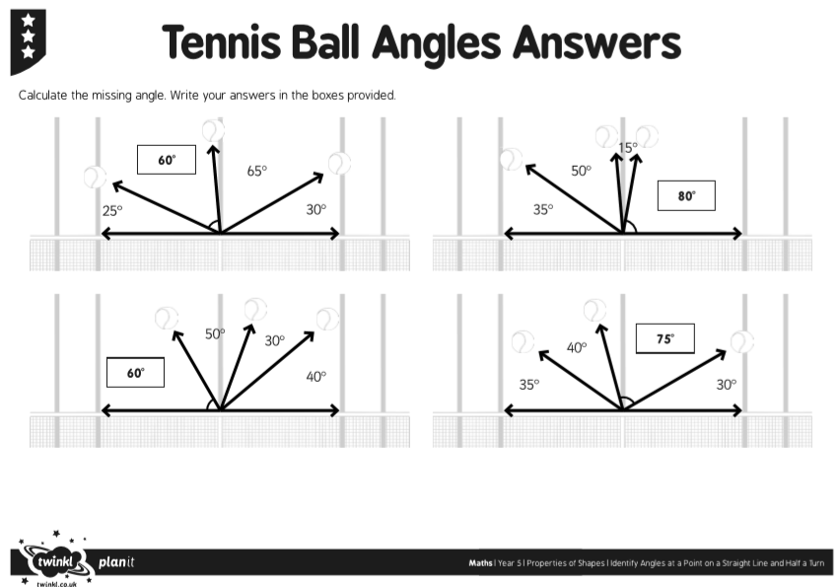

Wednesday: Calculate missing angles around a point.
First watch the video at https://www.youtube.com/watch?v=Yt2yvO-xkhY to help you understand the key teaching points.
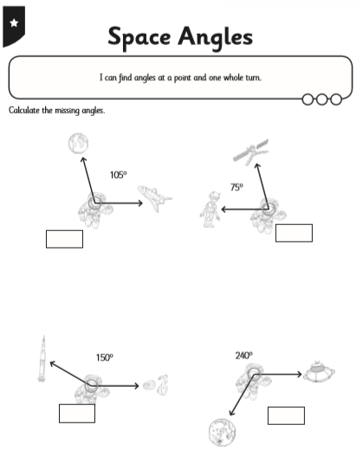
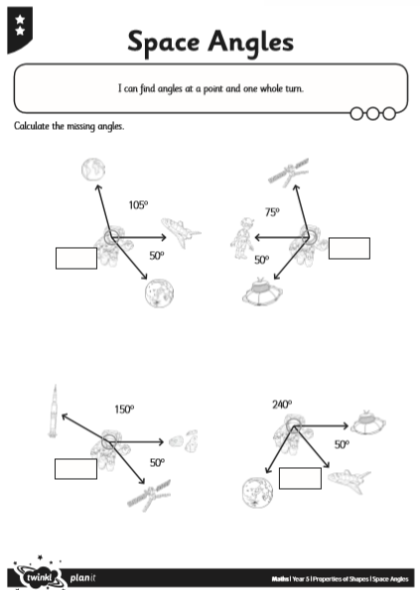

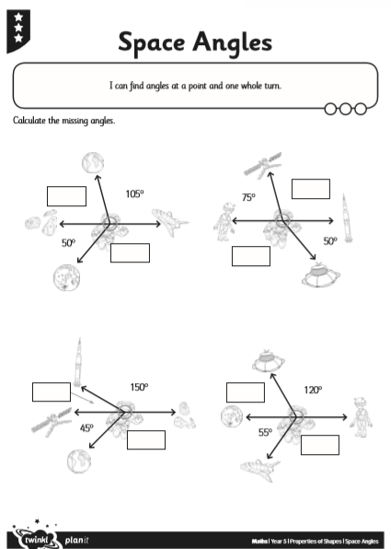

Thursday: Calculating angles around a point or on a straight line.
Remember, a right angle measures 90°. Two right angles (180°) make a straight line. Four right angles (360°) will bring you back to same point, so the angles all around a point add up to 360°.
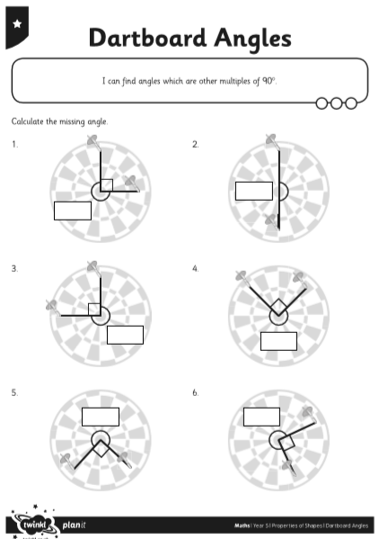

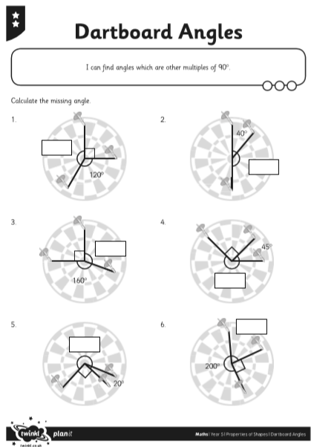
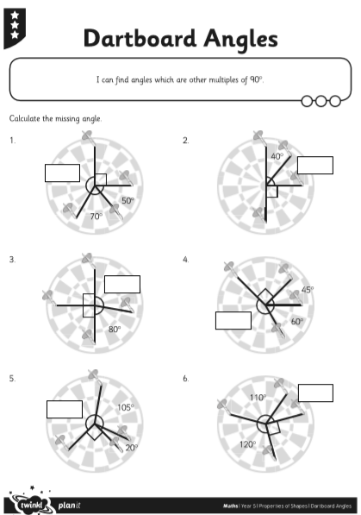
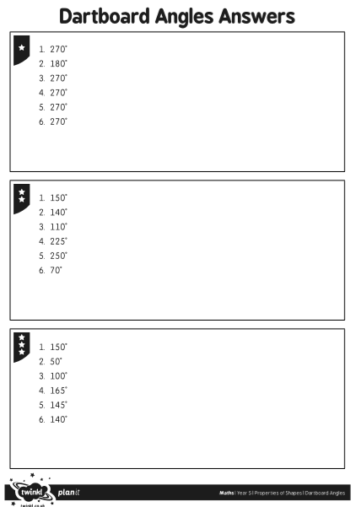
Friday: Use known properties of quadrilaterals to find missing lengths and angles.
First watch the video at https://www.youtube.com/watch?v=6ApegKO75d0 to ensure you understand the key teaching points.
