Learning
from Home

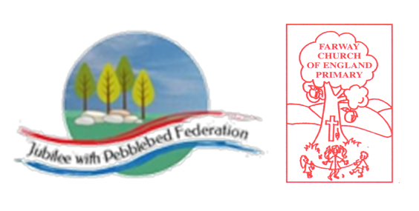
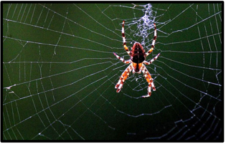 |  | Learning Behaviours  The first learning behaviour this week is Making Links. As we look back over the term, we will weave the web of our understanding, just as a spider weaves their web. We’ll be thinking about what we have learnt about historical characters and how they made a difference in their time. Y4 and Y5 will be thinking about how fractions, decimals and percentages are linked. Everyone will look at their art using mouldable materials and make links with how the product has improved over the term.  The second is Distilling, represented by the magpie who selects the shiniest things for its nest. We will magpie for the most relevant knowledge from this term and present our final piece of writing. |  |  |  |  | 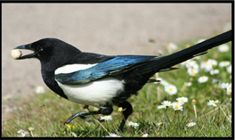
Class 2  Wk beg: 29th March 2021 | Spelling (15 mins) |  | Reading (30 mins) | Writing (1 hour) | Maths (45 mins) | Afternoon Project  When finished each day
Collective Worship | While at home, take 15 minutes to visit spelling shed.  https://www.edshed.com/en-gb/login  If you can’t get online, you should practice recent spellings.  There are lots of ways to do this – what’s your go-to?  My favourite is rainbow letters, where I write the tricky bit in a different colour. |  | https://www.activelearnprimary.co.uk/login?c=0 | WALT: contribute to plan for shared writing  Together we will plan a story to write together called Charlie and the pollution monster.  We will plan where to use ‘power of three’ phrases and multi-clause sentences.  We will think about where we will use short paragraphs to build tension or to contrast with multi-clause description.  We will decide on key phrases to use when we are describing our hero and our monster.  At home you can plan your own story using the blueprint ‘overcoming the monster’. | Warm up: play an addition and subtraction game at  https://www.topmarks.co.uk/maths-games/7-11-years/addition-and-subtraction  WALT: recognise and use hundredths in different ways  Y4 - hundredths  https://vimeo.com/519976198  WALT: record thousandths in different ways  Y5 - understanding thousandths  https://vimeo.com/519979817  WALT: form expressions in algebra  Y6 - forming expressions in algebra  https://vimeo.com/499980673 | PE  This week we have our fifth PE lesson of six provided by Callum Shipton from Exeter Football Club. The lesson is designed to be completed at home.  You’ll find the video attached in Google Classroom if our bubble is closed.  Music  More focus on birds today in our music session with BBC Radio. The song we will learn today is a celebration of Scandinavian birds. Birds also feature in the story: Loki flies to Jotunheim as a falcon to rescue Iduna; then he transforms her into a sparrow for the journey back...but Thiassi is after them!  Today’s extract is a famous melody from the Symphony No 5 by Jean Sibelius, composed in 1915. The melody is said to have been inspired by the calls of swans (YouTube video) after Sibelius watched a large number of the birds taking off one day.  - What can you say about the rhythm and tempo (speed) of the music?  - Which part of the music may have been inspired by the swans’ call?  - What aspects of the music might be said to create the image of swans in flight?  https://www.bbc.co.uk/teach/school-radio/music-ks2-viking-saga-songs-7-birds-of-the-north/zmb3y9q
Tuesday | https://www.edshed.com/en-gb/login  Practise the spellings set for you in ‘Assignments’. Then practise the statutory words for your age group. |  | https://www.activelearnprimary.co.uk/login?c=0 | WALT: write first two paragraphs of shared story  Today we will build the first part of our story together, ready to complete it through the rest of the week.  At home you can start your story by introducing your hero and monster (don’t forget that powerful description) and make your hero declare his vow to kill the monster! | Warm up with  Contact school if you need a reminder of your login details!  WALT: recording hundredths as a decimal  Y4 - hundredths as decimals  https://vimeo.com/520024278  WALT: recording thousandths as a decimal  Y5 - thousandths as decimals  https://vimeo.com/520007456  WALT: use rules to solve problems in algebra  Y6 - algebra - substitution  https://vimeo.com/500489180 | Science  WALT: compare life cycles across the animal kingdom  In today’s lesson we will revisit the life cycles we have learnt about over the last few week and you will be designing a fact file or a poster for one animal in the animal kingdom.  You will need to include the following key information in your fact file or poster.  - An illustration of the lifecycle of your chosen animal. The illustration must be labelled with the key stages in the animals’ life cycle.  - A short description about each stage in the animal’s life cycle.  - Any additional interesting facts and any additional and relevant illustrations or drawings, for example, the anatomy of a chicken egg.  For mammals you could research dolphins, polar bears or kangaroos. You could research echidna birds like a penguin. You could research kiwi amphibians like a salamander or you could research caecilian insects like a mosquito or a dung beetle.  https://classroom.thenational.academy/lessons/how-do-lifecycles-compare-across-the-animal-kingdom-6wv32r  PSHE – managing our emotions  It is important at this time that we keep building our emotional intelligence and mental resilience. We have talked about jealousy and anger and how to recognise and manage these emotions. This week we will focus on worry and remind ourselves of the techniques we can use when we are worried or overwhelmed.  This is the link to One Decision, which we will be using in class.  https://schools.1decision.co.uk/info/videos/fae-scorm-worry/index.html  We will complete ‘My envelope of worries’ and make ‘worry dolls’ to hold our anxieties.
Wednesday | https://www.edshed.com/en-gb/login  Can you write the spellings for this week and their definitions? If you are not sure, do your spelling shed task in easy and it will give you the definition and the word class too! |  | https://www.activelearnprimary.co.uk/login?c=0 | WALT: continue Charlie story from plan independently  Today everyone will continue the story we have started and write about the first fight, then the heroes journey to the final fight.  Can you use a wide range of verbs to describe how your hero moves? Which verbs will you use to describe the monster’s movements? Will you remember to build tension through your use of short paragraphs and simple sentences? | Warm up: play an addition and subtraction game at https://www.topmarks.co.uk/maths-games/7-11-years/addition-and-subtraction  Y5/6 will work with Mrs Marsh, looking at the PUMA test from last week.  Problem solving opportunities will be provided for children when they are not directly working with Mrs Marsh.  These will be an opportunity for children to use their skills from this term. | History – Final Presentation  This afternoon we will share our crafts and creations from the term. We will talk about the techniques we’ve used and then teach each other how to do it.  We will do our final presentations of topic slideshows.  If you are not with us – what was your favourite moment in our journey from the invasions of the 4th century to the settled newcomers bringing their crafts and knowledge to villages in Devon through the 8th century?  PSHE: managing worries  Today we will complete our worry dolls.
Thursday | https://www.edshed.com/en-gb/login  Practise the spellings set for you in ‘Assignments’. Then practise the statutory words for your age group.  Remember to challenge yourself by moving from easy to hard and maybe all the way to extreme! |  | https://www.activelearnprimary.co.uk/login?c=0 | WALT: complete Charlie story and edit to improve  Once you story is complete it is ready to edit. First, read it through start to finish OUT LOUD. This is important because you will spot any missing phrases or details (quickly add them in).  Have you marked your clauses with commas? This is especially important if you’ve used some multi-clause sentences for description. (Do I need to mention full stops?!)  Finally, look at the words you’ve used. Have you included some of the vocabulary you collected over the last few weeks? If not, add them in. | Warm up with  Contact school if you need a reminder of your login details!  Y4 will work with Mrs Marsh, looking at the PUMA test from last week.  Problem solving opportunities will be provided for children when they are not directly working with Mrs Marsh.  These will be an opportunity for children to use their skills from this term. | Science  We will spend this afternoon preparing our grounds for growing next term. This will include digging, weeding, tidying, composting and designing areas for growth.  Have you grown anything at home? An interesting experiment is to try planting scraps and ends of the vegetables you use. A man in Devon grew a pineapple from the top of a supermarket pineapple!

