Class 2, Farway C of E Primary School

Dear Parents and Members of Class 2,

This week in our virtual travels around the world, we are heading to Japan, known around the world for its Springtime cherry blossom festivals. Known as hanami in Japanese, cherry blossom festivals are an important custom and are held all over Japan during the spring. I hope you will enjoy learning more about the culture and traditions of this fascinating country, while also appreciating the blossoming of spring flowers in your own environment.

I just wanted to remind all of you that the activities I have suggested are intended to be a bank of resources for you to select the most appropriate ones for your context. You may have other suggestions also. There is no way I would expect anyone to complete all the activities. I hope to provide a reasonable mixture of activities that can be accessed online and those that involve more traditional or practical learning media. All of you will have different access to computers, tablets, printers and other resources. Do get in touch with me via the school admin email address if you need further support to access the activities and resources suggested.

Happy learning!

Mrs Marsh

The most important thing you can do to support your child’s learning whilst schools are closed is to ensure that they read every day and they continue to practise their number bonds and times tables.

Don’t forget to keep using the accounts you have through our school to practise basic skills, such as reading, reading comprehension (Bug Club), Times tables (Times Table Rock Stars) and Spelling (Spelling Shed).

I have set work on TTRS each week and I shall be checking these sites regularly to keep an eye on what you’re doing. Please visit studio and soundcheck to update me on your tables speed and accuracy. Feel free to challenge me (Irox Peel) or Miss Moss (Dot McRock) to a Rockslam competition! My score at the moment is 22 correct so 2.73 seconds per answer – can you beat me? I’ll warn you Miss Moss is an astounding 1.5 seconds per answer!

Week beginning Monday 20th April

Monday | Core activities | Suggestions for additional activities.
9.00 – 9.30 | Daily Dashboard:  Quel est la date aujourd’hui?  C’est lundi le vingt avril 2020.  Can you write the number date in Roman numerals?  What is happening in the world? Have a look at https://www.bbc.co.uk/newsround or https://www.dogonews.com/ to see what is going on in the world. Choose a news article or two to read. | Today is the UN Chinese Language day. How about trying to learn a few words in Chinese?  Have a look at https://www.youtube.com/watch?v=0fm11XFw8uY to learn a few words in Chinese… Hello, My name is…, Goodbye  Or https://www.youtube.com/watch?v=lpWYSLa3qME
9.30-10.00 | Spelling - see Spelling Resources
10.00- 10.30 | Time for some physical activity. What about trying one or two of the short workout videos on https://imoves.com/the-imovement which explain the benefits of different movements for your health. While on the site, you might want to check out some of the ideas for taking care of your mental health, as well as your physical health.
10.30-11.30 | Maths – Use the following website to watch tutorial videos, print off activities and then use the marking guidance to see how you got on. https://whiterosemaths.com/homelearning/  Today, we are flying from Thailand to Japan, a flight that takes 6 hours and 14 minutes. How many minutes is that in total? If episodes of my favourite comedy show are 25 minutes long, how many episodes would it be possible to watch during the flight?  Japan’s time is two hours ahead of Thailand’s time, which, as we saw last week, is 6 hours ahead of the UK. What is the current time in Thailand and Japan? If you catch a flight from Bangkok (the capital of Thailand) to Tokyo (the capital or Japan) that leaves Bangkok when it is 11.00 am in the UK, what will the local time be when you leave Bangkok and when you arrive in Japan? | Why not try a BBC Supermovers Maths video to help warm up your Maths brain while getting in a bit of movement?  https://www.bbc.co.uk/teach/supermovers/ks2-maths-collection/z7frpg8  Or play an online Maths game at https://www.primarygames.com/math.php This is an American site but has a whole host of games that are useful for practising and improving your core Maths skills.
11.30-12.00 | Have a break and play a game or do another activity that you enjoy. | Be proud of your very being!  Can you think of 5 things you have already done today to ‘fill someone else’s bucket?’ Why not plan 5 more that you could do by the end of today? It could be as simple as a smile, a phone call or an encouraging message and picture.
12.00- 1.00pm | Lunch break. Eat a healthy lunch and try to get outside for some fresh air!
1.00pm – 1.30pm | Go to https://www.tripsavvy.com/japan-cherry-blossom-festivals-1550069 and read about Japan’s cherry blossom festivals. Can you summarise this by writing down 5 key facts about hanami? | Don’t forget to read a bit more of your latest book on Bug Club and answer the questions. What have you most enjoyed reading lately? Write a brief recommendation of it for a friend, explaining why you enjoyed it.
1.30pm – 3.00pm | Theme  Go to https://www.3dgeography.co.uk/japan-worksheets where you can download and print a ‘Directions’ worksheet to help you revise the points of a compass and directions using a map of places in Japan. Use an atlas (online or from a book if you have one) to find out more about the features of Japan and label them on the map below. Can you trace the outline of Japan? Can you find this country on a map of the world? What are its neighbouring countries, seas and oceans? | Try completing some of the other worksheets from this useful website https://www.3dgeography.co.uk/japan-worksheets to research and find out more about the country of Japan.  Watch a 5-minute introductory video about Japan at https://video.nationalgeographic.com/video/00000144-0a41-d3cb-a96c-7b4dce6a0000

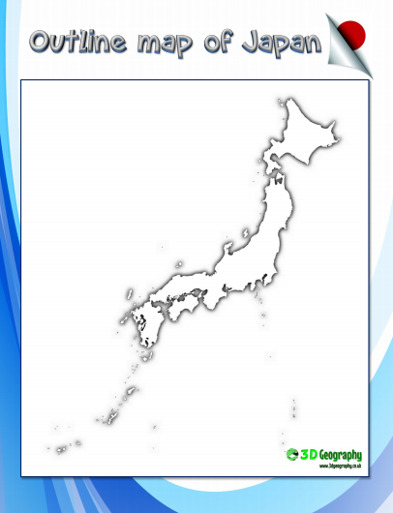

Tuesday | Core activities |  |  | Suggestions for additional activities.
9.00 – 9.30 | Daily Dashboard:  Quel est la date aujourd’hui?  C’est mardi le vingt-et-un avril 2020.  Can you write the number date in Roman numerals?  What is happening in the world? Have a look at https://www.bbc.co.uk/newsround or https://www.dogonews.com/ to see what is going on in the world. Choose a news article or two to read.  Watch the following 5-minute introduction to Japan: https://www.youtube.com/watch?v=UmSEUeTw5GA |  |  | What time is it now? What time would it be in Japan?  Have a go at learning a greeting in Japanese: https://www.youtube.com/watch?v=BvH7T5vKTlc  Find out a bit more about Japanese culture by watching a short video made by children: https://www.youtube.com/watch?v=IWxITIYE0lo
9.30-10.00 | Spelling – Practise spelling the following words from the statutory lists:  Y3/4 – famous, special, difficult, ordinary, naughty  Y5/6 – amateur, awkward, familiar, desperate, necessary, disastrous  What sort of words are these? Can you add suffixes or prefixes to alter the meanings of these words? Can you use them in sentences appropriately?
10.00- 10.30 | Time for some physical activity. Why not check out some of the silly songs and moves on https://family.gonoodle.com/?
10.30-11.30 | Maths – Use the following website to watch tutorial videos, print off activities and then use the marking guidance to see how you got on. https://whiterosemaths.com/homelearning/ | Investigate the Japanese method of multiplication using lines:  See https://www.youtube.com/watch?v=iEEKyvbCy9g or  https://www.youtube.com/watch?v=bbKjXKV9QNA  Can you use this method to multiply pairs of 2-digit or 3-digit numbers? Use a calculator or another method to check your answers.
11.30-12.00 | Have a break and play a game or do another activity that you enjoy.
12.00- 1.00pm | Lunch break. Eat a healthy lunch and try to get outside for some fresh air!
1.00pm – 1.30pm | Reading time – Read the comprehension text below about Japan and answer the comprehension questions. |  |  | Alternatively, read a chapter or two of a novel.
1.30pm – 3.00pm | Theme – Science/ Art/ Literacy  The Cherry blossom festival happens in Spring. Why not go for a walk and record in some way – through drawings, photographs to make a scrapbook, a diary – the signs of Spring that you observe. How do these signs fit with what you have already learned about plant and animal life cycles? Can you research and write/ draw in more detail an explanation of one of these lifecycles? |  | Why not investigate some Japanese Cherry Blossom art and have a go at painting your own cherry blossom picture. The following website provides a step-by-step lesson in painting blossom using watercolour paints: https://www.happyfamilyart.com/art-lessons/watercolor-art-lessons/cherry-blossom-watercolor-painting/
Year 3/4
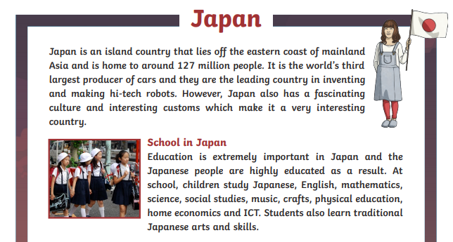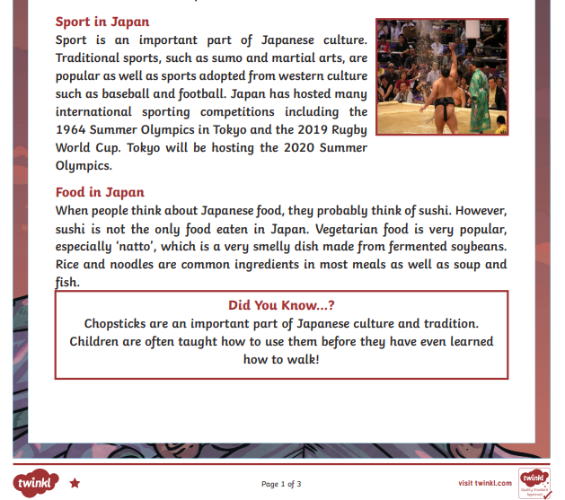

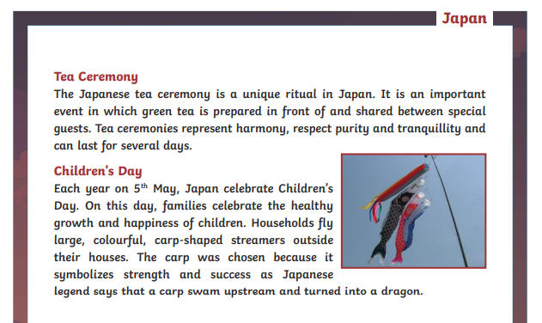

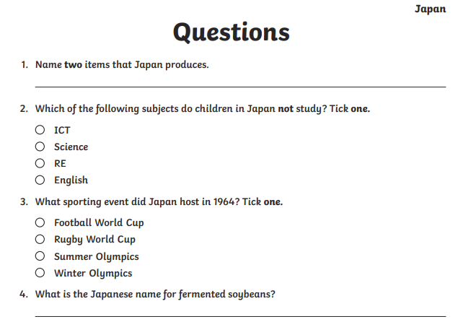
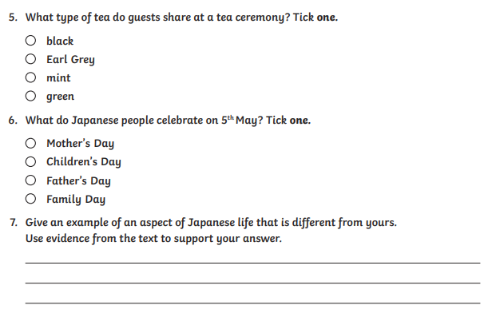

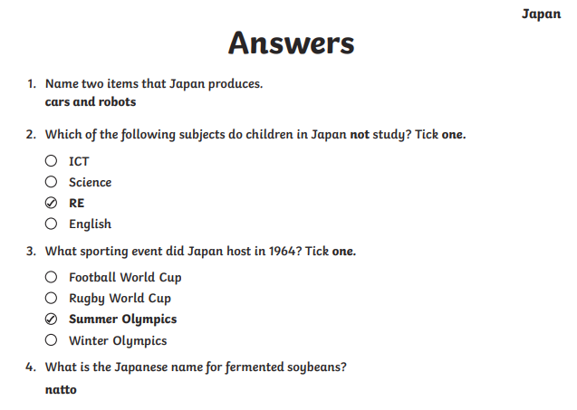
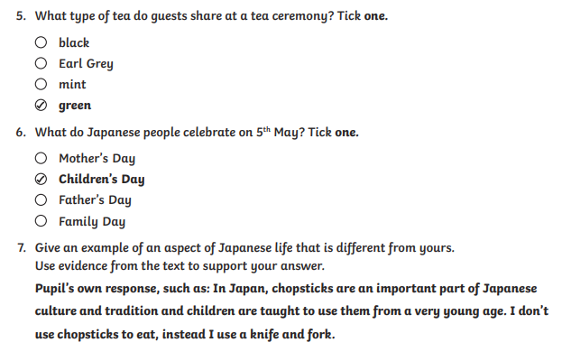

Year 5/6
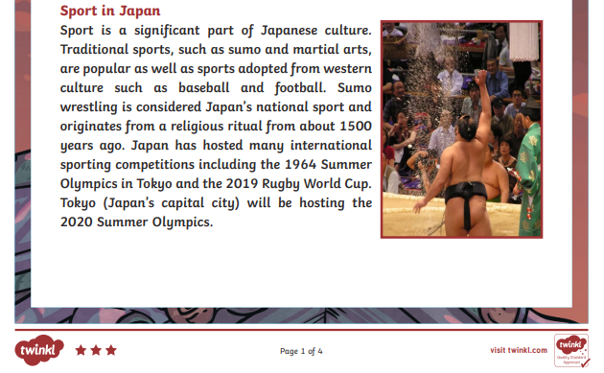
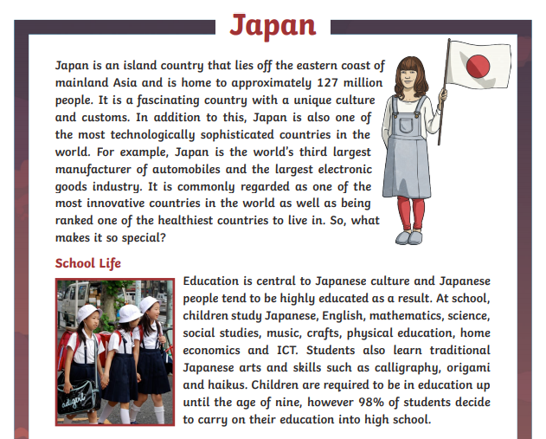

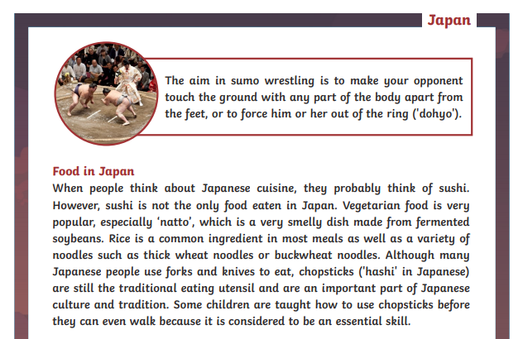
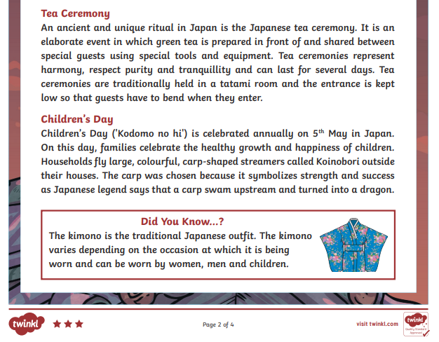
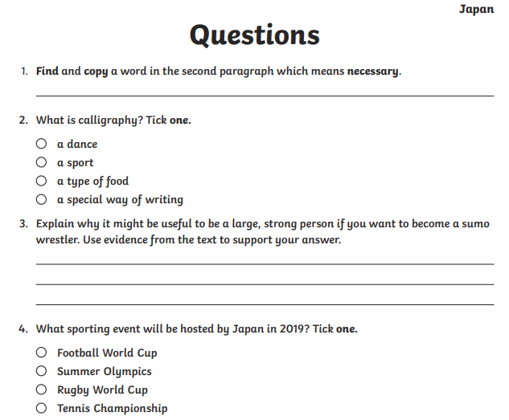

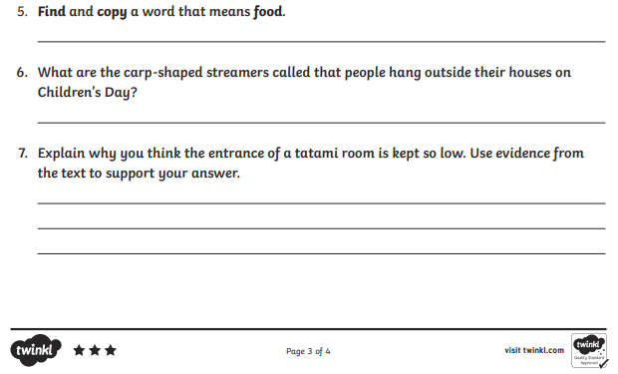

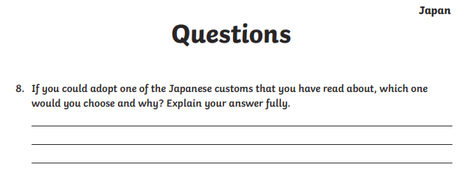

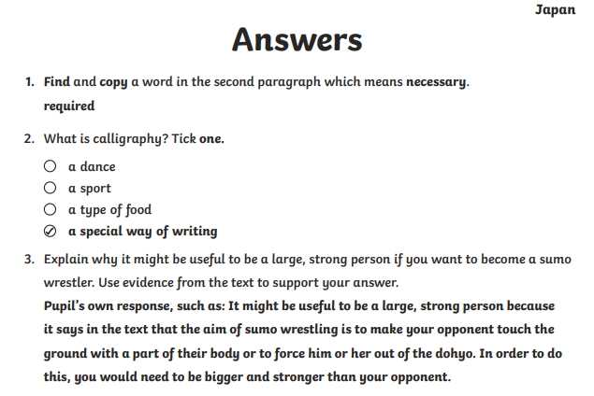
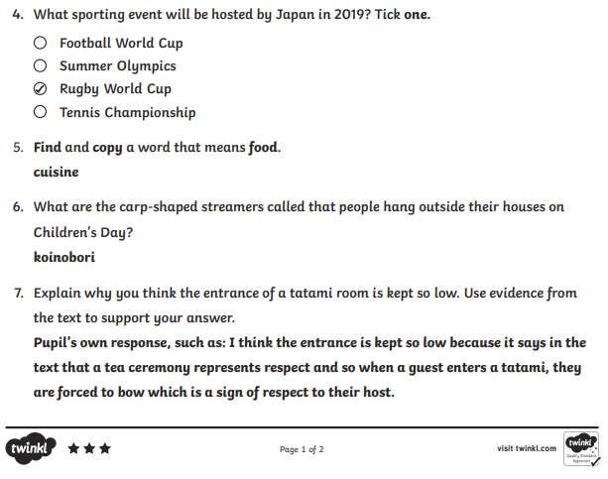

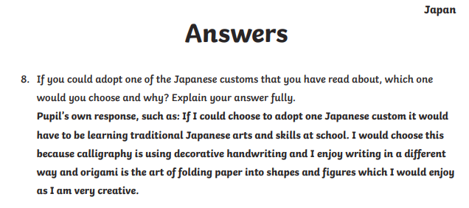

Wednesday | Core activities |  | Suggestions for additional activities.
9.00 – 9.30 | Daily Dashboard:  Quel est la date aujourd’hui?  C’est mercredi le vingt-deux avril, 2020.  Can you write the number date in Roman numerals?  What is happening in the world? Have a look at https://www.bbc.co.uk/newsround or https://www.dogonews.com/ to see what is going on in the world. Choose a news article or two to read. |  | Today is the United Nations ‘International Mother Earth Day’. https://www.un.org/en/observances/earth-day  What could you do today to show care for the planet on which we live?
9.30-10.00 | Spelling – see Spelling Resources
10.00- 10.30 | Time for some physical activity. What about looking at some of the fun Youtube dances of Australians Koo Koo Kanga Roo? https://www.youtube.com/watch?v=Imhi98dHa5w
10.30-11.30 | Maths – Use the following website to watch tutorial videos, print off activities and then use the marking guidance to see how you got on. https://whiterosemaths.com/homelearning/  Can you remember how to use the Japanese line-drawing method to multiply pairs of numbers? Have a go at multiplying a few more numbers in this way? How could you check your answers using another method? |  | How about a warm-up using Times Table Rock Stars or else play a Maths game to help practise core number facts?  Investigate Japanese currency (money). At the time of writing this, one British pound is worth 134.9 Japanese Yen  How much money in Japanese Yen would you get if you exchanged £10, £20, £100, £50?
11.30-12.00 | Have a break and play a game or do another activity that you enjoy. |  | Stay Connected: why not make a phone/ Zoom/ Skype call to a friend and share what you have been learning about and how you are getting on?
12.00- 1.00pm | Lunch break. Eat a healthy lunch and try to get outside for some fresh air!
1.00pm – 1.30pm | Reading time – Read a chapter or two of your latest book on Bug Club. Don’t forget to click on the bugs and answer the comprehension questions! |  | Alternatively, read a chapter or two of a novel. Can you summarise a chapter in less than 20 words?
1.30pm – 3.00pm | Theme  On the websites below, you will find several different ways to explore Japanese Art. Choose the one that most appeals – or the one you have materials for!  https://art-educ4kids.weebly.com/japanese-art.html  or  https://thecraftyclassroom.com/crafts/japan-crafts-for-kids/  or learn to draw faces in Manga style:  https://www.youtube.com/watch?v=JRzIiBUigj0&feature=youtu.be |  | Alternatively, why not have a go at the traditional Japanese art of origami?  https://www.origami-fun.com/origami-for-kids.html  My favourite to make is the flapping bird!  Or investigate the music of Japan and traditional Japanese instruments such as the koto. https://web-japan.org/kidsweb/virtual/koto/koto03.html  Listen to some beautiful Japanese music here: https://www.youtube.com/watch?v=Wp2oSuh1Hy0
Thursday | Core activities |  | Suggestions for additional activities.
9.00 – 9.30 | Daily Dashboard:  Quel est la date aujourd’hui?  C’est jeudi le vingt-trois avril, 2020.  Can you write the number date in Roman numerals?  What is happening in the world? Have a look at https://www.bbc.co.uk/newsround or https://www.dogonews.com/ to see what is going on in the world. Choose a news article or two to read. | Today is St. George’s Day, England’s National Day! Have you got an English flag to display? Why not make one and display it in your windor or outside your house.  Remind yourself of the story of St. George and the dragon: https://www.storynory.com/st-george-and-the-dragon/  This is a legend that celebrates the courage of St. George on behalf of others. How do you need to have courage today? What could you do to encourage or help others?
9.30-10.00 | Spelling – see Spelling Resources
10.00- 10.30 | Time for some physical activity. Have a look at https://www.lesmills.com/borntomove/ Did you know you can get a free trial subscription and join in with a host of exercise classes?
10.30-11.30 | Maths – Use the following website to watch tutorial videos, print off activities and then use the marking guidance to see how you got on. https://whiterosemaths.com/homelearning/  Why not visit https://nrich.maths.org/9803 and have a go at one of the Maths investigations there. Be warned – these will really make you think! |  | How about a warm-up using Times Table Rock Stars or else play a Maths game to help practise core number facts?
11.30-12.00 | Have a break and play a game or do another activity that you enjoy. |  | Drink lots! Don’t forget to stay well hydrated.
12.00-1.00pm | Lunch break. Eat a healthy lunch and try to get outside for some fresh air!
1.00pm – 1.30pm | Reading time – Since it is St. George’s Day, why not find out more about Japanese dragons and how they compare with dragons in Western mythology? See https://www.japan-talk.com/jt/new/6-Japanese-dragons and/or http://yabai.com/p/2516. |  | Alternatively, read a chapter or two of a novel. Pick out a few of your favourite sentences and consider what the author has done to make them have an impact on the reader.
1.30pm – 3.00pm | Literacy  Have a go at planning and writing your own story about a dragon. For an extra challenge, you might choose to set your story in Japan…although you might need to do a bit more research about setting and characters.  The following websites may help with this background research:  https://web-japan.org/kidsweb/explore/index.html  or  https://www.kids-world-travel-guide.com/japan-facts.html |  |  | Why not choose an aspect of Japanese culture that you are curious about and do some research to find out more? You could present the information in a short report.  Or use secondary sources to investigate and complete the Japan fact file sheet below.

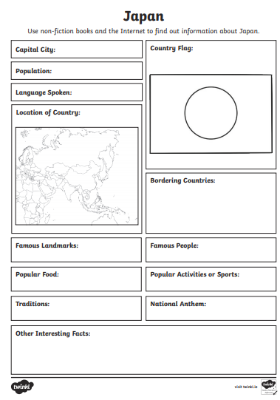
Friday | Core activities | Suggestions for additional activities.
9.00 – 9.30 | Daily Dashboard:  Quel est la date aujourd’hui?  C’est vendredi le vingt-quatre avril, 2020.  Can you write the number date in Roman numerals?  What is happening in the world? Have a look at https://www.bbc.co.uk/newsround or https://www.dogonews.com/ to see what is going on in the world. Choose a news article or two to read.  Today is our last day of learning about Japan – why not try to dress up in a ‘Japanese’ costume? Can you improvise a kimono from clothes or fabrics in your house? | Have a go at counting to ten in Japanese (see the cards provided below) Why not see if you can write out a few simple sums using Japanese numbers?  Today is the first day of Ramadan, the Muslim month of fasting. What do you know about the Muslim tradition of fasting for a month each year? See what else you can find out…
9.30-10.00 | Spelling – Have a look back over the words you have practised this week. Test yourself (or ask someone to test you) to see how well you have remembered these words. Then practise any words you still need to secure.
10.00- 10.30 | Time for some physical activity. What about setting up a variety of circuit-training activites? You could include: star jumps, burpies, calf raises, skipping, bicep curls (use water bottles for weights), shuttle runs, bear crawls, high knee running… what other exercises can you think of?
10.30-11.30 | Maths – Use the following website to watch tutorial videos, print off activities and then use the marking guidance to see how you got on. https://whiterosemaths.com/homelearning/ | How about a warm-up using Times Table Rock Stars or else play a Maths game to help practise core number facts?
11.30-11.45 | Have a break and play a game or do another activity that you enjoy.
11.45 – 12.00 | Why not join in with the act of Collective Worship that you will find on the school website. Take time to think about or pray for people that might be anxious or upset, ill or suffering.
12.00- 1.00pm | Lunch break. Eat a healthy lunch and try to get outside for some fresh air!
1.00pm – 1.30pm | Reading  Read the ‘Green Willow’ story below. What did you like or dislike about this Japanese story? | Alternatively, read a chapter or two of a novel. Pick out a few of your favourite sentences and consider what the author has done to make them have an impact on the reader.
1.30pm – 3.00pm | Theme/ Literacy  Read through the information about haikus (below)– a form of Japanese poetry. Then go for a little walk, before having a go at writing your own haiku poems about what you see or hear on your walk. |  | What are the most interesting things you have learned about Japan? Why not make a little booklet, fact file or poster or write a diary entry about your ‘visit’ to Japan.
That’s it for our visit to Japan – next week we are off to the Netherlands, to celebrate their National holiday of Koningsdag (King’s day)!

However, in ‘Additional learning about Japan’, you will find a few more pages of activities linked to Japan. Happy Learning!

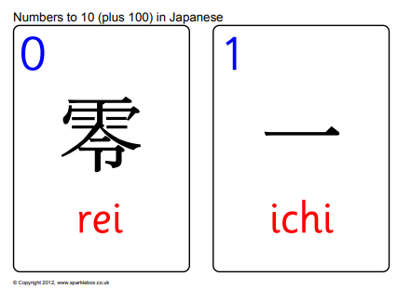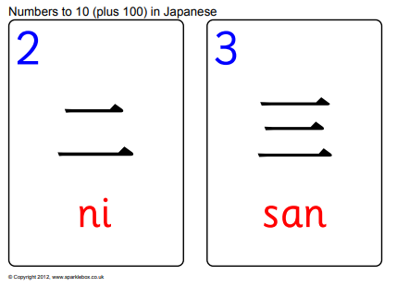

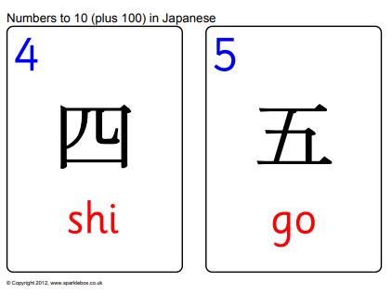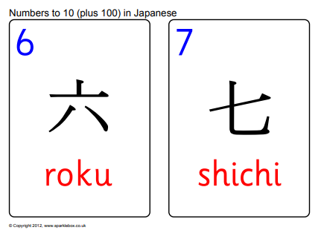
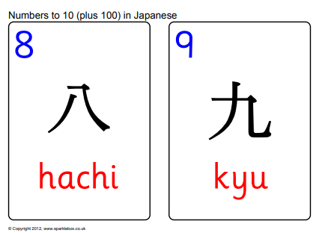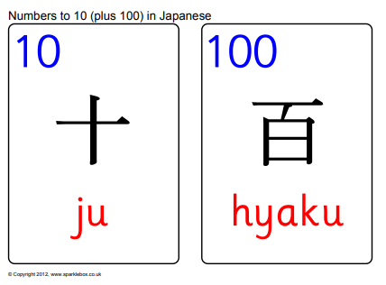

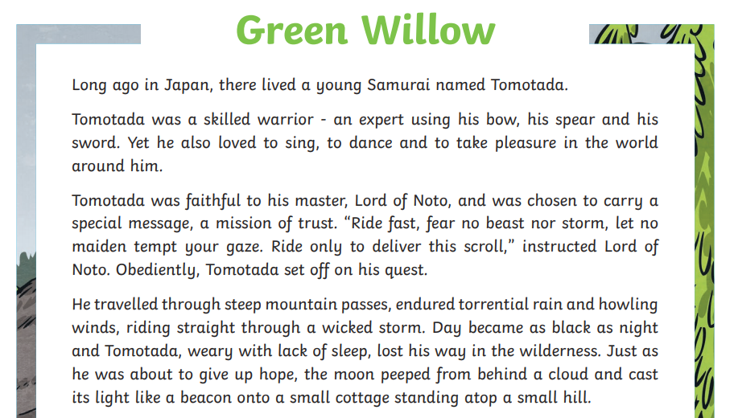
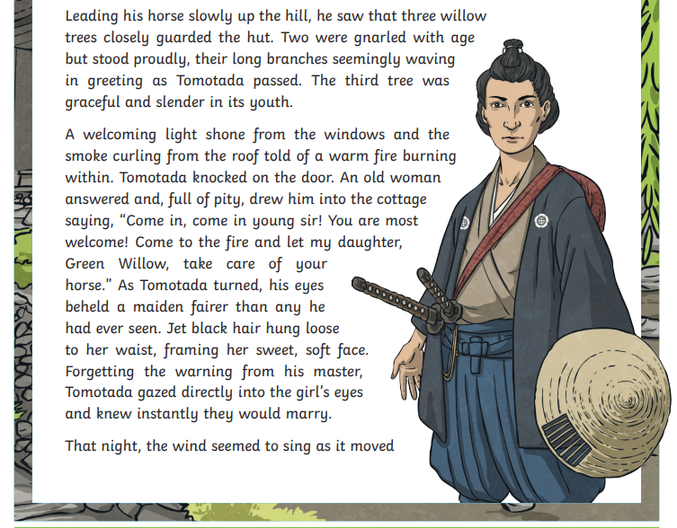
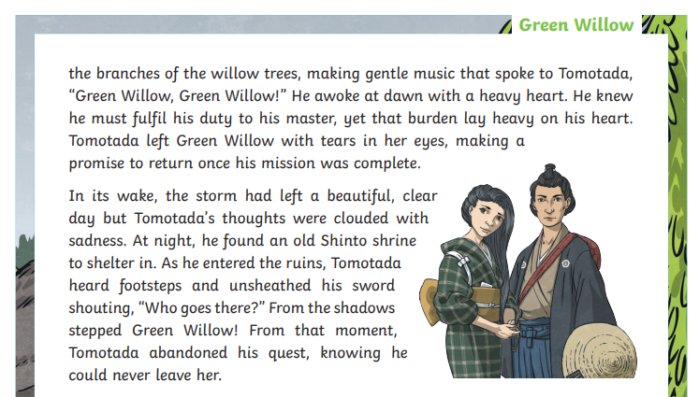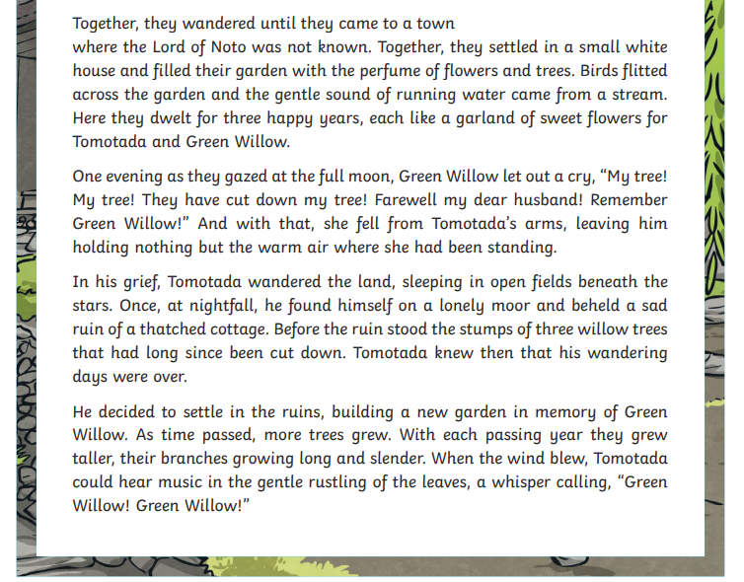
Name: Date:
Read the following haikus. Discuss with a partner what each is about and start to consider how each is written and structured.

A pair of haikus written by Matsuo Basho (1644-1694), often considered the greatest haiku poet:

An old silent pond...
A frog jumps into the pond,
splash! Silence again.
Autumn moonlight –
a worm digs silently
into the chestnut.
Here are two examples of haiku from Yosa Buson (1716-1784), a haiku master poet and painter:

A summer river being crossed
how pleasing
with sandals in my hands!
In the moonlight,
The colour and scent of the wisteria
Seems far away.
Two further examples from Masaoka Shiki (1867-1902), who helped to revive the modern haiku:

After killing
a spider, how lonely I feel
in the cold of night!
A mountain village
under the piled-up snow
the sound of water.
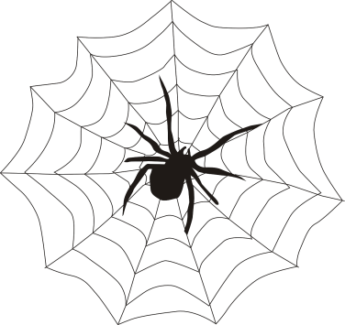

Haiku (俳句 high-koo) are short three-line poems with a 5-7-5 syllable structure that use sensory language to capture a feeling or image. They are often inspired by an element of nature, a moment of beauty, or another poignant experience. Haiku poetry was originally developed by Japanese poets, and the form was adopted (and adapted) by virtually every modern language, including English. The secret to writing great haiku is to be observant and appreciate nature.

Name: Date:
You are now ready to write your own haiku! Go outside with your colour chart and observe the colours, the sounds and the smells in the air. Write some ideas below.

Word bank:

Now write your own haikus. There are some starter ideas to help you.
Petals falling down | Insects teetering
Flower opening | A delicious scent

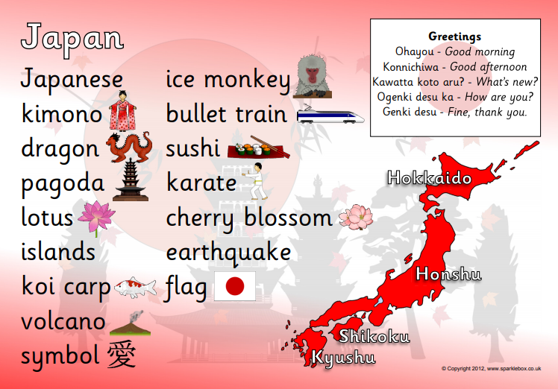

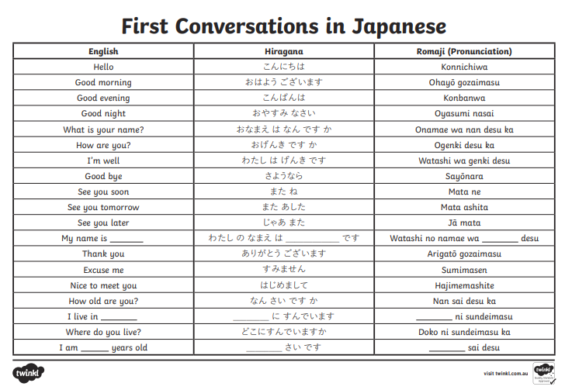

Have a go at writing a few brief conversations in Japanese, using the chart above.
