Maths Home Learning for week beginning 11th May.

Monday – WALT: sequence events and use language related to days of the week and months of the year.
Recap:
There are 7 days in the week. Can you name them and write these out in your books.
There are 12 months in a year. Can you name them all and write them in your books? Remember: names need capital letters!
Do you know how many days are in one month?
Do you know how many weeks are in one year?

- Think back to a typical school day. Can you sequence the events, then label them using the language: first, next, after, then, later, finally, morning, afternoon, evening …
You can draw your own pictures or use the daily routine cards attached, to complete this (not all cards will be applicable to everyone).

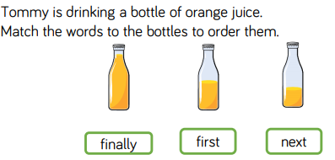

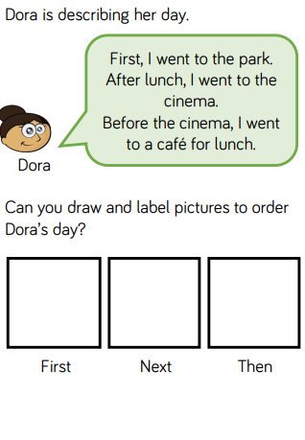
- Draw pictures to show what could have happened before and after.

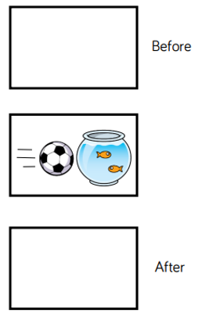
Tuesday – WALT: understand about days of the week and the months of the year.
- Fill in the missing days of the week, then complete the sentences.
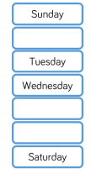
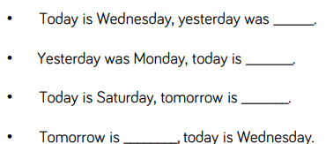

- Use a calendar to look at the names of the months. Discuss special dates in in your lives. For example: your birthday, your friend’s birthdays, and celebration holidays.

Complete the sentences:
My birthday is in __________________.

In _____________, I went to _____________.

Challenge: Why not try creating your own hand print calendar, like the one below. Focus your designs on a special celebration that happens for you, or your family, during this month.
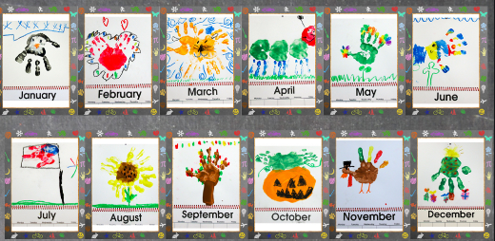

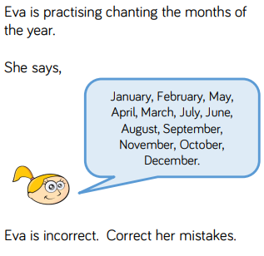

Wednesday – WALT: tell the time to the hour, using o’clock

Note: Children will need to understand that the hour hand is the shorter hand and the minute hand is the longer hand.
Teach - children will learn to read the time to the hour and know when the minute hand is pointing upwards to the 12 it is an o’clock time, and they need to look at the hour hand to see which hour it is.

If you have the clocks we made in class, these will be great for this. Alternatively you could use a real watch/clock to demonstrate this more visually.

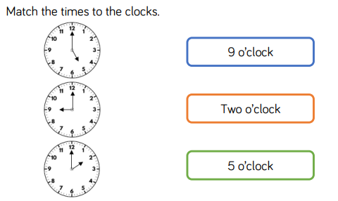

There are two hands on each clock. What is the same about the hands? What is different?

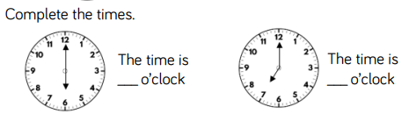

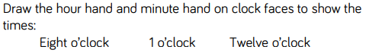

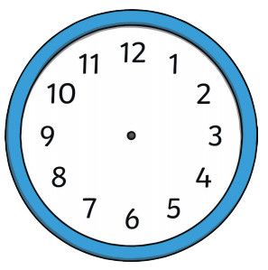

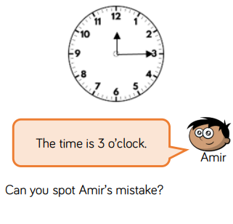

Thursday – WALT: tell the time to the half hour
Note: children should be encouraged to make links with their learning about half and whole. Half past is half of the whole hour. 6 is half of 12 – when the minute hand is pointing to the 6, it is half past the hour.
The minute hand has travelled half way around the whole clock.
The hour hand will be pointing half way between the hours.
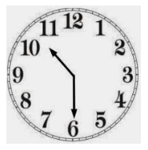
The minute hand is pointing to the 6. It has travelled half way around the clock.
The clock is showing half past 10.
The hour hand is half way between the 10 and the 11.

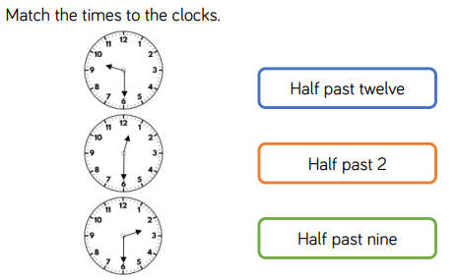

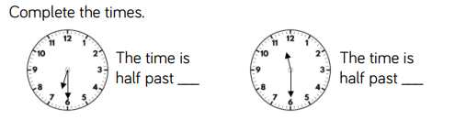

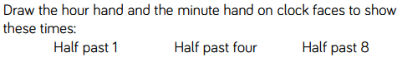

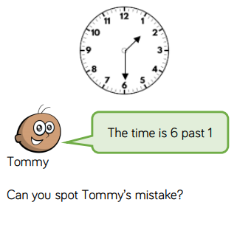
Can you write what the correct time that the closk is showing?

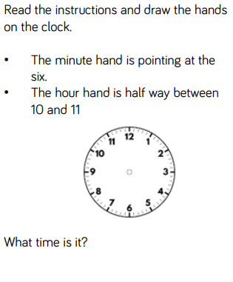

Friday – WALT: practise telling the time to the hour and half past the hour.

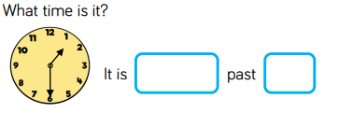

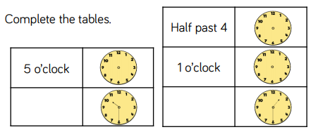

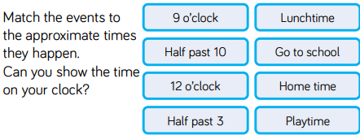

- Write the time shown on each clock.

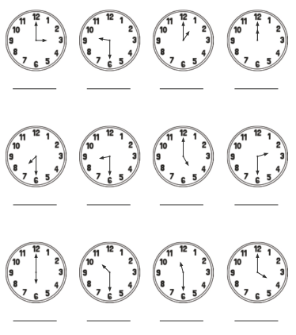

- Draw the time on each clock.

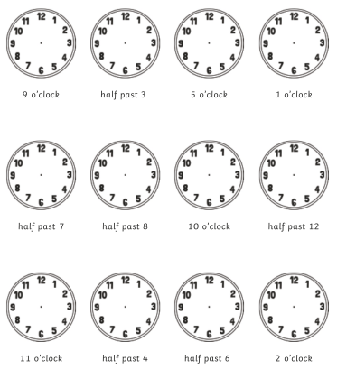

- Challenge:
