

Monday8th June

Dear Class 1

I hope you have all had a good week and managed to get some home learning done. I am looking forward to seeing some of you back in school this week!

This week, it is going to be slightly different, in regards to our learning, because some of you will be learning in school with me and others of you will be at home. I have tried to keep some coherence between the two so that you will all be learning something similar.

This week has been quite exciting because our chrysalides have finally started to hatch into beautiful butterflies!

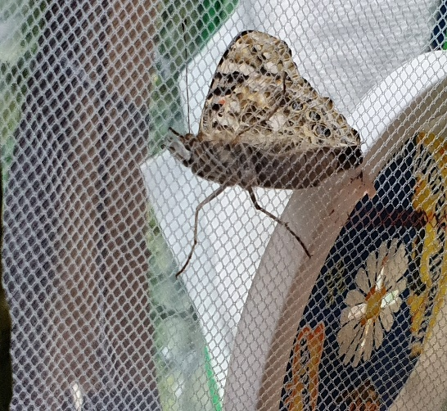 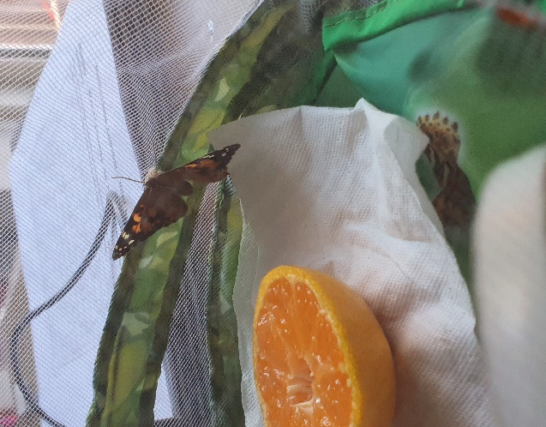

These are Painted Lady butterflies. It might be a nice idea if you spend some time at home researching facts about Painted Lady butterflies. Maybe you could make an information booklet or a poster?

As always, please do get in touch if you have any questions

Have a good week.

Kindest Regards

Mrs Jackson

**Monday – WALT: write an informal letter**

Last week we were looking at the story, ‘The Day the Crayons Quit’, by Drew Daywalt. We were exploring colour and emotion, whilst practising our letter writing.

I thought this week it would be a nice idea to continue with this theme and start the week, writing a letter to a friend you are missing.

Maybe you are at home and your friend is in school?

Maybe you are in school and your friend is at home?

Maybe you are both in school, but your friend is in a different ‘bubble’ to you?

Or maybe, they go to a different school, but you have been unable to meet up with them due to lockdown?

Whatever the reason, it is always lovely to receive a letter from a friend!

When we are writing a letter to a friend, we need to use an informal tone within our writing. This means we need to keep the tone friendly.

Informal means friendly, relaxed, casual

Last week we started writing a letter to Duncan, from your favourite coloured crayon. Today we will use a similar format. See below:

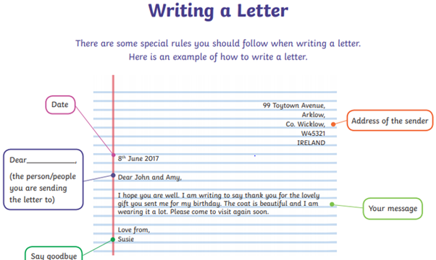

What can I include in my letter?

* Greeting, such as: Hello. Good morning.
* Questions, such as: How are you? What have you been doing?
* Share any news with your friend, such as: I have been learning to ride my bike during the school closure.
* Share how you are feeling, such as: I miss you, or I am worried about going back to school.
* Say goodbye, such as: love from, best wishes

When you have finished writing your letter, use the check list below to see whether you have included all the criteria for a successful letter.

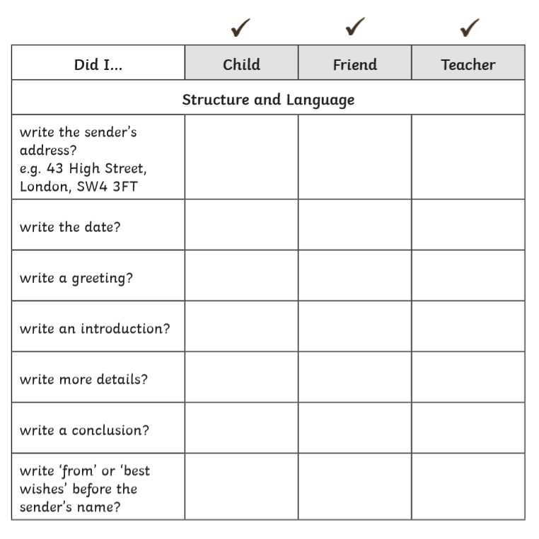

Check with your parent first, then send your letter to your friend! It is always lovely receive a letter from a friend!

**Tuesday – WALT: understand the point of view of a character**

As a class – read the story ‘The Day the Crayons Quit’, by Drew Daywalt. If you are at home, watch the clip below, from last week, to remind yourself of the story.

<https://www.youtube.com/watch?v=489micE6eHU>

Whilst reading the story (or watching the clip), pay particular attention to the opinions being expressed by the crayons, in their letters to Duncan.

What are the opinions and problems of the crayons?

It is important that the children understand that the crayons have a problem with **how Duncan uses them.**

Think about the point of view of four different crayons. Colour each crayon and record their thoughts and feelings in the boxes below.

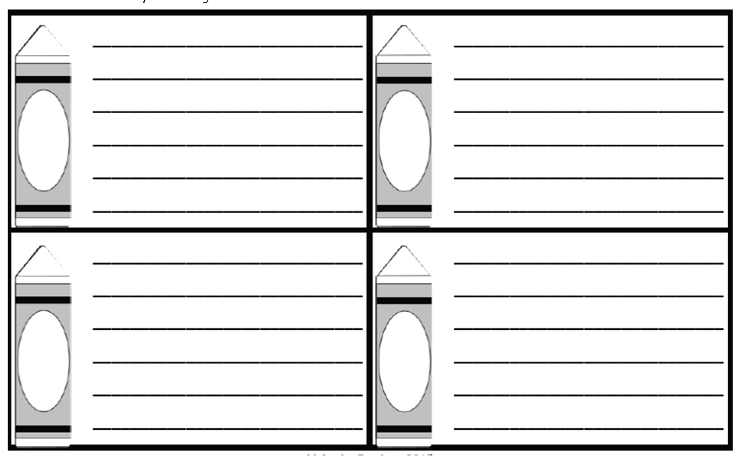(Last week the children were asked to read four of the letters, from Beige Crayon, Black Crayon, Blue Crayon and Red Crayon – it would be a good idea to encourage the children to re-read these letters themselves, aloud to you, to practise their reading skills.)

Next, support your child to make a list of stationary, that they may find within a classroom.

See how many ideas you can jot down in 3 minutes.

Finally, choose 5 of the stationary, from your list and discuss ideas that the stationary might have a problem with – jotting down ideas in the chart below:

I have done the first one for you. Can you think of 5 more. Please try and include one piece of maths stationary because you will need this for tomorrows lesson.

|  |  |
| --- | --- |
| Stationary item | Problem |
| Glue Stick | My lid is always left off my head and I keep drying out. |
|  |  |
|  |  |
|  |  |
|  |  |
|  |  |

**Wednesday – WALT: plan our ideas before we write**

Today, we are going to plan to write a letter to the teacher (Mrs Jackson), from a piece of maths stationary.

**First,** choose your favourite (or most tricky) piece of maths stationary. I have chosen a **number line.**

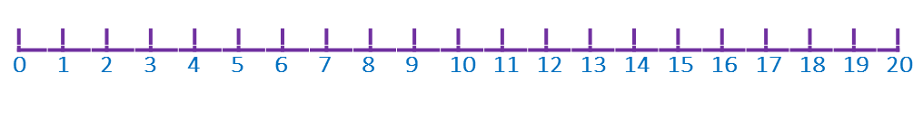

Then, think about the **problem** your piece of stationary might have. You need to think about the purpose of this piece of stationary.

For example: people keep counting on from the wrong number and scribbling all over me!

Now, think about what might happen if your chosen stationary quits? For example: adults will still be counting on using their fingers!

Finally, use the sheet below to plan your ideas.

What will quit? _________________

|  |  |
| --- | --- |
| How is _________ used? | Why might _________ be angry? |
| What will happen when __________ quits? | What do you need to remember about writing letters? |

**It would be a good idea to play around with several maths stationary ideas, so you can choose the one with the most ideas for your writing tomorrow.**

**Thursday – WALT: write for a purpose**

Today, we are going to write a letter to the teacher (Mrs Jackson), from your chosen piece of maths stationary.

Re-read through your ideas from yesterday. If you wrote several plans, pick your favourite plan to support your writing today.

As a class, we would share our ideas aloud, so if you are at home encourage your child to share their ideas with you and ask questions, such as: why did you choose this piece of stationary?

Now, we are ready to write our letters. Have a look at the model below, if you need support with your writing. Otherwise, have a go at writing your own letter independently. Use the letter format (Mondays lesson)

Dear Mrs Jackson,

I, the number line, officially quit!

I love working with the children. They are all smiles and enthusiasm, I _[opinion/action relevant to stationary]_ but now I am _[feeling/emotion]_.

I feel like this because _[reason for feeling/emotion]_. I would be really happy if _[resolution to problem]_. I look forward to reading your response,

Yours Gratefully

Number Line.

You could use the special crayon boarder paper, below, to write your letter.

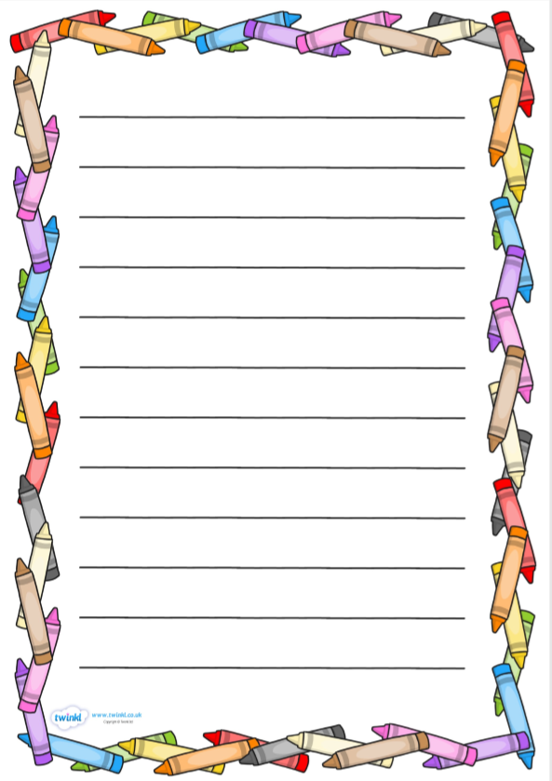

**Friday – WALT: create a mindfulness jar to help us think about our feelings**

Once again, our routine has changed. Those of you in school this week may have been feeling a range of emotions and feelings about all the differences to your school day.

Can you take a moment to have a think about all those feelings you have been feeling?

How are you feeling today?

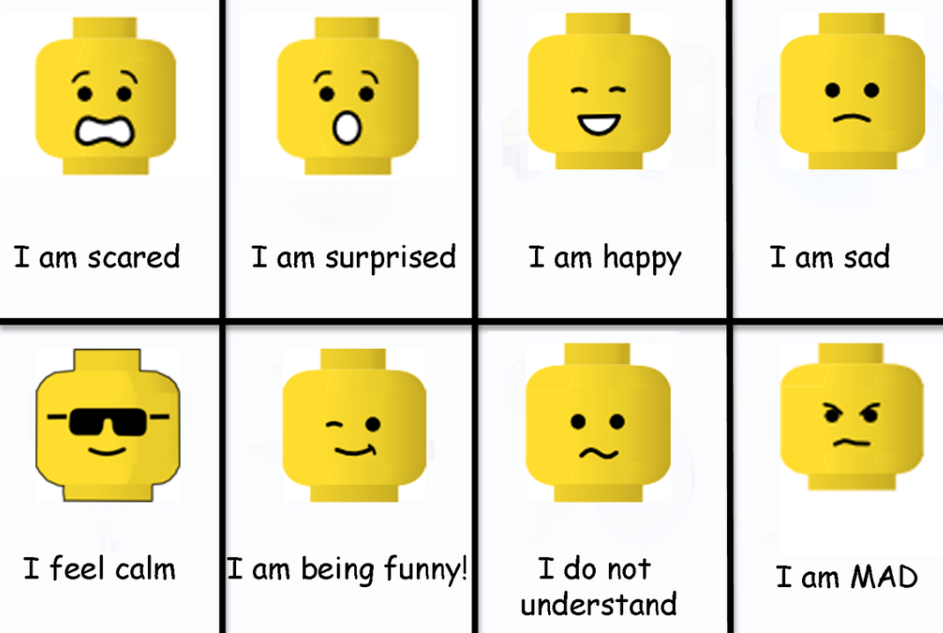

Sometimes when we are feeling lots of things, our feelings fly around our bodies and this can make us feel tired and exhausted. At times like this it is a good idea to slow down and be ‘mindful’.

Mindfulness is the opposite to rushing around and multi-tasking it means paying attention to something or slowing down and really noticing what you are doing and how you are feeling. Recent studies have shown that including mindfulness exercises in your daily routine reduces feelings of anxiety and tiredness.

Below I have attached a fun mindfulness activity for you to recharge yourselves from our busy week in school. Have fun!

