13th January 2022
Dear Parents,

The children had a particularly fun-packed month in December, despite lots of illness, culminating in their ‘Little Nativity’ School Play. Every child did their best, whether that was their expressive lines, being in the right place at the right time or learning all the songs. Some faced their fears of performing, others thoroughly enjoyed the spotlight! Thank you for supporting the children by preparing them, and vocally supporting their performance. Farway church was packed out! Also, thank you to the P.T.F.A for organizing drinks and mince pies back at school afterwards. We were also lucky to have a special visitor in his tractor trailer with a gift for each child. It was a delightful evening. Our Christmas meal was also a great success, all the children enjoyed our festive celebrations.

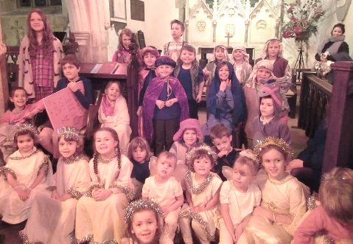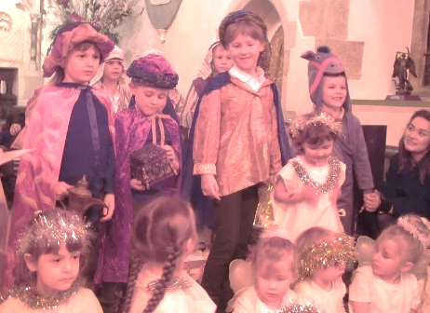

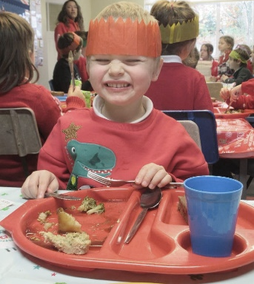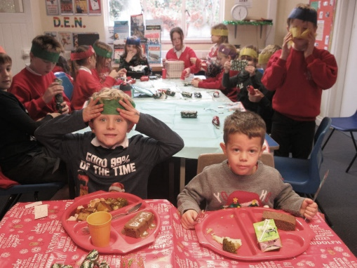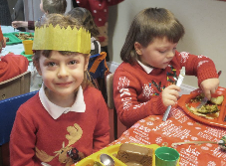

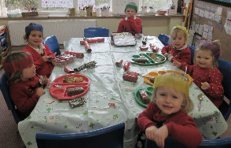

Thank you to all the parents that have been coming along to our sharing assembly each week, it has been wonderful to see you all. These special assemblies will be continuing this term, so please come along.

Class 1 have settled back into their learning brilliantly after Christmas and are looking forward to lots of exciting learning this term. This term’s topic is all called Moon Zoom. In history and geography, we will be learning about the space race and the moon landings. In science we are studying different materials and their properties in order to create a space craft.

As part of their music topic, Class 2 have been learning to play the glockenspiels and learning songs from the World War II era. This term they will be learning to play djembe drums, which are tuned percussion. They will improvise when creating their own tunes, using call and response and playing within set notes. They have also begun looking at traditional music from Mexico and enjoyed putting together movements to ‘La Tarantula’ this week.

Class 2 have also been taking part in ‘Music that…’ where they listen to a range of songs, from classical to modern, under a theme such as ‘Music that makes you smile’ or ‘Music that is sung in other languages’. They use their musical knowledge and vocabulary to give their opinions on the tracks shared, beginning to recognize styles and genres and identify instruments they hear. Mrs Marsh has asked that the children find out about music from home that is special to them, to share in school. Perhaps that could include favourite songs to sing along to in the car or songs that are special to an adult at home.

Class 2’s literacy culminated in poetry at the end of Autumn term, based on a book called Cloudbusting by Malorie Blackman. They created their own war poems which are very moving and descriptive. Please stop and read them displayed just outside Mrs Marsh’s classroom door when you are next in school for our sharing assembly.

Class 2 are also enjoying thought provoking Science lessons this half term, with Year 3 and 4 investigating magnets, while Year 6 have been focusing on mechanisms that increase or direct forces, reducing the effort needed to perform a task.

I would like to thank you all for the support you gave to staff this week and all the messages of ‘good luck’ for our Ofsted inspection. The inspectors said that parents had said some lovely things about the school and our staff team. This is always appreciated. Unfortunately, I can’t share the outcome of the inspection at this stage – the report will be published in about a month.

Thank you for all your continued support.
God bless and have a lovely weekend.
Best wishes from Katie Gray and the staff at Farway CE School

Question of the month:

Do New Year resolutions really work?

Key Dates – Spring Term 2023
Tuesday 24th January- Year 5 and 6 Girls Futsal at Honiton Community College.
Tuesday 7th February – Class 1 coordination event at Honiton Community College.
13th – 19th February - Half term.
Friday 31st March- End of term.

Orchard Aims
Class 1:
Robyn – for excellent reasoning in maths.
Wren – for being very kind and helpful to her peers.
Adriana –for perseverance and trying new things.
Blake – for great progress.
Toby – for great recall of information from last year.

Class 2:
Oliver Baily - for dedication to learning and contributions to lessons.

Important notices
School Access
Please note that the school grounds are strictly off limits outside of school hours, including during the school holidays. Entrance to the school grounds out of school hours is trespassing. This is very important for Health and Safety reasons.
Thimbleweed Thursday’s
As you know Thimbleweed Thursdays is our new outdoor learning, running every week, as part of our standard timetable, for all Reception and Nursery pupils. After their normal Phonics session, taught in the classroom to ensure consistency, the remainder of the day is taught outdoors, whether it be Maths, Literacy, Story Time or Collective Worship. Snack will be eaten outdoors too, although we will return briefly to tables indoors for lunch. Therefore, we ask that all Reception and Nursery children come to school every Thursday wearing old comfortable clothes, ready to spend the day completely outdoors come rain or shine. They will need wellies (please do not arrive at school wearing these) and waterproofs. Additional socks, gloves and hats when the weather turns colder will also be required. It would be useful to provide a set of spare clothes should the weather, or a muddy puddle, get the better of us! Children MUST bring their own water bottle. Please also make sure all clothes, including spares are named. We appreciate your help with this.

School Uniform
Please can you ensure that your child has all their uniform named? It really helps at the end of the day to ensure that the correct jumper is returned to the correct child. Also, as the weather gets colder, please ensure that your child has a warm coat, a hat and gloves, and that all of these are named. Thank you for your help.

School Times
We ask that children are in school by 8.50am each day. Please remember if your child arrives after 9am they will be marked as late.
Breakfast Club
Our breakfast club continues each morning at 8am and costs £2 per session, including breakfast. Please fill in a form, available from the office, if you would like your child to come along. Thank you.
Sickness
Please remember if your child experiences sickness or diarrhoea that they need to stay off school for a full 48 hours afterwards. This is recommended guidance to stop the spread of illness. Thank you for your help.
Medication
If your child has medication that needs to be administered in school, then you will need to bring it to the school office, so that it can be stored securely. The medication must be in its original box with the prescription label attached, naming the child. You will also need to fill in a special form giving permission for the school to administer the medication. Please ask at the office for more advice. Many Thanks.
Cool Milk
If you would like your child to have milk each day please register online. Under 5’s will be registered if you let the office know that your child would like milk. Children who are entitled to Free School Meals can have milk free each day. Please let the office know if you would like this to happen. Thank you for your help.

Child Absence
If your child is unwell please telephone the school before 9am to let us know that they will not be attending. This is a legal requirement. As a school we legally have to account for pupil absences, to do this we need written confirmation of any absence. We routinely send home absence forms when children are away from school. If these forms are not returned your child’s absence will be marked as unauthorised. Spare forms are always available from the school office. Thank you.

Water Bottles
Please could we remind all parents that all children including nursery children should have a water bottle in school at all times? Please do not send in juice in bottles. Thank you for your help with this.

Free School Meals
If your circumstances have changed your child may have become eligible for free school meals. This will also bring extra funding to the school, which will be used to help your child. For an instant decision or to learn more please go online at https://www.devon.gov.uk/educationandfamilies/school-information/school-meals.

Sharing Assembly
Sharing assembly will continue each Friday afternoon at 3.10pm. All parents/carers are invited to come and see the children sharing their learning.

Wellbeing
There has been much press in recent months about children’s mental health. As part of our drive to support this we are going to include something each month in the newsletter about Health and Wellbeing. We hope you find this section useful. If you have any topics you would like us to find some helpful tips about, please let us know.

After the Christmas break it has been lovely to see the children return to school. However, for some children, returning to school can be a worrying time, full of uncertainty and anxiety. As a parent, you always want to do the best to reassure your child and to ease their worries. Dr Barnardo's have developed some coping strategies to support children if this is a difficult time.
https://www.barnardos.org.uk/support-hub/back-school-strategies-coping-feelings
Back to school: Strategies for coping with feelings | Barnardo's

Grounding techniques. A grounding technique is a coping strategy for managing intense feelings and emotions. These techniques help to ‘ground’ us, which means they help us to notice the present moment we are in.
www.barnardos.org.uk

Collective Worship Activity
This term we will be focussing in school on the value of Perseverance. We hope your family will find these ideas helpful as you explore the value and have fun together. If the children bring back something that you have done at home linked to the Collective Worship activity, or can talk about a discussion they’ve had at home linked to it, then Mrs Gray will award them with a new special sticker.
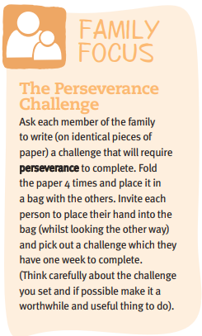

Seaton Swimming School is delighted to announce that we will be opening for lessons from Tuesday 21st February. Please email seatonswimmingschool@gmail.com for more details. Lessons are held between 3:45 and 5:45 on a Tuesday and Thursday and 9:30 to 11:30 on a Saturday, for ages 4+. We are based at Seaton Primary School, £9.50 per lesson, with a ratio of 1:4, all teachers are in the water.

