The Dragonfly bubble have really enjoyed being back together again, over the last few weeks. We have been making the most of the dry weather by practising our phonics outside, using natural resources to create our tricky sounds.
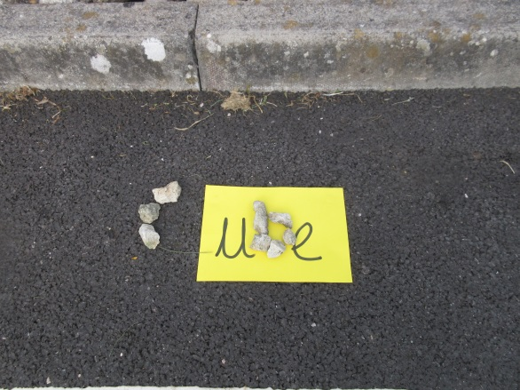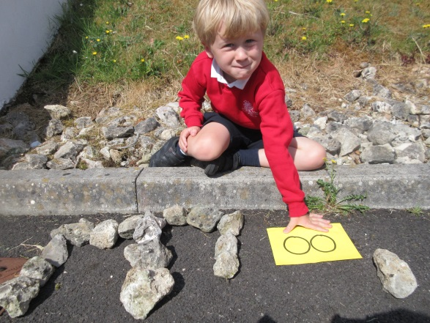
Whilst, in maths we have enjoyed making our own clocks, to help us to learn how to tell the time and explored creating bar charts to display Jubilee’s favourite coloured pencil crayon.
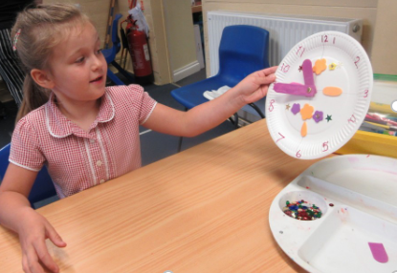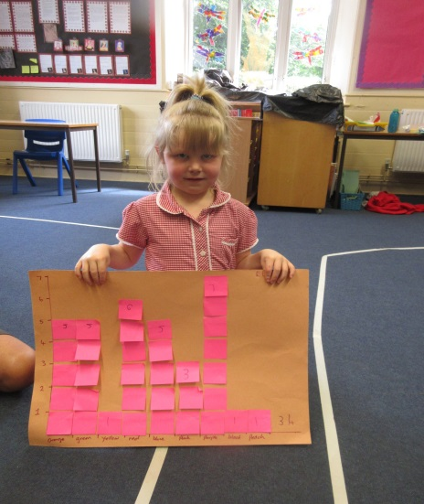
‘’The time is quarter to 11,’’ said Daisy. ‘’Purple is the favourite colour.’’

Some of our highlights have been:
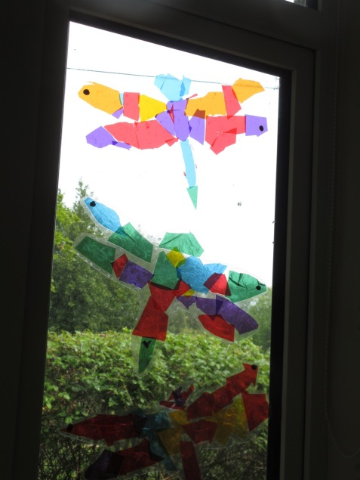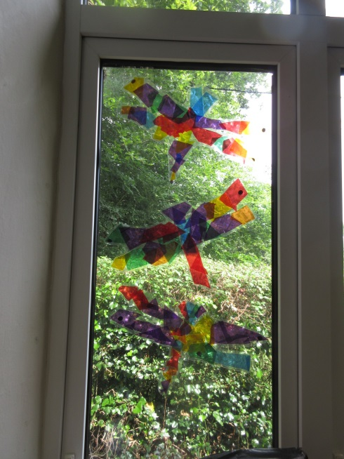
Designing and creating dragonfly stain glassed windows for our classroom.
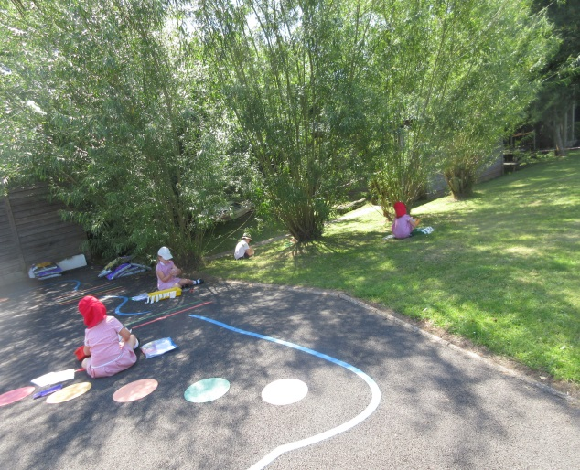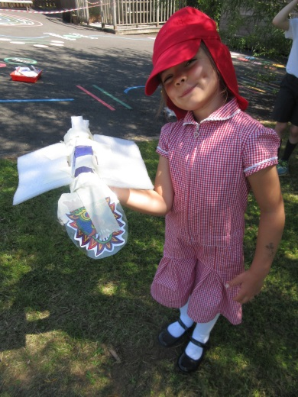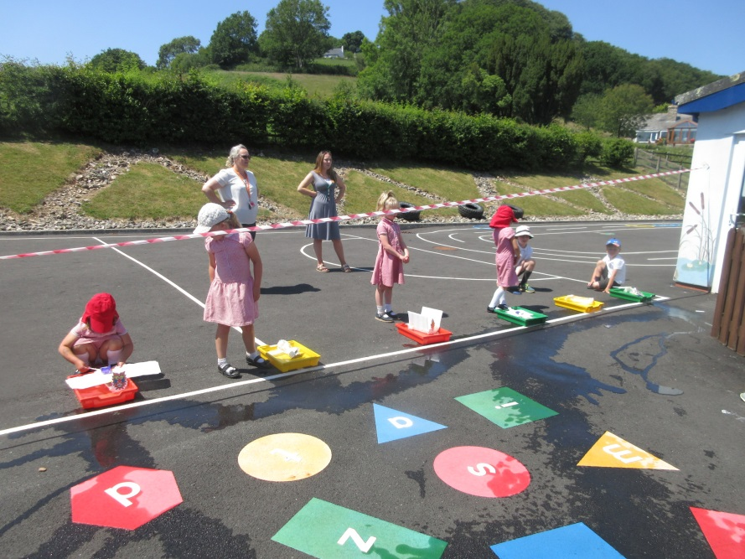
Creating and racing our dragon boats to celebrate the Chinese dragon boat festival. It was such a warm day we even decided to have a quick paddle to cool ourselves down!
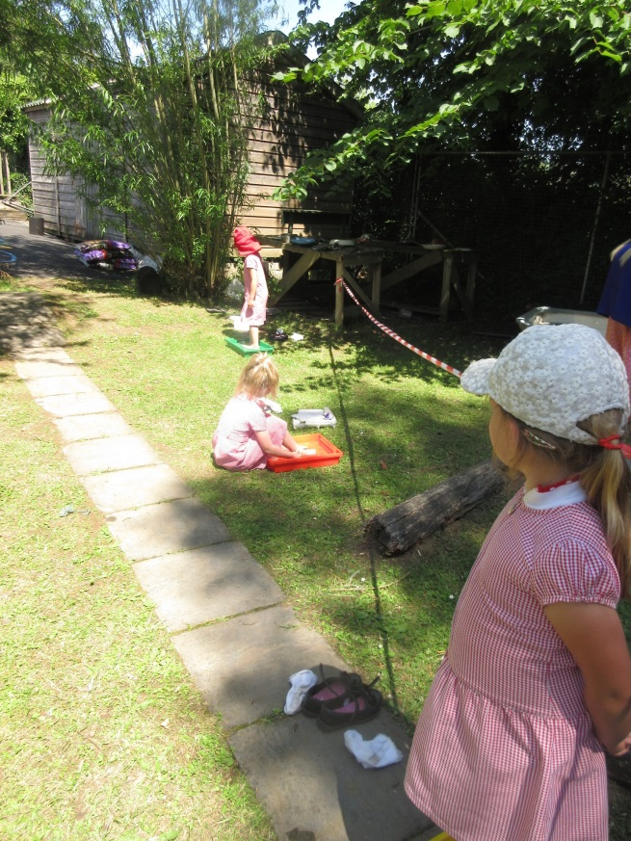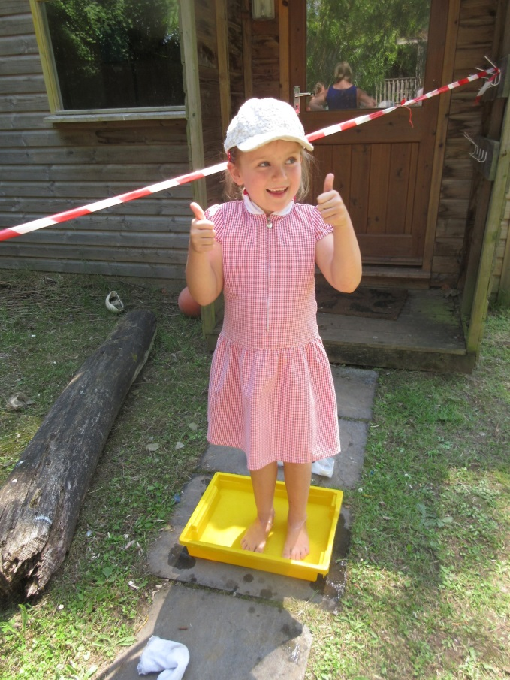
This week we have been learning all about sunflowers and decided to recreate Van Gogh’s famous Sunflower painting. The children were fabulously artist!
