’10 a day’ for Positive Mental Health
While we are working from home it is important that you continue to support your mental health. One way of doing this is to continue to use the ’10 a day’.
- Are you able to do each of these every day?
- What activities could you do that use more than one of the ten?
- Which activities can include the most?

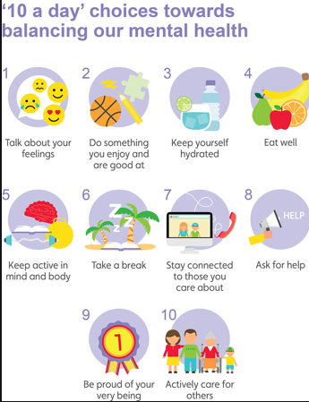

10 a day | Activity
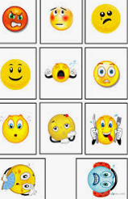
https://www.childline.org.uk/toolbox/
Use these games to think and talk about how you are feeling.
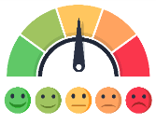
Make your own feeling barometer to show how you are feeling.

Do something you are good at and share it with your family.
Teach someone in your family to do something you are good at, e.g. drawing, playing an instrument, juggling, maths.
Challenge yourself to how much water you are going to drink in a day.
Can you work out how much you have drunk at the end of the day in millilitres or litres?
Try and aim for two litres.
Choose healthy snacks.
Help prepare lunch or dinner for the family.
Maybe try some of the recipes from these websites.
https://www.bbc.co.uk/cbeebies/shows/my-world-kitchen
https://www.bbc.co.uk/cbbc/shows/matilda-and-the-ramsay-bunch
https://www.bbcgoodfood.com/recipes/collection/kids-cooking
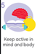 | Play in the garden.  Turn a walk into an exciting new adventure. Your goal is to notice as many birds, bugs, creepy-crawlies, and any other animals as you can. Anything that walks, crawls, swims, or flies is of interest, and you’ll need to focus all of your senses to find them, especially the little ones.  Wild workouts with Andy.  https://www.bbc.co.uk/iplayer/episode/p06tmn51/andys-wild-workouts-series-1-1-under-the-sea  Daily live PE lessons at 9.00am with Joe Wicks, The Body Coach  https://www.youtube.com/watch?v=-8o8wMgAT-Y  Learn to dance with Oti Mabuse  https://www.youtube.com/user/mosetsanagape  Complete quizzes for each other.  Complete school tasks
If you would like some help relaxing try this mindfulness meditation website.
https://www.cosmickids.com/mindfulness-meditation-videos-kids/

Find a comfortable spot to sit. Relax. Let your body be still. Think of 5 things you can see. 4 things you can hear. 3 things you can feel (these things could be as simple as feeling your feet in your shoe or on the soft grass.) 2 things you can smell and 1 thing you can taste.
Play some calm ocean music on YouTube. Alternatively listen to the YouTube video https://www.youtube.com/watch?v=6If7zcLsEV4 which will take you through a guided ocean breathing meditation. Lie still and relax your body. Match your in breath through your nose to the sound of the waves, out breathe through your nose with the wave retreating. In and out, in and out holding out and in as deeply as you can. Continue for a few minutes.

Write a letter or draw a picture to a relative to send.
Talk to relatives or friends on the phone or video call.
Ask a relative to teach you something, read you a story or help with you school work over a video call.

 | If you are stuck on your home learning or with your feelings ask someone for help. If you can’t put it into words write it down or draw pictures.
This can be done, either at the end of the day, or as you go. Every time something positive happens write it down on a post it and fold it up putting it in the jar. It can be a big thing like ‘I played a board game with mummy’ or a little thing like ‘the sun shone’. When your child is feeling blue encourage them to have a look back through the jar to give them a boost.
Keep a diary of all the positive things you do each day.
Show a family member something you have done that you are proud of.
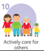 | Help in the house by doing the washing up, setting the table, tidying your room.  ‘Notice’ if someone is feeling down and ask if you can help.  Make and send a card to a neighbour to say that you hope they are okay.

