Grammar and Spelling Resources: Week Beginning Monday 13th July 2020 Year 5 and 6
This week we will be completing some revision activities to consolidate your learning and ensure you can remember what you have been learning this term. Repetition is important for building neural pathways in your brain! We will also complete some assessment activities. If you complete these and you are able to send them to Mrs Marsh at school, it would be really helpful to know how you are getting on!
Monday:
Today, please log in to spag.com and complete the end of term assessment that is set for you there.
If you do not have your username and password, call Mrs Marsh at school or email admin@farway.devon.sch.uk to ask for it and swap today’s work with Tuesday or Wednesday while you await a response.
Tuesday: Spelling and Handwriting
Practise spelling the following words from the Year 5 and 6 statutory list. What is the theme this week? Can you tell? (Clue: the list could be divided into 2 according to which way round they are.)
Can you include these words in sentences?

Wednesday: Statutory Spelling list for Year 5 and 6
Look at the list of words below that you have practised so far this term. If you can, ask someone to give you a spelling test. If you have a recording device, you could do this yourself by recording yourself reading the words and then listening and writing them down as you listen to the recording played back
accommodate
accompany
achieve
amateur
ancient
appreciate
awkward
bargain
cemetery
communicate
competition
conscience
conscious
controversy
correspond
desperate
dictionary
disastrous
embarrass
especially
exaggerate
familiar
foreign
frequently
government
harass
immediately
interfere
leisure
marvellous
mischievous
necessary
opportunity
parliament
physical
programme
pronunciation
recognise
recommend
rhyme
rhythm
secretary
shoulder
sincerely
symbol
system
temperature
vegetable
yacht

Keep hold of this list so that next week, you can practise spelling the words you still cannot remember.

Thursday: Relative Clauses – you were really good at writing with these in the spring term! Can you apply what you know about adding details?
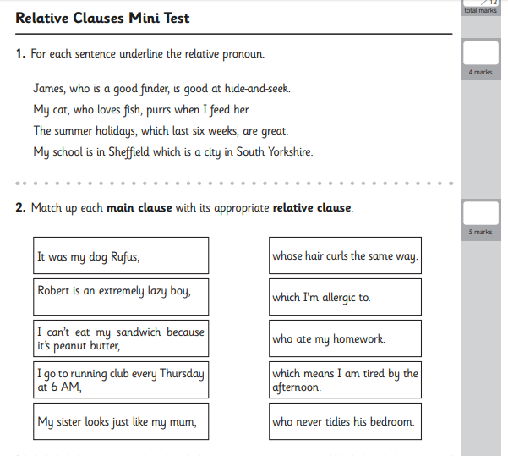
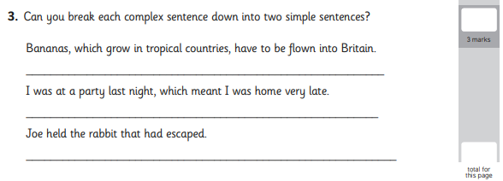

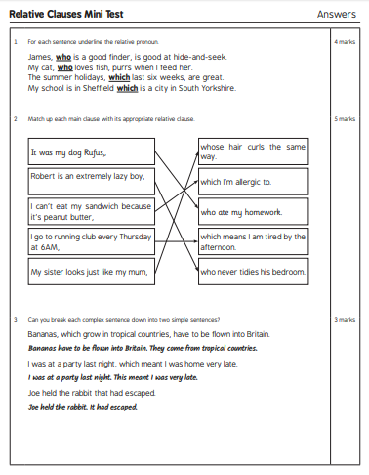

Friday: Inverted commas, dashes and Present Perfect tense revision (but no brackets: the alternative that also indicates parenthesis or additional detail!)
