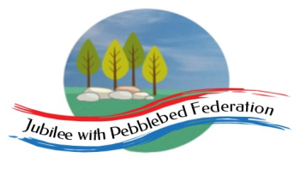 Home Learning Grid 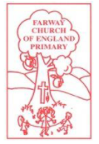
This is the home learning grid for the week beginning 26th April 2021. Please use this as a grid to support planning your child’s home learning. Additional resources will be made available on ‘google classrooms’, to support your child to access these activities. A daily reading and counting task are important to support your child to access their education but remember to have fun!
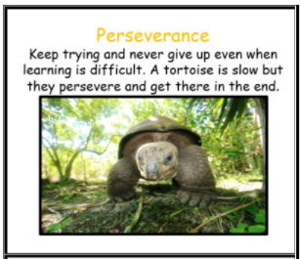
This week, we will be focusing on the learning behaviour: perseverance. It has been a very disruptive year to your school experience and some of you are beginning to feel quite deflated when faced with challenging tasks. Learning is a journey and sometimes things feel tough, but this is great because we learn from our mistakes and challenges. This week be the tortoise and keep trying! Never give up even when it gets difficult. Slow and steady, wins the race! But remember to have fun with your learning! It is your journey, so enjoy it!
If you have internet issues during a self-isolation period, you can still access Google Classrooms using your phones. You can also contact the school and we can try and support you with appropriate, alternative learning options.

Home Learning – week beginning 26th April 2021
Monday
Session 1  9:20 – 9:50 | Session 2  9:50 – 10:30  Literacy | Break time  10:30 – 10:50 | Session 3  10:50 – 11:50  Maths | Collective Worship  11:50-12:00 | Session 4  Afternoon  Holistic Wellbeing / P.E
Phonics  Reception – Phase 3 phonics – phoneme ear, written as /ear/  Year 1 – Phase 5  Unit 27, phoneme ‘e’, written as /ea/  Year 2 – SPAG  Learning suffixes – er/est/ment/ ful | Recap: Main characters, main events and ending.  Read children the 3 Little Pigs - can the children sort the information of the story under these headings? (use template sheet)  Reception – Listen to the story ‘The 3 Little Pigs’. Now use the story sequencing pictures to see whether the children can retell the story and whether they use any of the story language - observations.  Year 1 and 2  Teach: WALT: explore the specific language used in fairy tales.  Look through the Fairy Tales ppt and stop at the slide on ‘Openers’. Explain that Fairy tales often use a particular type of language such as ‘Once upon a time’. Focus on the spelling of once!  Explain that they also often have repeated refrains in them which often rhyme, ie: ‘’then I’ll huff and I’ll puff’’  Look through the story of 3LPs, together, can they spot any fairy tale language or repeated refrains?  Ask the children to choose their own fairy tale book (Rapunzel, Gingerbread Man, Little Red Riding Hood, 3 Billy Goats Gruff), then get them to explore the fairy tale. Can they find any ‘fairy tale language’? Use the openers poster to help them. Now, can they spot any repeated refrains?  Stick the writing frame (see resources), in their book as a guide for them.  As this is mostly a locate and copy comprehension exercise, remind them about accuracy and handwriting. | Do something physical that you enjoy. Move your body, have a drink, rehydrate your body and give your mind a break. | Reception/Yr1/Yr2 –  WALT: use 2D and 3D shapes to complete and make simple patterns.  Shape sorting PowerPoint – explore repeated patterns using 2D and 3D shapes – can you continue the patterns?  Now have a go at creating your own patterns using 2D and 3D shapes.  Take photo and make notes of the language chn use to describe their pattern.  Plenary – problem solving activity on PP.  Reception – using shape sponges, can they create repeated patterns using the 2D shapes?  Can they use the math vocabulary, talking about shape properties and identifying the shapes? | New theme - Justice | Dancing to music is a fabulous way to keep fit, whilst helping yourself stay happy and healthy in mind and body.  Why not listen to one of your favouite songs, feel the rhythm of the music and create a dance routine to accompay the music.  Check out Oti’s Boogie Beebies for some inspiration.  https://www.bbc.co.uk/programmes/m000jsdq  You could ask a parent to take some photos or even film your routine, so you can enjoy watching it back.  Why not practising dancing and leaping, outside in your scented garden, to enjoy all the space, fresh air and freedom to move in a way you enjoy.  Take a mental note of how you feel when you have finished.  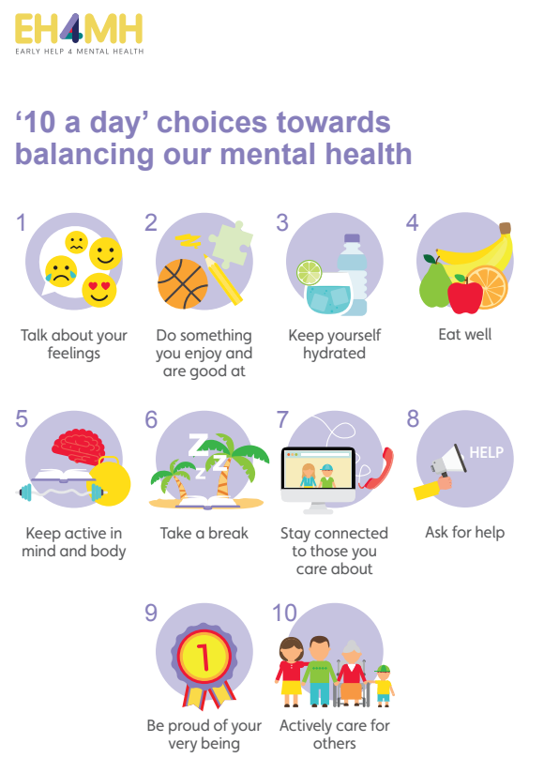
Tuesday | Literacy |  | Maths | Justice | Science
Phonics  Reception – Phase 3 phonics – phoneme air, written as /air/  Year 1 – Phase 5  Unit 27, phoneme ‘w’ ‘o’, written as /wa/  Year 2 – SPAG  Learning suffixes – er/est/ment/ ful | WALT: retell the fairy tale story of ‘The Enormous Turnip’.  Read the children ‘The Enormous Turnip’ – stress the importance of the 5 concepts of text (Reception). Ask: what do you think this story might be about? How do you know?  Can you think of any language they might use within the fairy tale story? (see Google classroom for shortened version to learn).  Share the story map with the children, demonstrating the accumulative value of the story.  Can the children identify the main characters, event 1 and event 2 and ending on the learning journey?  Children to work with adults to learn the story using actions to help them. Act it out for each other and record the children so that they can watch themselves doing this – engaging the audience / writer’s purpose.  - Introduce the key learning outcome for the sequence – to write their own, original fairy tale story.  Plenary: Read children the story of Sleeping Beauty. |  | Reception/Yr1/Yr2 – WALT: create symmetrical patterns  Recap – What do we mean by symmetrical?  Teach, yesterday we were exploring pattern making, using shapes and repeated patterns. Today, we are going to be creating symmetrical patterns!  Look through the PP (Google classrooms) – model creating symmetrical patterns, stressing symmetrical means the same – mirror reflection.  Children to start using the simple pattern templates and a mirror, then to move on to the more complex patterns as they progress.  Challenge: can you create your own symmetrical pattern? |  | WALT: Observe and describe how seeds and bulbs change over time as they grow into mature plants (ongoing project)  Today we will be ‘Sowing Sweet Peas’. Plant sweet pea seeds in eco-friendly plant pots made from newspaper and tape. Soak seeds for a few hours before planting to help them germinate. Carefully fill pots with compost, making a 3cm deep planting hole in each pot using fingers and dropping a seed into each. Care for the seeds, placing them in a sunny spot in the classroom and watering them daily.  Please note: Take care. Sweet peas are perfectly safe to touch, but the seeds are poisonous if eaten. Warn children that these seeds should not be eaten and make sure they wash their hands thoroughly afterwards. When the soil warms up in May you can sow them directly in the ground, still in their newspaper pots.  https://www.rhs.org.uk/plants/popular/lathyrus/growing-guide check out the website above to learn more about how to plant sweet peas.
Wednesday | R.E. |  | Maths | Justice | Reading
Phonics  Reception – Phase 3 phonics – phoneme ure, written as /ure/  Year 1 – Phase 5  Unit 27, phoneme ‘u’, written as /o/  Year 2 – SPAG  Learning suffixes – er/est/ment/ ful | I can retell clear, simple accounts of Bible text, ie: Matthew as a tax collector.  WALT: think more deeply about what the ‘good news’ means to Christians and how they can use this ‘news’ to help guide their own lives and behaviour.  Recap – what do we mean by ‘Good News’ and ‘Gospels’.  Teach: today we are going to be learning about the good news, that Jesus is a friend to the friendless.  Ask the class, if they were to choose 12 people to change the world who they would choose? (each child to choose and share at least one person with their peers – adding why they would choose this person (ideas to be written on the WB)  You might offer some photos of people they could choose (see google classroom Resources sheet 1), or think specific attributes, ie: brilliant, kind, inspirational, strong, clever …  Make a list of reasons for choosing the class’s 12 world-changers.  Teach: Jesus chose 12 men to be his world-changers, called the twelve disciples, but they were not who people might expect.  For example: Matthew the tax collector. From Matthew 9:9–13 tell the story of Jesus choosing Matthew, the tax collector as one of his 12 disciples, a man nearly everyone disliked. Encourage chn to join in with the story, chorusing ‘Oh no, Jesus, not him!’ when Matthew’s name is mentioned. https://www.youtube.com/watch?v=0nqllVTt1bA  Ask: Why was it a surprise?  Christians teach that Jesus brought good news because he was a friend to those left out by other people. A friend to the friendless.  Tax collectors were despised by the Jewish people because they worked for the occupying Roman forces, taking money from the Jewish people to give to the Roman armies.  After reading the story, ask chn: ‘how do you think Matthew’s life was changed after his encounter with Jessus? – Jesus became a ‘friend of the friendless’ (linking to themes of forgiveness and peace).  Compare with the story of Zacchaeus, Luke 19:1-10: Matthew becomes one of Jesus’ 12 disciples.  Teach: both these accounts (stories) are part of the ‘Gospel’ of Jesus, meaning ‘good news’.  Recap: What was the ‘good news’ that Jesus brought through telling these Gospels?  Task:  Draw or write – how this ‘good news’ teaches Christians to be a better person.  Plenary:  Reflect on our class rules and playground rules? How could we improve them to ensure Jesus’ ‘good news’ remains at the heart of our school life? |  | WALT: estimate amounts  Reception – To work with DW or EW (other to take observations for class teacher, with yr1&2).  Estimation station (more than / less than) – using: 22 small stones, 5 large stones, 30 daisies, 11 dandelions.  Ask: which has more? Most? Least? Fewer? Less than?  Estimate: how many objects do you think are in the jar? Explain your thinking? – write answer on post-it notes and compare your answers (TA to join in).  Finally, count out the total number of objects in each jar (one at a time), checking for 1:1 correspondence, and stressing cardinality using the noun (11 is the last number you counted, there are 11 dandelions).  Year 1 and 2  WALT: sort shapes according to their properties.  Recap 2D and 3D shape names with the children. Children to sit in a semi-circle, place two hoops on the carpet in the middle.  Prior to session, place a variety of 2D and 3D shapes inside a bag, randomly select one shape from a bag at a time. Ask chn ‘What shape is this?’ ‘How do you know?’ ‘Can you use your maths talk to describe the shapes by describing their properties?’  When all shapes are out of the bag, ask the children to sort them into 2D and 3D shapes. How do they know?  Next, ask children to sort the 2D shapes, according to: those with four vertices, those without four vertices.  Can the children think of other ways we can sort the shapes, according to their different properties?  Please take photos and TA to record what the children say, ensuring at least one observation recorded for each child.  Challenge: 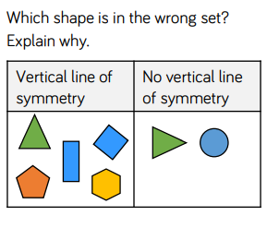 |  | WALT: Recognise simple recurring literary language and conventions in taught fiction genres, non-fiction genres and poems.  Children will be exploring a variety of reference books (plants/gardening). Together, spend time identifying the key features of non-fiction texts, titles or headings, subheadings, diagrams, photographs, pictures, labels, captions, index, contents and blurb.  Photocopy a chosen page, from one of the non-fiction books, and stick it in the centre of their topic book – using a ruler, ask the children to draw arrows to the key features on their non-fiction page and label appropriately, using the headings above.
Thursday | Literacy |  | Maths | Justice | PSHE
Phonics  Reception – Phase 3 phonics – phoneme ur, written as /er/  Year 1 – Phase 5  Unit 27, Language session – I’m, I’ll, it’s, I’ve  Year 2 – SPAG  Learning suffixes –er/est/ment/ ful | WALT: write simple and compound sentences using ‘and’ and punctuation.  Cut up simple sentences from the different fairy tales we have explored so far – 3 LP, J&BS, SB, 3BGG…and cut these into further sections of subject, verb and object (some will include an adverbial too). Use blue card for subjects and objects and pink for verbs. See resources.  Reda the sentences with the children, identifying the verb, subject/object (noun) and adverb.  Teach the children the structure of writing simple and complex sentences - model for the children picking a subject, e.g. Goldilocks (subject) + a verb planted + a Magic Bean(object) ‘and’ it slowly (adverb) grew and grew…  Model swapping the objects/verbs around to create new sentences with silly combinations and practise reading them. Establish which part is the verb and that we must have a verb in the sentence.  Practise saying the sentence and hammering the verb. Use actions for capital letter and full stop.  Children to write their favourite sentence in their books – does it make them laugh?  Display sentences on the WW. |  | Year 1 and year 2 – shape assessment (end)  WALT: apply our knowledge of shapes to revisit and support our understanding of repeated addition (year1) and multiplication (year2).  Show chn the PP – and ask: how many vertices are there altogether?  Chn can write their answers on a WB and explain their thinking.  Complete tasks in their books.  Challenge:  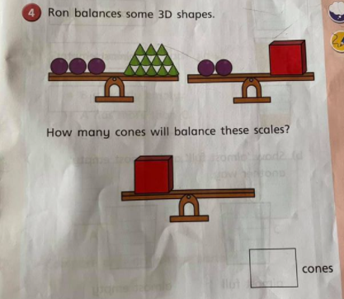 |  | WALT: Learn to recognise that not everyone feels the same at the same time, or feels the same about the same things.  Explore a range of smells, both pleasant and unpleasant, using sensory tubs. What can they smell? What might be inside? Sort smells into those they like and those they don’t like. Do the smells remind them of anything?  Note: Smell has a strong link to memory and emotion. Explore what memories are evoked by the smells, encouraging children to record their memories in drawing and writing activities. Smells to include could be burned toast, vinegar, fresh bread, coffee, perfume, orange peel, freshly cut grass, manure, tree bark, sweets, soil, mint and an old smelly sock. Use your imagination. The possibilities are endless.
Friday | Literacy |  | Maths | Justice | DT
Phonics  Reception – Phase 3 phonics – Language session (all/was)  Year 1 – phase 5  Unit 27 – assessment and tricky words (phase 5)  Year 2 – tricky words – though/through | WALT: use subordination and coordination to join sentences together and give more information.  Give the children two single clause sentences using the story as a model (The Enormous Turnip). Hammer the verbs. Model how to join the sentences using ‘and’/’or’/’but’ /’therefore’/ ’because’ - then finish with a full stop. Give children other combinations of single clause sentences to join with coordination.  Use CL card and full stop cards to practise putting them in the correct places. Introduce (Y2) the term ‘compound sentence’. Demonstrate how we don’t need to repeat the subject after ‘and’.  Display some examples on the WW. |  | Year 1 and 2 – spend 20 minutes using TTrocks stars at beginning of the session – recapping multiplication and division of 2s, 5s, and 10s.  Complete fraction elicitation sheet.  Reception – to recap number composition to 10 – number bonds / including subtraction, using their knowledge of number bonds. |  | WALT: Choose appropriate components and materials and suggest ways of manipulating them to achieve the desired effect.  Today, we will be making our very own batch of scented play dough! Follow the instructions available on google classroom. Then add your favourite scent! You could make several batches, using different scents, for example: lavender, basil (grind the basil leaves into a watery paste using a pestle and mortar) rose oil or mint tea.  Encourage children to carefully select which scents they want to add to their batch of play dough, explaining their choices. Do they want to attract others to play with their dough by giving it a beautiful smell? Or maybe they want to surprise others with a smell they weren't expecting?  Help them to measure out and add the ingredients, mixing and kneading, then play by rolling, squeezing and stretching the dough whilst enjoying its fragrant smell!  Please take photos!

