**Week Beginning 18th May**

**Grammar Task Monday**

Year 3 and 4**:** Types of nouns

Review your understanding of different types of **nouns** by reading the information below and then complete the task below:

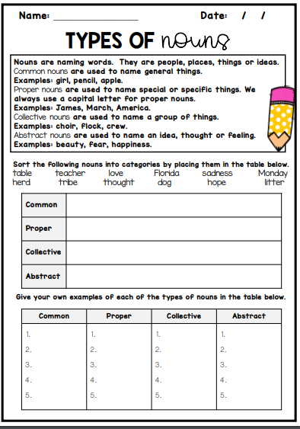

Year 5/6: Revision of nouns

Look at slides 1-7 of <https://www.slideshare.net/ghos001/grammar-power-point-presentation2> to revise different types of nouns, completing the exercises using the tables below.

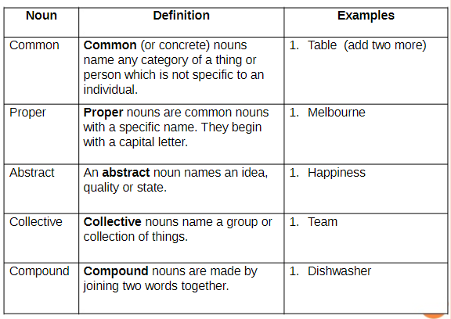

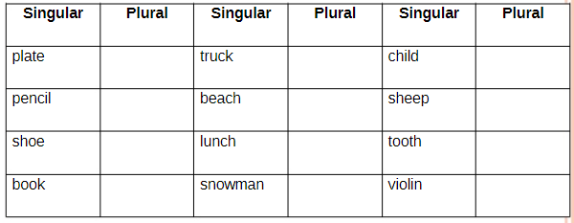

|  |  |  |  |  |
| --- | --- | --- | --- | --- |
| 20 nouns in 20 seconds – which nouns did you find? | | | | |
|  |  |  |  |  |
|  |  |  |  |  |
|  |  |  |  |  |
|  |  |  |  |  |

You could also use the BBC bitesize lesson at <https://www.bbc.co.uk/bitesize/articles/z4d6t39> to revise and practise identifying **expanded noun phrases.**

**Grammar Task Tuesday**

Year 3 and 4: CommonNouns and Proper Nouns

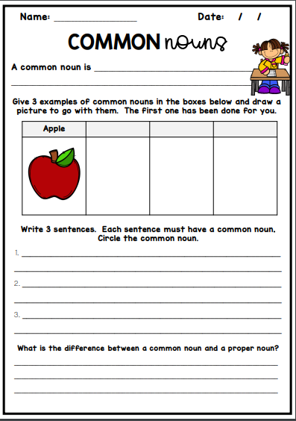

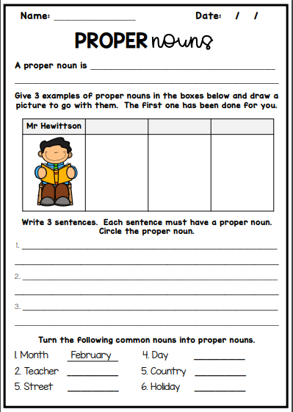

Year 5: Compound nouns and pronouns

**Compound nouns** are nouns that are created by combining two words together, such as *teabag, handbag*  or *paperclip.*

Complete slide 8 of <https://www.slideshare.net/ghos001/grammar-power-point-presentation2> to explore compound nouns (below), then watch the songs on <https://www.youtube.com/watch?v=aSwTlQNLqPA> and/or <https://www.youtube.com/watch?v=aSwTlQNLqPA> and read the information on slides 9-20 of the Powerpoint above to revise and extend your understanding of pronouns, using the tables below to record your responses:

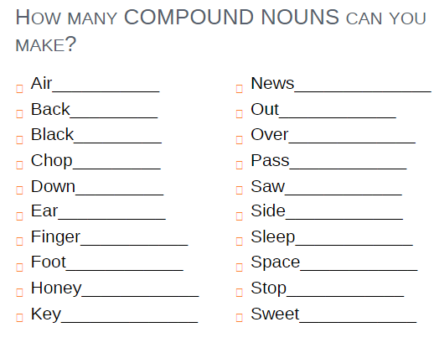

Slide 11: (You may wish to refer back to slide 10 in order to write these sentences.) Write some example sentences using the different types of personal pronoun from the chart on slide 10.

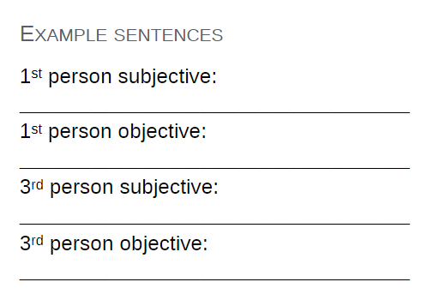

Slide 15: Reflexive Pronouns

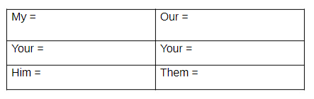

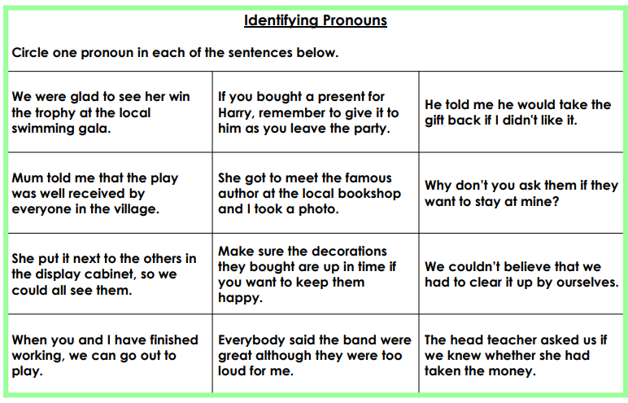

**Grammar Task Wednesday**

Year 3 and 4: Collective Nouns and Abstract Nouns

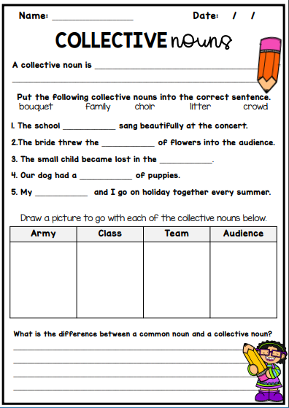

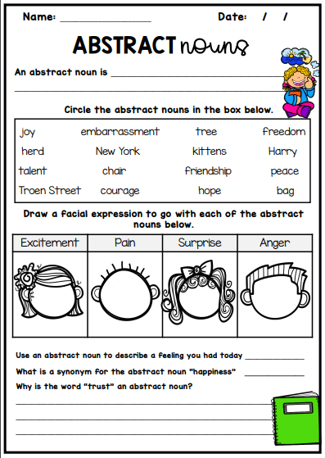

Year 5: Verbs

Look at slides 21-25 of <https://www.slideshare.net/ghos001/grammar-power-point-presentation2>

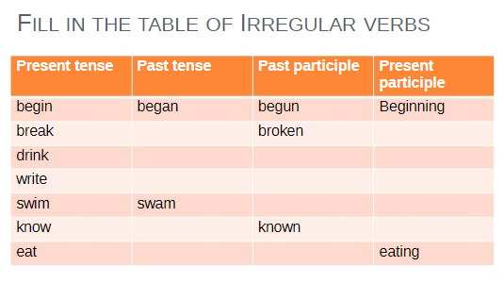

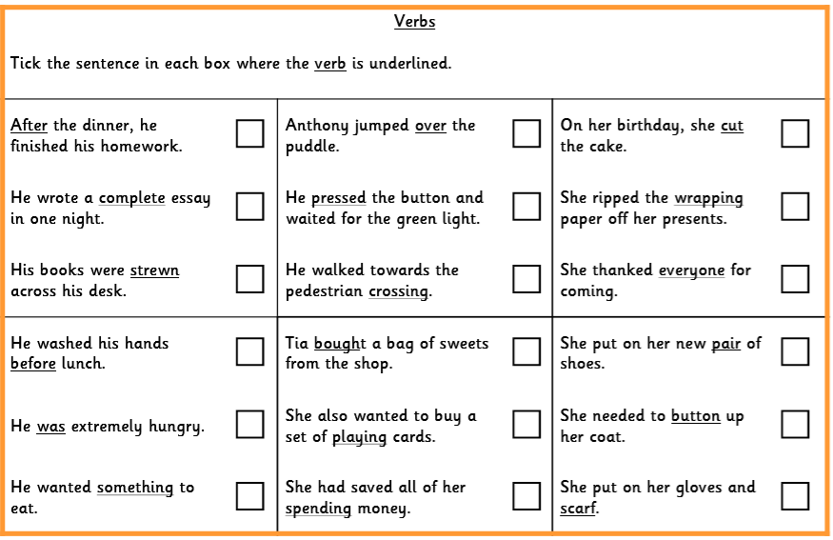

**Grammar Task Thursday**

Year 3 and 4: Four types of Nouns

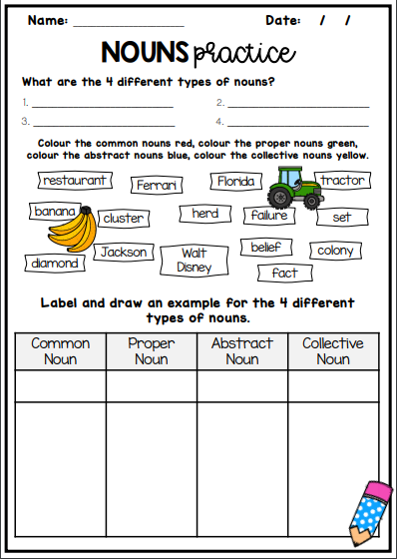

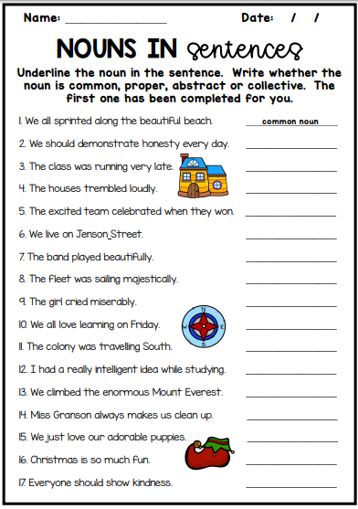

Year 5 and 6: Modal Verbs

Use the BBC Bitesize lesson and related activities found through the link below to revise **modal verbs.**

<https://www.bbc.co.uk/bitesize/articles/z4y492p> and/ or complete the work below to revise modal verbs.

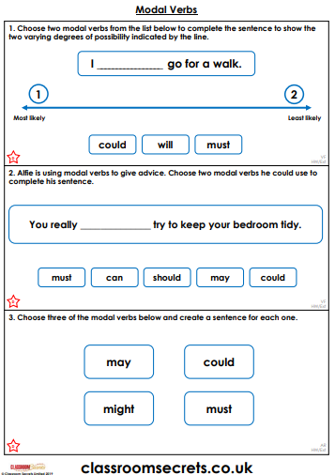

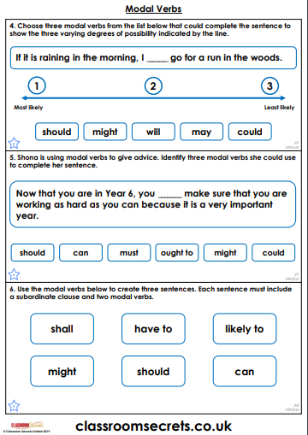

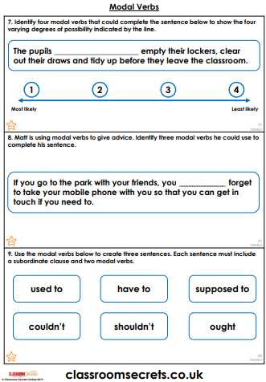

**Answers: Year 3/4**

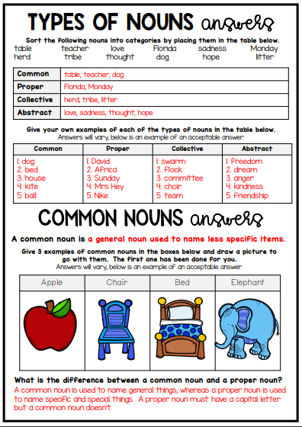

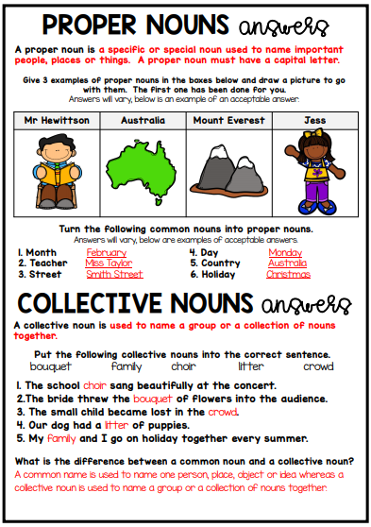

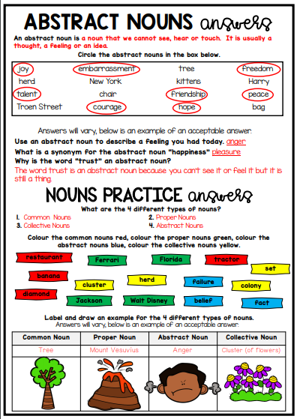

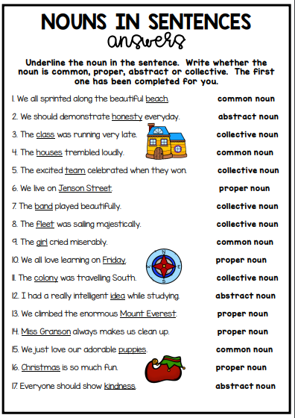

**Answers Year 5:**

**Monday**



violins

teeth

sheep

children

snowmen

lunches

beaches

trucks

books

shoes

pencils

plates

**Tuesday**



eg. He is going to bed soon. She will soon go home. They are all very tired.

eg. Dad asked if Lucy was speaking to him. Mum insisted that everyone listen to her. She asked them both to be quiet for a minute.

eg. Please pass that plate over here to me. Mum called us in for dinner.

eg. I am going to watch that today. We are at home.



themselves

yourselves

ourselves

himself

yourself

myself

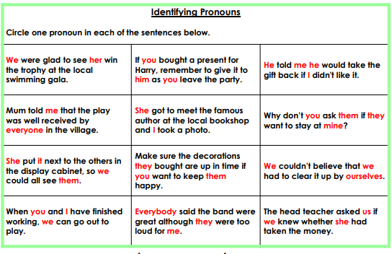

**Wednesday**



eaten

ate

knowing

knew

swimming

swum

writing

written

wrote

drinking

drank

drunk

breaking

broke

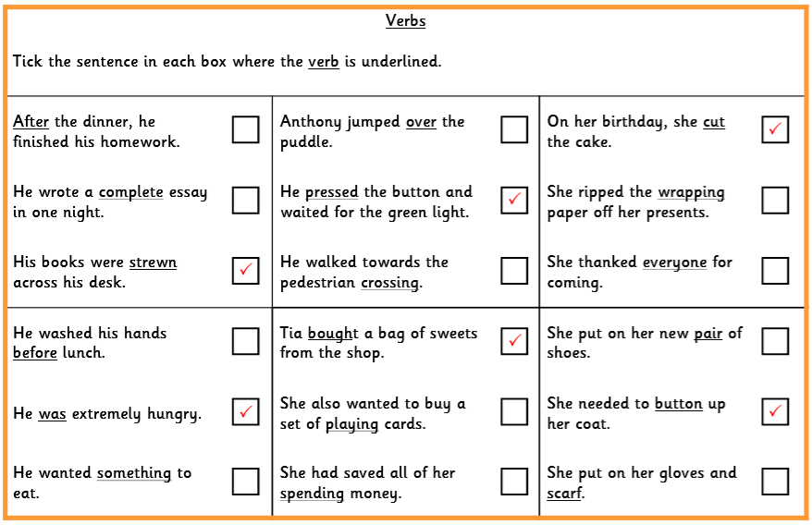

**Thursday**

