Week Beginning 4th May
Spelling Task Monday

Year 3: Vowels and consonants
Watch the video on https://www.bbc.co.uk/bitesize/topics/zxfyjty/articles/zs2crdm to revise vowels and consonants from KS1. There is also a fun song on https://www.youtube.com/watch?v=arQxkdRYyE4 which, although very young, will help you to consolidate the vowel sounds. Then, complete the activities below:
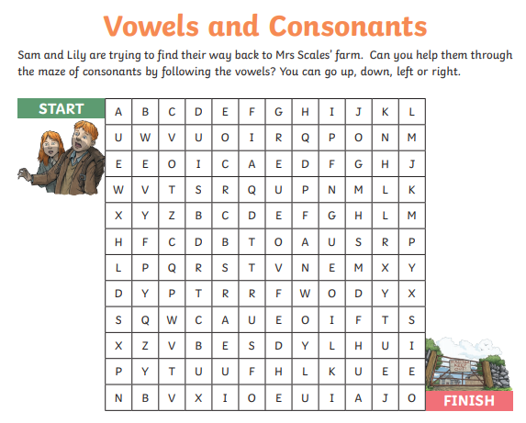
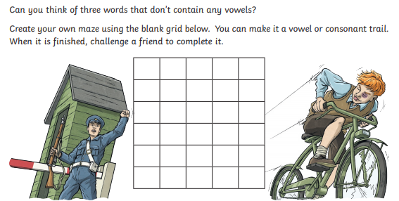

(Answers given at the end of this document to help you check your answers)

Year 4: -ous suffix
Cut out the words in the chart below to make word cards.
space | envy | envious | courage
fury | monster | poison | mountain
fame | courageous | spacious | vary
furious | mountainous | poisonous | various
famous | danger | dangerous

Then match the pairs of words that belong together. Have a look to see what happens to different words when you add the –ous suffix. What do you notice?
What word class do most of the root words belong to? (monster, envy, poison, fury, fame, danger, space)
Look at the endings of these words and sort them into groups – how does the ending of the root word affect what happens when you add the –ous ending?

The letters ‘ous’ are a suffix, meaning ‘full of’.
Usually, adding ‘ous’ changes a noun into an adjective, as in danger to
dangerous and there are conventions for the spellings:

- Words ending in ‘y’: delete the ‘y’ and add ‘ious’ (glory/glorious)
- Words ending in ‘ge’: do not drop the ‘e’(courage/courageous)
- Words ending in ‘ce’: drop the ‘e’ and add ‘ious’ (space/spacious
Words ending in ‘our’: change to ‘or’ and add ‘ous’ (humour/humorous)

There is a handy little BBC Bitesize video that helps to explain this suffix: https://www.bbc.co.uk/bitesize/topics/zqqsw6f/articles/zqcpv9q

Note: keep the word cards to use them again tomorrow.

Year 5: ie/ei
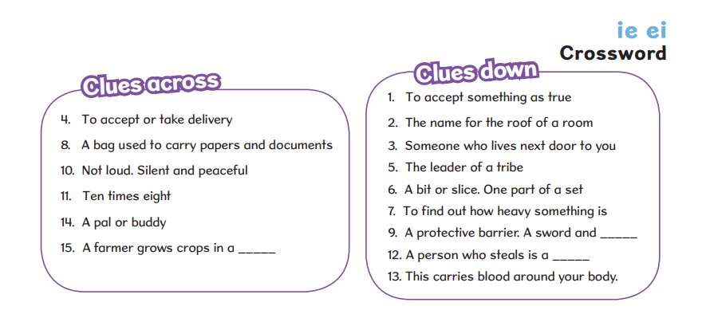
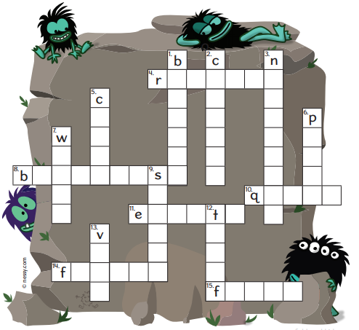
See end of this document for answers

Spelling Task Wednesday

Year 3: Vowels and Consonants
Have another look at the words you practised spelling last week. Write them out again using different colours for the vowels and the consonants. Remember the vowels are a, e, i, o and u. All the other letters are consonants.

Which words contain vowel digraphs? (A vowel digraph is when two vowels together create one sound: eg. ou, ai, ea, ee, oo)

Can you find some words in which a vowel digraph is used for a ‘short’ vowel phoneme?
eg. touch (the ou makes a short ‘u’ sound).

Year 4: -ous ending
Get out the cards you cut up yesterday. If you have someone you can play with, turn them all face down and play a game of ‘Memory Pairs’. (ie. Take it in turns to turn over two cards – if they make a pair, keep them and have another go. If not, put them back where you found them and play passes to the next person.) Sort the cards into two piles- the root words and the words with suffixes added. Take the root words one at a time and see if you can spell the words with the –ous suffix added. You may want to read through the guidelines from yesterday first. When you have gone through all the words, use the other pile of cards to check your spellings.

Challenge: Can you find other root words that will fit in each category and other words containing the –ous suffix? Try to find one or two words that are new to you, check out the meanings of those words and try using them in a sentence.

Year 5: Linking i
Have a look at the words in the wordsearch below. Look carefully at the spellings as you search for the words. All these words have something in common – a letter I used before a suffix. Do you know what each of the words means? Are you able to use each of them in a sentence? Have a go! Take care to remember the linking i!
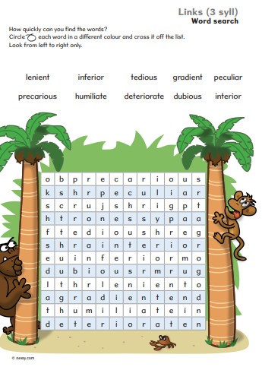

Spelling Task Thursday

Year 3: Year 3: Vowels and Consonants

Remember, when ‘short’ vowel sounds appear in the middle of longer words, they are often followed by a double consonant to indicate that the sound s short, not long. Remember the difference between hoping and hopping?
Have a look as this list of words: surround, attempt, correct, bottle, challenge, illegal, matter, intelligent, carry, stunning, shipped.
Try writing these out using different colours to show where the short vowel sound is followed byt a double consonant. Can you find other words like this? On https://www.spellzone.com/word_lists/list-6050.htm you will find these and other words, with a range of games and activities to help you practise spelling these words.

Year 4: -ous suffix
Have a look at https://www.spellzone.com/unit29/page4.cfm to remind yourself of the rules for adding the –ous suffix. Then try out the games and activities on https://www.spellzone.com/word_lists/list-428920.htm to practise spelling words that contain this suffix.

Year 5: linking i
Here are some more words that use the linking ‘i’ that we looked at yesterday. Circle the correct word to match the definition:
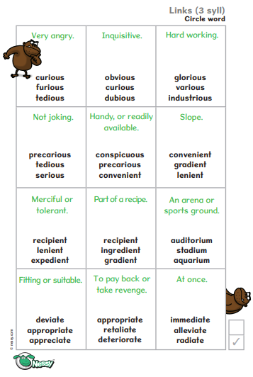
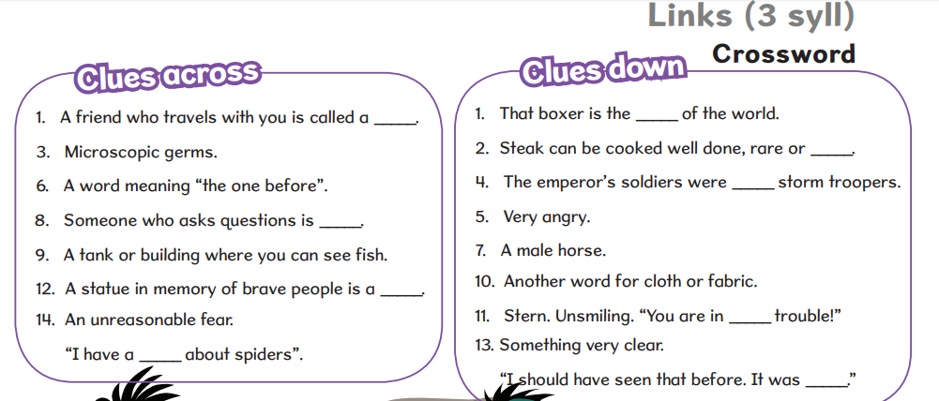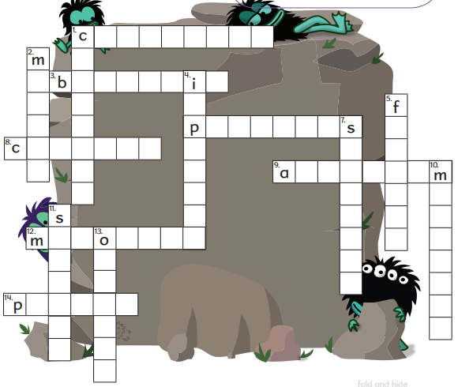
(See below for answers)

Year 3: Answers - Monday

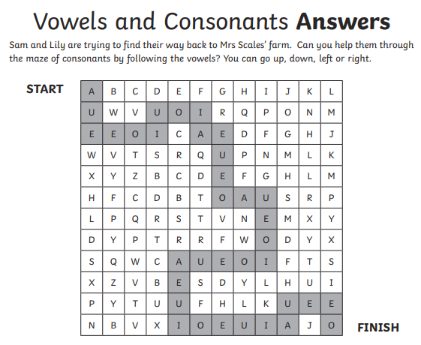
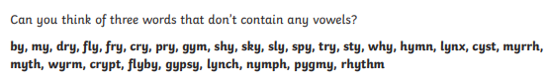

What do you notice about each of these words? What do they have in common?

Year 5: Answers – Monday
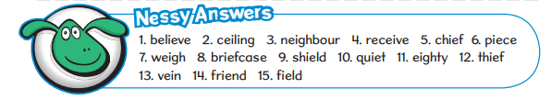

Year 5: Answers – Thursday

