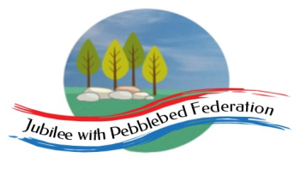 Home Learning Grid 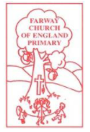
This is the home learning grid for the week beginning 29th March 2021. Please use this as a grid to support planning your child’s home learning. Additional resources will be made available on ‘google classrooms’, to support your child to access these activities. A daily reading and counting task are important to support your child to access their education but remember to have fun!
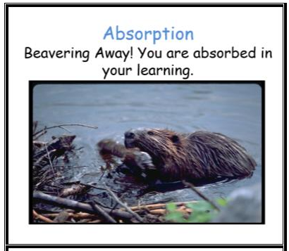
This week, in school, the children will be finning their PIRA and PUMA assessments, so there will be lots of opportunities for the children to choose their own learning tasks and activities to practise some of the skills we identified over the last few weeks. Therefore, Class 1 will be focusing on the key Learning Behaviour: Absorption. Recognising your own learning needs and choosing appropriate challenges is a real skill as a learner. Why not be like a beaver and become absorbed in your learning, applying your knowledge in different ways and challenging yourself in areas you feel less confident in. I cann’t wait to see which activities you choose! Please don’t hesitate to contact Mrs Jackson with any concerns or celebrations, you would like to share.
If you have internet issues whilst accessing your learning, you can still access Google Classrooms using your phones. You can also contact the school and we can try and support you with alternative learning options.

 | Farway C of E Primary School - Class 1 – week beginning 29th March
 | Phonics | Literacy / R.E | Mental Health | Maths
Monday  Please read for at least 10 minutes every day with an adult or a sibling.  You can use the Bug Club online books to access books in line with your child’s phonics ability. | Phonics - https://www.activelearnprimary.co.uk/login?e=-1&c=0#bugclub_phonics  Reception –  Recap Phase 3 sounds  Year 1 & 2  Recap Phase 5 sounds – unit 28  Once you have completed your phonics session – read for 15 minutes, on one of your allocated books and answer the Bug questions. | Literacy  Reception – WALT: continue discussing the sounds we hear.  Go for a little ‘sound walk’. What sounds can you hear? Do the sounds change when outside? Or inside? Maybe you could make a tally to record how many inside and outside sounds you can hear.  Discuss the sounds you hear. Can you make the sound with your mouth? Can you think of a word to describe the sound?  Challenge: (OW) - Can you think of any rhyming words for each sound?  Year 1 and 2  WALT: plan our own poem, boxing up our ideas.  Recap the class poem (innovate) by performing aloud together as a class. Discuss the similarities and the differences between the class poem and Michael Rosen’s poem. Note these on the WB.  Ask: what do you like about the class poem?  Can you remember what we mean by onomatopoeia?  I wonder if anyone notices any rhyming words in the class poem?  Now, have a go at planning your own poem, in the style of Michael Rosen’s poem, ‘The Rhythm of Life.’  Remember to include: capital letters, correct punctuation, rhyming words, onomatopoeia, repeated refrains to create rhythm and structure. | Practise meditation technique we practised in Literacy - 5 things you can see... 4 things you can feel… 3 things you can hear… 2 things you can smell… 1 thing you can taste.  Now you feel calmer, what do you notice about how your body feels?  Pick one of the Mindfulness senses challenge cards, and have a go at doing the activity on the card for at least one minute or more. | Maths  Reception, Year 1 and 2  Today, the children in Class 1 will be completing their PUMA assessment.  WALT: continue exploring 2D shapes and discuss the different properties  https://www.bbc.co.uk/bitesize/topics/zjv39j6  If you are home learning, then have a look through these videos and have a go at creating your own dinosaur shape picture – using 2D shapes.  Remember to identify the shapes you have drawn, discussing the properties of each shape with an adult.  Think about: How do you know that the shape is a triangle?  How many more edges do you need to make a square?  Can you identify the vertices on your shapes? Can you label the edges and faces?  Do all 2D shapes have only one face?
Tuesday  Please read for at least 10 minutes every day with an adult or a sibling. | Phonics - https://www.activelearnprimary.co.uk/login?e=-1&c=0#bugclub_phonics  Reception –  Recap Phase 3 sounds  Year 1 & 2  Recap Phase 5 sounds – unit 28  Once you have completed your phonics session – read for 15 minutes, on one of your allocated books and answer the Bug questions. | Literacy  Reception – WALT: use our phonics knowledge to write about the sounds we hear.  Give the children an image of a different object (that makes sounds) – can the children remember what sound the object makes. Can they have a go at writing the onomatopoeia word: bang, crash, ting…  OW – write a sentence – ‘The drum goes bang. The car horn goes beep…  Year 1 and 2  WALT: write our own poem, in the style of Michael Rosen’s ‘The Rhythm of Life’.  Using your plan from yesterday, have a go at writing your own poem. Once you have written it, re-read and revise for spelling, corrects / improvements you need to make. | Practise the meditation technique we practised yesterday - 5 things you can see... 4 things you can feel… 3 things you can hear… 2 things you can smell… 1 thing you can taste.  Now, choose one of the Easter mindfulness colouring sheets and sit outside to do some ‘mindful’ colouring – remember to try and keep your colouring in the lines. | Maths  Reception/Year 1/ Year 2  WALT: continue exploring 2D and 3D shapes.  Today, you are going to go on a shape hunt around your home/ learning environment. Warm up your brains using the interactive pdf – available on google classroom.  Now, go searching round your local environment / home. What shapes can you find? Can you describe the properties of each of the shapes you find?  Maybe you could make a tally chart of the shapes you find and put it into a block diagram to show your findings more clearly (linking your learning!)
Wednesday  Please read for at least 10 minutes every day with an adult or a sibling. | Phonics - https://www.activelearnprimary.co.uk/login?e=-1&c=0#bugclub_phonics  Reception –  Recap Phase 3 sounds  Year 1 & 2  Recap Phase 5 sounds – unit 28  Once you have completed your phonics session – read for 15 minutes, on one of your allocated books and answer the Bug questions. | R.E.  WALT: to continue exploring the question: why do Christians place a cross in their Easter garden?  Watch a clip of the Easter story.  https://www.biblesociety.org.uk/get-involved/easter/the-seriously-surprising-story/  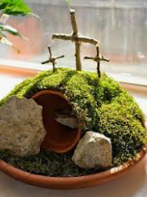  Children to finish creating their Easter garden, discussing what they have included and why (Tas to take photos and make observational notes about what the children say).  Finally, take part in an Easter egg hunt.  5 eggs are hidden for each child – 5 different colours. The children have to find all 5 eggs. Inside the eggs are images of different stages of the Easter story. Once the chn have found all 5 images, they need to sequence them correctly, and re-tell the Easter story to a friend, to win a chocolate Easter egg! | Practise Mindfulness ‘growing flower’ activity, that we have practised in school together.  Now, have a look at the flower ‘I can do’ sheet and colour all the petals in that you are currently go at doing. Have a look at any that you feel unsure of. These will be your target ‘I Can’ goals.  Please share these with Mrs Jackson, together we can create experiences to practise these goals together. | Maths  WALT: use our knowledge of shapes to build our own 2D and 3D shapes.  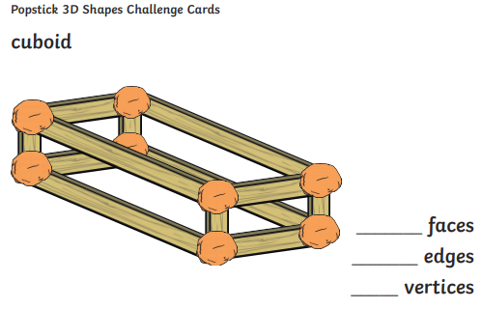  WALT: use our knowledge of shapes to create our own Easter cards.  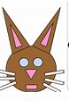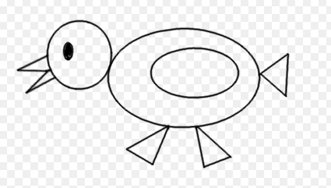
Thursday  Please read for at least 10 minutes every day with an adult or a sibling. | Phonics - https://www.activelearnprimary.co.uk/login?e=-1&c=0#bugclub_phonics  Reception –  Recap Phase 3 sounds  Year 1 & 2  Recap Phase 5 sounds – unit 28 | Today, class 1 are going to have a morning finishing our tasks from the week and exploring continuous provision.  They are going to have a go at:  - Painting spring flowers  - Solving math challenges (Nrich)  - Reading on Bug Club  - Practising TTRock Stars  - Writing instructions for how to make an Easter garden, in the style of ‘How to Wash a Woolly Mammoth.’  - Performing their poem to the nursery children  - Easter crafts  - Decorating Easter cards  - Celebrating Easter playing musical chairs and outdoors games | Practise Mindfulness ‘growing flower’ activity, that we have practised in school together. | Maths  WALT: explore lines of symmetry in shapes.  We will continue to explore this further when we return in the summer term. Today, we are just going to start exploring the concept ‘lines of symmetry’ and have a go at drawing our own lines of symmetry on 2D shapes.  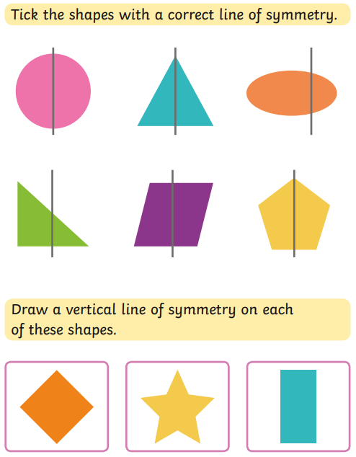
Friday  2nd March |  | Enjoy your Easter holiday!

