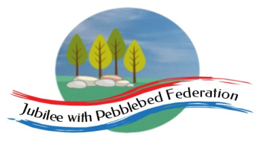 Home Learning Grid 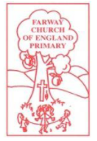
This is the home learning grid for the week beginning 10th May 2021. Please use this as a grid to support planning your child’s home learning. Additional resources will be made available on ‘google classrooms’, to support your child to access these activities. A daily reading and counting task are important to support your child to access their education but remember to have fun!

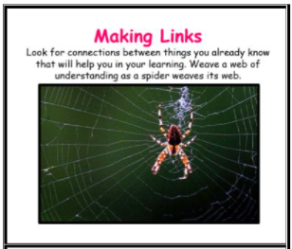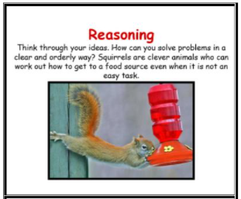

This week, we will be focusing on making links in our learning and experiences to support us in our writing of our very own fairy tale story. We will also be continuing to apply our knowledge of fractions and operations to practise problem solving in Maths. Therefore, the Learning Behaviours, for Class 1, will be: making links and reasoning. If you have internet issues during a self-isolation period, you can still access Google Classrooms using your phones. You can also contact the school and we can try and support you with appropriate, alternative learning options.

Home Learning – week beginning 10th May 2021
Monday | Literacy | Mind break | Maths |  | P.E.
Phonics  Reception: Phase 4, unit 12 adjacent consonants (CVCC)  Year 1: Phase 6, unit 28, suffix ending: split diagraph silent ‘e’ + ‘ing’, ‘ed’.  Year 2:  SPAG – writing verbs in present and past tense (regular and irregular) | WALT: box-up and plan our own fairy tale story.  Recap the structure of our fairy tale story – Main characters, Setting, Openers, Beginning, Middle, Ending.  Using the box-up structure chn begin planning their own story, exploring: who, what, where, when, why… problem/ solution…  Together, look through writing and correct any spellings. |  | WALT: continue recognising a quarter as one of four equal parts (Yr 1 & 2)  BM and DW – applying knowledge to problem solving  Recap - half  Have a go at the halving problem-solving questions on PP (assess who’s confident and who needs more support)  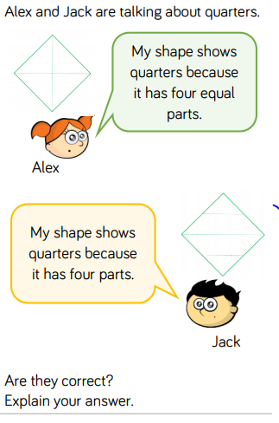  Recap – what do we mean by quarters. Show me a quarter (give chn a square of paper)  Complete main task – PP – chn draw 3 squares in their book (practise using a ruler) – show one quarter, more than a quarter, less than a quarter.  Lots of maths talk – equal parts, four equal parts, 3 quarters = 3 of those 4 equal parts. 2/4 = ½  Comparative work. |  | Holistic Wellbeing  Take some time this afternoon to do an hours exercise of your choice. Go for a run, go cycling or even skip around your garden. Listen to the sounds around you, use your sense to smell the different flowers and feel the sun on your face.  Spending time outdoors, in nature, exercising and doing something you enjoy, are fabulous ways to help stay healthy in both your mind and your body.  Have a look at the ten a-day to balancing mental health and think about the different ways you can help keep happy and healthy.  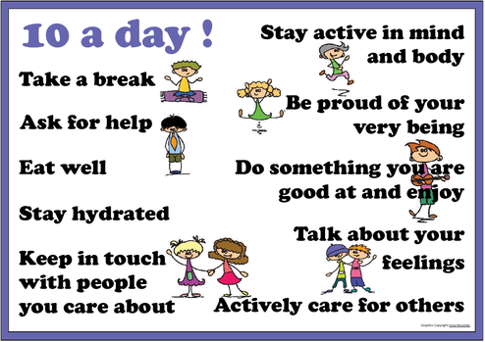
Tuesday | Literacy |  | Maths |  | Science
Phonics  Reception: Phase 4, unit 12 – language session 1  Year 1: Phase 6, unit 28, language session  Year 2:  Continue verbs for those who need more practise.  Revisit spelling homophones and near homophones | WALT: write a descriptive piece of writing about a main character or story setting.  Recap using adjectives, expanded noun phrases to provide more description about the subject (main character) or setting – emphasis purpose, to engage the reader.  Recap using verbs to tell the reader what your character is doing / likes doing (adding adverbs to add more information)  Children to write this piece of writing independently – towards assessment piece. |  | WALT: find a quarter of an amount  Practise mathematical graphics showing quarters on amounts.  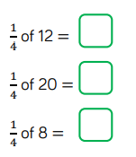  Use quartering place mats and concrete resources, where necessary to support learning – finding a quarter from different amounts. Can chn identify the whole amount when given a half or quarter? (yr2)  Using bar model to support/show their thinking.  Challenge: using fraction knowledge to solve word problems (PS) |  | WALT: Use our observations and ideas to suggest answers to questions.  Match the five senses to images of body parts that we use for each sense. Imagine what it might be like to lose one or more of their senses by wearing a blindfold and trying to eat cereal, blocking their ears and trying to follow an instruction or holding their nose and eating an apple or onion. Talk about what it feels like to lose a sense.  Watch the video of Helen Keller.  Links available of Google Classroom.
Wednesday | Literacy |  | Maths |  | Art
Phonics  Reception – Phase 4, unit 12 – adjacent consonants (CCVC)  Year 1 and 2 – Phase 6, unit 30, prefix ‘re’  Yr2 – explore how the prefix changes the meaning of the root word. | WALT: write the beginning of our story (assessment)  Today, children will complete their second assessment piece – writing the opening paragraph of their story. Stress importance to the children, not to rush it and to provide as much information as possible to the reader, using descriptive writing and setting the scene.  Children to evaluate/revise work after writing it, with help of an adult. |  | WALT: find the whole amount when given a half or a quarter (yr 1)  WALT: find a third of a shape or an amount (yr2)  https://whiterosemaths.com/homelearning/year-2/spring-week-11-number-fractions/ - find a third |  | WALT: apply our artistic knowledge to create illustrations for our fairy tales.  This half term we have been focusing on observational drawings of scented flowers, using hand lenses to look closely at colours, shapes and patterns. Today, we will be applying these skills to creating illustrations for your fairy tale stories.  Explore a variety of different fairy tale illustrations (Google Classroom), take time looking at the different shapes and colours. What do you like best about the illustrations?  Have a go at creating your own observational drawings, using the sketching skills you have been learning. Choose from a range of drawing materials, such as chalks, felt pens, wax and pencil crayons and pastels, to record their ideas. Try smelly pens to add a sensory dimension to artwork.
Thursday | Literacy |  | Maths |  | PSHE
Phonics  Reception – Phase 4, unit 12 – language session (2)  Year 1 and 2 – Phase 6, unit 30, prefix ‘un’  Yr2 explore how the prefix changes the meaning of the root word. | WALT: write the middle paragraph of our fairy tale story.  Depending on how successful the chn’s writing was yesterday (independently – beginning), will depend how much help the children receive today with their writing.  Have they used: adverbs, verbs, past/present tense correctly? Have they used expanded noun phrases to add detail? Have they shown progress in their individual targets? Have they used openers and story language?  May need to be a modelled ‘shared write’ initially. |  | WALT: explore unit fractions (yr2)  Consolidate our learning (yr1)  https://whiterosemaths.com/homelearning/year-2/spring-week-11-number-fractions/ - unit fractions  Activities available on curriculum maestro. |  | WALT: recognise that not everyone feels the same at the same time, or feels the same about the same things.  Explore a range of smells, both pleasant and unpleasant, using sensory tubs. What can they smell? What might be inside? Sort smells into those they like and those they don’t like. Do the smells remind them of anything?  Note: Smell has a strong link to memory and emotion. Explore what memories are evoked by the smells, encouraging children to record their memories in drawing and writing activities. Smells to include could be burned toast, vinegar, fresh bread, coffee, perfume, orange peel, freshly cut grass, manure, tree bark, sweets, soil, mint and an old smelly sock. Use your imagination. The possibilities are endless.
Friday | Literacy |  | Maths |  | R.E.
Phonics  Reception – Phase 4 – common exception words.  Year 1 and 2 – Common exception words. | WALT: write the ending of our fairy tale story (final assessment piece)  Children to read through their beginning and middle of their stories, use the structure box-up grid to support them to remember how they planned to end their story, then have a go at writing their ending independently – using as much detail and story language as possible. |  | WALT: explore non-unit fractions (yr2)  Continue to consolidate our understanding and explore equivalent fractions (yr1)  https://whiterosemaths.com/homelearning/year-2/spring-week-11-number-fractions/ - non-unit fractions  Activities available on curriculum maestro. |  | WALT: Explore the idea of forgiveness and understand how this is important to Christians.  Read chn the Gospel: Luke 6:37- 42, about forgiveness.  Ask: What does this story teach us?  Jesus teaches his followers that God forgives them, but they need to forgive others too.  Recap about who needs forgiveness and how people might feel if they are forgiven. Jesus taught: ‘Forgive and you will be forgiven’. Put these words of Jesus in the centre of large pieces of paper. Ask pupils to work together to draw cartoons of people who need forgiving. Then ask them to draw a speech bubble from each person, with the word ‘Sorry’ in it. From above, draw speech bubbles saying, ‘You are forgiven’. Look at each other’s work and discuss the idea that God forgives people who say sorry.  Should we forgive people who say sorry too?  Do Christians think Jesus was good news because he gave God’s forgiveness to everyone who was sorry?  What happens if someone does not forgive, compared to if they do?  - Link to last collective worship theme.

Home Learning Certificates.
