Home Learning Class 1 Farway - Week 2 – beginning 20.4.2020

Monday
Over the next few weeks, we will be exploring life cycles.

First, lets explore what we mean by a life cycle.

Copy and paste this link into your search bar and you can watch a fabulous video about life cycles.
https://www.generationgenius.com/?share=54D71
As an alternative you tube has lots of videos you can access if you prefer, or if you have books you can use to explore Life Cycles, these are just as good.

A life cycle is a series of stages a living thing goes through during its life, it shows us how plants and animals grow and change over time.
We use the word cycle because ‘cycle’ means – circle, round. These stages of life happen in a repeated cycle, going round and round.

In the autumn term we were exploring our topic, ‘animals’ and were really fortunate to have one of our parents bringing in chicks for us to see. So, I thought we could start our topic ‘Life Cycles’, thinking about the life cycle of a chicken.

Challenge: see if you can draw the life cycle of a chicken (without looking), to see if you can check how much you already know!
The different stages to include are adult chicken, hatchling, egg, and chick.
What comes first? The adult chicken or the egg?

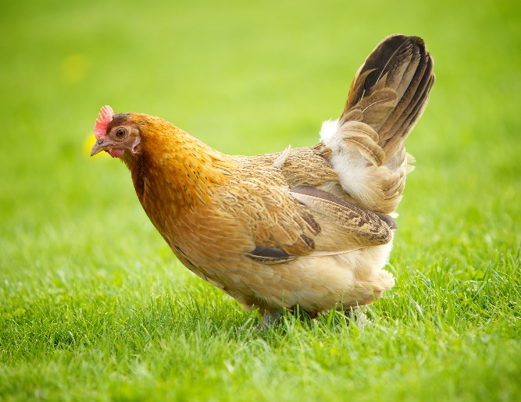 Adult chicken (hen) | 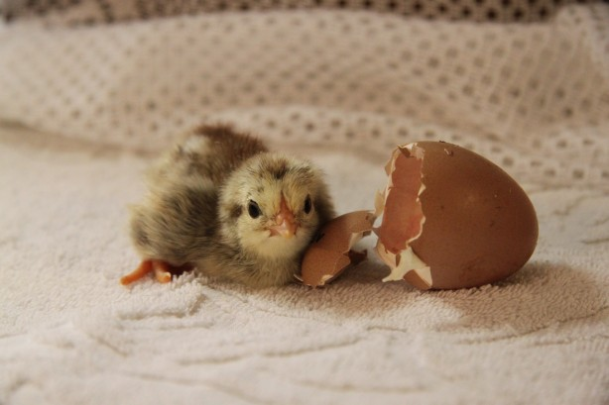 Hatchling
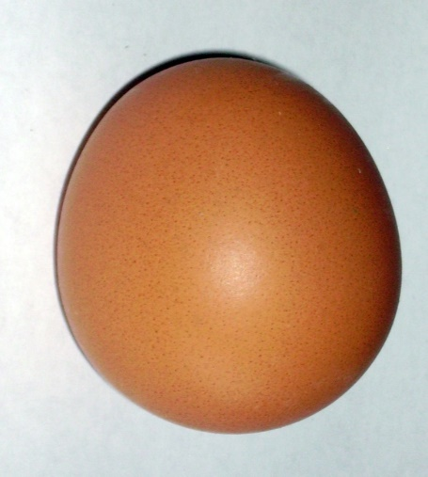  Egg | 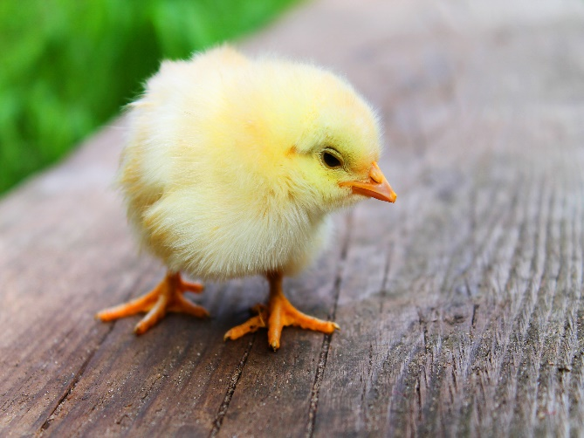 Chick

Now, cut out the pictures and order them correctly within the life cycle frame, using the completed life cycle to help you, if needed.

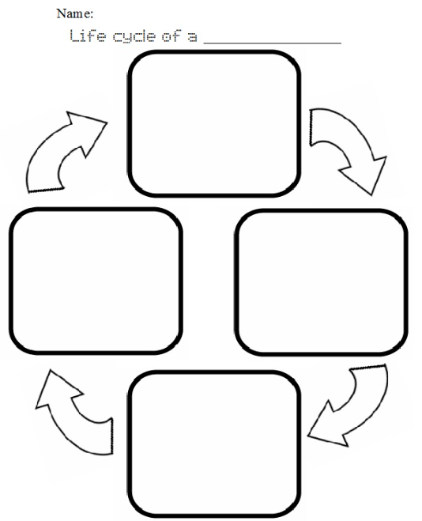

Life cycle of a chicken

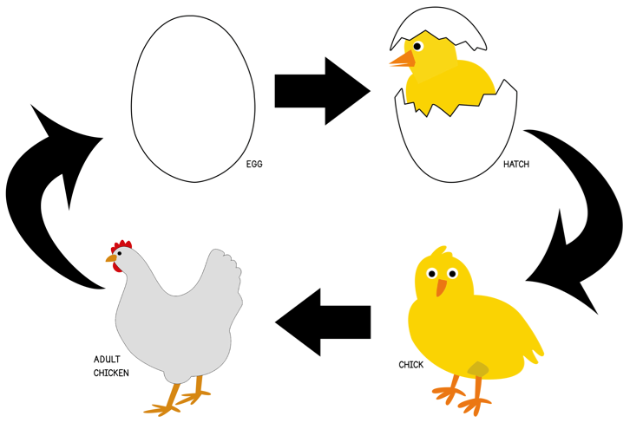

Extension: If we were in school, we would be having a go at making our life cycle of a chicken, like the one below. If you have the resources and would like to have a go, please do. I would love to see them to include in our scrap book!

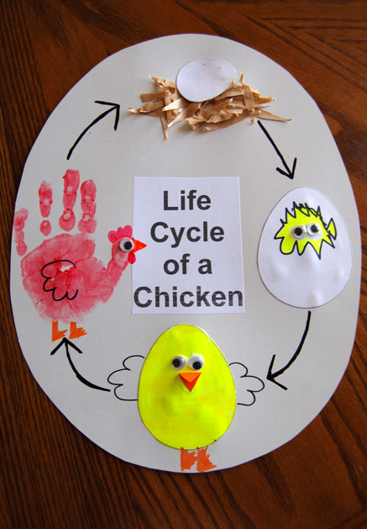

Tuesday
Yesterday we learnt about the life cycle of a chicken. Today I would love you to have a go at describing the life cycle of a chicken, using time connectives: first, next, then, finally. These are often used in chronological writing, to show there is an order in which things (stages) happen.

Title: Life cycle of a chicken.

First,
Next,
Then,
Finally,

I have done the first one for you as an example. Remember! Use your life cycle drawings to support your writing!

First, the adult chicken lays an egg. The hen incubates the little egg by sitting on it to keep it warm.

Next, ...

One sentence correctly punctuated in your neatest handwriting is enough. But you can add more information if you would like to.
Please email your completed writing into admin@farway for Mrs Jackson to see.

Wednesday
We have learnt about the life cycle of the chicken. Today I would love you to have a go at practising your reading retrieval skills from an article about the hen’s life cycle. This is a really important skill to develop and is extremely good reading practice.
Have fun!
Please email your completed answers to Mrs Jackson (using admin)
Just pick one reading paper to complete. They are differentiated according to reading ability and confidence: *** is most confident.

*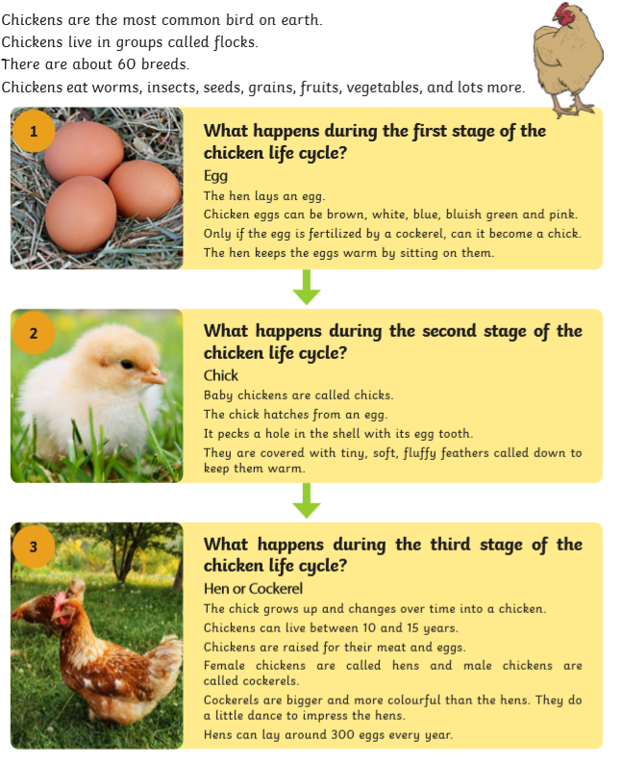
*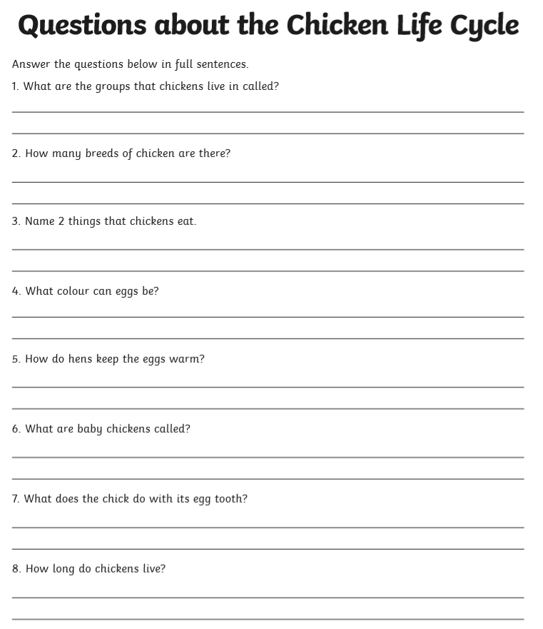

** 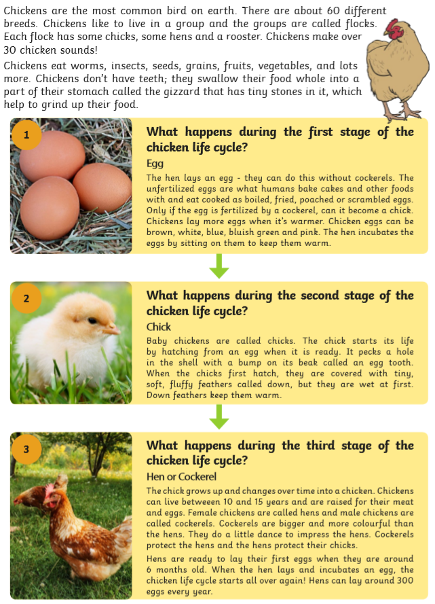

**
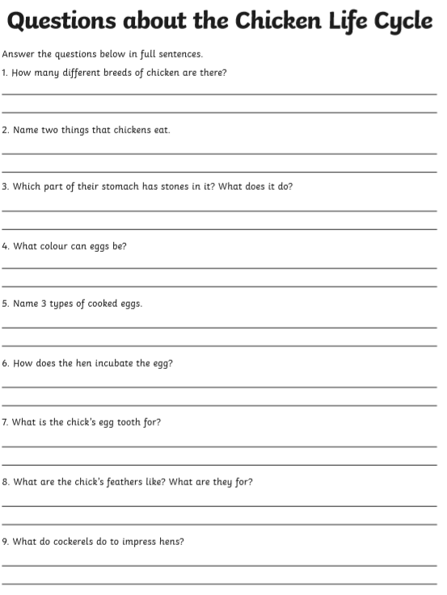

***
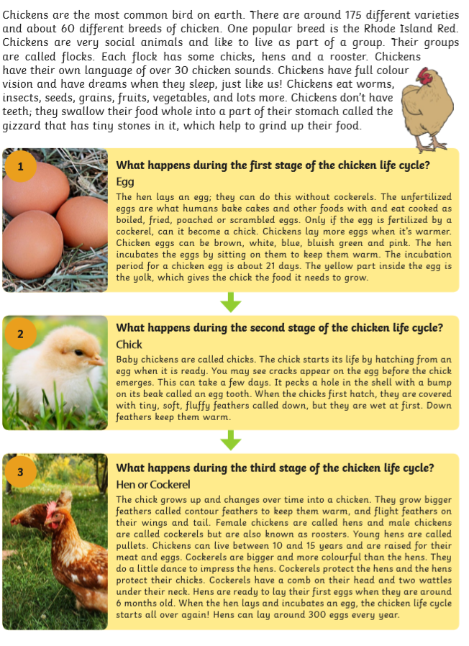

***
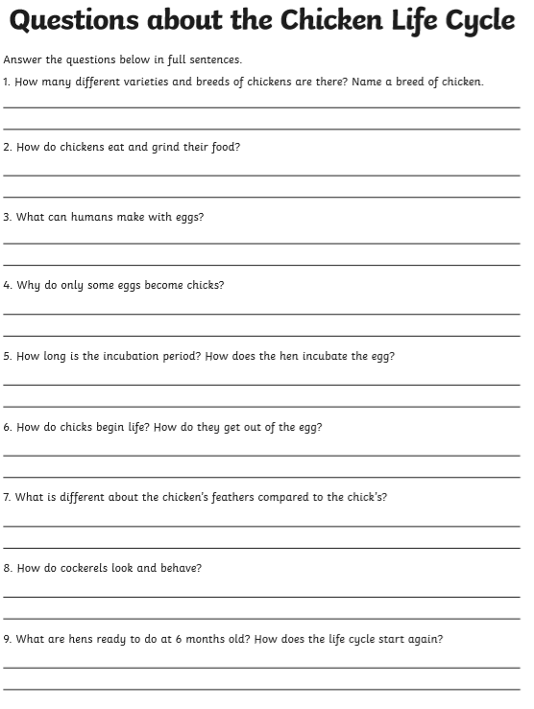

Thursday
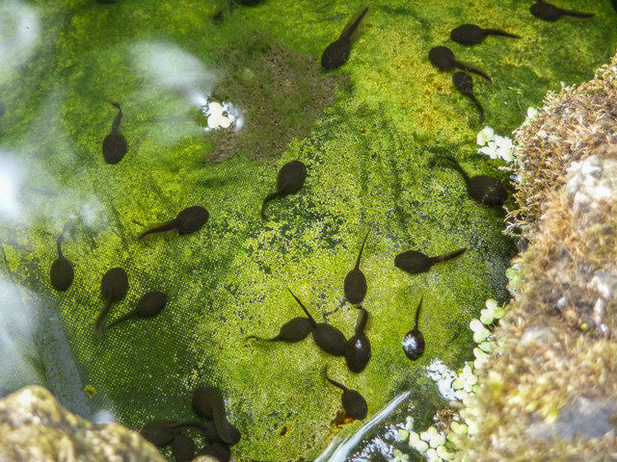
Look at this picture. What can you see? Write a descriptive piece, in the present tense, using expanded noun phrases, conjunctions and verbs.
What do you think will happen next?
Write your predictions and why you think this.

Challenge: maybe you could try writing a story about a tadpole?

Friday
Please copy and paste this link into your search bar to access today’s story: ‘The Teeny Weeny Tadpole’, by Sheridan Cain and Jack Tickle.
https://www.bing.com/videos/search?q=bedtime+stories+teeny+weeny+tadpoles&&view=detail&mid=D9515019A8E8916E49F0D9515019A8E8916E49F0&&FORM=VDRVRV

Enjoy sharing the story together and think about the different stages of the frog’s life cycle.

Challenge: have a go a drawing the life cycle of a frog and label the different stages: tadpole, egg (frogspawn), frog, froglet.
Extension: research the different stages of the frog’s life cycle
We will be exploring the life cycle of the frog more next week.

