Maths Home Learning for Summer Term 1 - Week 1

WALT: recognise 2D and 3D shapes. Talk about their properties, sort and compare the shapes and make patterns using 2D and 3D shapes.

Tuesday – Today I will be able to recognise and name simple 3D shapes from different orientations.
I will begin to see 2D shapes on the faces of 3D shapes.

1.
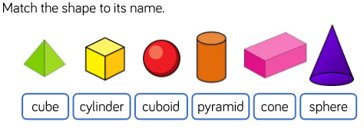
2.
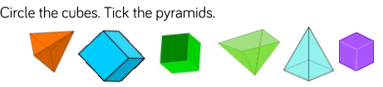

3.
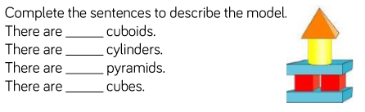

Have a look around your own home for as many 3D shapes as you can. Can you name all the shapes?
Try making a model using the shapes you have found, take a photo and describe your model to a family member. You could send your photos and descriptions into Mrs Jackson, using the admin email. She would love to see them!

Problem of the day:
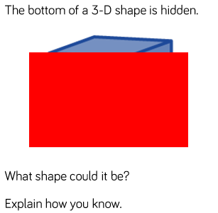

Wednesday – a) I understand that 2D shapes are flat. Whereas, 3D shapes are three dimensional, they have length, width and depth.
b) I can talk about the properties of 3D shapes and name the 2D shapes on the faces of 3D shapes.
Watch this clip on bbc bitesize to support your understanding and view relevant vocabulary. https://www.bbc.co.uk/bitesize/topics/zjv39j6/articles/zgqpk2p

1.
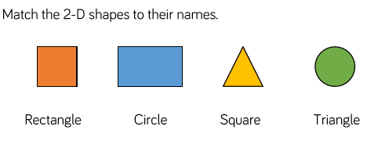
2.
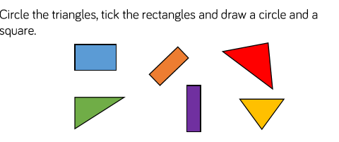
Task: Go on a shape hunt around your home and garden. Take photos of the shapes you find (need for Thursday).
How many shapes can you find? You could create a tally to record all the shapes you see.
CHALLENGE – use your maths talk to describe the properties of the shapes you find: vertices (corners), edges (sides), faces

Problem of the day:
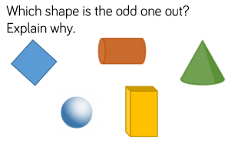

Key Vocabulary:
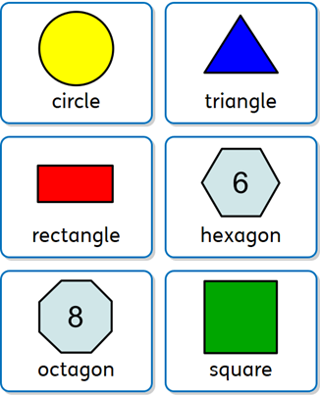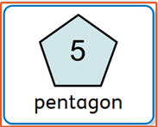
Key Vocabulary for Shapes
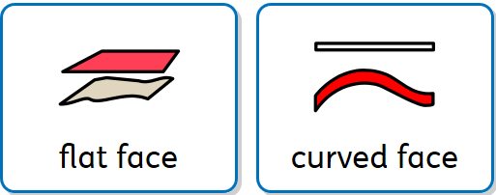
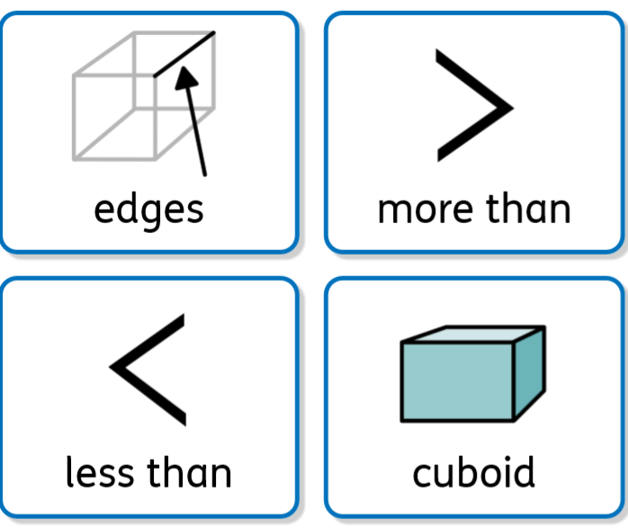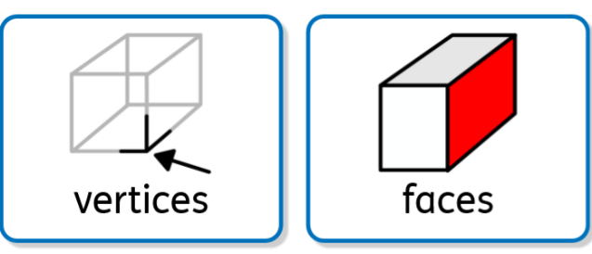
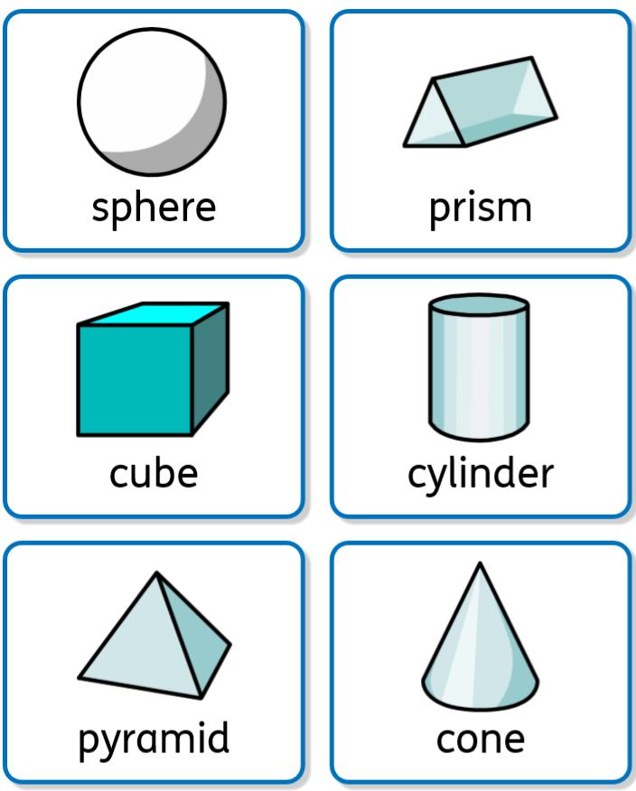

Thursday – Can you complete this sheet, using the key vocabulary we explored yesterday?

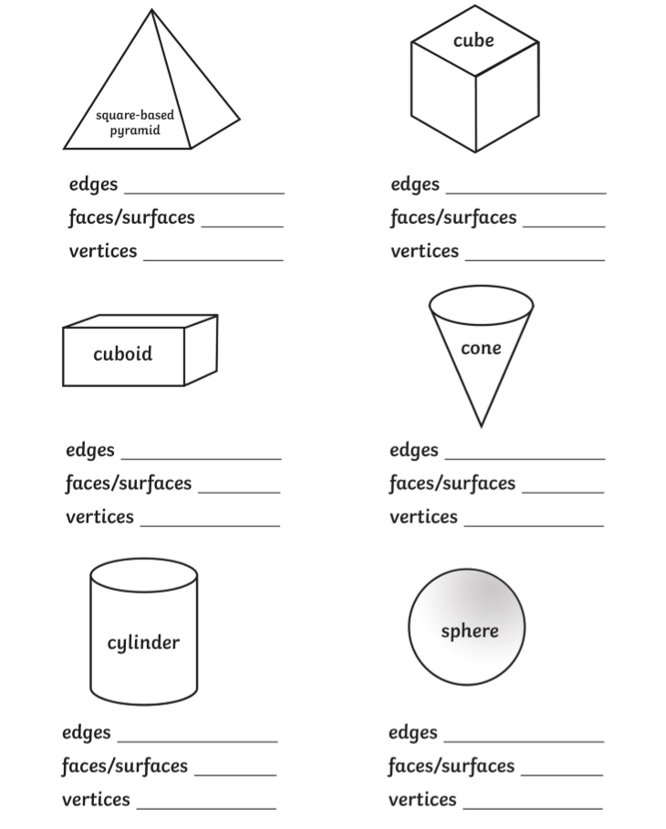

I can sort 3D shapes according to their properties.
I also understand that orientation does not affect the properties of a shape.

1.
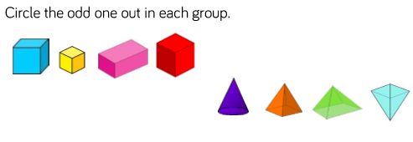
2.
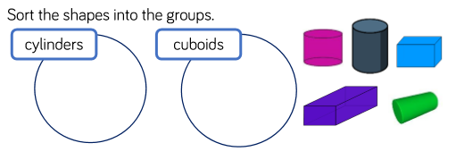
3.
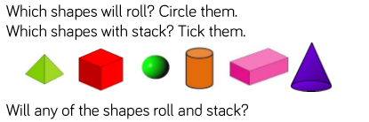
Explain your thinking, using the key vocabulary (yesterday).

Problem of the day:
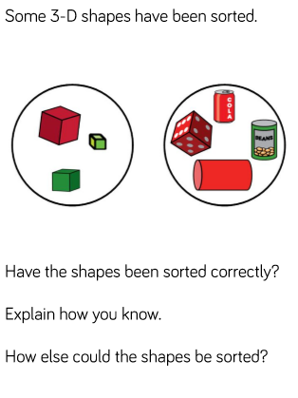

Friday – I can sort 2D shapes according to their properties and understand that orientation does not affect their properties.
- On Wednesday you went on a shape hunt around your home and garden (if you haven’t, you can do this now).
Can you print out your photos and sort them into groups according to their name or properties. Explain how you have sorted them. Can they be sorted in a different way?

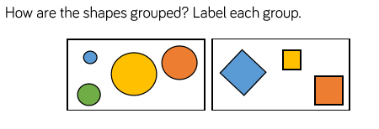

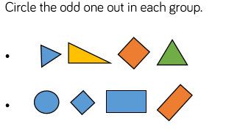

Problem of the day:
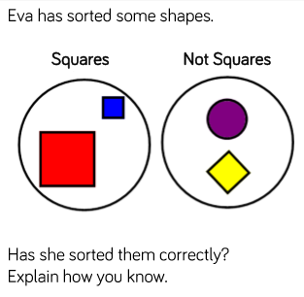
Additional challenge - I can use 2D and 3D shapes to complete and create simple patterns, focusing on different shapes, size and colours.

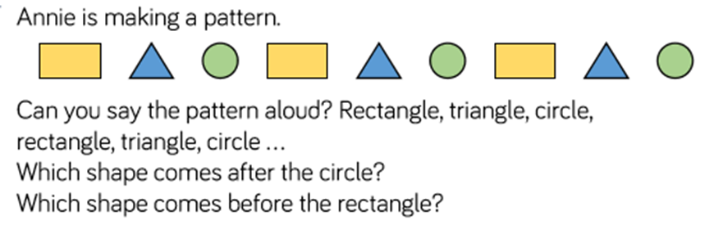

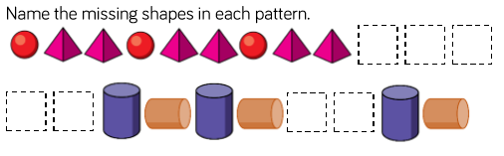

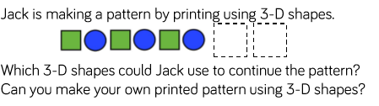

- Can you complete the patterns below?

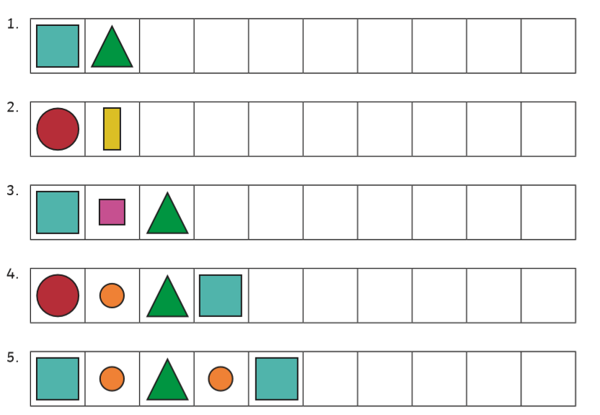

- Can you create and draw your own repeated shape patterns?

Problem Solving:
