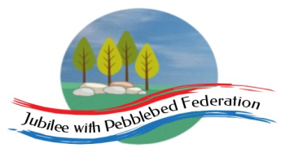 Home Learning Grid 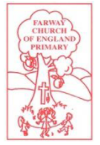
This is the home learning grid for the week beginning 8th February 2021. Please use this as a grid to support planning your child’s home learning. Additional resources will be made available on ‘google classrooms’, to support your child to access these activities. A daily reading and counting task are important to support your child to access their education but remember to have fun!
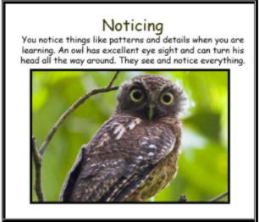
This week Class 1 will be focusing on the key Learning Behaviour: Noticing. As the Lockdown period continues to go on, some of you are beginning to struggle to keep noticing God’s little drops of hope in the world. This week, keep looking out for those little drops of hope in your daily walks and learning tasks, for this storm will pass. Remember we are all here for you, if or when you need us, so please do make contact.

Please remember, if you have internet issues during this lockdown period, you can still access Google Classrooms using your phones. You can also contact the school and we can try and support you with alternative learning options.

 | Farway C of E Primary School - Class 1 – week beginning 8th February
 | Lesson 1 | Lesson 2 | Break time | Lesson 3 | Lesson 4
Monday  Please read for at least 10 minutes every day with an adult or a sibling.  You can use the Bug Club online books to access books in line with your child’s phonics ability. | Phonics - https://www.activelearnprimary.co.uk/login?e=-1&c=0#bugclub_phonics  Reception – Phase 3, unit 10, Language session.  Year 1  Phase 5, Unit 29, suffix ending – ‘s’ (as plural morpheme)  Year 2  SPAG – types of sentences check. | Literacy  WALT: Create a timeline about the significant events in Mary Anning’s life.  Look through the National geographic website and see what key facts you can find out to place in the timeline attached. Make sure you are focusing on the key events of Mary Anning’s life, including any facts we explored last week that were of real interest to you.  When we write up her biography on Friday, it is much easier if we are writing about information that you, yourself have found interesting.  Using the timeline provided, please try and add your key information under the correct headings (dates).  -Please share your timeline with me so that I can gage an understanding of your knowledge about Mary Anning.  Reception – Watch the video all about Mary Anning.  Can you answer these questions?  *Who was Mary Anning?  *Why was she famous?  *What did she discover?  To learn even more about Mary Anning, have a look at these additional links. Maybe your parent or sibling would help you to read the key facts about Mary Anning.  Task:  Can you sequence her key events, using the cards and timeline attached? | Make sure you take time to have a brain break today and stretch your bodies. Have a look through the links below to explore different mindfulness techniques to help stay focused.  https://positivepsychology.com/mindfulness-for-children-kids-activities/  Why not try some yoga stretches with Rebecca and Duggee!  https://www.bbc.co.uk/cbeebies/watch/yoga-with-rebecca-and-duggee | Maths  Last week, in maths, we reached the end of our multiplication and division unit. From the assessments I can see you are all getting really good at multiplication and division, but some of you are finding it more challenging to apply these skills to solve word problems. If you think this is you, have a go at the questions on google classroom, before moving on to writing numbers as words.  If you need any help, please do contact me!  Reception:  WALT: recognise and write numbers to 10, in numerals and words.  Challenge: to 20 (OW)  Please watch the video link provided on google classrooms (this can be accessed via your computer, tablet or phone).  Then have a go at the activities provided.  Year 1  WALT: read and write numbers from 1-20 in words  View the online video – through google classroom (this can be accessed either by a phone, tablet or computer), then have a go at the activities provided.  Year 2  WALT: read and write numbers to 100 in words  Watch the video link above (1-20), then have a go at the year 2 challenge task to explore numbers 20-100,  Have fun! | Holistic wellbeing – Physical and Mental health.  Please warm up your bodies doing your weekly mile, using your favourite track. Then take part in the live P.E lesson, on google classroom.  Alternatively, a P.E grid has been placed at the bottom of this homework grid.  Now you have exercised those bodies make sure you rehydrate them by drinking plenty of water, and enjoy a nice healthy snack to refuel your body with energy. Keeping our bodies healthy and happy, helps to keep our minds healthy and happy also! Have a go at creating these fun and healthy snacks to refuel your bodies! I would love to see photos.  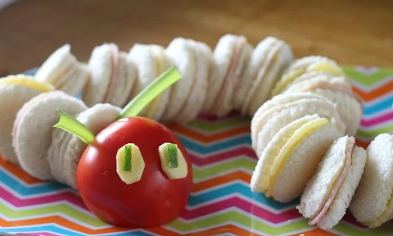  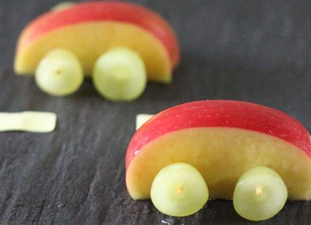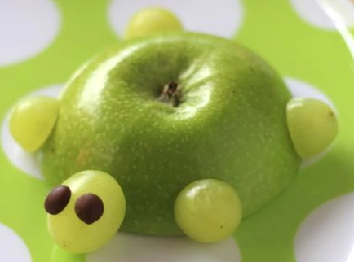  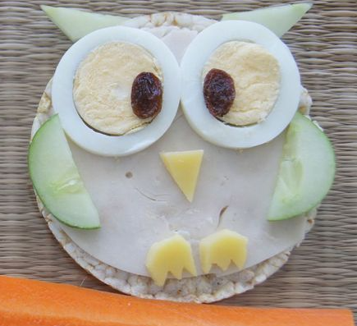  Challenge: measure your heart rate before you exercise, then again after you have exercised. What do you notice? Why do you think this is?
Tuesday  Please read for at least 10 minutes every day with an adult or a sibling. | Phonics  https://www.activelearnprimary.co.uk/login?e=-1&c=0#bugclub_phonics  Reception – Phase 3, unit 11, phoneme ‘ear’, written as ‘ear’.  Year 1  Phase 5, Unit 29, suffix ending – ‘es’ after ‘ss’, ‘x’  Year 2  SPAG – types of sentences | R.E – WALT: think about the religious symbols of Christianity, Judaism and Islam.  Watch the video link - listening to Mrs Finn as she reminds you what we have learnt about what is important to Christians, Muslims and Jews in their special places.  Discuss with your adult or sibling: which sacred place is your favourite and why?  Draw a picture and see if you can label the sacred areas/artifacts, from previous learning. | Make sure you take time to have a brain break today and stretch your bodies. Have a look through the links below to explore different mindfulness techniques to help stay focused.  https://positivepsychology.com/mindfulness-for-children-kids-activities/  Why not try some yoga stretches with Rebecca and Duggee!  https://www.bbc.co.uk/cbeebies/watch/yoga-with-rebecca-and-duggee | Maths  Reception  WALT: explore number bonds – to 10 (part 1)  https://www.bbc.co.uk/teach/supermovers/ks1-maths-number-bonds-with-martin-dougan/zf6cpg8 - get moving whilst learning those number bonds to 10.  https://classroom.thenational.academy/lessons/number-bonds-to-10-part-1-68rk4t  Year 1 and 2  WALT: recap number bonds to 20  to 100 (year 2)  https://www.bbc.co.uk/bitesize/articles/zh8m6v4 - recap your number bonds to 20, then have a go at the activities provided. | Topic – History/Geography –  Please watch the video link (1) provided by Mrs S – then print off the timeline provided (alternatively you can raw it), then have a go at adding some of the animals you have just looked at, to your timeline, in the correct time period.
Wednesday  Please read for at least 10 minutes every day with an adult or a sibling. | Phonics  https://www.activelearnprimary.co.uk/login?e=-1&c=0#bugclub_phonics  Reception – Phase 3, unit 11, phoneme ‘air’, written as ‘air’.  Year 1  Phase 5, Unit 29, suffix ending – ‘es’ after ‘ch’, ‘sh’ and ‘tch’  Year 2  SPAG – types of sentences check | Literacy  WALT: use present and past tense consistently and correctly (year 1 and 2)  use the progressive form of past tense verbs (year 2)  Recap events of Mary Anning’s life.  Mary Anning isn’t alive today so we need to make sure we are writing about her events in the past tense.  Mrs Jackson has been really struggling to write about the key events of Mary Anning using the past tense. Please can you help her to correct her writing – ensuring the correct tense and verbs have been used.  - Look at Mrs Jackson’s sheet and highlight any verbs or tenses that need changing.  - Correct the changes in a different colour, on the sheet.  - Write up the corrected sentences, in your neatest precursive handwriting!  - Send to Mrs Jackson to see.  Reception – Mary Anning’s ‘curiosity’ findings inspired many artists to paint pictures of what they thought the world would have looked like during the Triassic period. Have a look at the images.  Discuss: Which is your favourite image and why?  Next: Have a go at painting or drawing your own ideas about what you think the world looked like during the Triassic period. I would love to see your ideas! | Make sure you take time to have a brain break today and stretch your bodies. Have a look through the links below to explore different mindfulness techniques to help stay focused.  https://positivepsychology.com/mindfulness-for-children-kids-activities/  Why not try some yoga stretches with Rebecca and Duggee!  https://www.bbc.co.uk/cbeebies/watch/yoga-with-rebecca-and-duggee | Maths  Reception -  WALT: explore number bonds – to 10 (part 2)  https://classroom.thenational.academy/lessons/number-bonds-to-10-part-2-ccwk2e  Year 1 and year 2  WALT: revisit numbers within 100  https://classroom.thenational.academy/lessons/revisiting-numbers-within-100-64v30c?activity=intro_quiz&step=1 | Topic – Science – create a volcano.  Watch the video link attached, learning about the different parts of the volcano, then have a go at labelling these correct parts.  https://www.natgeokids.com/uk/discover/geography/physical-geography/volcano-facts/  https://www.bbc.co.uk/bitesize/articles/z62xwnb  Now, we are going to have a go at erupting our own volcanos!!  First, explore what makes a volcano erupt? https://www.bbc.co.uk/bitesize/articles/zrj6gwx  Now, have fun erupting your own volcanos!!  https://www.sciencefun.org/kidszone/experiments/how-to-make-a-volcano  I would love to see photos!
Thursday  Please read for at least 10 minutes every day with an adult or a sibling. | Phonics  https://www.activelearnprimary.co.uk/login?e=-1&c=0#bugclub_phonics  Reception – Phase 3, unit 11, phoneme ‘ure’, written as ‘ure’.  Year 1  Phase 5, Unit 29, language session  Year 2  SPAG – common exception words | Literacy  WALT: use subordinating and coordinating conjunctions within our writing.  Watch the video attached and have a go at doing the activities as instructed on the video.  Please remember to write the sentences in your neatest handwriting – using precursive writing (I have attached a sheet to help you remember this).  Reception – Mary Anning’s findings have inspired millions of people to explore and search for curiosities of their own. Today, I would love you to go for a walk in and around your local area, or explore your garden, and search for ‘curiosities’ that you find interesting!  Collect your curiosities in a little bag, bring them home and give them a really good clean, in hot soapy water! (Remembering to wash your own hands well!)  Once your curiosities are clean and dry, explore your findings and create some labels for them. Can you invent some interesting names for your curiosities, using your fabulous phonics knowledge!  Please take a photo to show me! I would love to see your very own ‘curiosity’ museum! | Make sure you take time to have a brain break today and stretch your bodies. Have a look through the links below to explore different mindfulness techniques to help stay focused.  https://positivepsychology.com/mindfulness-for-children-kids-activities/  Why not try some yoga stretches with Rebecca and Duggee!  https://www.bbc.co.uk/cbeebies/watch/yoga-with-rebecca-and-duggee | Maths  Reception  WALT: investigating number combinations within 20. https://classroom.thenational.academy/lessons/investigating-number-combinations-within-20-64tp8d  Year 1 and Year 2  WALT: explore the components within 100  https://classroom.thenational.academy/lessons/exploring-the-components-of-numbers-within-100-cgvp8d?activity=video&step=2 | Science – labelling the human body.  Last week you had a go at labelling the parts on a dinosaur’s body / skeleton. Today, your task is to label the parts on a human body.
Friday  Please read for at least 10 minutes every day with an adult or a sibling. | Phonics  https://www.activelearnprimary.co.uk/login?e=-1&c=0#bugclub_phonics  Reception  Phase 3, unit 11, phoneme ‘ur’, written as ‘er’.  Year 1  SPAG – common exception words  Year 2  SPAG – common exception words | Literacy  Assessment – write up the biography of Mary Anning  Using our work from this week and your timeline to support your writing, have a go at writing up your biography for Mary Anning.  Big Write – Make sure you include:  Title  Introduction – interesting opening statement or did you know question?  Written in the Past tense  Subordinating and coordinating conjunctions  Third person pronouns – she/he  Key events in Mary’s life to be written in chronological order!  Reception – Mary Anning’s findings have also inspired many people to write stories about dinosaurs and fossils.  Have a look at the video link below, listen to the story carefully, listening out for any rhyming words.  What do we mean by rhyming words? – https://www.bbc.co.uk/bitesize/topics/zjhhvcw/articles/zqjgrdm  Once you have listened to the story and explored what we mean by rhyming words, have a go at matching the rhyming words, to create rhyming pairs.  Challenge:  Can you think of any other rhyming words to add to your pairs?  We will continue to explore rhymes after the half term. | Make sure you take time to have a brain break today and stretch your bodies. Have a look through the links below to explore different mindfulness techniques to help stay focused.  https://positivepsychology.com/mindfulness-for-children-kids-activities/  Why not try some yoga stretches with Rebecca and Duggee!  https://www.bbc.co.uk/cbeebies/watch/yoga-with-rebecca-and-duggee | Maths  Reception  WALT: explore numbers to 30  https://classroom.thenational.academy/lessons/investigating-number-combinations-within-20-64tp8d  Year 1 and Year 2  WALT: compare and order numbers within 100  https://classroom.thenational.academy/lessons/comparing-numbers-within-100-on-a-number-line-6wv64r?activity=intro_quiz&step=1 - compare  https://classroom.thenational.academy/lessons/ordering-numbers-within-100-c4vkec - order | Topic – History / Geography – Watch the second video, provided by Mrs S and have a go at completing the activities attached.  You could even have a go at painting your own representation of what you think the Triassic, Jurassic, and/or Cretaceous period may have looked like.

