Grammar and Spelling Resources: Week Beginning Monday 8th June 2020
Monday: Years 3 and 4
https://www.youtube.com/watch?v=wdv59REiNZQ
Watch the video to help you understand what is meant by the word determiners in English grammar. You may find it helpful to watch it with an adult to help you with the reading or to pause every so often to check your understanding. Notice that some of the determiners are pronouns; others are articles (a, an, the). You may want to watch the video more than once.
Then, enjoy the following song to help you remember what determiners are: https://www.youtube.com/watch?v=B8MnOXgX0Kk
There is another (slightly more complicated) song about determiners at https://www.youtube.com/watch?v=4prb1Vuu_m4

The learning mat below contains a handy reminder of the different types of determiners. However, generally speaking you do not need to be able to name the different types; you just need to be able to identify which words in a sentence are determiners.

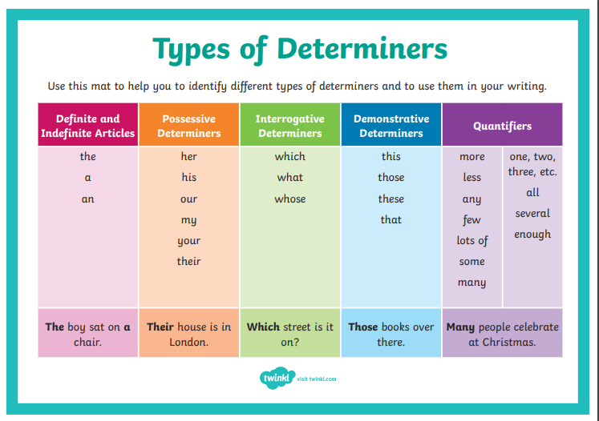

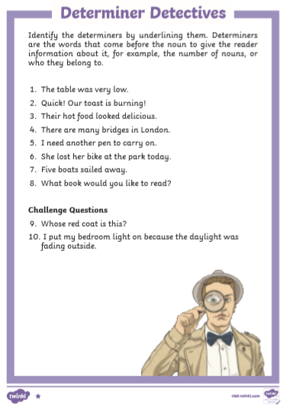
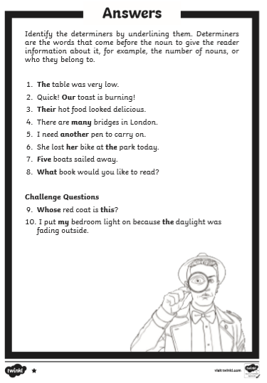

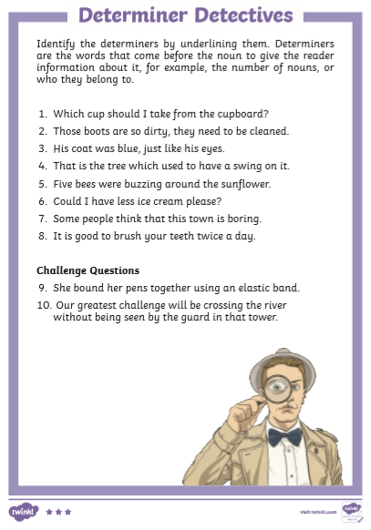

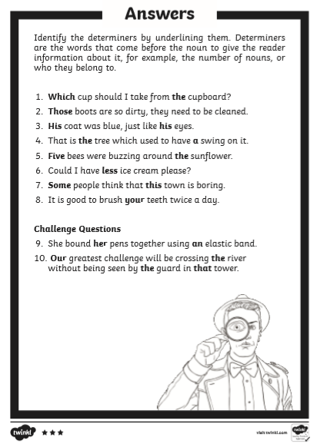
Monday: Years 5 and 6 – Expanded noun phrases
You may find it helpful to revise determiners by looking at the videos listed above for Year 3 and 4 before completing this lesson. Look at the BBC Bitesize lesson: https://www.bbc.co.uk/bitesize/articles/znpbgwx
Here are the worksheets to complete:
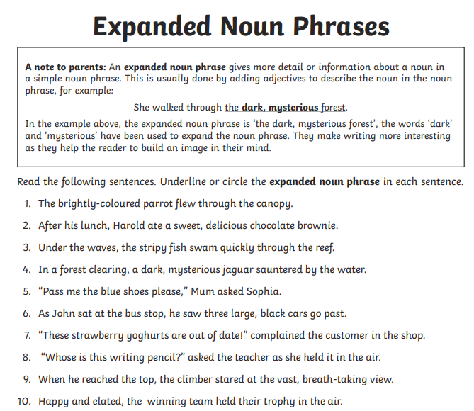

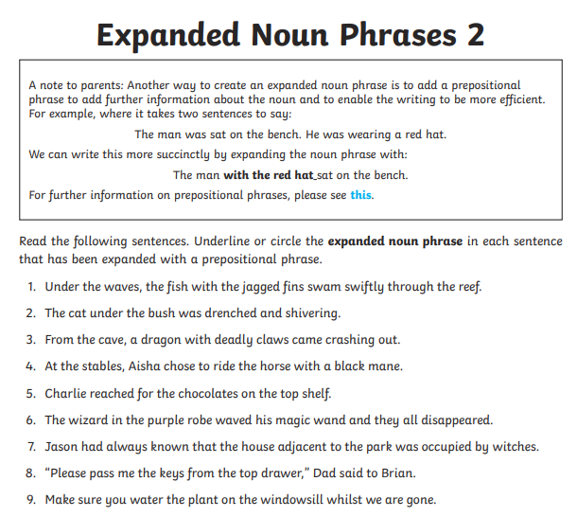

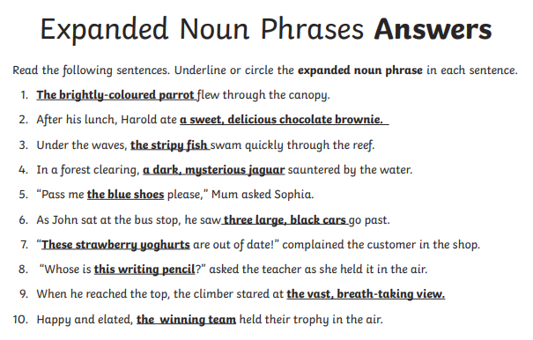
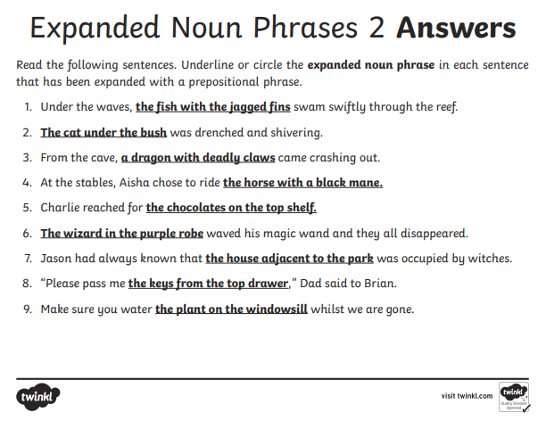

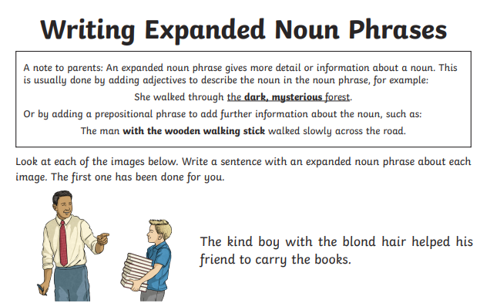
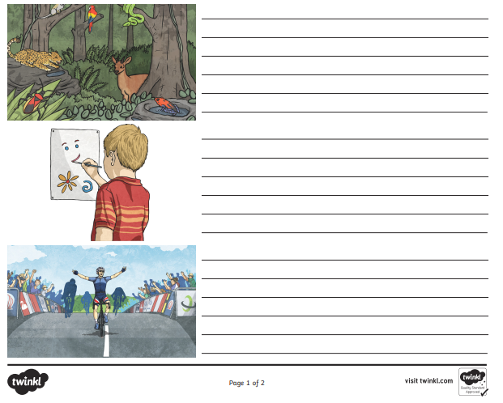
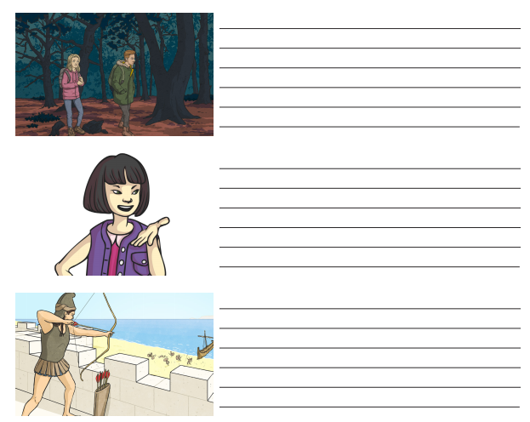
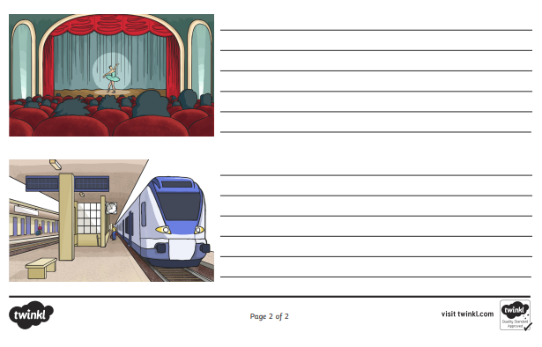
Tuesday: Years 3 and 4 – practise spelling the following words from the Year 3 and 4 statutory spelling list. Can you include these words in a sentence using a determiner?
earth
early
breath
breathe
appear
disappear
Did you notice what all these words have in common?
They all contain the letter string ea. How many different phonemes are there for this grapheme? Can you find any more in other words?

Tuesday: Years 5 and 6 - practise spelling the following words from the Year 5 and 6 statutory spelling list. You may need to investigate what each word means.
Can you include these words in a sentence as part of an expanded noun phrase?

controversy
yacht
convenience
cemetery
rhythm
pronunciation

Wednesday: Years 3 and 4 – Vowels and Consonants
A few weeks ago, Year 3 did some work on recognising and distinguishing between vowels and consonants. Can you remember which letters were the vowels and which were the consonants? The following web page contains a handy reminder video and notes: https://www.theschoolrun.com/what-are-vowels-and-consonants
Have a look, then complete the following work:
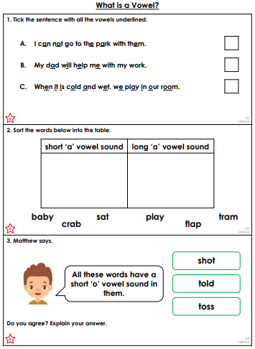

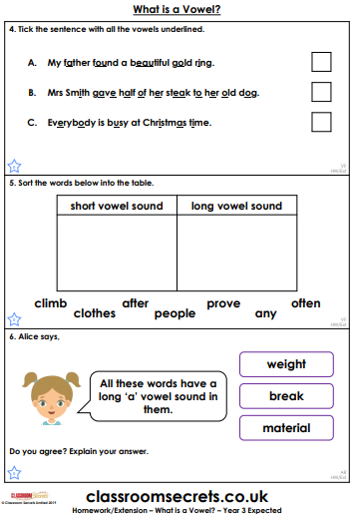

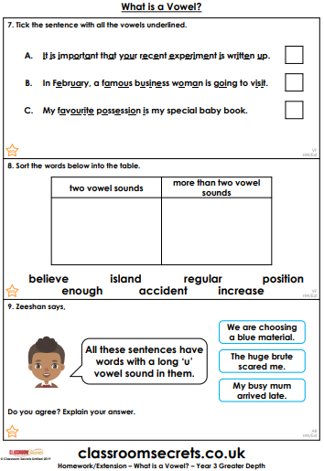
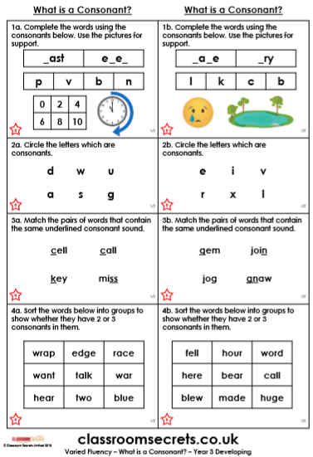

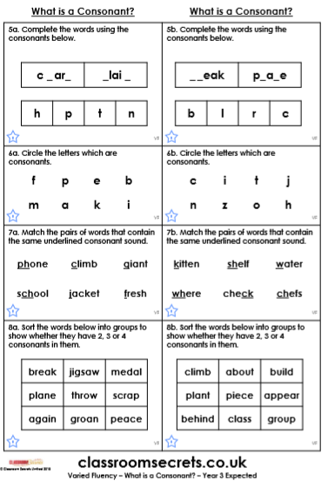
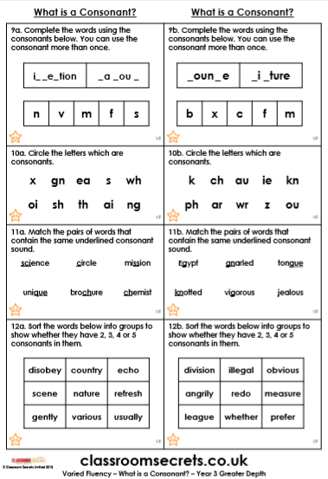
Wednesday: Years 5 and 6
Review Monday’s lesson on expanded noun phrases. Remember, a noun phrase is formed by modifying a noun by adding one or more adjectives or words to develop or describe the noun. These modifications could be in front of the noun, such as in the following phrase: the enormous, unending depths. We call this pre-modification of the noun. They can also be after the noun eg. the depths of the blue ocean. We call this post-modification of the moun. Some expanded noun phrases involve both pre-modification and post-modification. Eg. the enormous, unending depths of the blue ocean.
Today, practise adding adjectives to nouns as pre-modification or preposition phrases after a noun as post-modification.

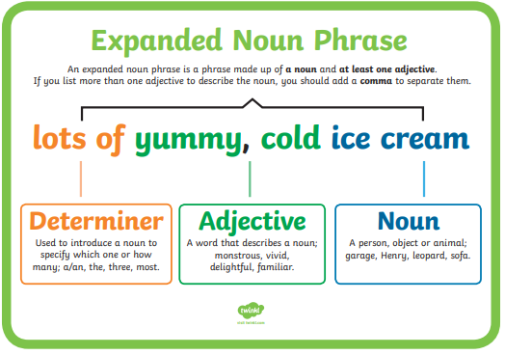

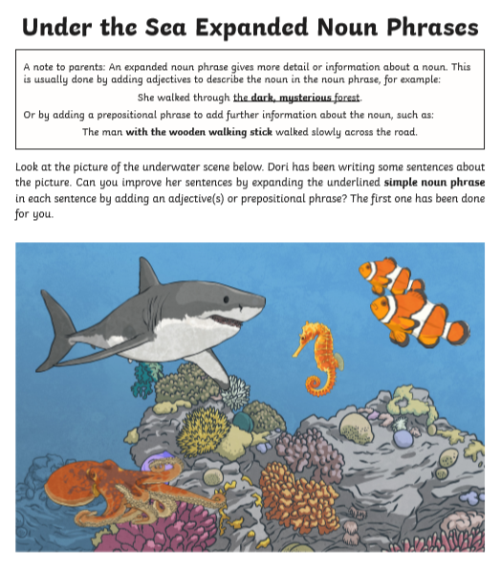

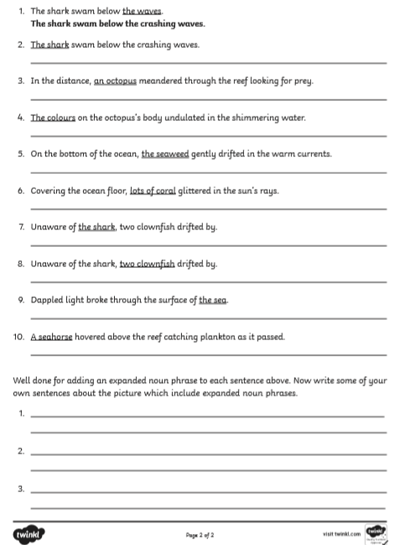

Thursday: Years 3 and 4 – the, a or an?
On Monday, we learned about determiners. On Wednesday, we revised vowels and consonants. You will need to understand both of these in today’s work, which focuses particularly on the articles the, a and an. A and an are known as indefinite articles as opposed to the definite article word, the. You will need to write the answers to the questions below in your Orange exercise books.
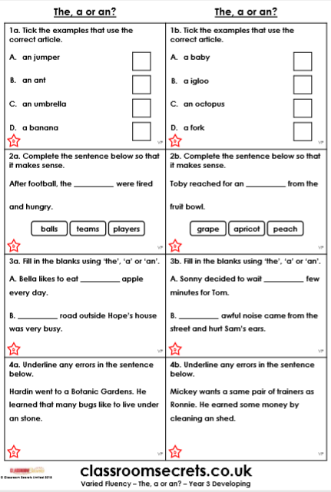
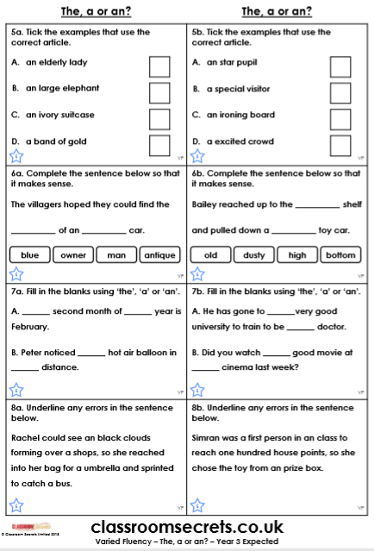
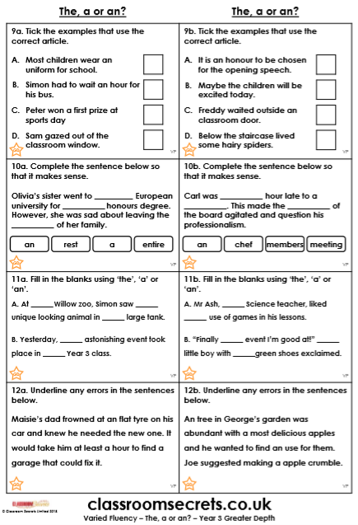

Answers
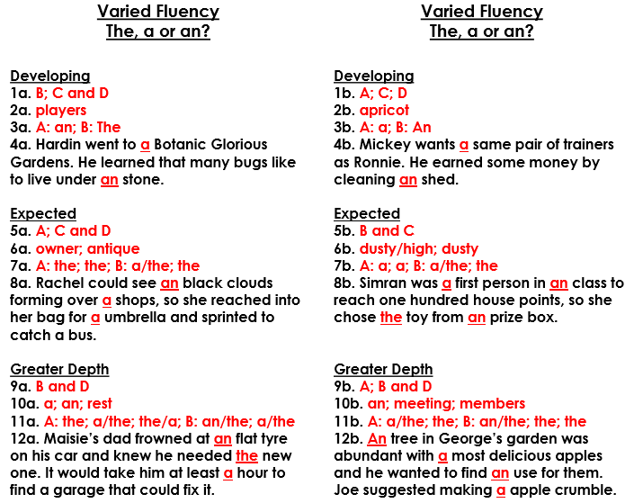

Thursday: Years 5 and 6 – identifying noun phrases – phrase or clause?
So far this week, we have been practising forming expanded noun phrases. Today, have a go at identifying whether parts of a sentence are noun phrases, main clauses, relative clauses or preposition phrases. \things to remember:
- a clause MUST contain a verb
- the main clause contains the main verb or action in the sentence
- a relative clause is introduced by a relative pronoun (eg. who, that, which, when, whom, where)
- a preposition phrase will begin with a preposition (eg. with, at, on, between, beside)
- a noun phrase will contain a determiner, a noun and one or more adjectives
Have a go at recognising which these are:
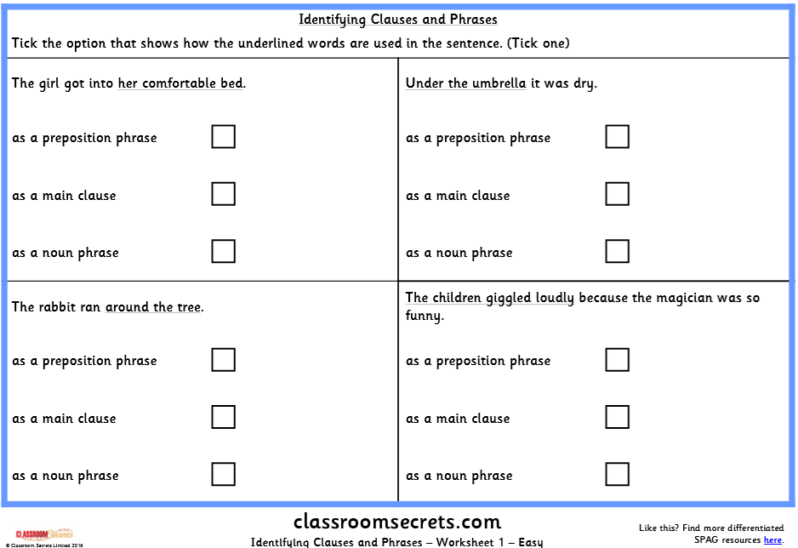
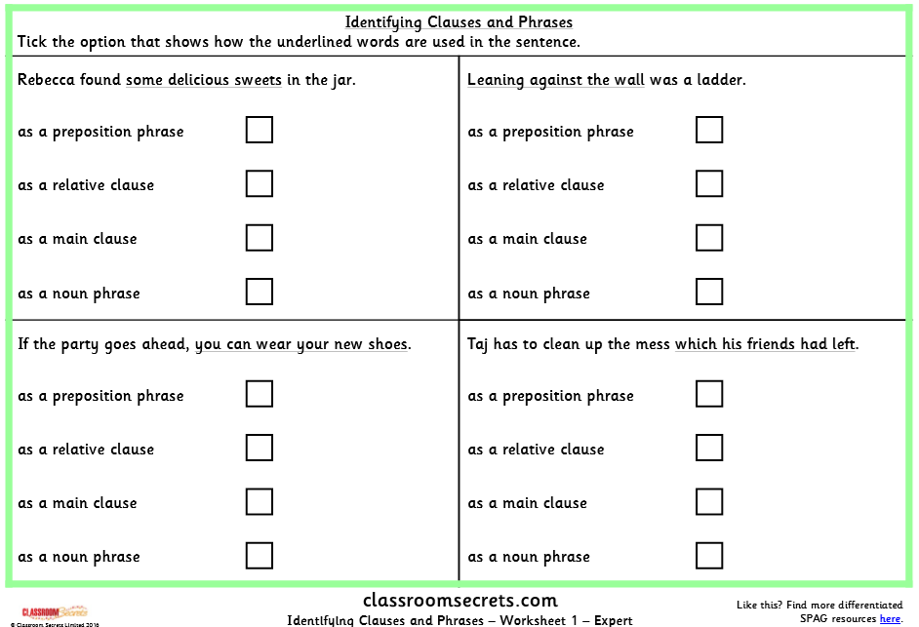
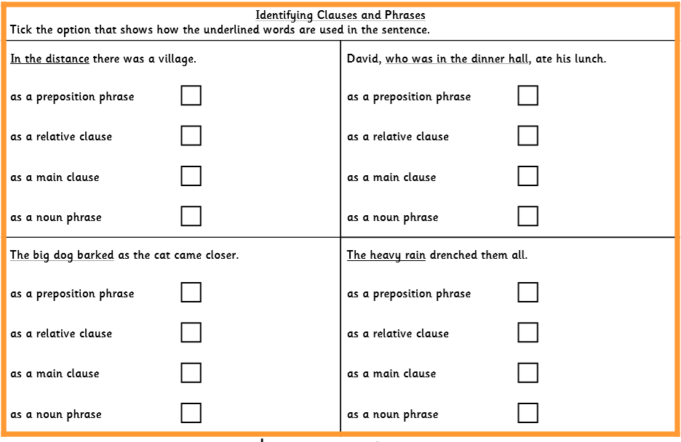

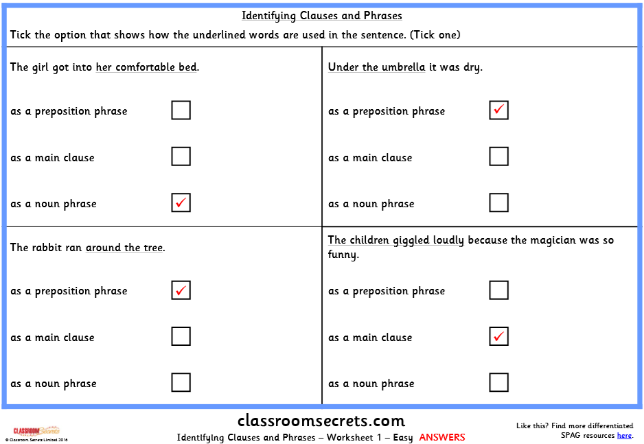
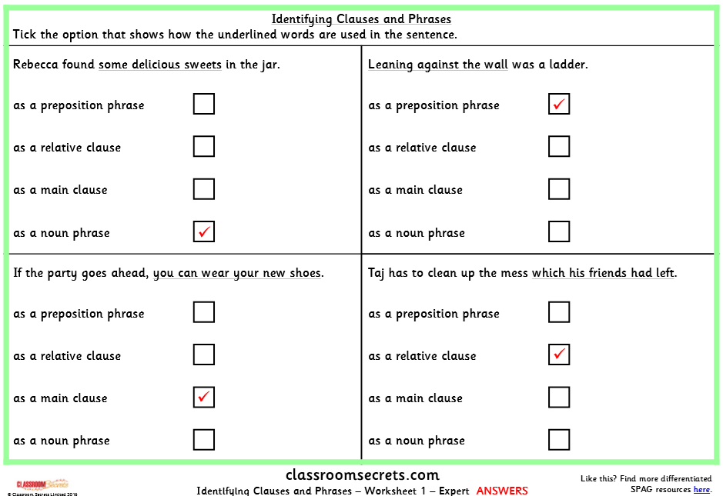
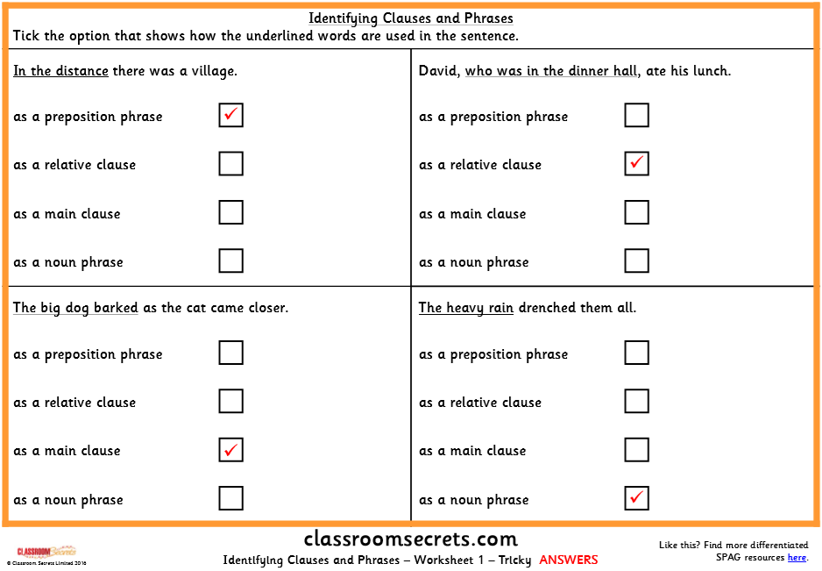

If you complete these with time to spare, what about making up some examples of your own?

Friday – Year 3 and 4 – determiners before modifiers
By now, you should have an idea what determiners are and how they can be used. A modifier is a word that is used to adapt another, such as using an adjective with a noun to create a noun phrase: eg. the painted house; a new toy; his old teddy. Remember that to create a noun phrase, you should start with the determiner, then the modifier, then the noun. 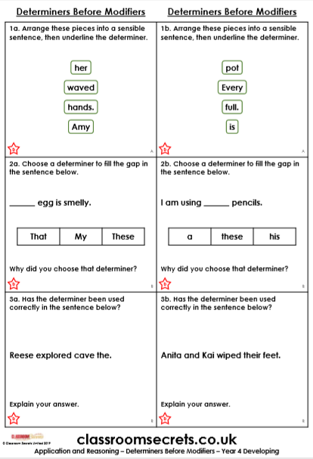

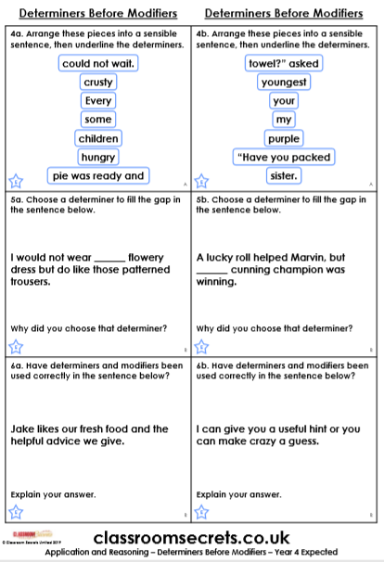
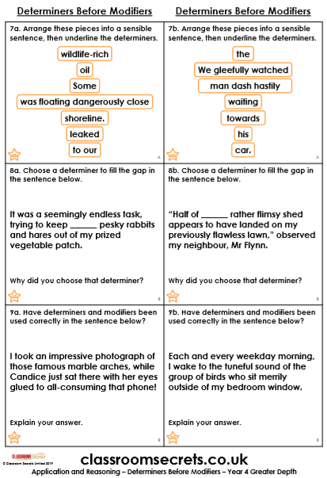
Answers
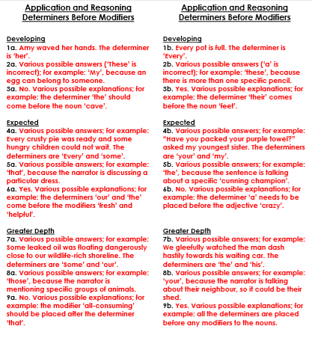

Friday – Year 5 and 6
This week, we have particularly learned about identifying and writing expanded noun phrases.
Try writing a paragraph of description - it could be to do with our work on the oceans this week or on a theme or your choice – and include expanded noun phrases to enhance the description. Then go back and underline to show where you have used expanded noun phrases. Have you used adjectives as modifiers and preposition phrases? If not, could you add a preposition phrase as post-modification as well as adjectives before the noun.

Take one or two of your own expanded noun phrases and write them out with annotation to explain the different parts of speech.
Eg.
The silvery fish in the pond
The – definite article, determiner
silvery – adjective
fish – noun
in – preposition
the- definite article
pond - noun

