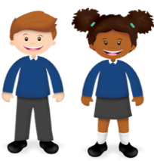
Learning
from Home

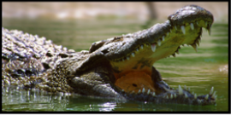 |  | Learning Behaviours  The first learning behaviour this week is Meta Learning. Like the alligator, who can live and hunt on land or water but spends most of his time in water, we will be thinking about how we learn best. Do you learn best by reading, writing, watching, listening or doing? Can you talk about how you learn? What are ways you can help yourself be more effective when learning in a manner that is not your preferred manner, such as fiddling, doodling or changing the focus? The second is Empathy and Listening, represented by the rabbit with its long ears. We will be listening to each other to help us understand one another better and rebuild the bonds that make us effective learners in the classroom. |  |  |  |  | 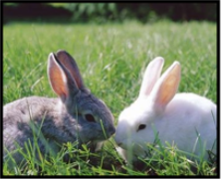
Class 2  Wk beg: 1st March 2021 | Spelling (15 mins) |  | Reading (30 mins) | Writing (1 hour) | Maths (45 mins) | Afternoon Project  When finished each day
Collective Worship  You will find a link to today’s Collective Worship on the Google Classroom. | Practise the spellings set for you in ‘Assignments’ twice. Then practise the statutory words for your age group once.  https://www.edshed.com/en-gb/login |  | https://www.activelearnprimary.co.uk/login?c=0  Some of you will be able to read a book in one half hour session, others only part of a book.  Just read and quiz for 30 minutes every day and you will see results! | WALT: orally rehearse a story based on a blueprint.  Today we are showing what we can do while writing using a blueprint.  A blueprint is a basic plot that stories can be reduced down to. There are seven blueprints but we will be focusing on ‘overcoming the monster’.  Elicitation Write  Using the steps below, plan out a story you can write tomorrow. What words/phrases will you use for the hero? The monster? Tell your story verbally  - We meet the monster and the hero.  - The hero moves towards the monster but still feels safe and comfortable.  - The hero and the monster meet. They battle and it looks like the hero might fail.  - There is a big battle where all seems lost but is finally won.  - The monster is dealt a fatal blow and its dark power is overthrown. The hero enjoys the prize. | 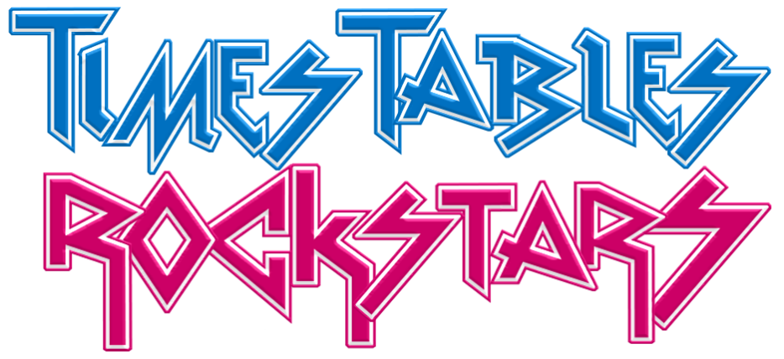  Warm up with  Contact school if you need a reminder of your login details!  This week we are completing our multiplying and dividing unit. We will also be assessing the topics completed over the last 8 weeks to check for holes and misconceptions.  Today we will complete the fractions assessment from White Rose for our year group.  https://whiterosemaths.com/resources/assessment/primary-assessment/end-of-block-assessments/  Remember to mark easy questions A, tricky but had a go questions B and I just don't’ know what to do questions C!  If there are lots of ‘C’s on your sheet then try the Year below you for a starting point.  Once we have completed the sheet we will share our techniques and make a list of things we want to focus upon and practice further. | PE  This week we have our fifth PE lesson of six provided by Callum Shipton from Exeter Football Club. The lesson is designed to be completed at home.  You’ll find the video attached in Google Classroom.  Music  Learn about Thor - God of Thunder in this week’s music lesson.  https://www.bbc.co.uk/teach/school-radio/music-ks2-viking-saga-songs-4-thor-sing-us-a-saga/zh89cqt  Mental Health  We will be thinking about big emotions and how we cope with them.  https://www.youtube.com/watch?v=S-8WezbUkq4
Tuesday | https://www.edshed.com/en-gb/login |  | https://www.activelearnprimary.co.uk/login?c=0 | WALT: write a story using the blueprint ‘overcoming the monster.  Today use your time to write your elicitation story.  Y4 - just write about the battle (section 3 and 4)  Y5/6 - write the whole story  Everyone - focus on precise language and description to make your reader feel like they are there. | Warm up with  Contact school if you need a reminder of your login details!  Today we will complete the multiplication and division assessment from White Rose for our year group.  https://whiterosemaths.com/resources/assessment/primary-assessment/end-of-block-assessments/  Remember to mark easy questions A, tricky but had a go questions B and I just don't’ know what to do questions C!  If there are lots of ‘C’s on your sheet then try the Year below you for a starting point.  Once we have completed the sheet we will share our techniques and make a list of things we want to focus upon and practice further. | History - Viking Raiders  Today we will share the information we have gained so far about Vikings and how they differed to Anglo Saxons. See Google Classroom for the slideshows created by children.  History - Art - Soap Carving  Carving is known as subtractive sculpting, as bits of the original material are cut away. The carved materials can be painted when dry to create a stone effect. Acrylic paint is the best option when painting air-dried clay projects.  Runic Alphabet: https://kidadl.com/articles/viking-runes-ks2-explained  In this lesson we will use clay tools and wooden toothpicks to carve letters from the runic alphabet into flat, rectangular soap blocks.  You could also carve a more complex design or story into a clay slab made from air-drying clay, such as Model Magic, or another soft modelling material.  Adding paint to the carved out areas of your sculpture will embellish and enhance your work.
Wednesday | https://www.edshed.com/en-gb/login  Practise the spellings set for you in ‘Assignments’. Then practise the statutory words for your age group. |  | https://www.activelearnprimary.co.uk/login?c=0 | WALT: show our GPS/SpaG knowledge  Today we will complete the assessment set on SPAG.COM  www.spag.com  Then watch part one of the Beowulf story on bbc.co.uk linked below.  https://www.bbc.co.uk/teach/school-radio/english-ks2-ks3-beowulf-part-1/zfymxyc  Record your likes, dislikes, puzzles and patterns about the story so far. | Warm up: play an addition and subtraction game at https://www.topmarks.co.uk/maths-games/7-11-years/addition-and-subtraction  Today we will continue exploring dividing by partitioning and using our knowledge of multiples of 10. This will include exchanging 10s for 10x1 and what to do with remainders.  Y4 divide 2 digits by 1 digits  https://vimeo.com/497936690  Y5/6 divide 2 digits by 1 digits  https://vimeo.com/492054019 | Forest School  We will spend our afternoon outside with Linda.  Find some forest school activities you can complete at home on the link below.  https://www.outdoorsgroup.co.uk/blog/bringing-forest-school-home-in-lockdown/
Thursday | https://www.edshed.com/en-gb/login  Practise the spellings set for you in ‘Assignments’. Then practise the statutory words for your age group.  Remember to challenge yourself by moving from easy to hard and maybe all the way to extreme! |  | https://www.activelearnprimary.co.uk/login?c=0 | WORLD BOOK DAY CELEBRATION!  We will be looking at Julia Donaldson as our author study and comparing her with Anthony Browne, who both writes and illustrates his books.  Learn more about Julia Donaldson here:  https://www.juliadonaldson.co.uk/about.htm  Learn more about Anthony Browne here:  https://kids.britannica.com/kids/article/Anthony-Browne/605085  Explore Anthony Browne books here  Selection of Anthony Browne books  Explore Julia Donaldson books here  Selection of Julia Donaldson books | Warm up with  Contact school if you need a reminder of your login details!  Today we will continue exploring division, moving into applying the same techniques with 3 digit numbers.  Y4 divide 2 digits by 1 digits  https://vimeo.com/497601665  Y5/6 Divide 3 digits by 1 digit  https://vimeo.com/492054040 | WORLD BOOK DAY CELEBRATION  Choose one of the books you explored this morning and complete one of the activities below.  Make puppets of each character you can then use when retelling the story  Write (and illustrate) another adventure for the characters in your chosen book.  Online you could create a slideshow with illustrations for each part of the book and sound buttons for you to read each part of the book.  Imagine the sounds you might hear as the story is being read. Create music to accompany a reading, using body percussion and sounds around your home. (These sound effects could also be recorded and inserted into a slideshow like above.)  Invent a new character in the style of the book and draw and write about them.
Friday | https://www.edshed.com/en-gb/login  Practise the spellings set for you in ‘Assignments’. Then practise the statutory words for your age group.  Remember to challenge yourself by moving from easy to hard and maybe all the way to extreme! |  | https://www.activelearnprimary.co.uk/login?c=0 | Watch part 2 of the Beowulf story on BBC below  https://www.bbc.co.uk/teach/school-radio/english-ks2-ks3-beowulf-part-2/znghpg8  Write about your likes, dislikes, puzzles and patterns | Warm up with a game from https://www.mathplayground.com/index_addition_subtraction.html today and keep simple mental skills sharp!  Today is our final session dividing, where we subtract multiples of 10 to find our answers.  Y4 - divide 3 digits by 1 digit  https://vimeo.com/497992648  Divide 4 digits by 1 digit  https://vimeo.com/492054136 | RE  HOW AND WHY DO PEOPLE MARK THE SIGNIFICANT EVENTS IN LIFE?  How do Jewish people mark becoming an adult?  What do you look forward to about becoming an adult? What will you be able to do? Make a list. With rights come responsibilities. What responsibilities do you have as an adult?  Bar and Bat Mitzvah mark the move for Jewish young people from childhood towards adulthood. After becoming Bar/Bat Mitzvah – meaning ‘son/daughter of the commandment’ – young people are considered responsible for their own decisions and actions and old enough to follow the mitzvot, commandments, for themselves.  Watch these clips of Bar or Bat Mitzvah such as this one about BatMitzvah www.bbc.co.uk/programmes/p02n2kgx,  https://www.bbc.co.uk/bitesize/clips/zm7tfg8/ and/ or  https://www.bbc.co.uk/teach/class-clips-video/religious-studies-ks2-preparing-for-bat-mitzvah/zvgpy9q  A letter to an uncle: Write an imaginary letter from Sarah or Mimi or David to a non‐Jewish uncle who could not attend the celebrations. In the letter you must include;  − a description of what happened in the service  − an explanation of the significance of becoming bar/bat mitzvah and of the specific parts of the ceremony and celebrations  − technical language with definitions, referring to your glossary  In Britain today, the move from child to adult is often not marked at one moment by a ritual. Still, the transition to secondary school is a big thing for many children, and primary schools do often make a celebration of the end of primary school. What links are there between the Jewish ceremony and moving on up to secondary school? In both, there is a time of preparation, learning of new skills, a test (in public?), and an achievement to be celebrated by family and friends.

