Literacy  - Write a diary account of your favourite day over the Easter weekend - past tense, conjunctions, expanded noun phrases, verbs  - Write instructions for washing your hands  - Write instructions for making stress balls, using bossy verbs.  - Writing / designing a superhero – why would you choose these powers? | Maths  - Shapes  - Connective model sheets – subtraction (counting backwards)  - Time – start looking at half past, quarter past and quarter to (we will do more of this after fractions next week)  - Explore capacity using water (in line with the Songkran festival)
R.E  - Making links between Christianity beliefs and Buddhism reliefs. | Art/Craft  - Design and paint a superhero  - Build temple sculptures using a variety of available resources (sand, Lego, recycled materials)  - Draw/paint a Buddhist temple  - Making flowers using tissue paper  - Make an elephant using milk bottle tops (as we have done in class. Could you make a different animal?)
PSHE  - Superheroes  - Managing stress  - Re-capping 10 a day – doing something we enjoy  - Have a water fight with your family.  - Wash the car / windows | Science / Topic  - Research Thailand and the Songkran festival  - Discuss the different uses of water  - Water Cycle – design a poster to explain the water cycle  - Start exploring life cycles – Have a go at drawing a picture of your own ‘human’ life cycle.

Literacy – WALT: write instructions using imperative verbs
Tuesday
Write a letter to Mrs Jackson, telling her all about your Easter weekend, so that she can read what you have been up to.
Please write in the past tense and try to include conjunctions (and, but, so, because) and expanded noun phrases (to add more descriptive detail).
- Challenge – try to include powerful verbs to strengthen your writing. For example: instead of the verb - ‘laughed’, you could use, ‘chuckled’ or giggled’.
Here are some other examples:
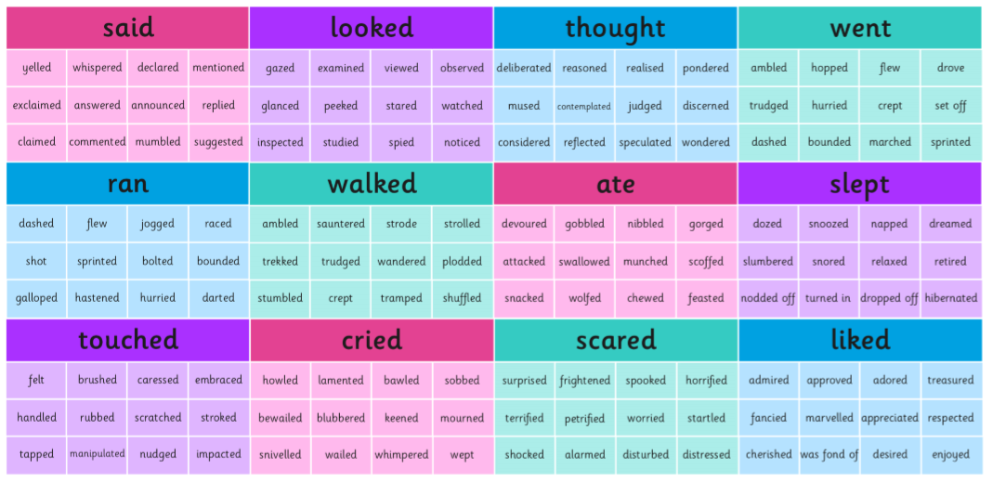

Wednesday
This week we will be looking at how to write instructions, using bossy verbs. Otherwise known as: ‘Imperative Verbs’.
Imperative verbs are used to give an order, command someone, or instruct someone on how to do something. They are commonly found within instruction writing. For example: how to catch an alien. The imperative (bossy) verb here would be to ‘catch’.
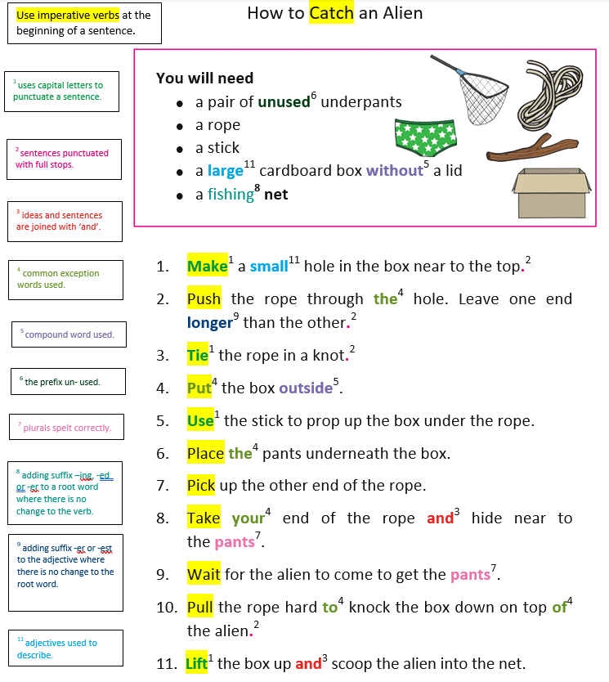

Here are some examples of imperative (bossy) verbs:
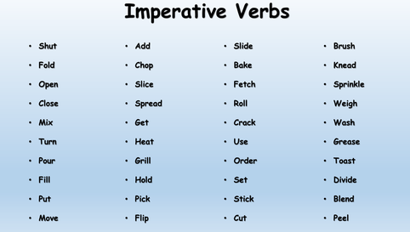

Challenge - Write instructions for an alien to instruct them on how to wash their hands. Think about which imperative verbs would be best to include in your sentences.

Thursday
Making stress balls – using cornflour and conditioner
Note for parents: Please read instructions prior to making the stress balls and verbally talk through the instructions with your child, discussing the imperative verbs as you carry out each action. Maybe children could try highlighting the imperative verbs in the instructions below.
Have fun together making stress balls!
You will need:
- Balloons
- Cornflour
- Conditioner (low cost, own branded supermarket conditioner works well)
- Mixing Bowl
- Wooden spoon (if preferred but not necessary)

Instructions:
- Pour 2 (full) cups of cornflour into the mixing bowl
- Squeeze half a bottle of conditioner into the middle of the cornflour.
- Mix the cornflour and conditioner together using hands (can use a wooden spoon if preferred, but it feels great on your hands!) The mixture should be of a smooth consistency and malleable when finished mixing. If not…
- Add more conditioner or cornflour depending on the consistency.
- Squeeze, Squash and Mould your dough within your hands.
- Knead in into different shapes and enjoy exploring!
- Next, pull open one of your balloons (will need a parent to help) and push your dough inside the balloon.
- Fill the balloon until you have a sufficient round ball in your hands.
- Tie a knot in the end of the balloon.
10.Finally, wash hands and enjoy playing with your stress ball!

Friday
First, recap (verbally) how you made the stress balls yesterday. Which imperative verbs can you remember using?
Now, have a go at writing the instructions for making the stress balls.
You could also try baking a cake or making playdough, then try writing the instructions, should you prefer. However, it is important you think about the imperative verbs you need and what they will instruct he reader to do.
Mrs Jackson would love to see your instruction writing!

