Grammar and Spelling Resources: Week Beginning Monday 6th July 2020 Year 5 and 6
Monday: Sentence Punctuation
This week, we will have a focus on using punctuation correctly. Let’s start by revising how commas are used for clarification in sentences. (Answers are given at the end of the document.)

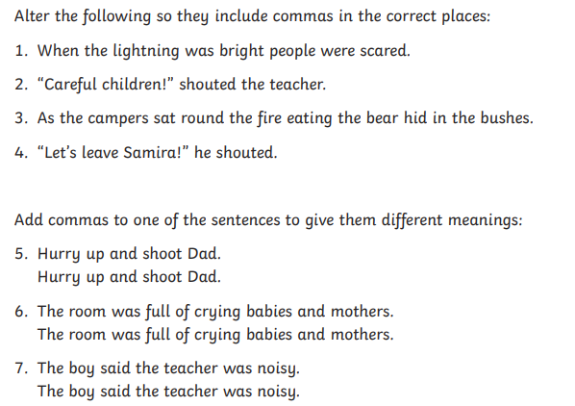
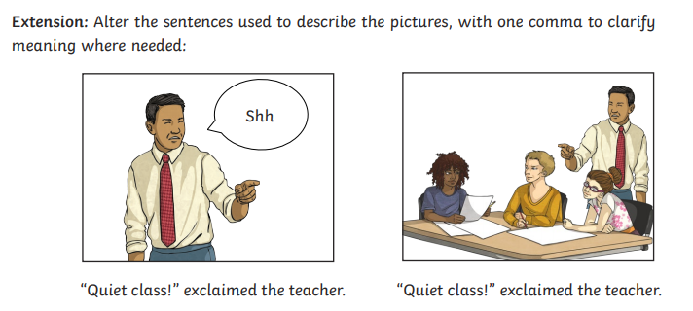

Tuesday: Spelling and Handwriting
Practise spelling the following words from the Year 5 and 6 statutory list. All of these are words that can be used as verbs. Can you find any other similarities between them, such as in the spellings?
Now check that you know what each of the words means and practise writing some sentences containing the words you have been learning. Take care to punctuate your sentences with care!

Wednesday: Punctuation – semi-colons
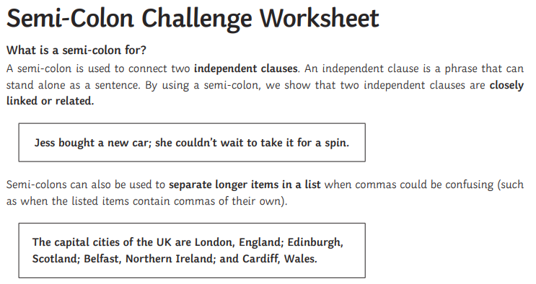
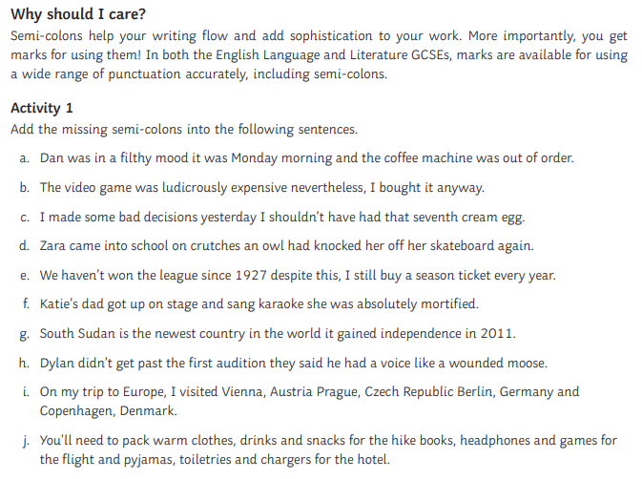

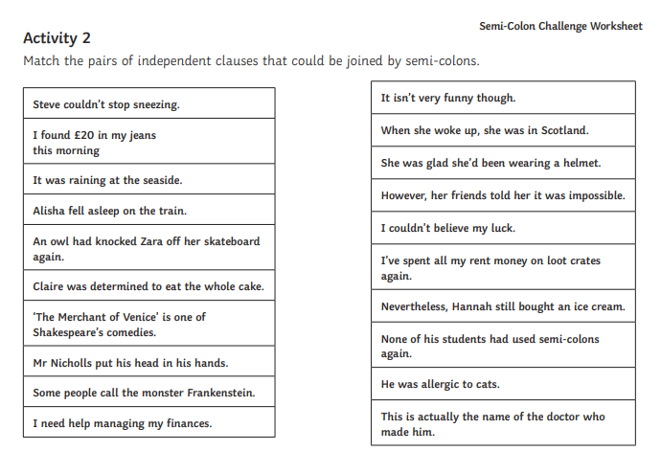
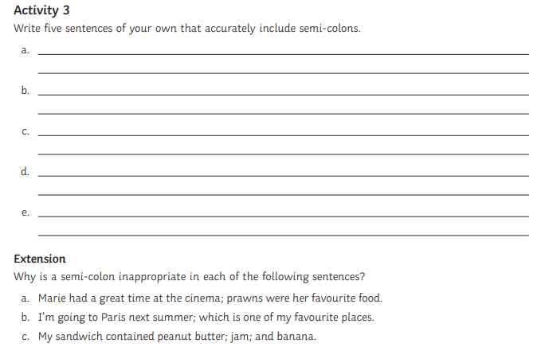

Thursday: Punctuation – colons and semi-colons
Watch and read the lesson on semi-colons and colons at https://www.bbc.co.uk/bitesize/topics/zs4qn39/articles/z4k2xyc
Place semicolons in the following sentences. Semicolons are used in between independent clauses if they are not joined by a comma and a conjunction (and, but, or, nor, for, & yet. (See rule above.) Semicolons can also be used between independent clauses joined by words like hence, however, for instance, furthermore, etc. 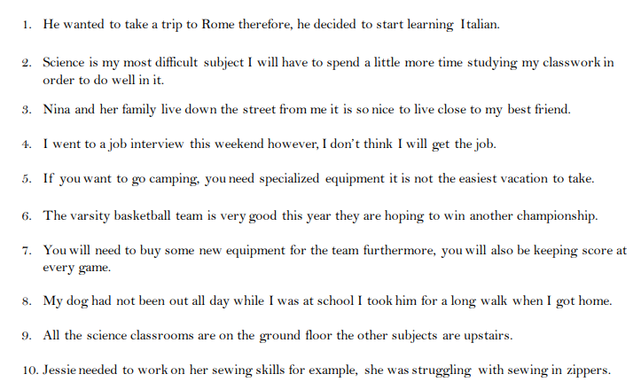

Place colons in the following examples or sentences. Colons are used to indicate the following: “note what follows,” to separate hours and minutes when writing out the time, between a chapter and verse when referring to the Bible, and after a greeting of a business letter.
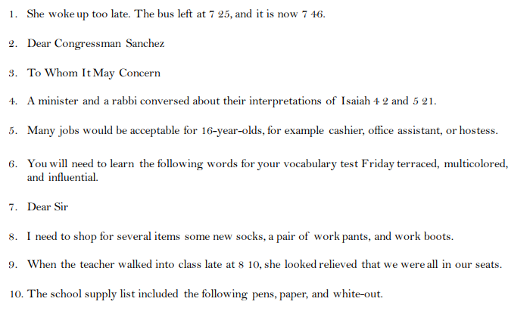
Review. Place the appropriate punctuation mark in the following sentences. The spaces for punctuation are marked for you. Choose between comma, semicolon, and colon.
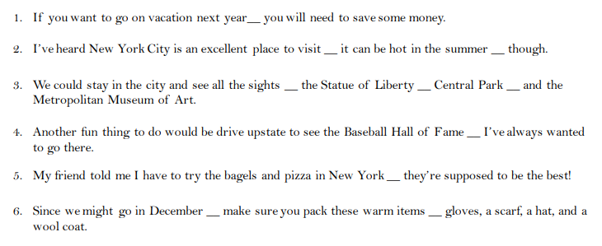

Friday: Punctuation – Parenthesis
Have a look at the lesson on https://www.bbc.co.uk/bitesize/articles/zn8c47h about using brackets, commas or dashes for parenthesis. Then complete some of the activities linked to this lesson.

Answers:
Monday: Commas for clarification
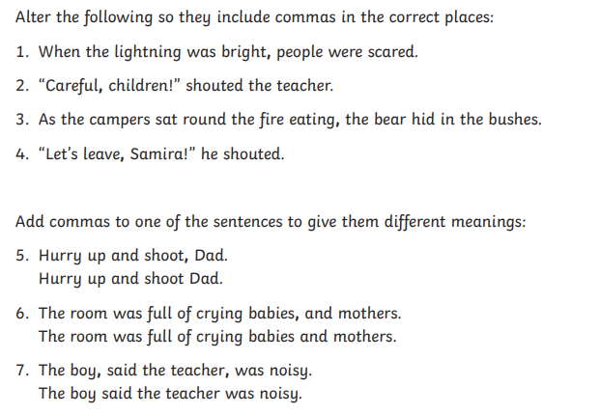

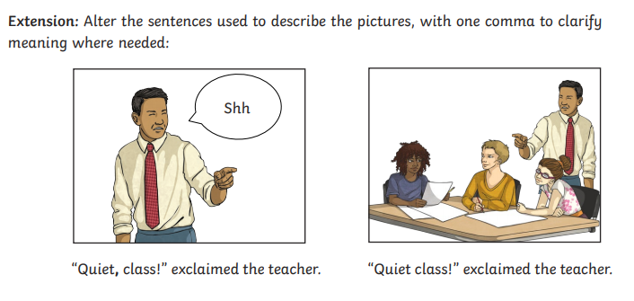

Wednesday: Punctuation – semi-colons
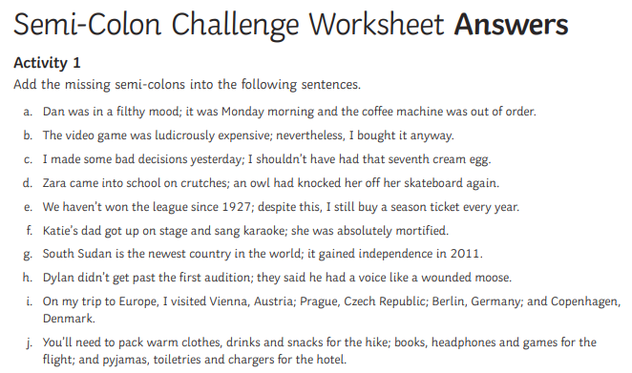
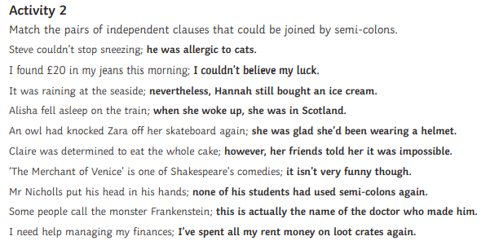
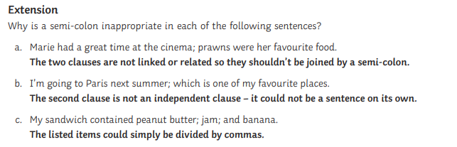

Thursday: Punctuation – colons and semi-colons
