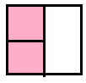  Two quarters | ½ | 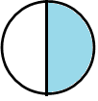  half | 1 | 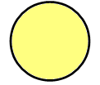  whole | ¾

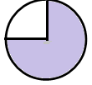  three quarters | ¼ | 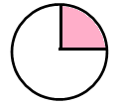  quarter | ½ | 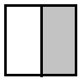  half | 1

  whole | ¾ | 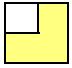  three quarters | ¼ | 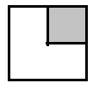  quarter | 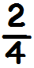

two quarters | 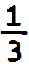 |   third | ¼ | quarter | 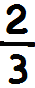

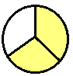  two thirds | ½ | half | 1 | whole | ¾

three quarters | 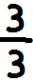 |   three thirds | ½ | half | 1

whole | ¾ | three quarters | ¼ | quarter

